Jesus One evening after the Passover Meal, Jesus and his disciples went to the Garden of Gethsemane to pray. One of Jesus’ disciples had left the group on a secret mission to betray Jesus. His name was Judas. Judas had agreed to help the members of the Sanhedrin find Jesus in a quiet place so they could arrest him. The Sanhedrin hated Jesus and wanted to see him crucified for telling people he was the Son of God. Although they studies scriptures and should have recognized Jesus as the Messiah, he didn’t fit what they though the Messiah should be. They thought he was just trying to trick the people and pretend to be God. This made them so angry and full of hate that they wanted to see him killed.

Jesus Is Arrested

Jesus knew all that was about to happen to him. He had tried to warn the disciples, but they didn’t understand all that would take place or why it needed to take place. Jesus was very troubled that it was time for all of the bad things to start happening. He had gone to the garden to pray about all that was about to take place. Jesus asked his disciples to stand watch as he prayed because he knew they would all soon be in danger and he wanted to focus on praying. Three times Jesus came back from where he was praying in the garden to find the disciples asleep. They had no idea how serious things were about to get but Jesus knew exactly what was about to happen.

A little while later, Jesus woke the disciples telling them that Judas was coming. Judas knew Jesus often came to the Garden of Gethsemane to pray, so he knew exactly where to lead the high priest, elders, and the guards.

Judas walked up to Jesus and said “Master, Master!” and then gave him a kiss. Jesus knew that kiss was not a friendly greeting like many people did in that time. Jesus knew that kiss was a sign to the other men who were with Judas. Judas was letting them know that Jesus was the man they needed to capture. The soldiers grabbed Jesus to arrest him. The disciples didn’t know what to do. They wanted to help Jesus, but they were scared all at the same time.

Peter grabbed one of the swords Jesus had given them earlier that night, and he cut off the ear of one of the men. The man’s name was Malchus. He was a servant of the high priest. Peter thought he was being brave and helping Jesus, but Jesus didn’t need them to fight. Jesus told Peter to stop fighting. It was God’s plan for him to be arrested. Jesus touched the man’s ear, and he was healed. Then Jesus was taken away by the guards and priest and the disciples scattered in fear just as Jesus told them they would do.

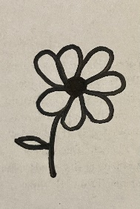

Printing Practice

Judass

Jj

Kk

kiss

Ee

ear

1. Where were Jesus and his disciples?
2. Who lead the guards to find Jesus?
3. How did Judas know where to find Jesus?
4. What did Judas do to Jesus so they would know who they should arrest?
5. What did Peter do to one of the guards?
6. What did Jesus do to the man’s ear?
7. Why didn’t Jesus want the disciples to fight the guards?
8. What did all the disciples do after Jesus was arrested?

When Jesus was arrested, Peter was filled with fear and cut off the soldier’s ear. Fear and ear rhyme. They have the same ending sound. Look at the pictures below and see if you can match the items that rhyme.

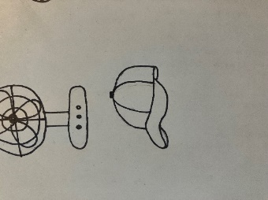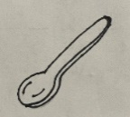

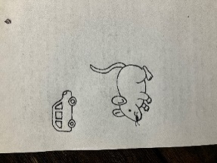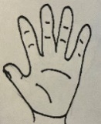

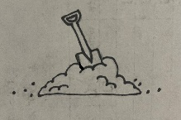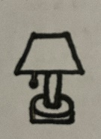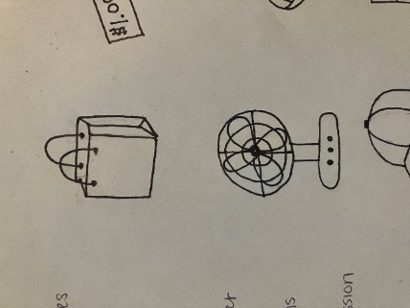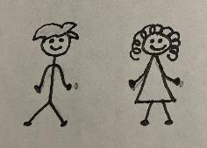

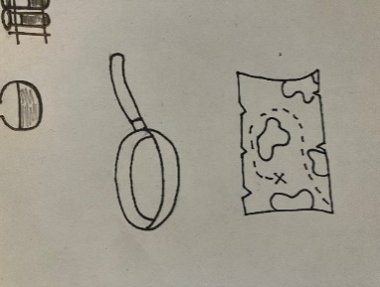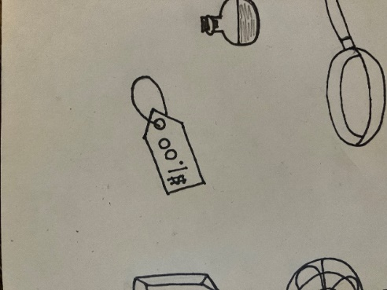

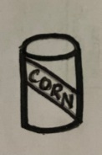

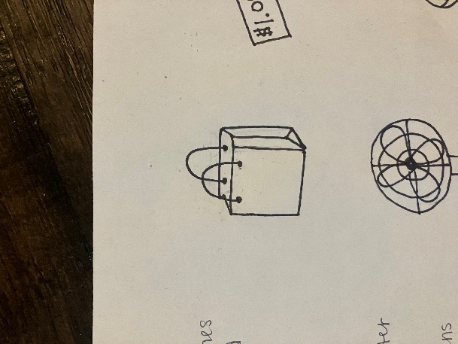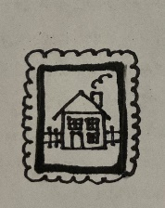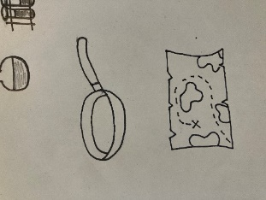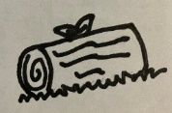

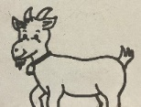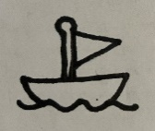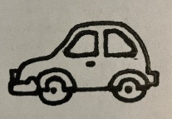

Memory Verse

Find it, Read It, Write It, Explain It!

**And they laid hands on him, and took him.**

**Mark 14:46**

Cursive Practice

udas

j

K k

kiss

E e

ear

U

“Hold Your Fire!”

Have you ever heard someone say this, maybe in a

movie or on tv? Just when a fight is about to break out. Everyone

is ready to attack but its’ not the right time. So, they leader says, “hold your fire>” This is what Jesus was telling Peter. Peter watched as Jesus was being arrested and he wanted to help Jesus so he did the first thing he could think of. He attacked. It wasn’t the right time for fighting. Jesus knew it was part of God’s plan for him to be arrested. Peter was just trying to help someone he loved but fighting was against God’s plan. I’m sure Peter was confused when Jesus told

him to stop. He thought he was doing the right t thing. Sometimes the right things seem wrong,

and the wrong things seem right. This is why

we should ask God to show us how to

react to all things in life.

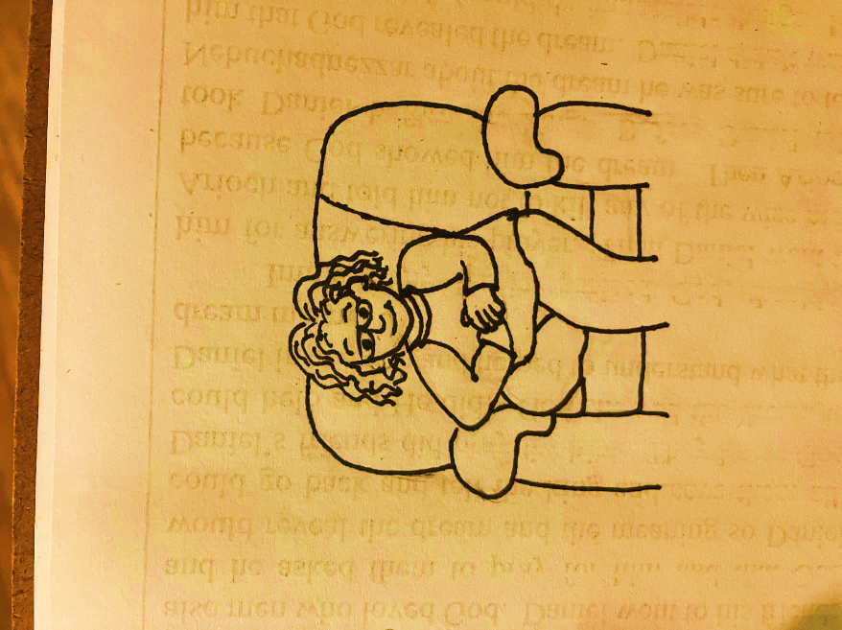

Crossword Puzzle

Down

1. Jesus touched Malchus on the ______ and he was healed.
2. Where did Judas know he would find Jesus?
3. What did Peter use to cut off Malchus’s ear?
4. Who led the priest, elders, and guards to find Jesus?

Across

2. Who arrested Jesus?

5. What was the sign so the guards would know who to

arrest?

6. Who grabbed a sword and cut off someone’s ear?

|  |  |  |  |  |  |  |  |  |  |  |
| --- | --- | --- | --- | --- | --- | --- | --- | --- | --- | --- |
|  |  |  |  |  |  |  |  |  |  | 4 |
|  |  |  |  |  |  |  |  | 3 |  |  |
|  |  |  |  | 5 |  |  |  |  |  |  |
|  |  |  |  |  |  |  |  |  |  |  |
|  |  |  |  |  | 2 |  |  |  |  |  |
|  |  |  |  |  |  |  |  |  |  |  |
|  |  | 1 |  |  |  |  |  |  |  |  |
| 6 |  |  |  |  |  |  |  |  |  |  |
|  |  |  |  |  |  |  |  |  |  |  |
|  |  |  |  |  |  |  |  |  |  |  |
|  |  |  |  |  |  |  |  |  |  |  |

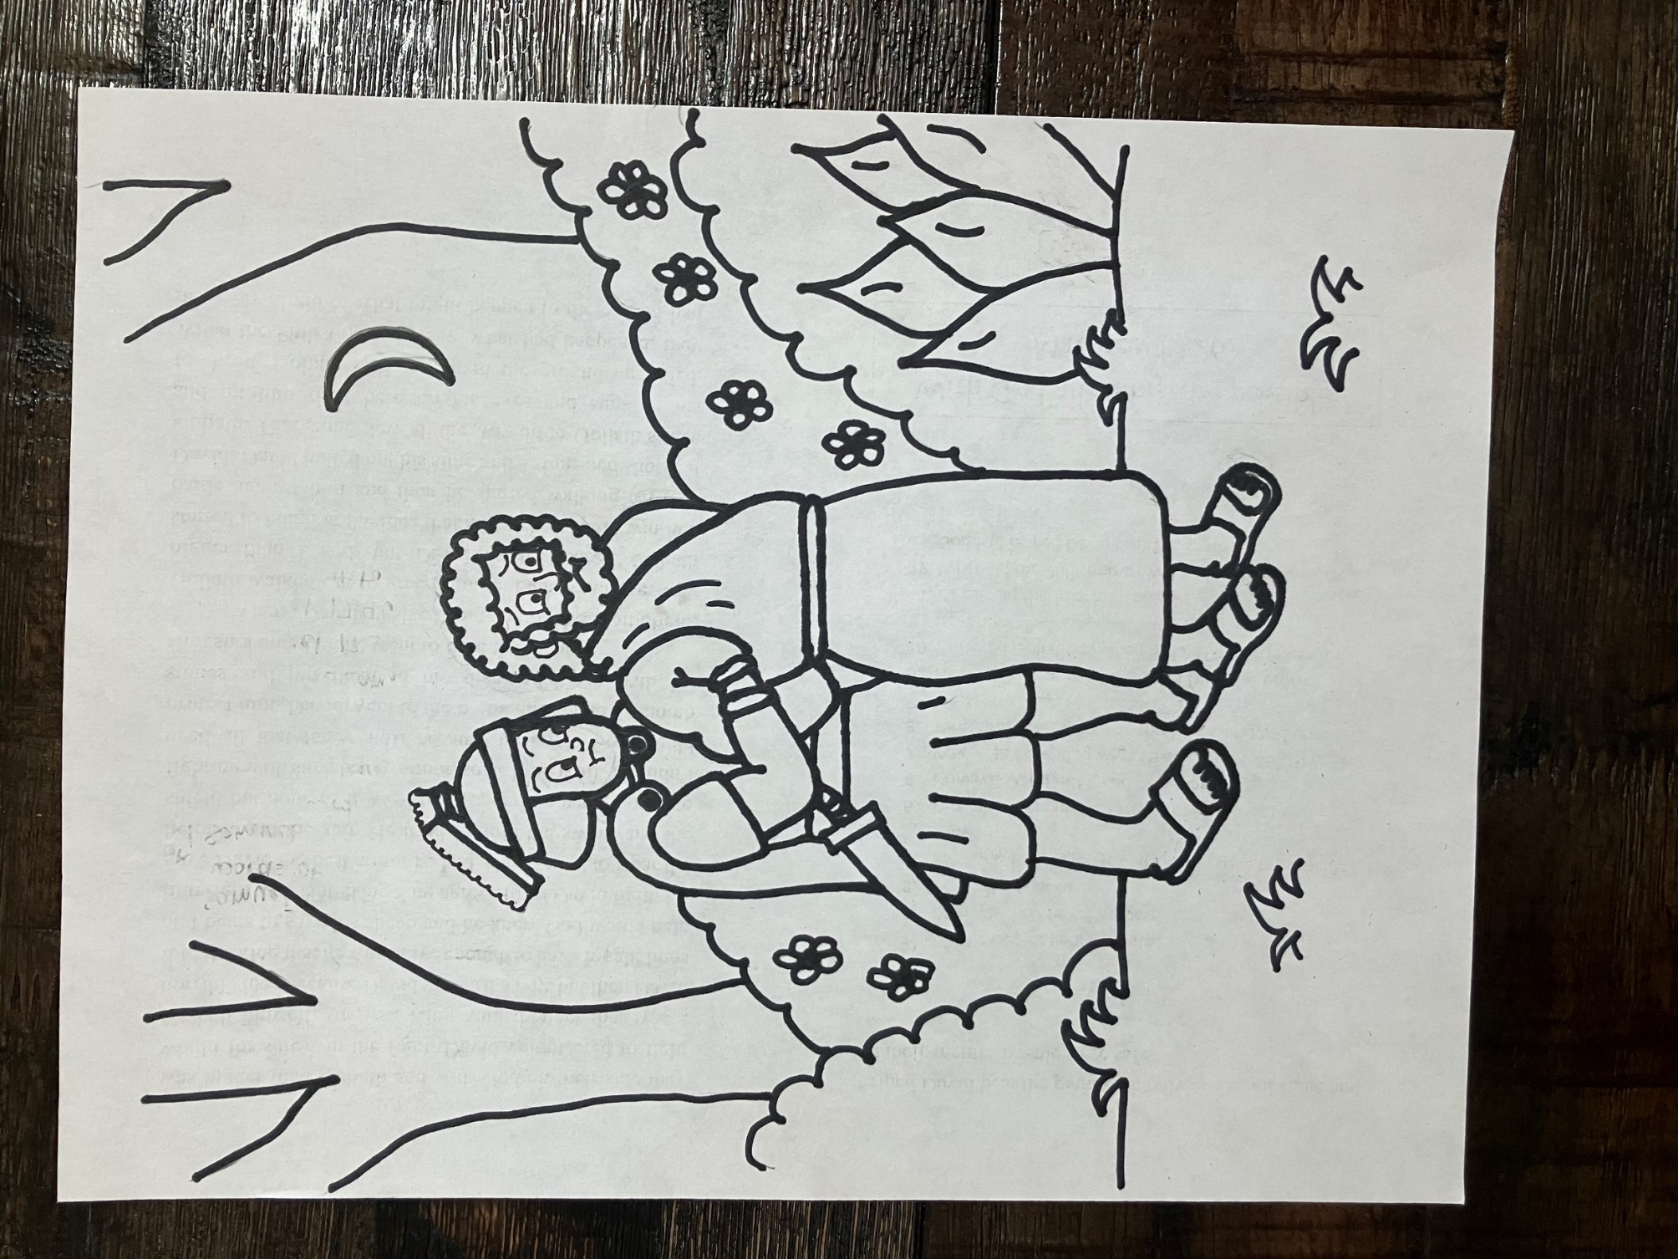

**6**

**And they laid hands on him, and took him. Mark 14:46**

**7**

**7**

**4**

**4**

**1**

**2**

**4**

**4**



**1**

**4**

**3**

**2**

**4**

**2**

**5**

**3**

**1**

**2**

**5**

**5**

**1**

**1**

**1**

**2**

1 – tan 2 – green 3 – purple 4 – red

5 – light green 6 – dark blue 7 - brown



Dear God,

Thank you for this

lesson. Thank you for Peter. Thank you for

choosing to use people who mess up and do the wrong things because that’s all of us. Peter’s love for Jesus was so strong that he got all caught up in the moment and reacted so fast that he didn’t realize what he was doing was against your plan. Please forgive us for those times when we act like Peter. Please help us to always try to do exactly what you would have us do. Please help us to take time before we respond to so scary situations so we can be sure we are doing the right thing. Please forgive us when we get all caught

up in the moment and make things worse when we

think we are helping. Please help us to trust you to

know exactly what to do and when to do it.

In Jesus’ Name,

Amen