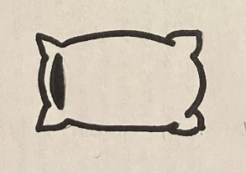

INSTRUCTIONS:

Print the rhombuses on pages 1 and 2 on regular printer paper. Cut out, cover front and back with contact paper. Cut out.

**Soft G**





**Soft G**

**Soft G**

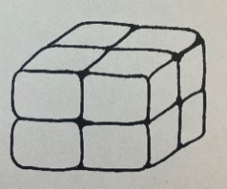



**Hard G**

**Soft G**



INSTRUCTIONS:

Print the rhombuses on pages 3 and 4 on full-page labels. Cut out, stick to the inside of a file folder. (Optional) Cover folder with contact paper.

**Hard G**



**Hard G**

**Hard G**





**Hard G**

**Hard G**

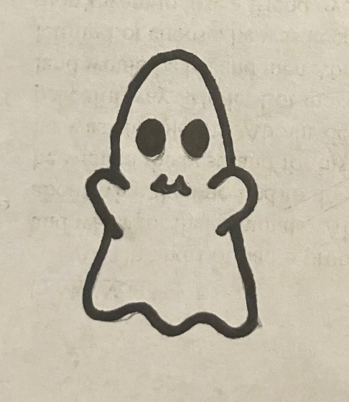

“The Letter G”

-Letter Sounds

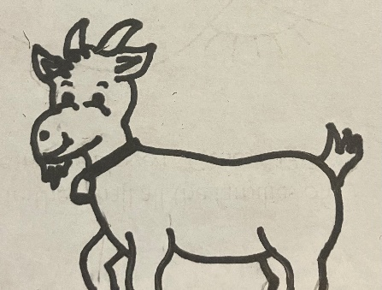

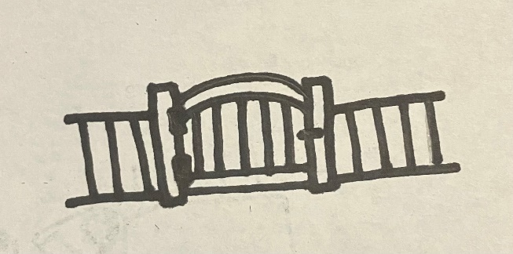

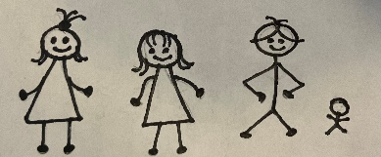

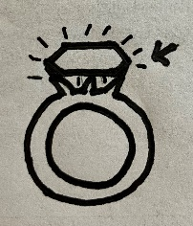

Goliath and giant both start with the letter G. Goliath has the hard G sound and giant has the soft G sound. Look at each picture and decide if it starts with the Hard G or the Soft G.

