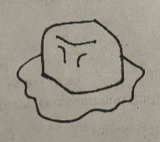

INSTRUCTIONS:

Print hexagons on pages 1 and 2 on regular printer paper. Cut out, cover front and back with contact paper. Cut out.

A





A

A





E

E





INSTRUCTIONS:

Print hexagons on pages 3 and 4 on full-page labels. Cut out, stick to the inside of a file folder. (Optional) Cover folder with contact paper.

E





I

E





I

I



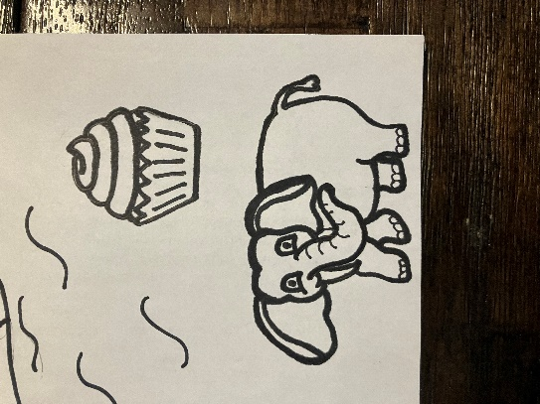

“Cold as Ice”

-Vowel Sounds





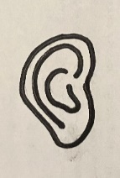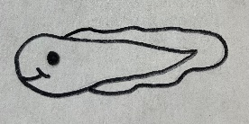





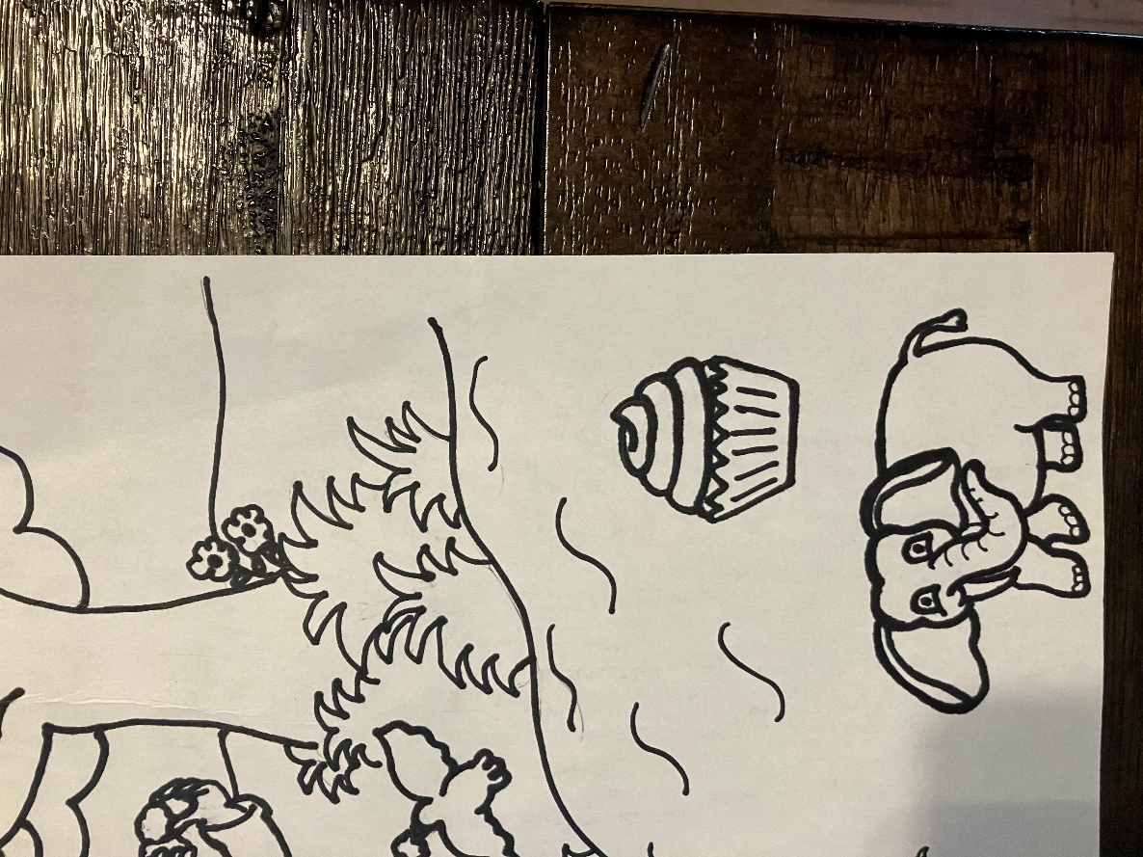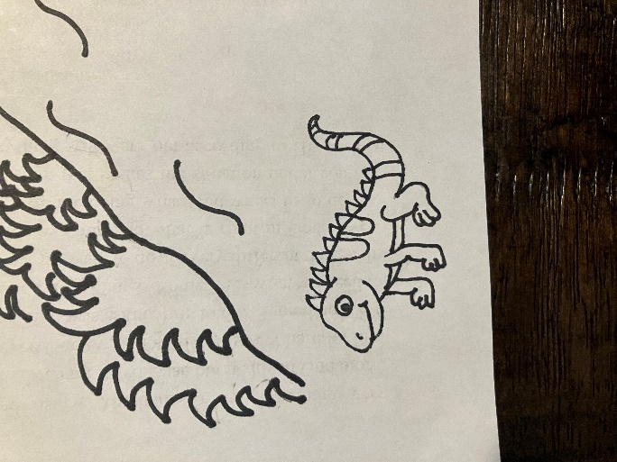





Isaac starts with the letter I. I is a vowel and vowels have a short sound and a long sound. Match the items below with the vowel that begins its name.

