One day Jesus and his disciples were on their way to Jerusalem. Lots of people were going to Jerusalem because it was time for the Passover Feast. This was a special meal to remember how God had protected the Israelite children. People came from all around for this special celebration. Jerusalem was full of people.
Jesus Arrives in Jerusalem
Jesus Arrives in Jerusalem
When Jesus and his disciples were getting close to Jerusalem, Jesus told two of his disciples to run ahead of them into the city. There they would find a young donkey tied to a tree. Jesus told them to get the donkey and bring it back to him. He said, “If anyone asks you why you are taking the donkey, tell them Jesus needs it and then it will be returned.”
His disciples ran ahead, and just inside the city, just as Jesus had said, there was a young donkey tied to a tree. They untied it and someone stopped them to see what they were doing. The disciples answered that Jesus needed the donkey and it would be returned. The people in Jerusalem had heard of Jesus and they were willing to let him borrow the donkey. So, the disciples led the donkey back to where Jesus and the other disciples were walking.
The disciples put clothes on the donkey’s back and then Jesus climbed up on top of it and rode it into the town of Jerusalem. When other people saw Jesus coming, they started laying clothes and branches for the palm trees on the ground in front of where the donkey was walking. They were making a special path for Jesus. The people knew that Jesus was special. They had heard about his teachings and the miracles he had done. They knew he must be the Son of God. They started saying “Hosanna, Blessed is he that cometh in the name of the Lord.”
Many people cheered and worshiped Jesus as he was entered Jerusalem, but not everyone was excited to see Jesus coming to town. There were also people who didn’t believe that Jesus was the Son of God. It made these people very angry to hear other people praising Jesus. These people were the Pharisees. They were the high priest and elders. They worked in the church. They studied the scriptures and told everyone how to follow the rules and live the way God wanted them to live. They were supposed to be the good guys, but they were very jealous of Jesus. They were jealous that people loved Jesus. They didn’t think Jesus was the one the scripture was saying would come to rescue the people. They thought he was lying and just trying to trick people, and this made them very angry. So, that day, they decided they would have Jesus killed. He was messing up their plans and they were going to come up with a sneaky plan to arrest him and have him crucified. The Pharisees decided to wait until after the Passover celebration. They thought there were too many people visiting Jerusalem who might try to help Jesus. They weren’t exactly sure what they were going to do but they were afraid if they didn’t do something soon, people would listen to Jesus more then they listened to them. Their minds were made up that it was time for them to put an end to Jesus’s ministry.
Jesus knew bad things were about to start happening to him. He had warned the disciples many times that his time on earth was about to be over, but they didn’t understand what he meant. All the disciples could see was how much people loved Jesus. They didn’t understand what was about to happen, but even when Jesus was riding on the donkey’s back listening to the people shout “Hosanna,” he knew exactly what the Pharisees were planning to do.

- Why were Jesus and his disciples in Jerusalem?
- What did Jesus tell tow of his disciples to run ahead of them to get?
- What did Jesus do with the donkey?
- What were the people shouting when Jesus entered the city?
- What did the people put on the ground in front of the donkey?
- Why didn’t the priest and elders like Jesus?
- What were they planning to do?
- Why didn’t they want to wait until after the Passover to try to capture Jesus?
- Who else knew what they Pharisees were planning to do?

Look it Up! (Answers are KJV specific)_
Down
- Mark 11:10 Blessed be the _________ of our father David…
- Mark 14:2 But they said, Not of the feast day, lest there be
and _________ of the people.
- Matthew 21:11 And the multitude said, This is Jesus the prophet
of ___________ of Galilee.
- Mark 11:4 And they went their way, and found the ______
- Mark 14:1 …and the chief priest and the scribes sought
how they might take him by craft, and put him to _________
- Mark 11:1 And when they came night to Jerusalem, unto
Bethpage and ____________
Across
- Matthew 21:1 …unto the mount of __________, then sent
Jesus two disciples
- Mark 11:7 And they brought the colt to Jesus, and cast their
__________ on him
- Matthew 21:8 …others cut down branches from the trees…
- Matthew 21:4 And this was done, that it might be fulfilled
which was spoke by the __________, saying,
 |  | 1 |  |  |  |  |  | 4 |  |  |  | 5
 |  |  |  | 2
 |  |  |  |  |  |  | 7
 |  |  |  |  |  |  | 3
 | 8
 |  |  |  |  |  |  |  |  |  |  |  | 6
 |  |  |  |  | 9
10
Reflection Questions
- Have you ever let embarrassment of what other might think keep you from doing something?
- Have you ever judged someone by the car they drive, the clothes they wear, or the house they live in to then later find out you were wrong about the kind of person they were?
In My World
Jesus rode into town on the back of a donkey. Jesus, the Son of God, was riding a donkey and it wasn’t even his donkey. Even in bible times a donkey wouldn’t have been the most lavished mode of transportation. Yet riding the donkey fulfilled the prophecy in Zechariah 9:9 and even while riding the donkey, the people still recognized him as the Messiah. They didn’t’ care about the donkey, they worshipped Jesus. Sometimes in life we might need to humble ourselves to do something that feels like riding the donkey. Sometimes life may require us to do something that we might think we are too special or too important to do. Don’t let pride keep you from doing that God has for you to do. Jesus riding on the back of the donkey into town was a very important part of God’s plan. It would help people to know that he was the person they had been waiting for. You never know what God may use as part of His important plan for your life. Keep your eyes fixed on what God is calling you to do even if you think you deserve something better. God’s plan will lead you to the best life for you.

My Prayer for You
My prayer for you is that you ride the donkeys with your head held high. Pride is a sin that can either lead to arrogance or embarrassment. Jesus was neither arrogant nor embarrassed. Jesus rode the donkey because that’s what he needed to do. He was content in God’s plan and didn’t let what other people might think alter his plans for the day. I pray that you find contentment in what God has given you. I pray that you follow God’s plan and trust Him to provide what you will need even if it’s a donkey.
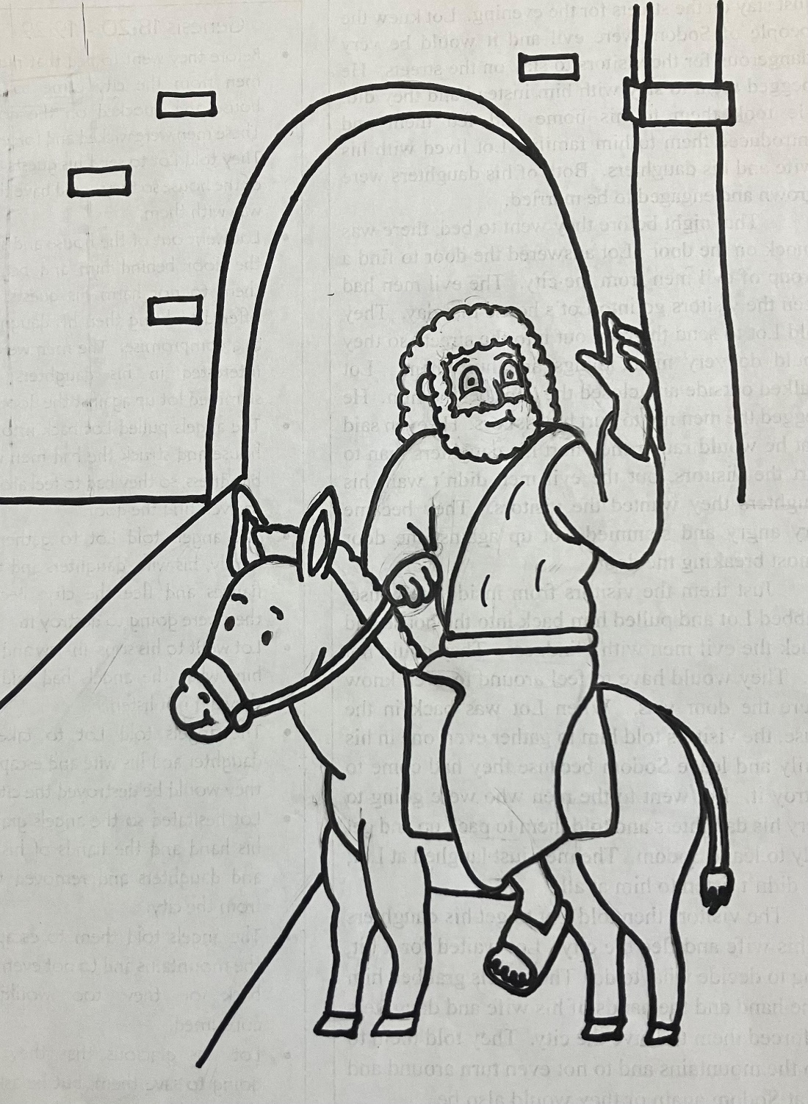
Hosanna, Blessed is he that cometh in the name of the Lord. Mark 11:9

