Jesus and his disciples had just finished the Passover meal when Jesus stood up from the table and began washing the feet of the disciples. The disciples didn’t understand what Jesus was doing because washing feet was usually a job completed by the servants in the house, not someone who they referred to as Master. Jesus explained to the disciples that allow him to wash their feet was another way he was able to connect with them. His disciples wanted to be as close to Jesus as possible, all but one.

The Lord’s Supper

When Jesus had finished washing the disciples’ feet, he stood up, put his out clothing back on and then returned to his spot around the table. Jesus then announced that one of the disciples would soon betray him. Jesus knew that one of the disciples would do something that would cause him a lot of pain and sadness. The disciples were shocked. They couldn’t believe anyone in this group would do such a thing and they started to question Jesus, “Is it me? Will I be the one?” Peter leaned over the John who was sitting beside Jesus and told John to ask Jesus who it was. John leaned over near Jesus’ chest and asked him who of them would do such a horrible thing. Jesus answered John telling his that it would be the one that he gave bread to. Jesus then stood up, took a piece of bread, dipped it in the sauce and walked over to Judas. Jesus knew it was Judas who would help the high priest and elders arrest him. He handed Judas the bread and said, “that thou doest, do quickly.” Then Judas stood up from the and left.

The table and left the upper room. The disciples didn’t know why Judas left. He was the disciple who took care of the money. They thought he might have left to buy items for the meal they were eating or even to go help the poor. No one else knew that it would be Judas to betray Jesus. They were still talking and questioning who it might be. Then they started to wonder who the greatest disciple of them was.

Jesus sat back down and explained to the disciples that “greatest” the way the world thinks and “greatest the way that God thinks are two different things. In the world people think someone is great because of how much power, money of fame someone has. In heaven greatness has nothing to do with those things. Instead, it would be how you would describe someone who serves others. Those who treat others with love and kindness and help others would be the person who is called “great.” He told them just as he had washed their feet, they were to wash each other’s feet. He didn’t let the fact that they called him “Master” keep him from serving them even to do the dirty jobs. Being willing to show kindness and serve others is one way we can share God’s love with them.

Then Jesus took the bread from the table and gave thanks for it. Then he broke it into pieces and shared it with the disciples but before they ate the bread, he said something very important to them. This bread is like my body, take it, eat, and when you do remember that I am about to give my body because e of my love for you. Jesus knew he would soon be killed. It was part of God’s plan for him to die to pay for the sins of all the people who would

believe in him. The disciples didn’t completely understand what Jesus was saying but they loved him and believed he was the Son of God, so they listened and did exactly what he told them to do.

Then Jesus just took the drink and blessed it. Then he shared the drink with the disciples just as he had shared the bread. He told the disciples the drink was like his blood that he was about to shed in death. His blood would pay for all the sins of all those who believe in him. They would no longer have to make animal sacrifices for their sins. Jesus was the going to be the sacrifice for all people. Jesus told them to think about his sacrifice and his blood every time they drank it. Then Jesus and the disciples sang a song and left the upper room and followed Jesus to the Garden of Gethsemane.

On their way to the garden, Jesus explained several things to the disciples. He told them that all of them would soon leave him. This upset the disciples. They didn’t want to leave him; He told them the bible said that when the shepherd was attacked the sheep would scatter. He was the shepherd they were the sheep. This was just another thing that had to happen for God’s perfect plan.

Peter was outraged. He said, “They may leave you, but I never will.”

Jesus turned to Perter and said, “You will deny that know me 3 times before the rooster crows tomorrow.”

Peter did not want to believe this was true. He said, “I will die with you. I will not deny you.”

Then Jesus started to explain to the disciples the things they needed to do differently after he was no longer with them. While Jesus was there with them, they didn’t need money or weapons but once he was gone from them, they should always have those things. Jesus gave the disciples two swords. They would need to be prepared to protect themselves. There would be people who hated them just because they were his followers. Jesus and his disciples continued to the garden. He spoke of many things while they walked.

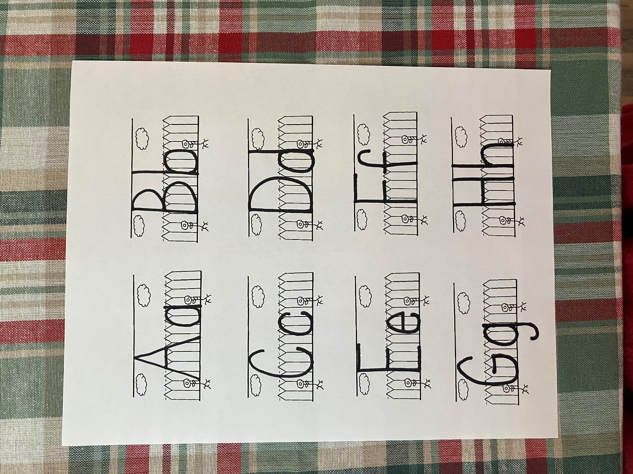

B



b

bread

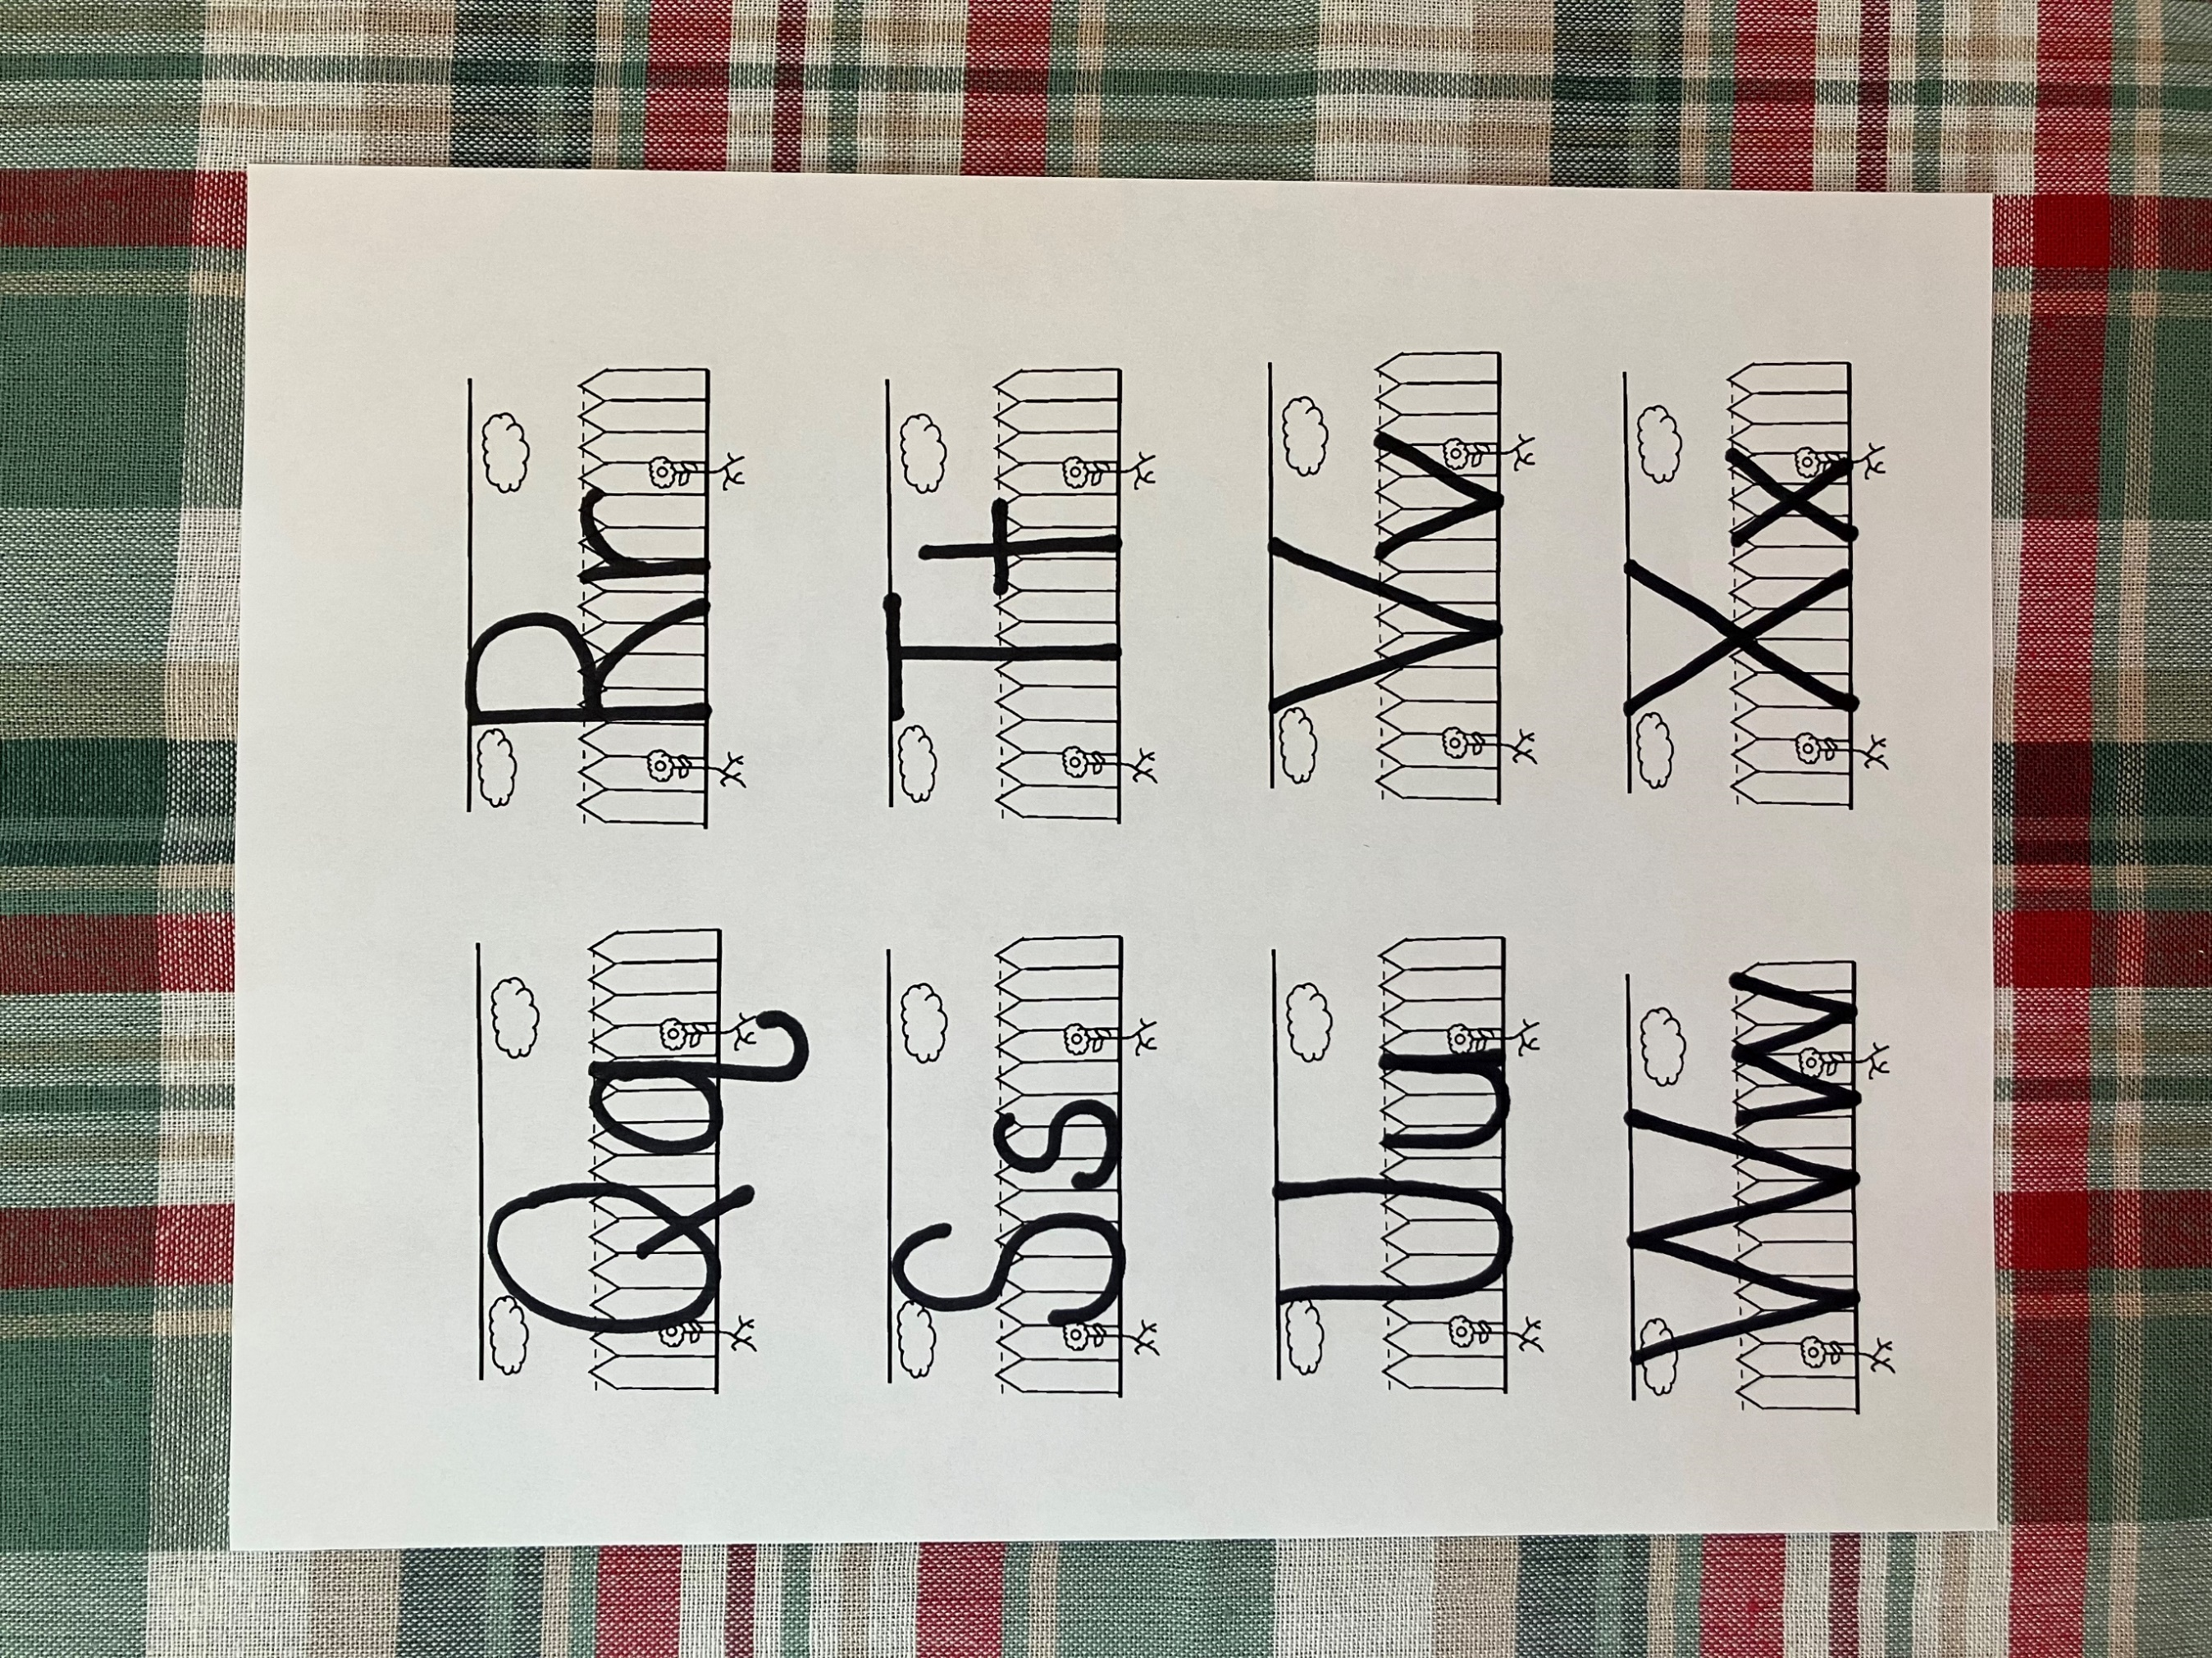

S



s

serve

1. Who was the disciple who was going to betray Jesus?
2. How is “greatness” different in the world than in heaven?
3. When Jesus shared the bread what did he compare it to?
4. When Jesus shared the drink what did he compare it to?
5. Where did Jesus and the disciples go after they sang a hymn?
6. When Jesus told the disciples they would leave him, what did he tell them about the bible when they started to get upset?
7. Which disciples said that he would never leave Jesus?
8. How many times did Jesus say Peter would deny him before the rooster crowed?
9. Why did Jesus give the disciple swords?

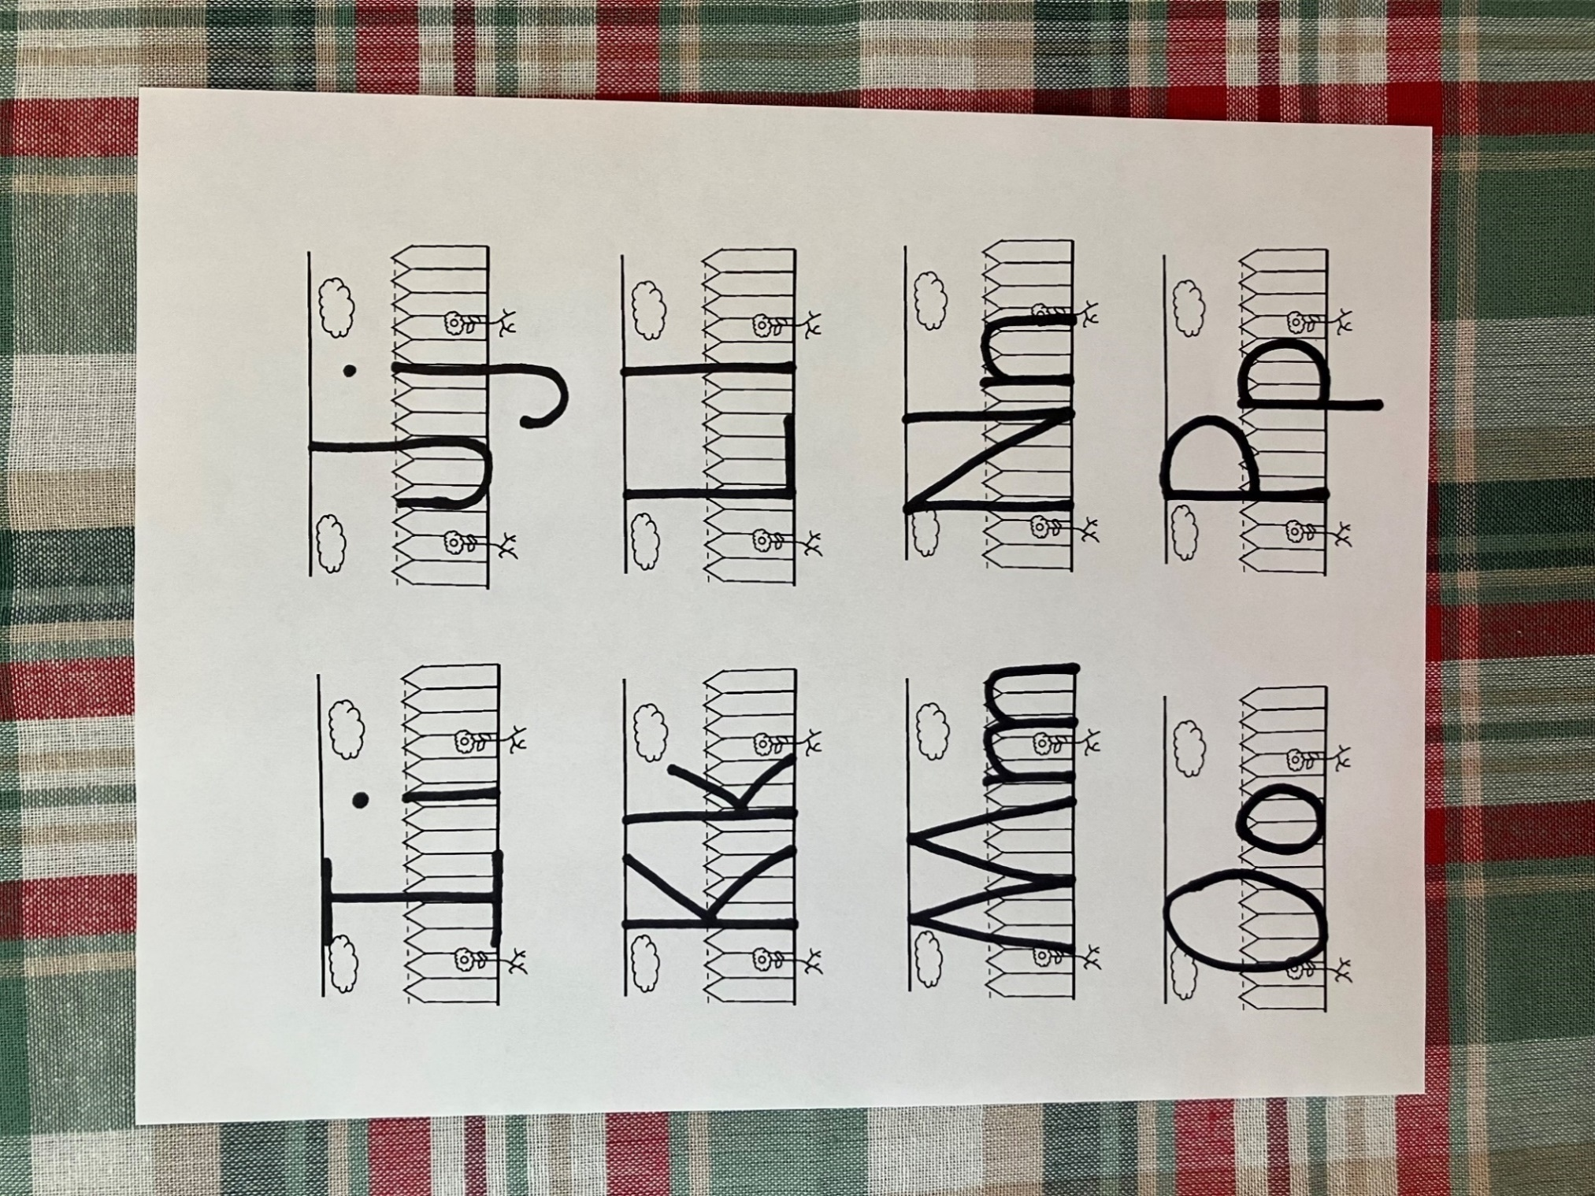

J



j

Judas

Bread, break, body, blood, and betray were all important words in this lesson. All these words start with the letter Bb. Look at the pictures below and circle the pictures of the things that also start with the letter Bb.

.

.

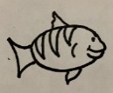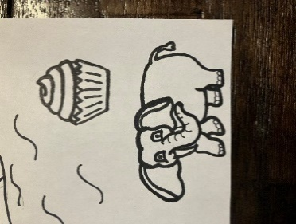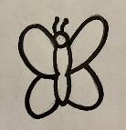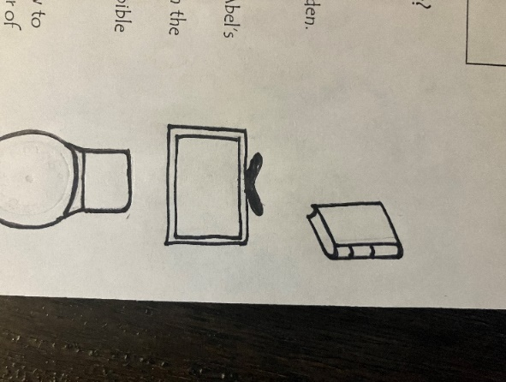

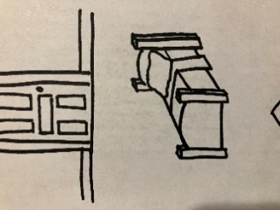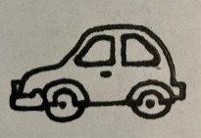

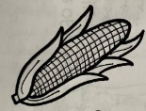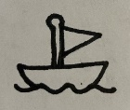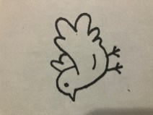

Jesus broke the bread and shared it with the all the disciples. Look at the pictures below. How would you divide the food to share it with each group of people? Draw a line on the food to show each part.

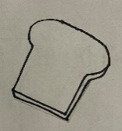

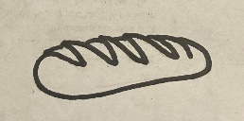



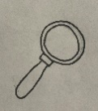

**Ss**



**Bb**

**Take, eat; this is my body. Mark 14:22**

Jesus broke the bread and shared it with his disciples. Then he shared the drink. In the space below draw a cup.

betray

* To do something that hurts someone you are close to.
* I ate the Passover meal with Jesus.
* Jesus shared the bread and the drink with me.
* I walked with Jesus to the garden.
* I didn’t like that he said we would leave him.
* He said I would deny him 3 times before the rooster crowed.

Who am I?

___ ___ ___ ___ ___

Take, eat; this is my body. Mark 14:22