Jesus and his disciples had just finished the Passover meal when Jesus stood up from the table and began washing the feet of the disciples. The disciples didn’t understand what Jesus was doing because washing feet was usually a job completed by the servants in the house, not someone who they referred to as “Master.” Jesus explained to the disciples that allowing him to wash their feet was another way he was able to teach them. His disciples wanted to know everything he had to teach them.
The Lord’s Supper
When Jesus finished washing the disciples’ feet, he stood up, put his outer clothing back on and then returned to his spot around the table. Jesus then announced that one of them would soon betray him. Jesus knew that one of the disciples would do something that would cause him a lot of pain and sadness. The disciples were shocked. They couldn’t believe anyone in their group would do such a thing. They started to question Jesus, “Is it me? Will I be the one?” Peter leaned over the John who was sitting beside Jesus and told John to ask Jesus who it will be. John leaned over near Jesus’ chest and asked him who of them would do such a horrible thing. Jesus answered John telling him it would be the one he gave bread to. Jesus then stood up, took a piece of bread, dipped it in the sauce and walked over to Judas. Jesus knew it was Judas who would help the high priest and elders arrest him. He handed Judas the bread and said, “that thou doest, do quickly.”
Then Judas stood up from the and left the upper room. The disciples didn’t know why Judas left. He was the disciple who took care of the money. They thought he might have left to buy items for the meal they were eating or even to go help the poor. No one else knew that it would be Judas to betray Jesus. They were still talking and questioning who it might be. Then they started to wonder which one of them was the greatest.
Jesus sat back down and explained to the disciples that “greatest” the way the world thinks and “greatest” the way that God thinks are two different things. In the world, people think someone is great because of how much power, money or fame they have. In heaven, greatness has nothing to do with those things. Instead, it would be how you would describe someone who serves others. The one who treats others with love and kindness and help others would be the person who is called “great.” He told them just as he had washed their feet, they were to wash each other’s feet. He didn’t let the fact that they called him “Master” keep him from serving them even to do the dirty jobs. Being willing to show kindness and serve others is one way to share God’s love with people.
Jesus then took the bread from the table and gave thanks for it. Then he broke it into pieces and shared it with the disciples. But before they ate the bread, he said something very important to them. “This bread is like my body, take it, eat, and when you do, remember that I am about to give my body because of my love for you.” Jesus knew he would soon be killed. It was part of God’s plan for him to die to pay for the sins of all the people who would believe in him. The disciples didn’t completely understand what Jesus was saying but they loved him and believed he was the Son of God, so they listened and did exactly what he told them to do.
Then Jesus just took the drink and blessed it. He shared the drink with the disciples just as he had shared the bread. He told the disciples the drink was like his blood that he was about to shed in death. His blood would pay for all the sins of all those who believe in him. They would no longer have to make animal sacrifices for their sins. Jesus was the going to be the sacrifice for all people. Jesus told them to think about his sacrifice and his blood every time they drank it. After that, Jesus and the disciples sang a song and left the upper room. They followed Jesus to the Garden of Gethsemane. The garden was a special place where Jesus went to pray.
On their way to the garden, Jesus explained several things to the disciples. He told them that all of them would soon leave him. This upset the disciples. They didn’t want to leave him; He told them the bible said when the shepherd was attacked the sheep would scatter. He was the shepherd, and they were the sheep. This was just another thing that had to happen for God’s perfect plan.
Peter was outraged. He said, “They may leave you, but I never will.”
Jesus turned to Perter and said, “You will deny that know me three times before the rooster crows tomorrow.”
Peter did not want to believe this was true. He said, “I will die with you. I will not deny you.”
Then Jesus started to explain to the disciples the things they needed to do differently when he was no longer with them. While Jesus was with them, they didn’t need money or weapons but when he was gone from them, they should always have both of those things. Jesus gave the disciples two swords. They would need to be prepared to protect themselves. There would be people who hated them just because they were his followers. Jesus and his disciples continued to the garden. He spoke of many things while they walked.
- Who was the disciple who was going to betray Jesus?
- How is “greatness” different in the world than in heaven?
- When Jesus shared the bread what did he compare it to?
- When Jesus shared the drink what did he compare it to?
- Where did Jesus and the disciples go after they sang
a hymn?
- When Jesus told the disciples they would leave him, what did he tell them about the bible when they started to get upset?
- Which disciples said that he would never leave Jesus?
- How many times did Jesus say Peter would deny him before the rooster crowed?
- Why did Jesus give the disciple swords?

Look it Up! (Answers are KJV specific) _
In My World
We celebrate Christmas to remember Jesus’ birth. We celebrate Easter to remember Christ resurrection. Even though it may not be a marked day on a calendar, when we observe the Lord’s supper it is to remember that he gave his life on the cross so that we might be saved. It’s easy to get caught up in presents and eggs and forget the real meaning we have set that time apart to remember Jesus. Don’t let the world make you forget the reason those times are special.
Down
. 1. Matthew 26:32 But after I am risen again, I will go before you unto ____________.
2. Matthew 26:22 And they were exceeding ____________ and began every one of them to say unto him, Lord is it I?
3. Matthew 26: 23 He that __________ his hand with me in the dish, the same shall betray me.
4. Matthew 26:29 But I say unto you, I will not drinketh ___________ of this fruit of the vine,
5. Mark 14:27 I will smite the shepherd, and the sheep shall be ______________
6. Luke 22:16 Until it be ___________ in the kingdom of God.
Across
7. Luke 22:14 He sat down, and the twelve ____________ with him.
8. Matthew 26: Verily I say unto you, that one of you shall __________ me.
9. Mark 14:24 This is my blood of the new ________________ which is shed for many.
 |  |  | 1
 |  |  |  |  |  |  |  |  | 3
1
 |  |  |  |  | 2 |  |  |  |  |  |  |  |  |  |  |  | 5
 |  |  |  |  |  |  | 7
 |  |  |  |  |  |  |  |  |  |  |  |  |  |  | 4
 | 8
 |  |  |  |  |  |  |  | 9
Reflection Questions
- Have you ever participated in the Lord’s supper? Did you fully understand what was happening?
- Have you ever found yourself not remembering Christ the way you should during the Lord’s Supper, Christmas, or Easter?
My Prayer for You
My prayer for you is that you don’t forget to remember. Life is distracting and things of this world are always trying to steal our focus from Christ. My prayer is that you fix your mind on things above. I pray that you set aside time to intentionally think about and appreciate all that God has done for you. I pray you never forget to remember him the way you should.

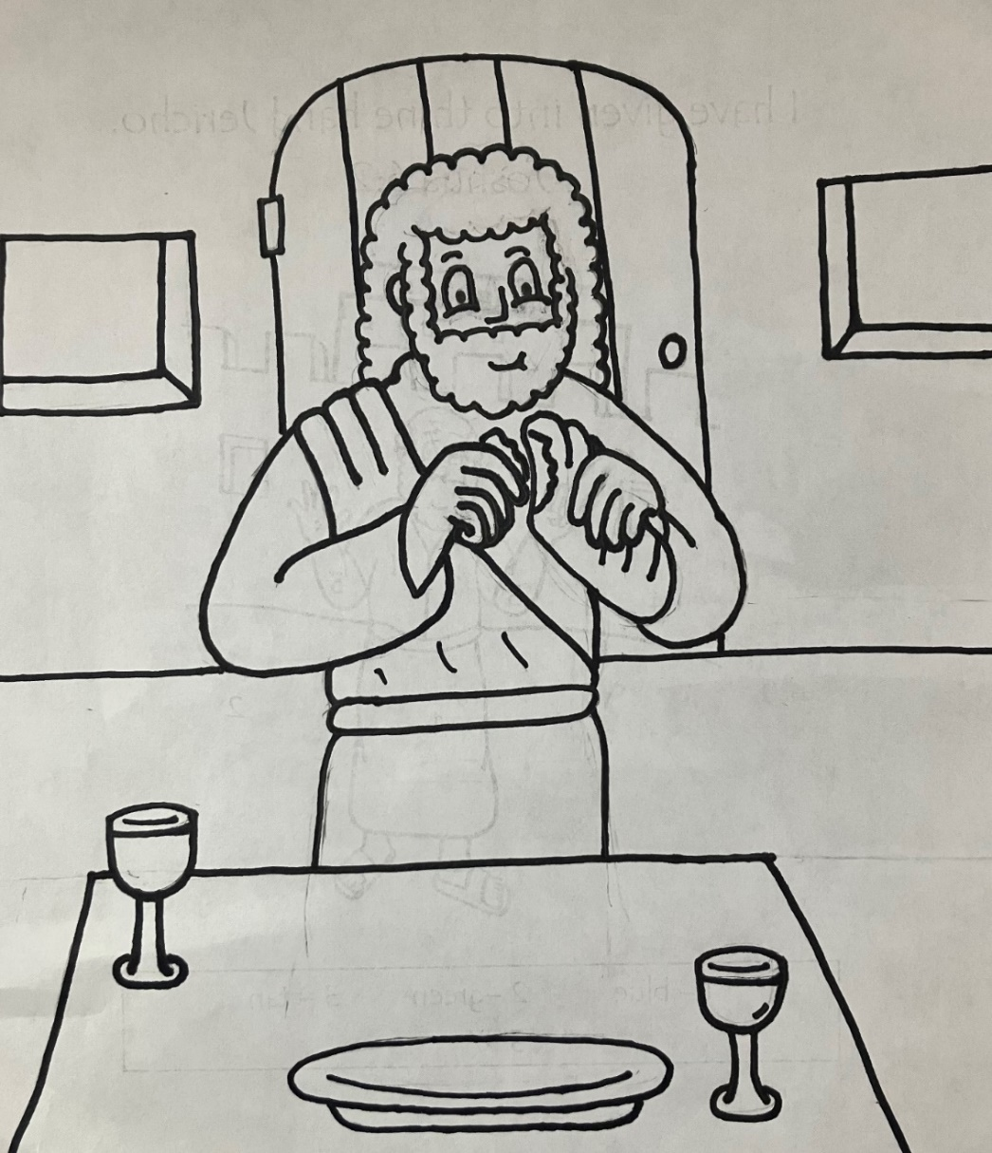
After that he poureth water into a basin and began to wash the disciples’ feet. John 13:5

