Long ago in Jerusalem, there were religious leaders who worked in the temple. They studied the scriptures, and it was their job to make sure people were obeying the laws of the Old Testament. This group of men were referred to as the Sanhedrin. Although they were very smart about things of the bible, these men had hatred in their hearts. They did not believe Jesus was God’s Son. They had heard of the Messiah, but they didn’t think Jesus was good enough to be him. They thought Jesus was trying to trick the people and this made them very mad at him and all who followed him. They were so angry that they decided that Jesus should be crucified because he was messing up their plans.

Jesus is Questioned

The Sanhedrin teamed up with Judas, one of Jesus disciples, and came up with a plan to have Jesus arrested. Then they took Jesus to Caiaphas to be judged. Caiaphas was the leader of the Sanhedrin, and he said that Jesus was guilty of pretending to be God and he should die. Caiaphas had a lot of power but not enough to have anyone crucified, so he had to send him to the Roman governor, Pontius Pilate. If Pilate found him guilty, Jesus would be crucified.

The morning after Jesus was arrested the guards took him to the home of Pilate. The members of the Sanhedrin didn’t like Pilate. He had used his power to take money from the temple. Usually, they would have wanted nothing to do with him, but they knew he was the only person who could see their evil plan followed out. Pilate was also a Gentile. The members of the Sanhedrin were Jewish. The Gentiles did not believe in God or worship the way the Jewish people did. The Jews had rules about even being around the Gentiles, so when Jesus and the Sanhedrin arrived at Pilate’s, they refused to go inside. Going into his house would have been against their rules so they waited for him to come outside to speak to them. When Pilate walked out onto his porch, he asked them why they had brought Jesus to him.

The members of the Sanhedrin were very smart and very sneaky. Caiaphas said that Jesus was guilty of blasphemy, or pretending to be God. Blasphemy was against the rules in the bible, but it was not against the rules of the government. If they told Pilate Jesus was guilty of blasphemy, Pilate wouldn’t have punished him. Instead, they told Pilate that Jesus was guilty of telling people not to pay their taxes, causing riots in Galilee, and thinking he was more powerful than Ceasar who was over the entire Roman Empire. Even though those things weren’t exactly the truth, they knew those things were against the law and Pilate would punish Jesus for doing them.

Pilate turned to Jesus and asked him if he was the King of the Jews? Jesus answered, “thou sayest” and then he didn’t answer anymore of Pilate’s questions. Pilate watched Jesus carefully while the priest and elders were talking about him. Jesus didn’t try to fight back. Jesus didn’t try to argue that they were wrong. Jesus was very peaceful and that was strange to Pilate. He didn’t think Jesus was guilty. He didn’t think Jesus needed to die. He could tell the members of the Sanhedrin were jealous of him. Pilate didn’t want to have to decide jealous of him. Pilate didn’t want to have to decide if Jesus wanted to be punished. He decided to send Jesus to a different governor. Pilate was the governor over Jerusalem, but he was not the governor over Galilee. If Jesus was causing trouble in Galilee, that governor could decide if he was guilty. The governor in Galilee’s name was Herod Antipus, and he was in Jerusalem for the Passover Meal. Pilate sent Jesus to where he was staying.

When Jesus and, the guards, and the members of the Sanhedrin arrived in front of Herod Antipas, they told Herod all the things they had told Pilate. Herod had heard of Jesus. He had heard of all the miracles he had performed, and he was excited to meet Jesus. He wanted to see Jesus do something amazing. But when Jesus stood before him, he didn’t speak. Jesus didn’t answer any of his questions either. By this time other people had gathered around, and they began to mock Jesus…they laughed at him and called him a fake and a phony. When Jesus didn’t do a miracle to save himself from the trouble he was in, Herod started joining the people as they mocked him. He didn’t think Jesus was guilty of anything bad enough to be killed. He didn’t want to make the decision to kill Jesus, so he sent him back to Pilate.

.

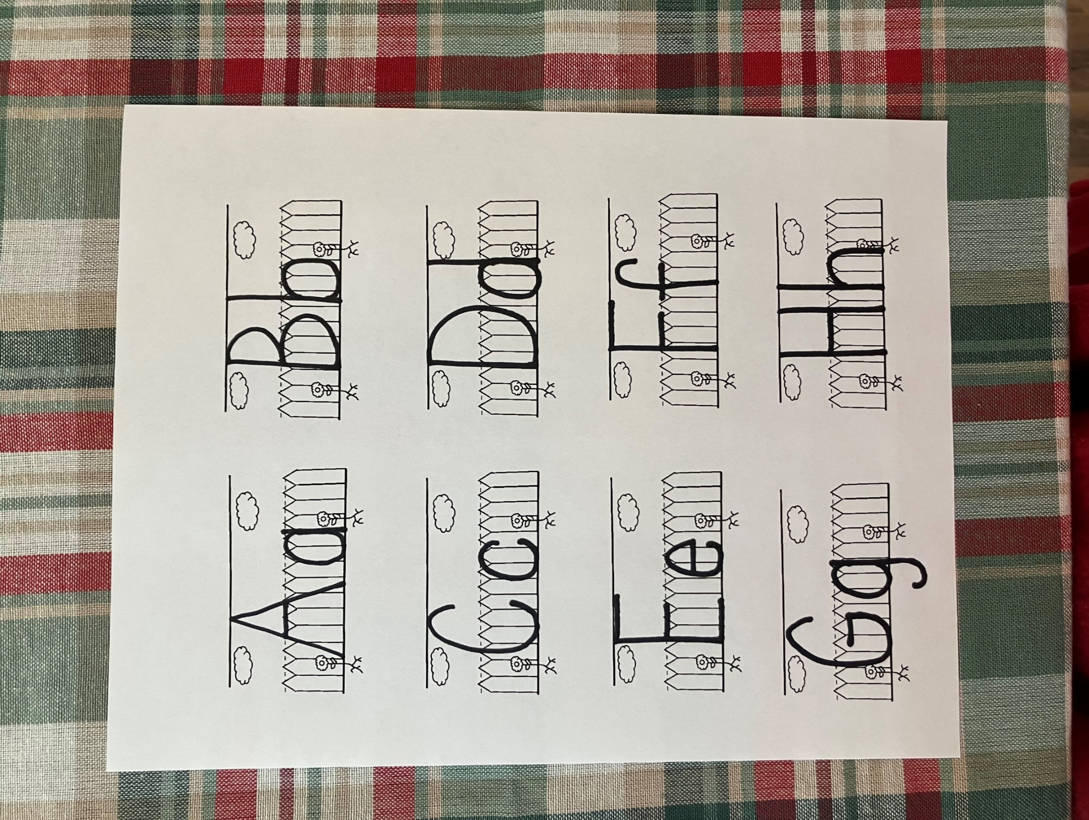

H



h

Herod

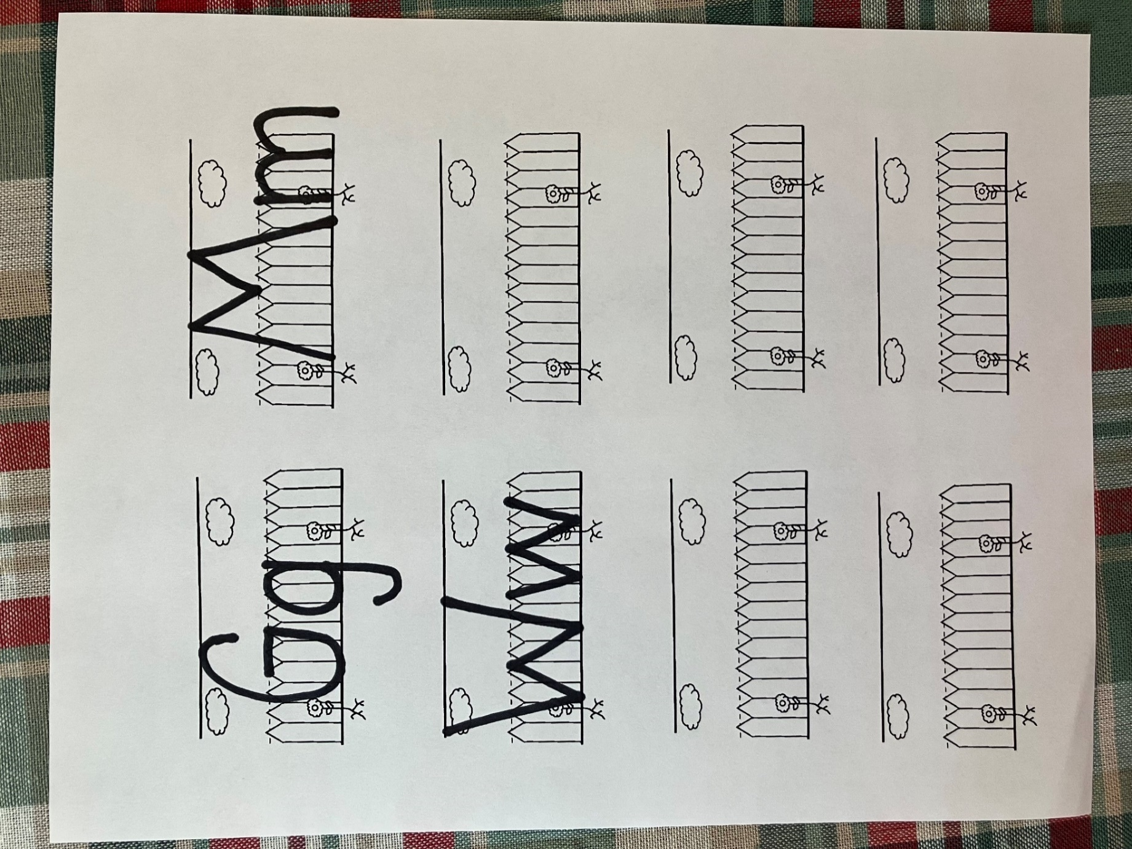

G



g

Galileer

1. Who was the governor of Jerusalem?
2. Why didn’t the Sanhedrin like Pilate?
3. What did the Sanhedrin tell Pilate Jesus was doing?
4. Why didn’t the members of the Sanhedrin go into Pilate’s house?
5. Who was the governor of Galilee?
6. Why was Herod in Jerusalem?
7. What did Herod want Jesus to do?
8. Who did Herod send Jesus to see?
9. Who thought Jesus was guilty of a crime?
10. Who did not think Jesus was guilty of a crime?

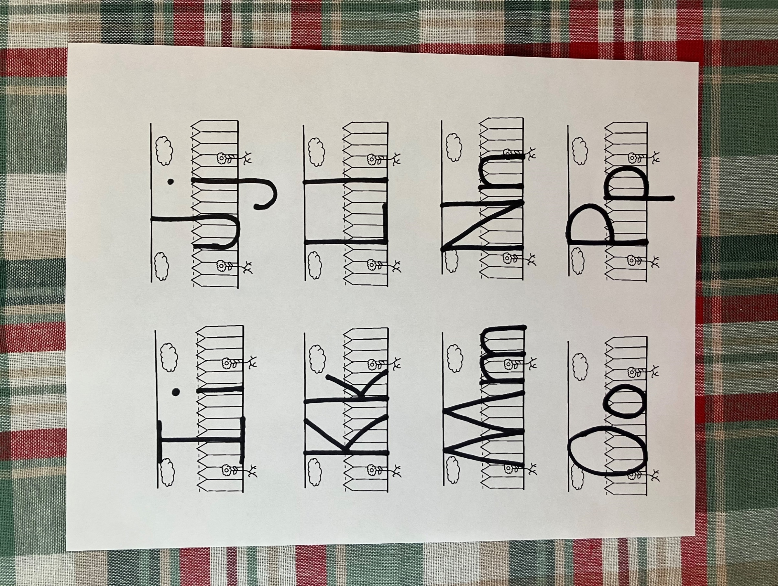

L



l

laughed

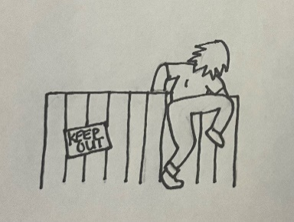

Pilate and Herod were supposed to listen to the Sanhedrin and to Jesus. Then they were to decide if Jesus had done something wrong. Look at the pictures below. Circle the pictures if the person is doing something good. Put and X on the picture if the person is doing something bad.

.

.

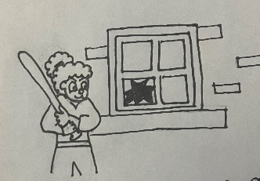



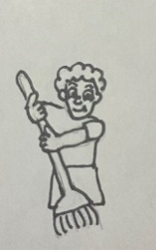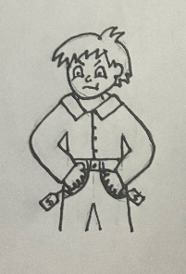



Jesus was taken before two governors. Two of something is a pair. Look at the shoes below. Match them in pairs.







**But Jesus yet answered nothing: so that Pilate marvelled.**

**Mark 15:5**

**Ll**

After Jesus was arrested, they led him to Annas, Caiaphas, Pilate, Herod, and then back to Pilate for questioning. Back then they might have had his hands tied in ropes to keep him from trying to fight them. Today the police use handcuffs instead of ropes. In the space below, draw handcuffs.

guilty

* A person who has done something wrong or broken a law
* The members of the Sanhedrin brought Jesus to me.
* Jesus wouldn’t answer the questions I asked him.
* I did not think Jesus was guilty, but I didn’t want to be the one to decide.
* I was governor of Galilee.

Who am I?

____ ____ ____ ____ ____

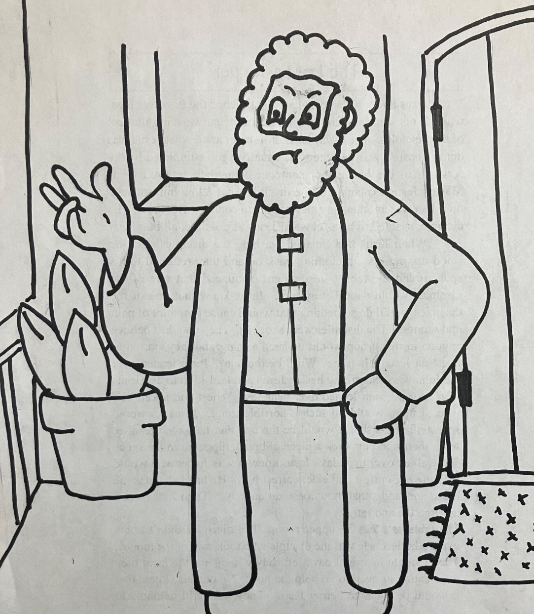

But Jesus yet answered nothing: so that Pilate marvelled. Mark 15:5