INSTRUCTIONS:

Print plates on pages 1 and 2 on regular printer paper. Cut out, cover front and back with contact paper. Cut out.

Vegetable

Dairy

Vegetable

Dairy

Bread

INSTRUCTIONS:

Print plates on pages 3 and 4 on full-page labels. Cut out, stick to the inside of a file folder. (Optional) Cover folder with contact paper.

Meat

Fruit

Meat

Fruit

Bread

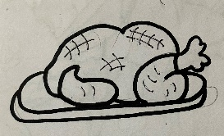

“What am I Eating?”

-Food Groups

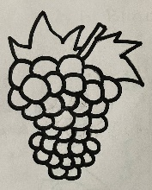

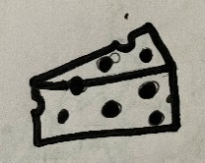

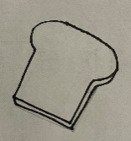

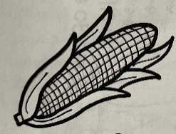

Cain grew fruits and vegetable and the farmer. Abel took care of the animals, so he was able to provide meat and milk which is dairy. Fruits, Vegetables, Meat, Dairy and Bread are some of the food groups. Look at the pictures and decide what food group each item belongs to.

