MAHANTESH NAGAR RAHAWASIGAL SANGH’S
COLLEGE OF EDUCATION (B,Ed)
Mahantesh Nagar Belagavi-590016

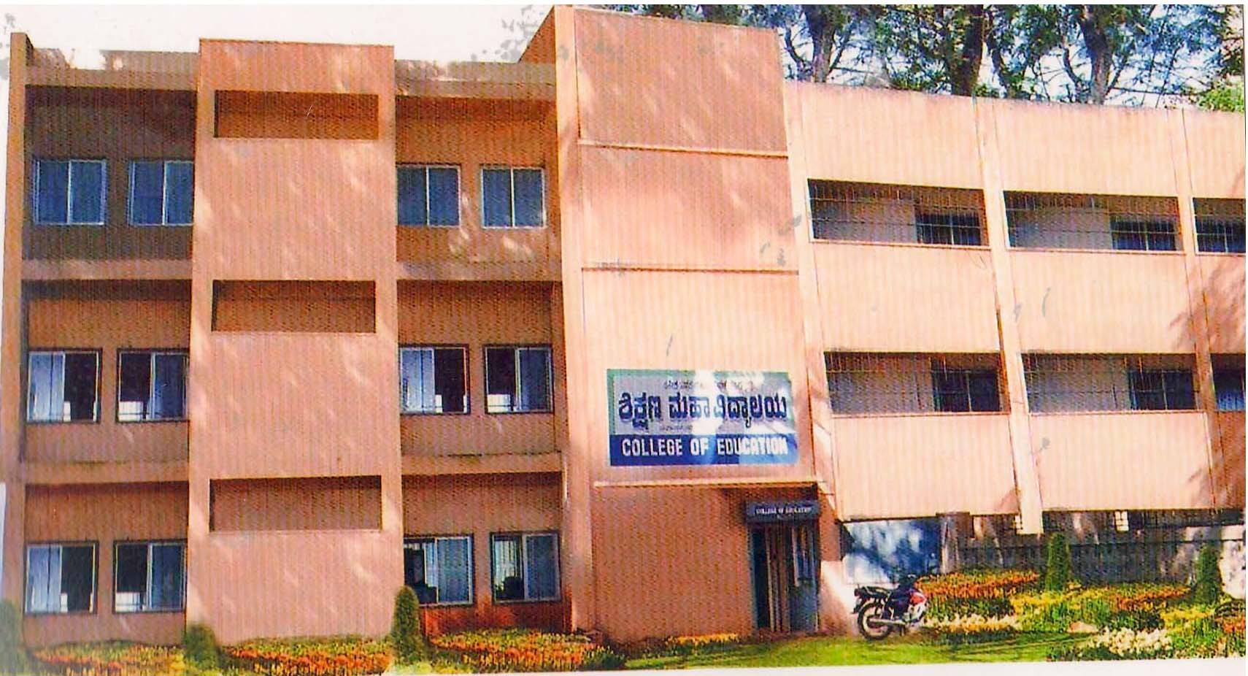

ASSIGNMENT

YEAR – 2019-20

NAME : _______________________________________________________

ROLL NO : _______________________________________________________

SEMESTER :________________________________________________________

SUBJECT :________________________________________________________

MEDIUM :________________________________________________________

NAME OF THE ASSIGNMENT :____________________________________________

___________________________________________________________________________

DATE :

Signature of the method master

