Brain Transplant and Open Heart Surgery!
So the Grabber GT had sat for almost 15 years prior to being rebuilt (body-wise) by Autokraft Nebraska. The body and paint work is excellent, but I was seeing some serious drivability issues. Having recently run a 5.0 Blown 67 Mustang on a local dyno, I already understood that the Grabber’s power plant, while good in 91, was severely lacking by today’s technology standards. For starters, the addition of the Supercharger SHOULD have required bigger injectors than the 24PPH units that were in the car, and the fuel supply lines should have been upgraded from the OEM 5/16” lines to include a bigger fuel pump. Finally, to accomplish good spark patterns at higher boost levels, the original builders had installed an MSD 6AL Spark Box – good in its day, but not so much in 2018.
We also had several coolant and oil leaks that would need to be addressed – more on that shortly.
So, with some serious research, I contacted Pro-M Racing and discovered their complete late model Mustang computer, wire harness and programming software that would allow the Grabber to really open up its capabilities AND allow variable tuning on the fly with a laptop PC. Further, Pro-M had recently debuted its complete Coil On Plug Ignition system, and was also now able to supply a Fox Mustang specific, high flow rate fuel tank pump hanger, pump, and all plumbing necessary to upgrade the Grabber to late model capabilities while fully accommodating the boost levels generated by the Paxton blower. This requires a COMPLETE change out of the A9L EEC-IV based processor, the entire engine harness, both O-2 sensors (they now use two WIDE Band sensors), along with the entire fuel system from the pump in the tank to the newly specified 42 PPH injectors with matching high-flow fuel rails. Going to take some SERIOUS work!
Back to the various leaks – we noted coolant leaks from the thermostat neck and the timing cover, along with several leaks due to loose hose clamps on 26 year old hoses. We also noted that a number of the PROTHANE Red Urethane suspension bushings were in poor shape due to atmospheric decay. Finally, we saw oil leaks from the oil sump and rear main seal. Given the new items being installed, it made the most sense to remove the engine and transmission for work outside the car. This is where the “fun” began…….
Photo 1 below shows the disassembly of the engine in preparation for removal. The hood is actually resting on a 64 Convair Convertible – another project in progress! Photos 2, 3, and 4 show the engine coming out. So far, so good. We did note that two of the oil pan bolts were missing (actually one missing, and one broke off) but at least they covered the holes with silicone. This should have been an indicator—
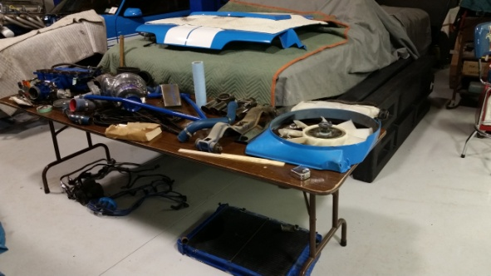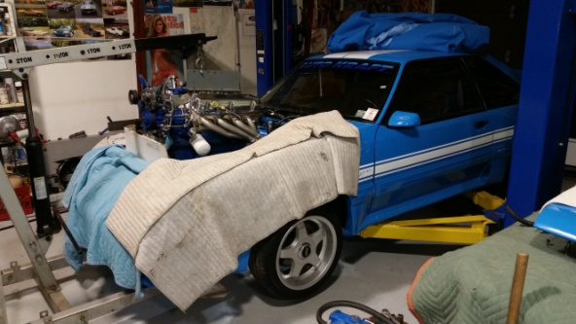
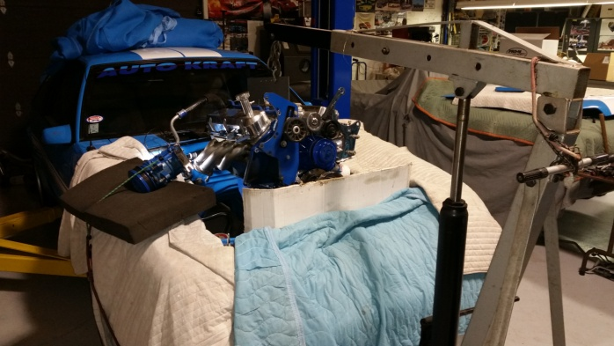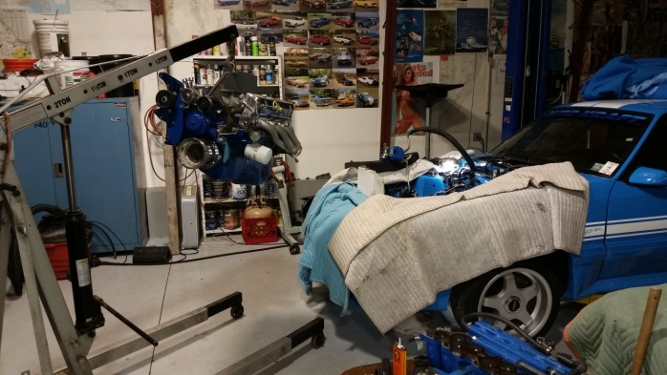
After the engine was out and on the stand, we commenced to remove the remaining front accessories. We noted with a bit of concern an excessive amount of blue silicone rubber extruding all around the timing cover. Apparently someone in the past thought that “More was Better” - Almost never the case.
Removal of the timing cover revealed why it was leaking. Our suspicion is that from sitting idle in south Florida for almost 15 years, the coolant had corroded the water ports on the cover. See pictures 5,6, and 7 below for the pitting that existed on the gasket surfaces. This necessitated a new cover as the best fix (vrs attempting to patch the corrosion with JB-Weld)
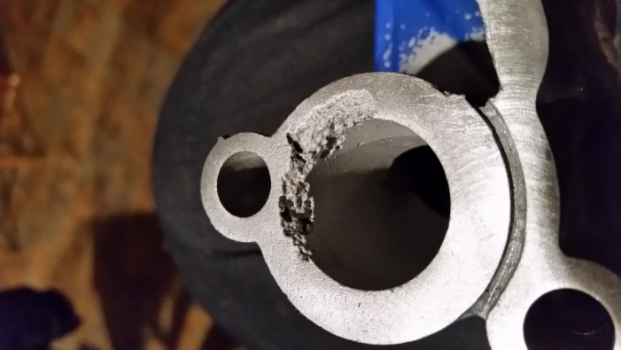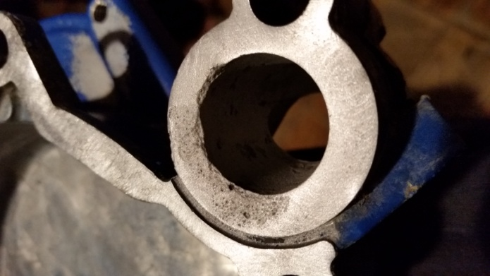
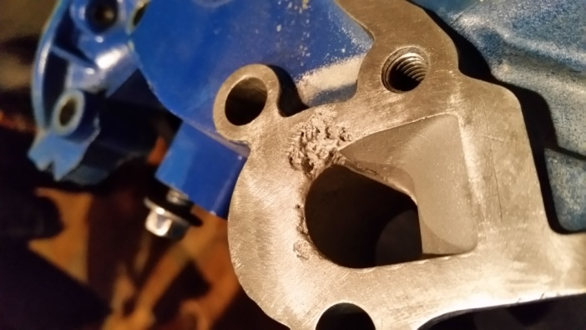
While the engine was on the stand, my son, an ASE full qualified mechanic, noticed some irregularities around the intake manifold, and since the engine was on the stand and readily accessible, we opted to remove the intake to investigate further. This is where things begin to go downhill in rapid fashion! After breaking two intake manifold bolts, it became quite apparent that the individuals that installed the Edelbrock Performer Heads back in ’94 never used any anti-seize. We finally got the intake manifold off, only to discover extreme corrosion and pitting around all of the water ports on both the heads AND intake manifold, which now required the removal of the heads! See the next two pictures :
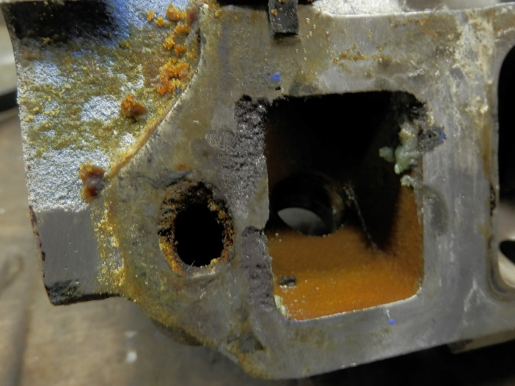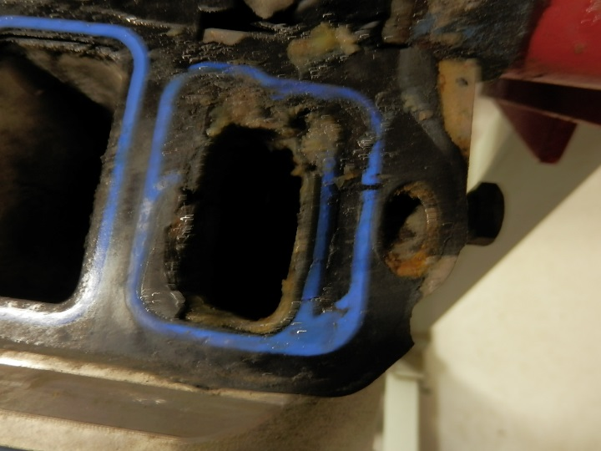
But, if that wasn’t bad enough, we also discovered that all of the head studs were quite rusty, AND that the builders had never used the required “T” or “hat” washers under the nuts. In the case of using Edelbrock Performers, the stud/bolt holes are drilled for ½” bolts, yet the 5.0 small block Ford uses 7/16” bolts/studs. This configuration makes it mandatory to insert the “T” washers which center the bolt in the drilled hole of the head, and prevent the head from moving slightly due to the space between the ½” hole and the 7/16” stud. None were present – in fact, NO washers were under the nuts, which caused slight galling of the aluminum as the nuts were tightened years ago! Additionally, during the disassembly, we found that the oil fill baffle retaining screws were improper self drilling/tapping sheet metal screws which were being retained with silicone AND that the oil pickup gasket was blocking at least ½ of the oil pickup tube due to poor installation. You CAN’T make this stuff up!
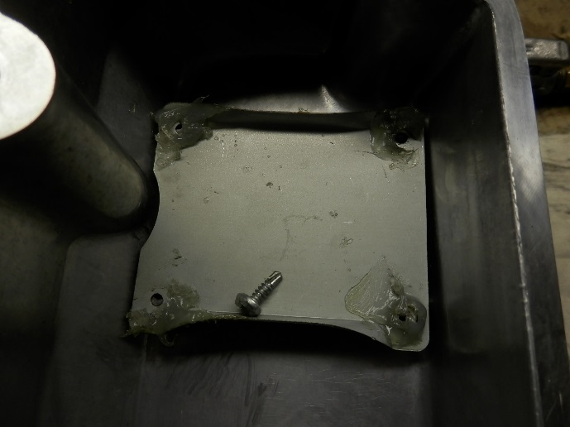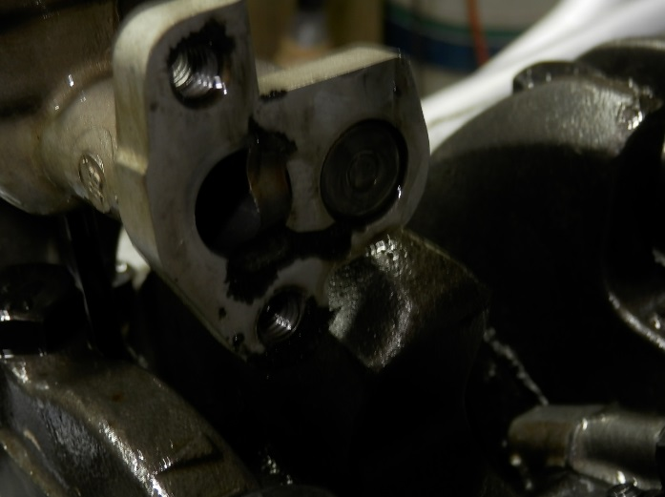
The heads and intake were taken to a local Engine shop for repair while the block was gone over. Quite a bit of green slimy substance was flushed from the coolant passages and while indeterminate, it is believed to have been radiator stop leak. It turned out that even the water neck and EGR Spacer exhibited the same corrosion. The EGR was not going to be used, and the water neck was replaced.
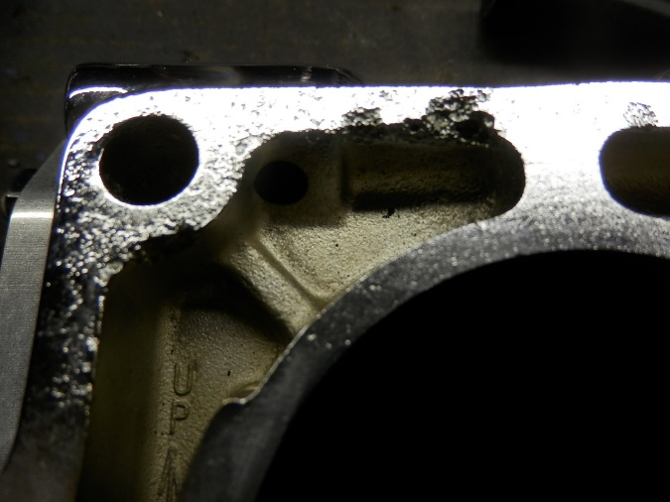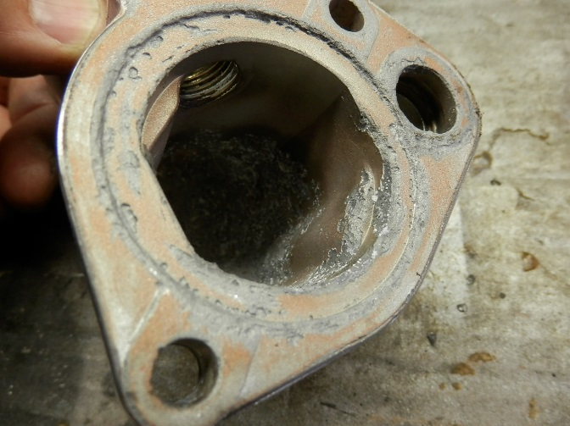
The engine shop studied the corrosion damage and determined that a weld repair would not work due to the depth and severity of the corrosion, so a decision was made to repair utilizing an epoxy like substance, and then sanding the respective area smooth. Didn’t turn out too bad, so we re-assembled the engine.
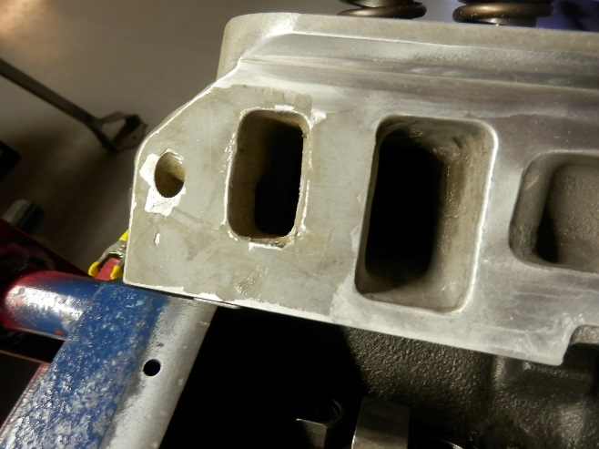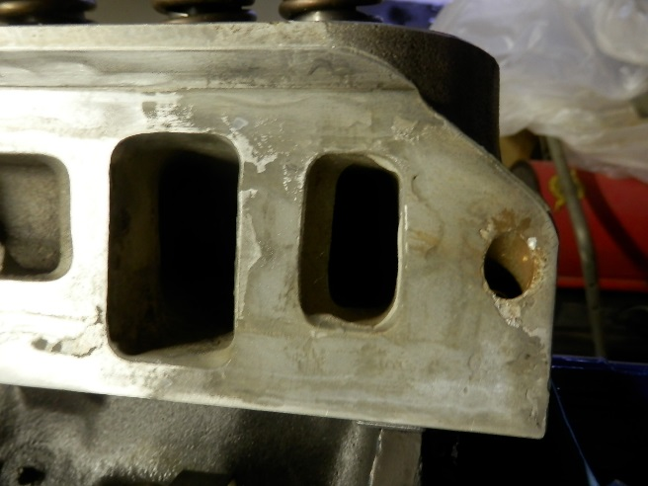
Photos of engine being assembled and installed:
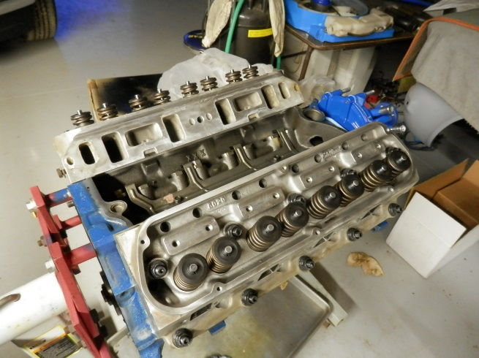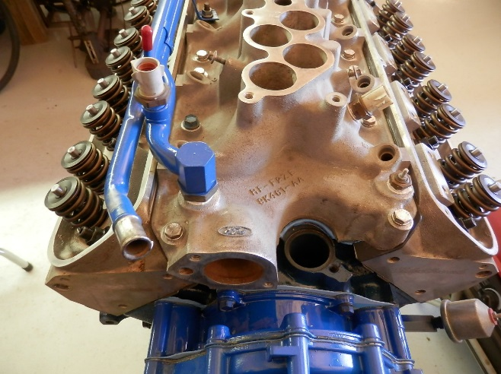
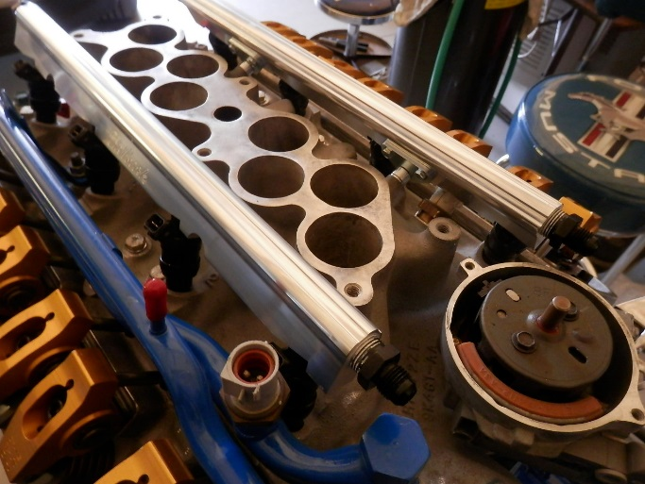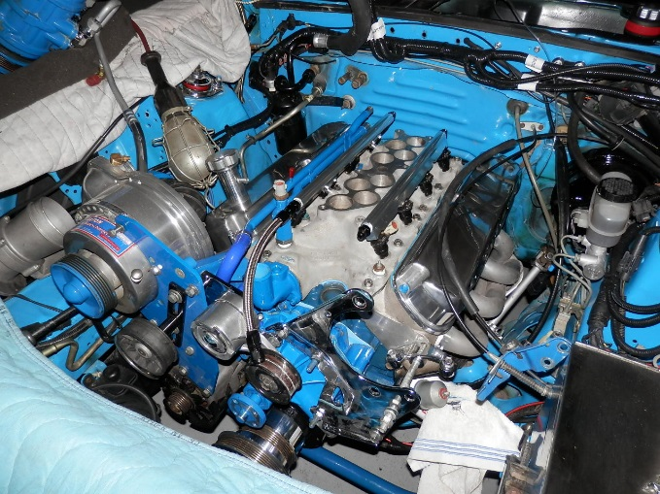
In the course of this, we also had the entire exhaust system out of the car to remedy some issues with improper pipe hangers, and removed the fuel tank to install the new pump hanger (with nice AN-6 hose fittings) and the new 255LPH fuel pump. Below are the pump and hanger:
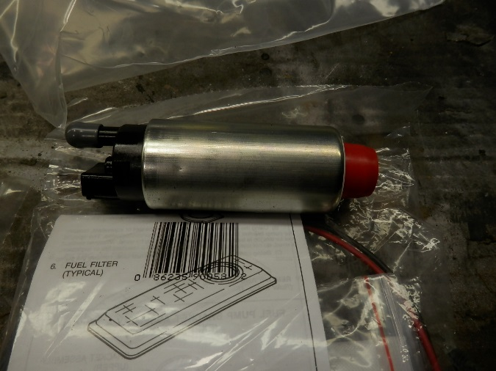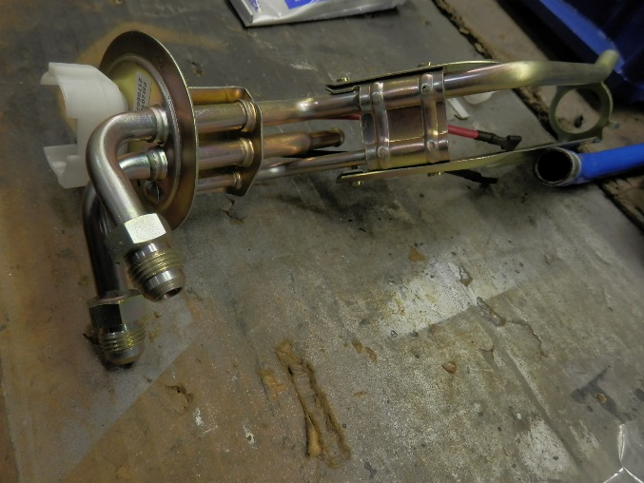
Additionally, we got the all new PRO-M harness installed, along with the Processor, which gets located under the passenger seat. Of course, ALL of the old computer and engine harness, along with the antiquated A9L engine PCM get removed. PRO-M has done an OUTSTANDING job of replicating the FOX body engine harness making the job nearly a plug and play operation. THE most difficult part was routing the interior side of the harness down thru the firewall opening. When they suggest having someone inside to GENTLY pull the wires, they are serious! Also, the fuel system comes with a length of stainless braided hose and a number of fittings. For me, I learned the easiest way to cut the hose and install the fittings was to first band the hose with tape, then cut with a die-grinder. The tape kept the stainless braid from flaring out. PRO-M does show cutting the hose with a concrete chisel, but I couldn’t make that trick work. In the end, all fittings at the tank, included fine element filter, pressure regulator, and fuel rails worked out fine.
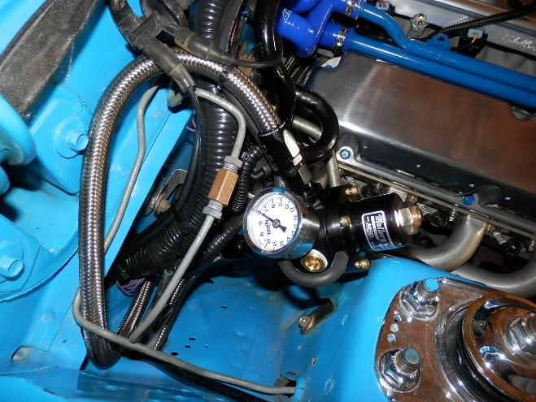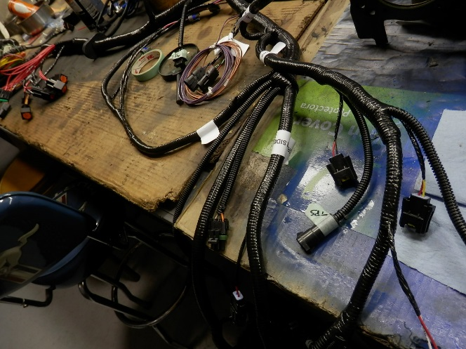
Along with a new processor, the MASS AirFlow Meter needed to be recalibrated. It was sent to PRO-M, along with its air-horn, and a full calibration table developed for the planned 42PPH injectors. Installation of the horn into the fender was easy, but replacing the original spiral wrapped hose to the blower inlet proved daunting. The initial end result seemed like it would work, but the future had other ideas in mind------
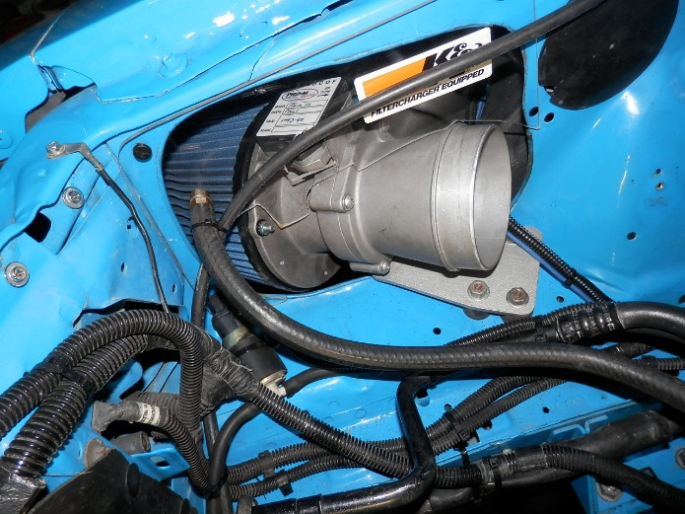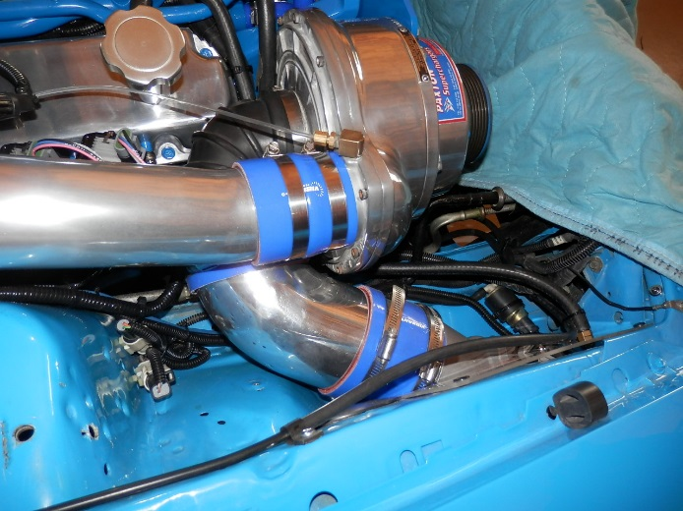
This new system uses dual Wide band O-2 sensors to self calibrate. They are made by Innovate, and require new bungs to be welded into the pipes, as they must be 24” away from the header collector. The original O-2 ports were plugged, and the original A.I.R plumbing was removed with the resultant holes in the Cats being welded shut.
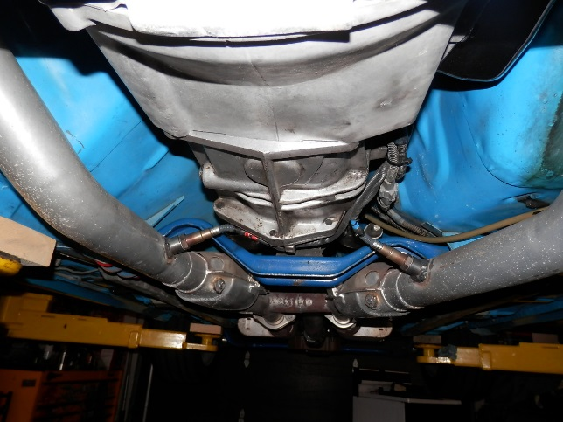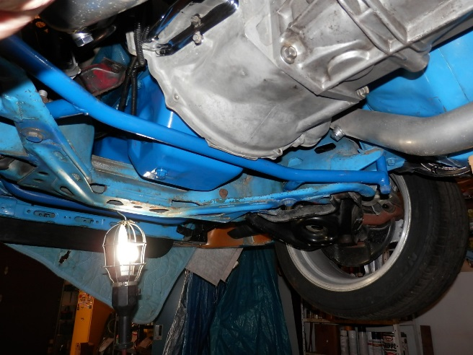
Another advancement in this upgrade includes coil on plug spark, eliminating the need for a distributor. The system retains the distributor simply as a crank position indicator, and thus PRO-M supplies a nice billet cover for the interruptor wheel. All we needed to do was figure out the best place to mount the coil packs. After much discussion and thought, along with locating an on-line article, we decided to drill and tap the valve covers and mount them just above each plug. Spacers are needed, and initially plastic type spacers were employed, but they were subsequently changed for aluminum spacers. The screws are 10-28, and are stainless steel. They were installed with blue locktight to prevent vibrating loose, and also include a lock-washer on each screw. Spark plug cables were from Summit and are Ceramic 135 degree tips. All of the cables are the same length and reach the plugs nicely with no rubbing on the headers!
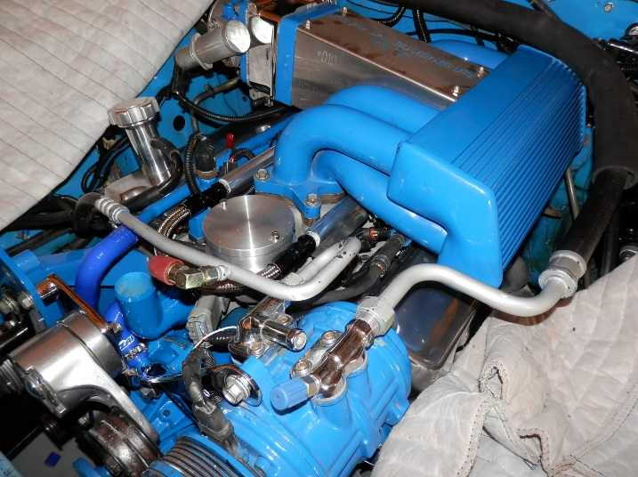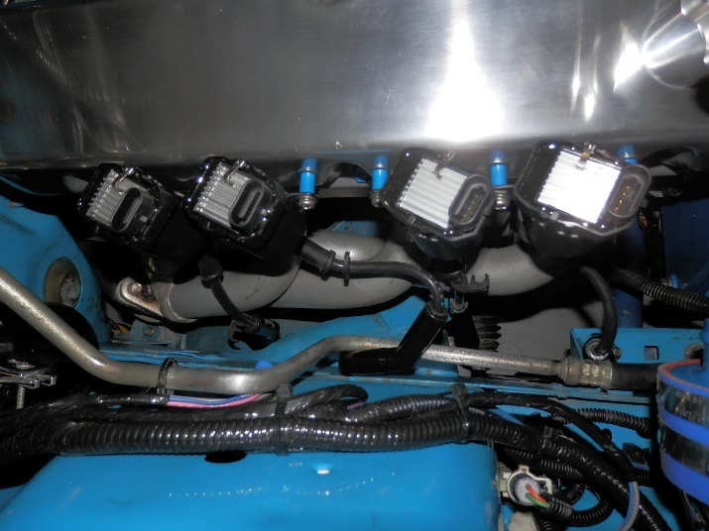
SO – here it is, all done and pretty, with new blue coolant hoses, new vacuum hoses, battery cables, fuel lines, wiring, etc and so forth!
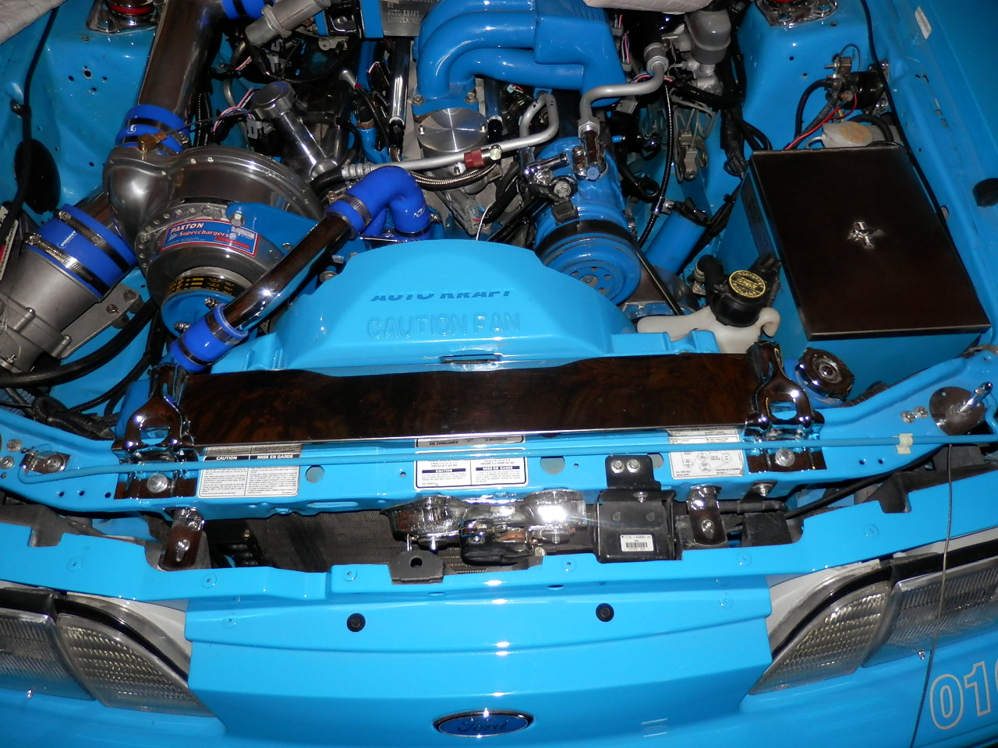
Except it would NOT start! I played with it for hours, thinking the timing was off, checking all possible wire locations etc. Hardly even a single fire indication. I even checked and adjusted the fuel pressure regulator to 40 PSI (or so I thought---). Finally, I realized that the fuel pressure regulator was in fact WAY over pressuring the system and it had in fact diluted the oil. Not happy that I had let that happen, I put off any further action till the next day when I planned to drain the new oil and replace it before starting again.
The next day, as I was beginning to drain the oil, I noticed that the first few drops that leaked out of the drain plug were coolant-green! This was VERY NOT GOOD, especially as the engine had not even ran yet. Now feeling rather totally disgusted, I began to tear into it to determine the source of the leak.
First off was the entire intake, looking for possible slippage of the intake manifold gaskets. No evidence was seen. Next, I contemplated the heads. I did not want to remove them (and thus ruin the new lock wire head gaskets) but there was a nagging item I had read from Edelbrock that said to use a small bead of silicone on the head gasket. Though I had not done this, several other individuals that I had spoken with agreed that it should never be done. Before further action, I called Edelbrock. The initial person on the phone agreed that silicone should never be used on the heads, but after I pointed out that I had found it written in their install instructions, he sought the advice of one of their senior engine builders. That individual said that yes, indeed you do need a small strip of sealer on the head gasket, especially if it is a Fel-Pro Print-O-Seal type gasket (it was---). So, off came the heads!
But – after removing the heads, there was no indication of a leak in the area that Edelbrock said needed sealer. Being more confused than ever, I sat pondering the situation, and suddenly noticed that the new Fel-Pro gaskets called for by Edelbrock did not properly cover a fly-cut coolant passage in the deck of the head. Upon seeing this, and conferring with my son who agreed, we called Edelbrock again. This time, the individual who answered had been at the company for quite some time. He immediately knew the problem – the heads were over 25 years old (true---) and had been discontinued by Edelbrock almost 20 years ago due to their inability to stop coolant leaks at this very spot. To further confirm this, I noticed some rust forming on the block deck opposite this fly-cut on the head surface! This would mean new replacement heads as they are not repairable absent significant welding and refinishing!!! See the photo below and the area circled in red. It was NOT a good day in Grabber world----
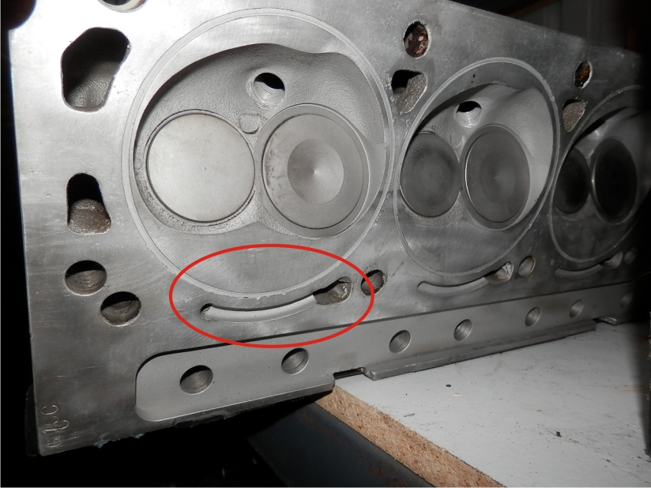
A lot of research followed, and I settled on Air Flow Research Street heads with 1.9 intake valves. Anything more would have required removal and modification of the pistons, which I was unwilling to do. Additionally, looking at the corrosion repairs on the intake, I decided to upgrade the intake to the PRO-M Single Plane intake, along with their 1000CFM EFI Throttle Body. This was going to require replacing the new Edelbrock fuel rails for compatibility, and replacing the heater hoses as the OEM Mustang metal coolant tubes on the original intake manifold would no longer work. As is often the case, one change mandates several others! Here are the AFR heads, the Single Plane intake and the 1000CFM throttle bode. Very nice pieces!

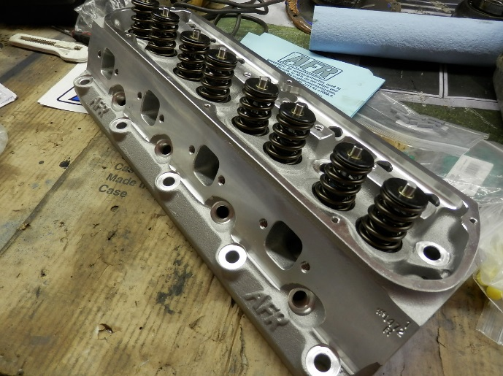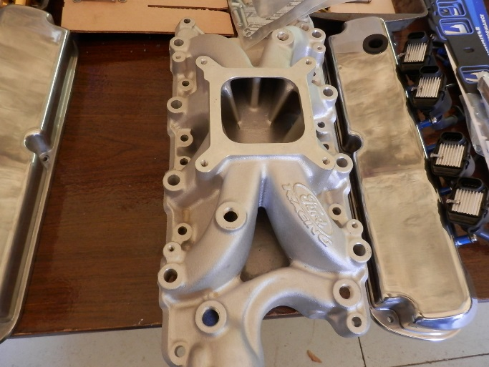
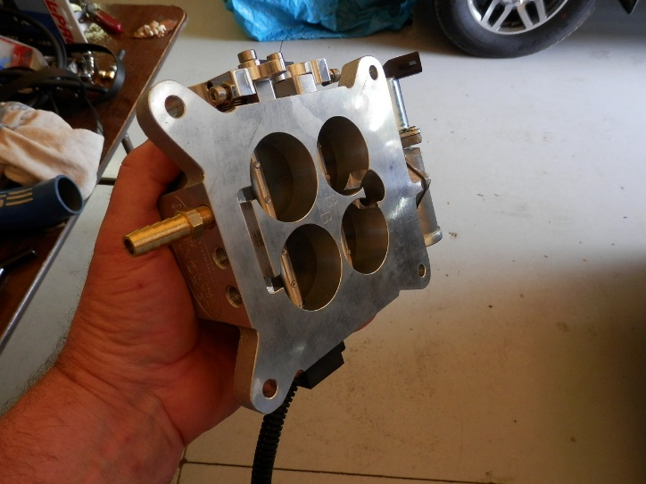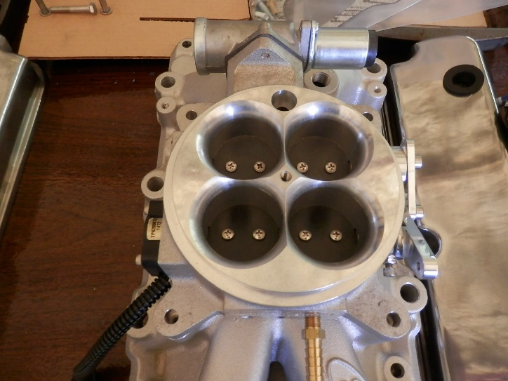
For the intake installation, Chris Richards at PRO-M has some great videos where he shows opening the port to match the heads, and the CORRECT way to use the Fel-Pro cork end gaskets. Seems that Fel-Pro uses a cellophane double stick tape so you can peel the wax paper protector and just stick to the block. Not good, and the oil eventually melts the adhesive and makes the cellophane ooze out, resulting in an intake leak. Chris nicely shows how to remove the cellophane and residual glue, and then use RTV to adhere the cork to the block. I did this both times that I installed the intake on the Grabber and like the results very much. The second part of the trick is to RTV the cork onto the block and WAIT 12 hours to proceed. Makes a huge difference! In the photos, I am using large sockets to weight the cork while the RTV sets up.
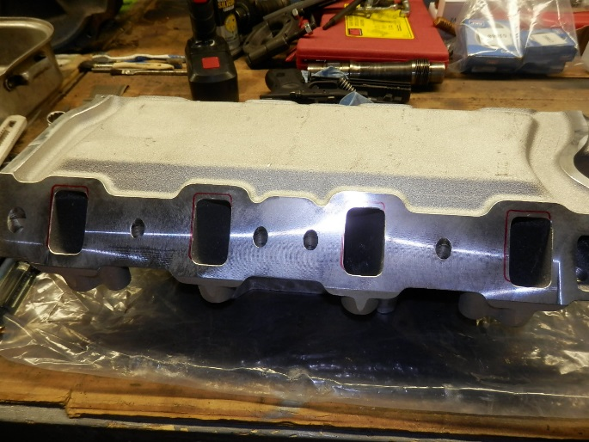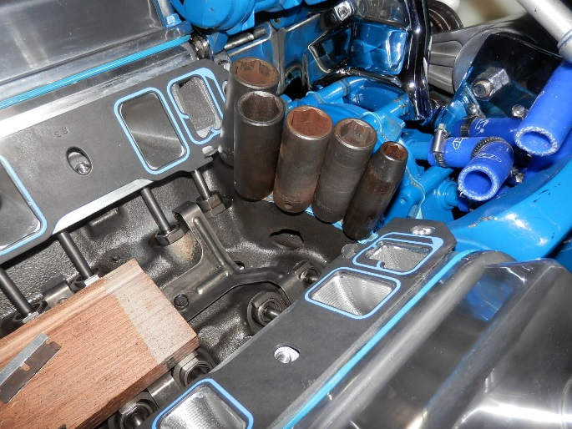
The following pictures show the new PRO-M fuel rails installed (After I powder-coated them Blue!) along with a supplemental PCV Check valve. Chris Richards strongly suggests this modification when running boosted applications, as the normal PCV valve is not capable of preventing back-flow under higher boost situations. He even provides source information from McMaster Carr to order the correct valve!
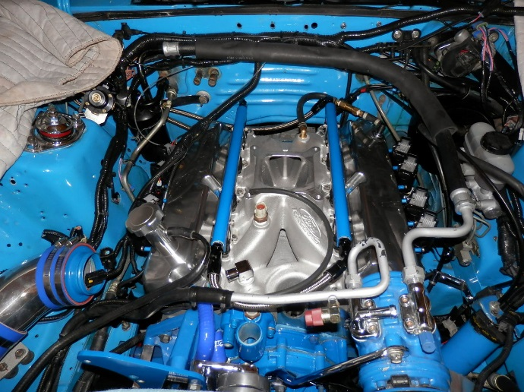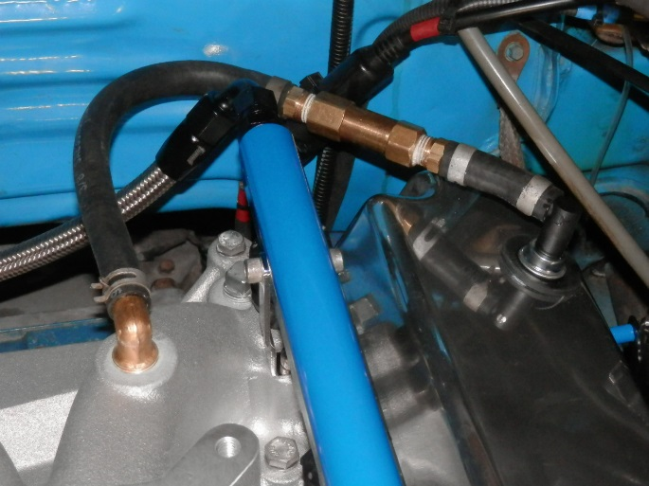
Here is the throttle body installed. PRO-M is adamant to keep separate vacuum sources for the needed accessories. Here, we have a feed to the Fuel Pressure Regulator, one to the EVAP canister, and one to the vehicle firewall “Tree” to supply the A/C & Heating, Speed Control etc. Note that the accelerator cable is connected to the throttle body just as if it were a carburetor, and everything fits nicely around the intake manifold. The Coil packs can be seen off to the side, and the new heater hoses can be seen routed along the passenger side inner fender. Next, we will tackle the blower connections!
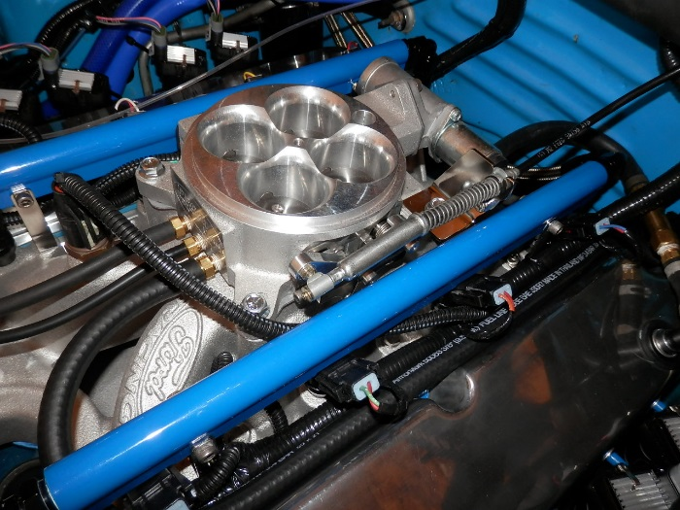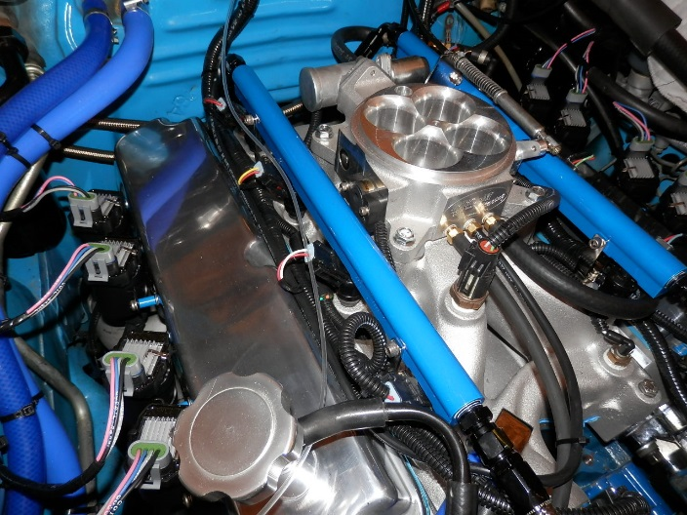

Because we had switched to a carburetor like throttle body and a different intake manifold, the pathway into the engine from the Supercharger had changed significantly. Further, I was unhappy with the previous attempt to connect the mass airflow horn to the input of the blower. Extensive research on Summit Racing revealed several connectors that could be modified to make smooth transitions. The biggest issue on the input was the needed transition from the 4” outlet of the Mass Air horn into the 3.00” inlet to the back of the blower. A bell-reducer fixed this, along with a new 45 degree bend aluminum pipe into the Paxton original 90 degree elbow on the blower input. Good to go now.
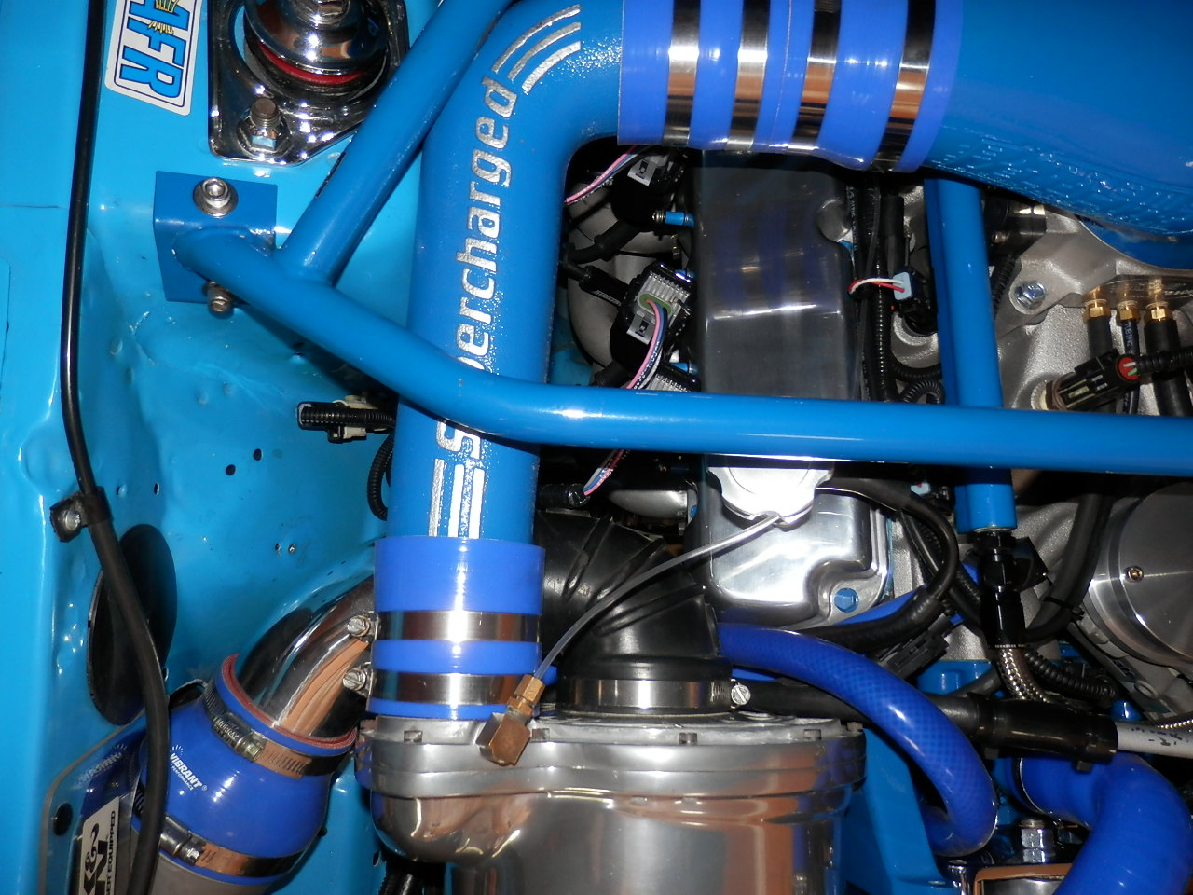
On the blower outlet, the car had apparently been fitted with a fiberglass painted tube originally, but had bee changed for a polished aluminum tube. Deciding that the painted tube looked better, and being of the same size as the aluminum tube, the painted fiberglass tube was placed back into service.
Next came the issue of the throttle body connection. I was able to locate a supplier of “bonnets” for supercharged carburetor applications that had a perfect fit for EFI throttle body, as it is identical to the Motorcraft 4100 carburetor. It was delivered in unpolished aluminum, which enabled powder-coating in matching bright blue. All in all, the new silicone rubber adapters and couplers provided a nice tight air path from the filter all the way to the throttle body.
The final layout under the hood appears below:
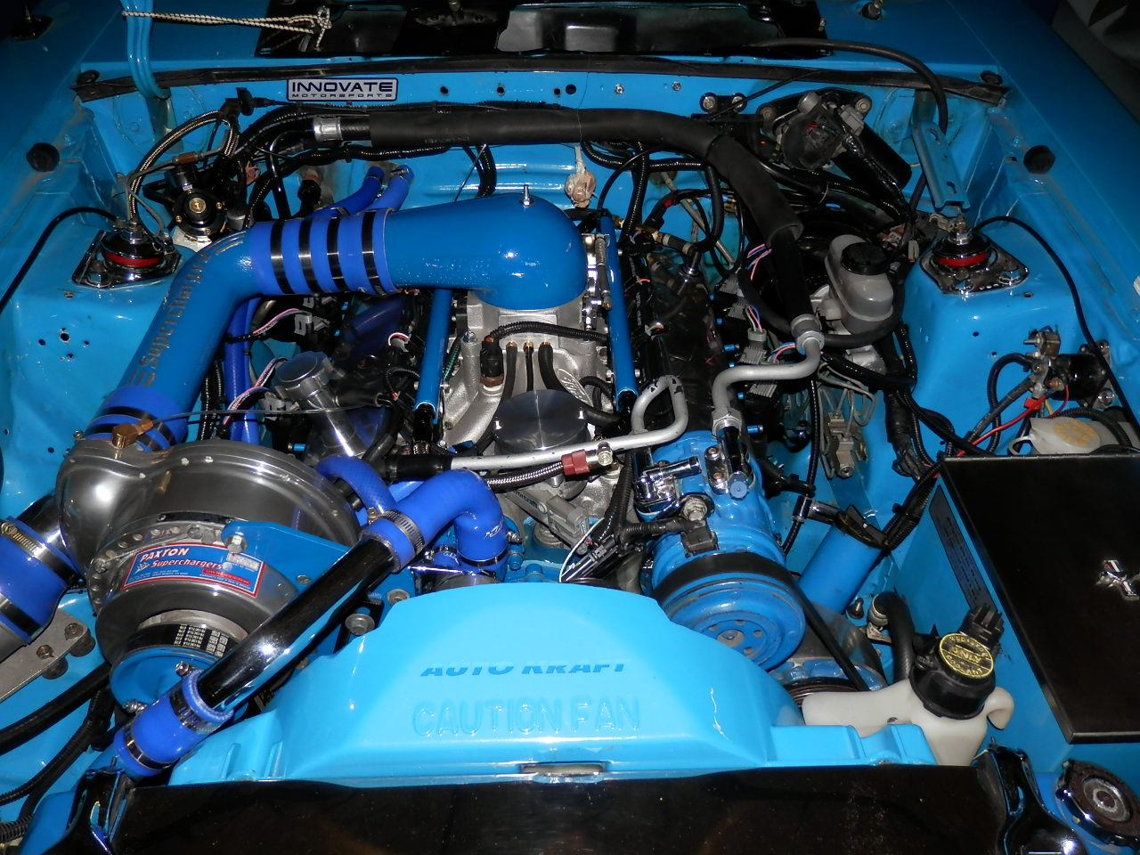
Now came time to start – again! The engine started, but was running rough, and showing codes on one of the injectors. A lot of careful examination revealed a wire pulled out from one of the injector connections. Some careful re-crimping and soldering provided the needed fix:
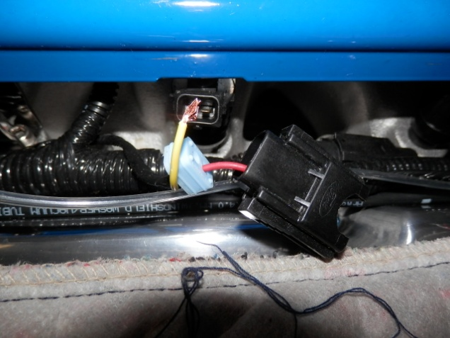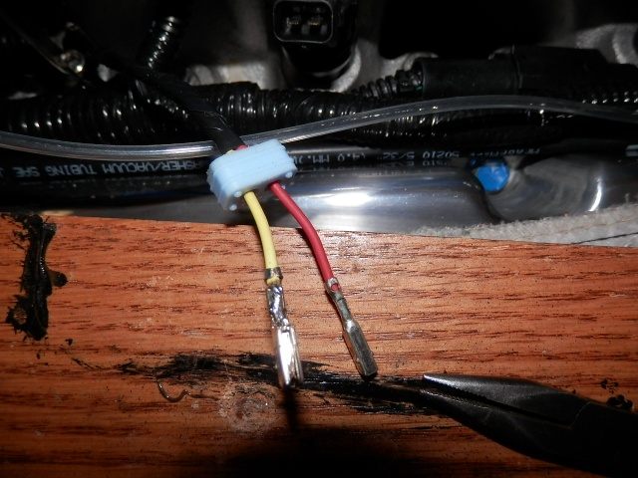
So now we’re up and running, but with some noise – tapping under both valve covers in the vicinity of the baffle plate for the oil filler tube and in the vicinity of the baffle for the newly installed PCV valve. This required the removal of both valve covers and the dressing of the screw heads used to hold the baffles in place. Despite removal of material from the screw heads, I was unable to eliminate the tapping of the rockers onto the screw heads. Below photos show the nicking happening to the rockers:
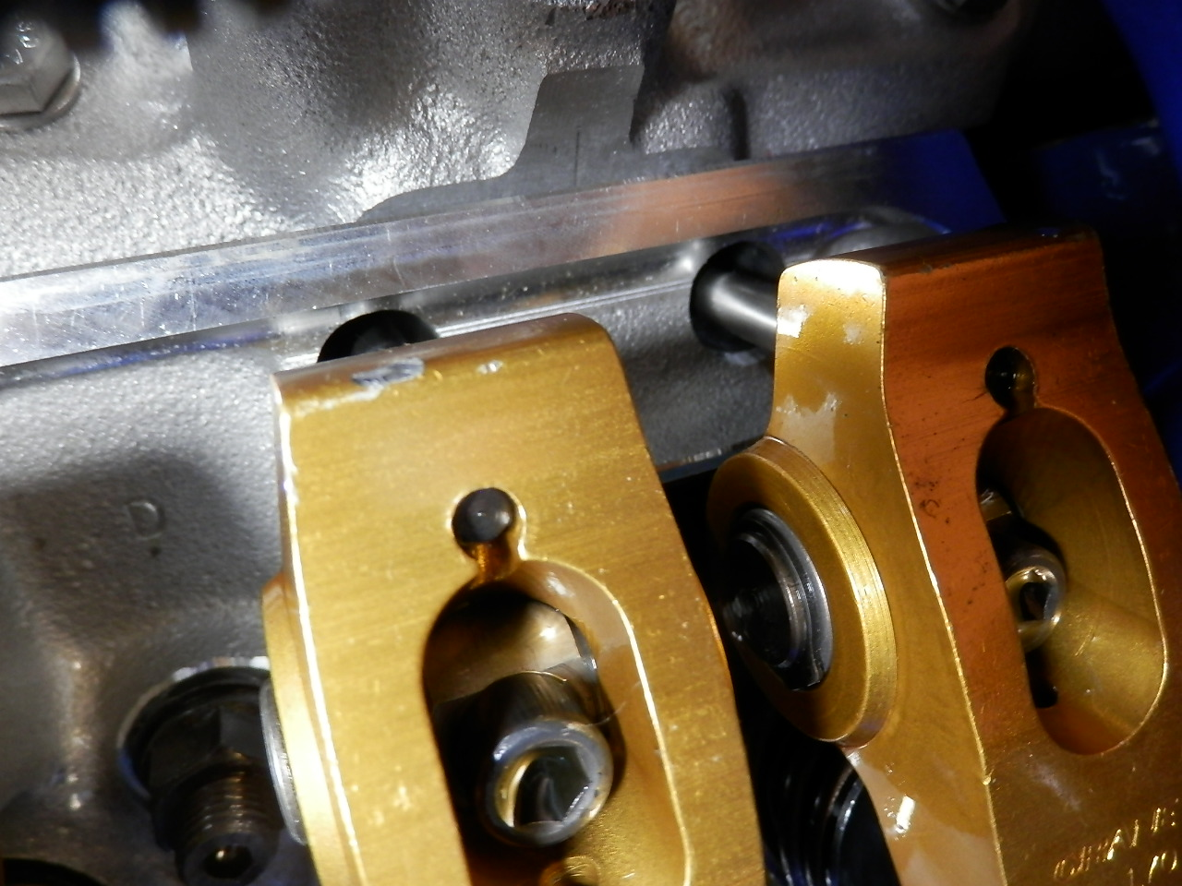
Though minimal, it was something that needed to be addressed. Viewing the rockers from the side, there is a significant amount of material on the upper tail end of the rocker. A simple sanding with a dremel tool removed a slight amount of material and eliminated all noise – success!
The final item to touch off the project was the addition of a FORD logo’d air-cleaner nut over top of the stud holding the inlet bonnet onto the throttle body. In addition to all the improvements under the hood, we also added a dual Innovate Air/Fuel Radio gauge on a powder coated plate in the center console and a new custom made shift ball from CJ Pony parts. Car drives like a dream!
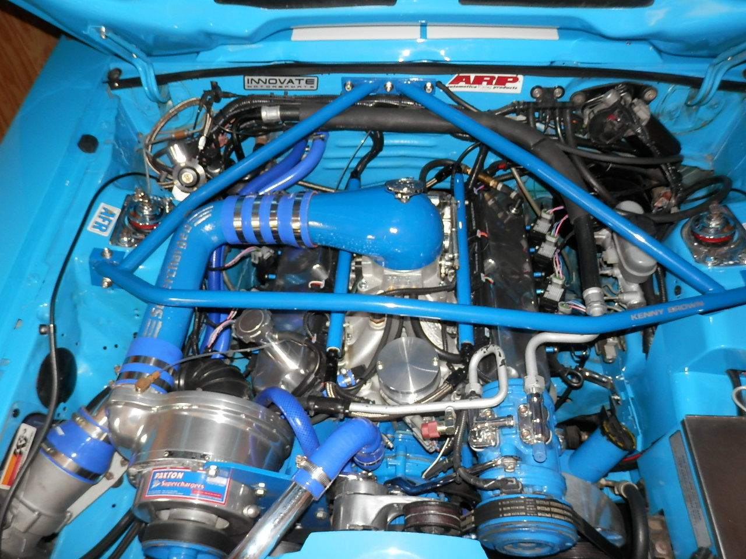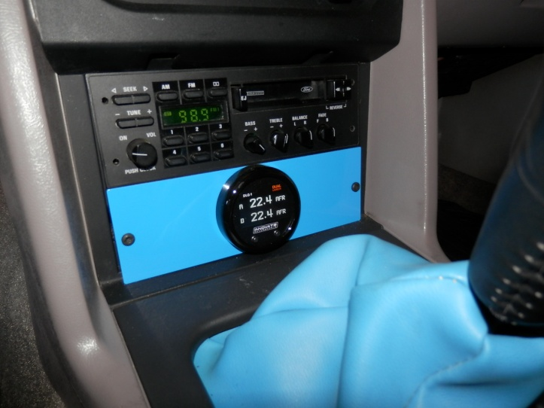
Fall 2018 Update – We drove the car on a weekend long Wine Cruise in the Thousand Islands Region of New York. Performed well, except the driver’s window refused to raise near the end, and I began to experience uncommanded high idle. Got the drivers window motor replaced, and worked with Pro-M to adjust the idle speed. We are now waiting for better weather to do some test driving, but think the idle issue is corrected by reseating the connector to the Throttle Position Sensor and slightly adjusting the mechanical idle stop screw. In the meantime, the shifter handle was also upgraded from CJ Pony Parts. The stripes match the SAAC stripes on the car, and the color is near perfect match to the vehicle paint!
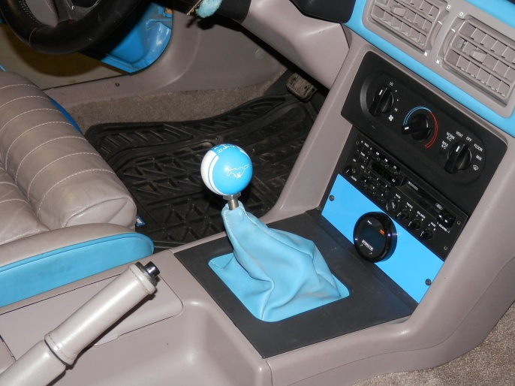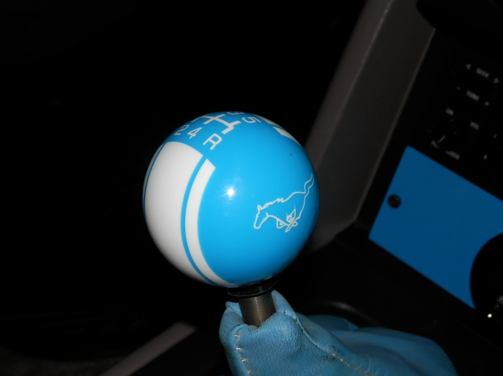
A final picture for the story shows the car pulled out of the garage to test run for the throttle adjustment. It had a really difficult time maneuvering on the ice covered driveway, and was VERY happy to return to the warmth of the garage!
