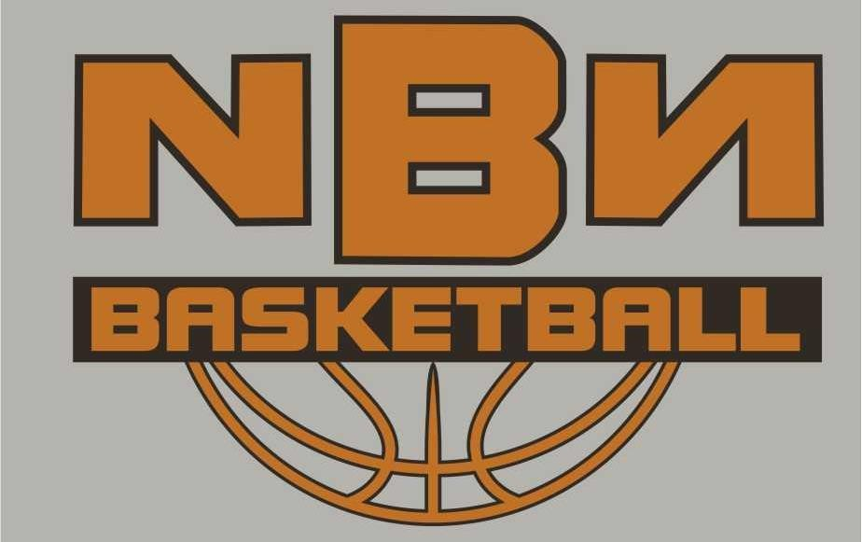

Registration Form

Date: July 8th-11th, 2026

Place: Southern Okanagan Secondary School Gym, Oliver B.C.

Time: 9am-12noon (Rookie Camp)
1pm-4pm (Pro Camp)

Cost: Rookie and Pro Camps: $ 200.00
No Refund After June 13th, 2025.
Late Fee for the camp after June 13th: $ 225.00

What to bring: Proper basketball gear, water bottle, and a great attitude!
What you get: an NBN camp T-shirt, basketball(Courtesy of Canadian Tire Oliver) Gatorade, gift certificates and other prizes. What do we do: NBN is for players of all levels. We focus on improving basketball skills and strategies while stressing proper FUNdamentals on both ends ohe court! Ball handling, shooting, passing and fun games every day, as well as offensive and defensive and strategies. BC Basketball Hall of Famer, UVIC Hall of
Famer, Former UBC and UVIC assistant coach, Coordinator of Lake City Development, Spencer McKay, brings incredible knowledge and unmatched international experience to NBN.
--------Please cut here--------Keep top portion for your reference------

Name of Player: __________________Gr: _____ Parent/Guardian: _________________________________________________________
Contact Number :_____________________ Email:_____________________________
Parent/Guardian Signature: _________________________________________________
Medical Number: ______________________________Allergies:___________________
Camp Selection: Please Check off :
Rookie Camp (Gr. 3-6) $200 _______Pro Camp (Gr. 7-12) $200_____
Day Drop in ($60/day) days_______
Shirt: Adult: Please circle size XXL XL L M S Youth L M
Make Cheque Payable to NBN Basketball: Mail: NBN Camps 134 Hemlock Ave, Kaleden, BC V0H 1K0, or etransfer to smckay15@gmail.com
Make sure all e-transfers contain the name of the player and camp for our record keeping

Release form: In consideration of the acceptance of this application for registration. I, intending to be legally bound, hereby for myself, my heirs, executors, and administrators, waive and release any and all rights and claims for damages I sustained and suffered by me in connection with my association with or entry to this camp and which may arise out of my traveling to, participating in or returning from the camp. We are unaware of any illness or injury that would prevent full participation in the camp.

The NBN Staff reserves the right to send a player home without refund if he/she is in violation of camp rules and regulations.

Visit us at: nbnbasketball.ca

PROUDLY SUPPORTED
BY:


