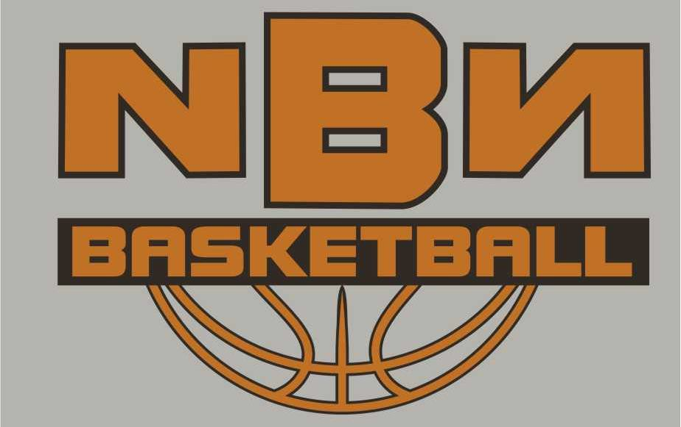

***Registration Form***

**Date:** July 7-10, 2025

**Place:** Southern Okanagan Secondary School Gym, Oliver B.C.

**Time: 9am-12noon** (*Rookie Camp*)

**1pm-4pm** (*Pro Camp*)

**Cost: Rookie and Pro Camps: $ 199.00**

**No Refund After June 13th, 2025.**

**Late Fee for the camp after June 13th: $ 224.00**

***What to bring:***Proper basketball gear, water bottle, and a great attitude!

***What you get*:** an NBN camp T-shirt, basketball, Gatorade, gift certificates and other prizes. ***What do we do****:* **NBN** is for ***players of all levels****.* We focus on improving basketball skills and strategies while stressing proper ***FUN***damentals on both ends of the court! Ball handling, shooting, passing and fun games every day, as well as offensive and defensive and strategies. **BC Basketball Hall of Famer, UVIC Hall of Famer, Former UBC and UVIC assistant coach, Coordinator of Lake City Development,** **Spencer McKay**, brings incredible knowledge and unmatched international experience to **NBN.**

--------Please cut here--------Keep top portion for your reference------

Name of Player: _______Birthdate: Gr: _____ Parent/Guardian:___________________________ Contact#:___________________

Parent/Guardian Signature: _______________________Email:_____________________

Medical Number: ______________________________Allergies:___________________

Camp Selection: Please Check off :

**Rookie Camp (Gr. 3-6) $199** _______**Pro Camp (Gr. 7-12) $199**_____

**Day Drop in ($60/day)** days_______

**Shirt:** **Adult: Please circle size** XXL XL L M S **Youth**  L M

**Make Cheque Payable to NBN Basketball: Mail: NBN Camps 134 Hemlock Ave, Kaleden, BC V0H 1K0, or etransfer to** [**smckay15@gmail.com**](mailto:smckay15@gmail.com)

**Make sure all e-transfers contain the name of the player and camp for our record keeping**

**Release form:** In consideration of the acceptance of this application for registration. I, intending to be legally bound, hereby for myself, my heirs, executors, and administrators, waive and release any and all rights and claims for damages I sustained and suffered by me in connection with my association with or entry to this camp and which may arise out of my traveling to, participating in or returning from the camp. We are unaware of any illness or injury that would prevent full participation in the camp.

**The NBN Staff reserves the right to send a player home without refund if he/she is in violation of camp rules and regulations.**

**Visit us at: nbnbasketball.ca**



***PROUDLY SUPPORTED BY:***

