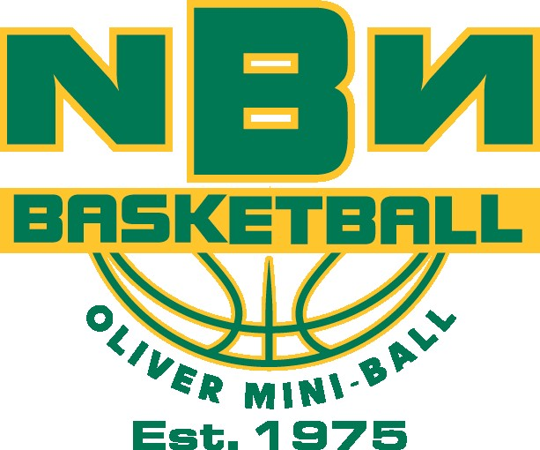
Oliver Mini-Ball 2026. Season 3rd is here. Let’s Go!!
Oliver Mini-Ball Dates:
January 4,11,18,25
February 1,8, Semi Finals 22
March 1, Finals
*All sessions will be at SOSS Main Gym
Divisions: Rookie Division: Boys & Girls Grades 2-3
Pro Division: Boys & Girls Grades 4-5
All Stars: Boys & Girls Grades 6-7

Times: Rookies 1:15 pm- 2:45 pm
Pros 3:00 pm- 4:30 pm
All Stars 4:45 pm- 6:30 pm

Costs: $200 per player. Deadline to register is December 19th, 2025.
Cost includes:

1. 8 WEEKS OF ORGANIZED BASKETBALL with Oliver hoops legend SPENCER MCKAY!
2. Each session will be 1 hour of skill development, followed by 30 min. games
3. Oliver Mini-Ball reversible uniform.
4. Minimum 1-2 coaches per team.
*ALL PARTICIPANTS MUST BRING A BASKETBALL TO EACH SESSION. League cost DOES NOT include a basketball. Basketballs can be purchased from NBN for $25.00.
Players should bring a water bottle and must wear proper indoor shoes and shorts to each session.
Limited space!! Each division has a maximum of 40 players (4 teams of 10). Divisions will fill up quickly, so we will create a wait list for late registrants.
Release form: In consideration of the acceptance of this application for registration. I, intending, parent/guardian to be legally bound, hereby for myself, my heirs, executors, and administrators, waive and release any and all rights and claims for damages I sustained and suffered by me in connection with my association with or entry into this league and which may arise out of my traveling to, participating in or returning from the league. We are unaware of any illness or injury that would prevent full participation in the league.
The NBN Staff reserves the right to send a player home without a refund if he/she is in violation of league rules and regulations after the second week of the league.
Name of Player: ___________________________ Birthdate: _____________
Grade: _____ Male or Female
School: _________________________________________________________________
Parent/Guardian:___________________________ Contact#:_______________________
email:___________________________________________________________________
Please check correct Division: Rookie: Grades 2-3 ______
Pro: Grades 4-5 ______
Allstars: Grade 6-7 ______
Need a basketball: Yes___ No ___ (if YES, please add $25 to the registration fee).
Need a reversible: Yes___ No____ (if Yes please add $25 to the registration fee).

Please check your reversible size: Youth S_____M______ L______
Adult S______ M______

Make Cheque Payable to NBN Basketball: Drop off at Oliver Elementary school, Tuc El Nuit, or Sen Pok Chin Schools. Or you can e-transfer to smckay15@gmail.com please make a note in the message in the e-transfer as to who the payment is for and the league they will be in.
**Receipts for this activity can be used as a Canada Income Tax deduction**

