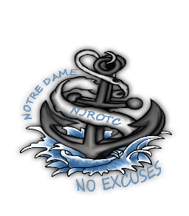
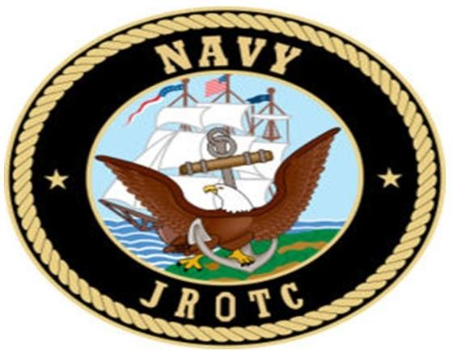

To: SNSI/NSI
Via: Operations Officer
From: Operations LPO/LCPO

Subject: UPCOMING EVENT
Name of Requesting Organization: ________________________________________
Location of Event: _________________________________________________________
Date of Event :_____________Time of Event:_____________Ending Time of Event:
Time in Which Cadets Must Show Up: _________________
Number of Cadets Needed:_________________
Attire:__________________________ Indoor Or Outdoor:_______________
Event Description:

NSI initial approval (within 48 hours) _________________________________
After initial approval, the Communications Officer will contact the requested organization ASAP, to inform them that this is in for action.
Operations LPO/LCPO:______________ Assigned OIC:_____________ Date:_____
Added to Operations Board in ADMIN _____ Sign-Up Sheet Posted in Hallway _____ Add to Event Log _____
Communication Officer: _______________ Contact the Organization via: email (CC NSI), Update all calendars, sing up sheets and add to event log.

Color Guard LPO:________________ Date:_______ Color Guard Routing Letter
48 hour max.

Safety Officer:_________________________ Date:________ ORM Completed

Operations Officer: _______________________ Date:___________ Ready to go

SNSI/NSI for final approval: ________________________ Date:___________

This form should be completed within five school days.

