Inc. Village of Woodsburgh

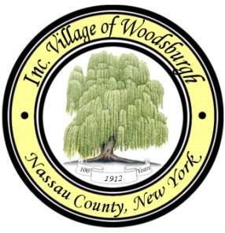

**ALAN HIRMES**, DEPUTY MAYOR

**CARL CAYNE**, TRUSTEE

**SHIRA HOSCHANDER**, TRUSTEE

**BARRY ROZENBERG,** TRUSTEE

**MICHELLE BLANDINO**, CLERK TREASURER

**BRIAN S. STOLAR**, VILLAGE ATTORNEY

**DENNIS FROMIGIA**, BUILDING INSPECTOR

30 PIERMONT AVENUE • HEWLETT, NEW YORK 11557

**TELEPHONE (516) 295-1400** • **FACSIMILE (516) 295-1406**



**JACOB HARMAN, MAYOR**

December 8, 2023

Dear Residents:

I am pleased to advise that the next meeting of the Board of Trustees will be held at 6:30 p.m. on Wednesday, Dec 13, 2023, at Village Hall.  We will have our usual monthly reports, address any pending or new village business and as always, be available to discuss any other matters of concern.

On behalf of the Board and Village staff, I would like to wish everyone a very happy and healthy holiday season and thank you for your support and involvement in the Village of Woodsburgh.

As previously communicated, if you are planning on going away for the Holiday Season or for the Winter, we suggest you consider calling Village Hall and complete a vacant premise report. All information is kept strictly confidential and given to the Security Patrol and the 4th Precinct to monitor homes while away.

As always, should you have any questions or concerns please do not hesitate to contact Village Hall. We look forward to having you join us at the next meeting.

Very truly yours,

Jake Harman

Mayor