Indiana Dental Assistants Society Presents:

Word of Mouth Newsletter 2021

President’s Message

Hello Indiana!

I hope this newsletter finds everyone safe, healthy, and happy! I am pleased to let everyone know that our annual session this year will be held in person again! Details are on the next couple pages of this newsletter. This year has been tough for everyone, but we have made it so far, and we can continue with that streak.

As the president of the Indiana Dental Assistants Association I would like to say how proud I am of everyone for continuing their membership with the ADAA and IDAA. Finances have not been easy for anyone, but to see that we gained members instead of lost them this year is extremely heartwarming. When we look back on 2020 we can see that it was a learning experience for everyone and that patience was the main factor that got us all through.

I am super excited to be your president during the 100th birthday of the IDAA. Be sure to bring your party gear and celebrate with us this year! I encourage everyone to bring photos from years past and to tell stories. Let’s reconnect this year with the help our centennial celebration.

I encourage our new members to become involved. Indiana has a very strong dental society, and we don’t realize how lucky we truly are to be such a great organization. The first time I was president of the IDAA I had no clue what I was doing, but I had great mentors that helped through the entire process. I volunteered not knowing the amazing opportunities this has brought me. I would not be where I am today without taking that first leap and volunteering my time to this wonderful organization. If you are interested in becoming an officer or volunteering your time with the IDAA, please let us know! We have several spots that need filled this year. If you’re hesitant, you can come talk to anyone about the responsibilities of the position you’re interested in.

With all of that said, I can’t wait to see you all in May, we have a great birthday celebration ahead of us!

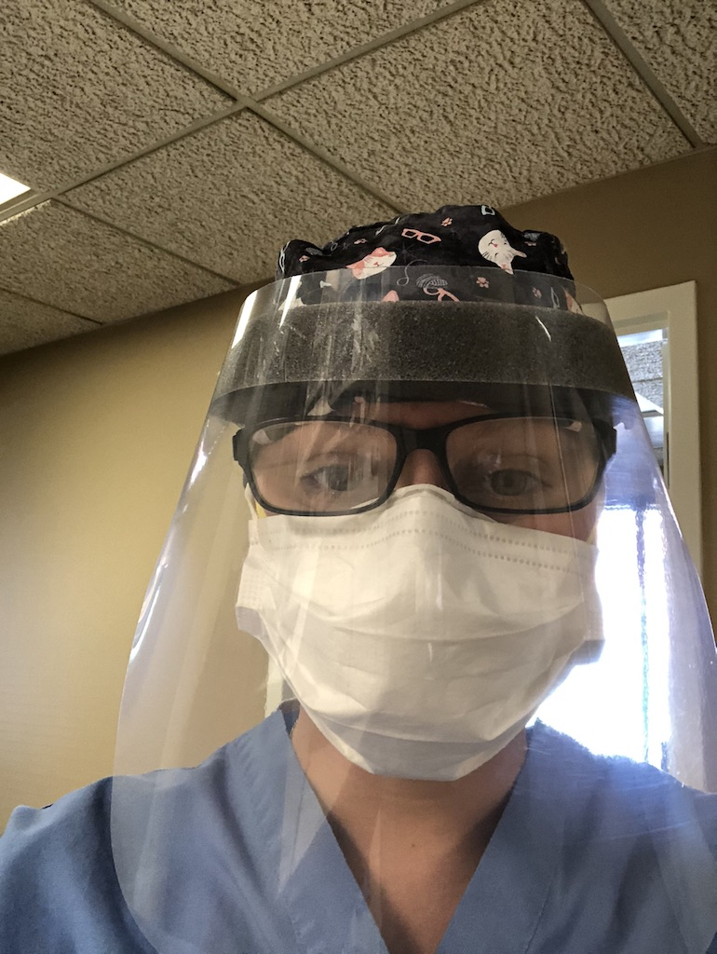
Meagan Morton, CDA
IDAA President
EDAS President-elect
DANB Board of Directors

Vice President

Cathy Roberts

As of March 15, 2021, IDAA has 290 Professional Members, 4 Emeritus and 49 Students. Of the 290 Professional members:

- 246 Active Professional Members
- 18 Life Members
- NPRO2 4 Members
- NPRO3 6 Members

Compared to 2020 we had 255 Professional Members and 59 Students

2021 has had an increase of 44 new active members!

Secretary

Hello everyone! With 2020 being the mess that it was, I wanted to say “thank you” to everyone for making the 2020 Annual Session (our first fully virtual) go so well. I’m excited to be back live with all of you! Just a reminder that delegate packets will be digital. I will need each locals list of delegates and their email address by April 29, so that I can send packets on April 30th. You will be responsible for printing your materials and bringing them to the meetings. I may have some extras on hand, but please don’t count on it. If you have issues please reach out to me at sneadkcda@gmail.com. I wanted to inform everyone that I will not be running for a 5th term as secretary. I have enjoyed learning with you and thank you for your patience in my journey. I will be very happy to help guide your new secretary and answer any questions. I have also created a “how to” guide and timeline to help ease our new officer! I greatly appreciate you all!

-Katherine Snead
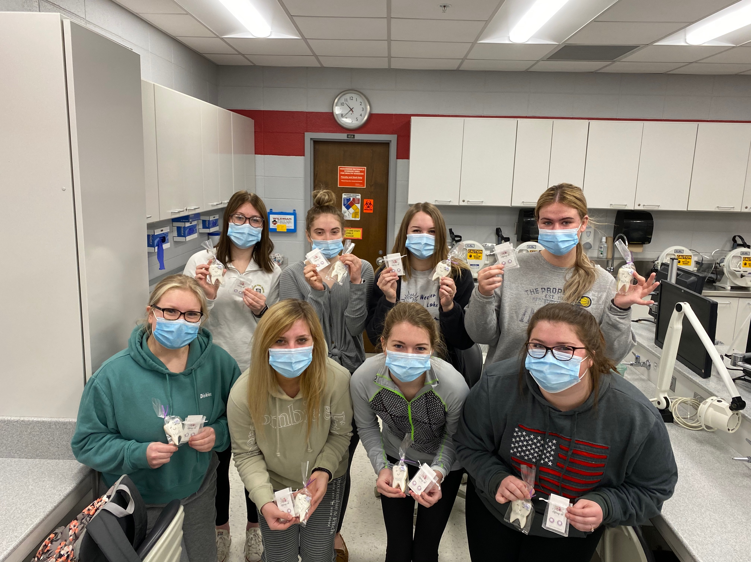
IUFW students during Dental Assisting Recognition Week

Financial Aid

As the chairperson of the IDAA Financial Aid committee, I am pleased to announce the winner of the awards. Each of the eleven Indiana CODA-Accredited Dental Assisting programs were contacted by e-mail to submit the name of a student that they felt deserved the award. New this year, each winner receives one full year of paid active membership to the American Dental Assistants Association (which includes the amount for State and Local dues). This membership will afford them with complimentary continuing education courses, $50,000 in professional liability coverage, and loads of networking opportunities.

Winners:
- Kate Bennet, from Indiana University School of Dentistry, IU Fort Wayne
- Laura Brust, from Indiana University School of Dentistry, IUPUI
- Ashley Fagel, from Ivy Tech Community College, Kokomo
- Katelyn Graber, from University of Southern Indiana, Evansville
- Brittany Sanders, from Ivy Tech Community College, Anderson
- Marrisha Smith, from Ivy Tech Community College, Sellersburg
- Lexi Wasser, from Indiana University Northwest, Gary

Best wishes to these winners! The IDAA extends regards to their continued success in school and throughout their career in dentistry.

Wilhemina R. Leeuw, MS, CDA
IDAA Financial Aid Chair

IDAA 100th Annual Session

May 14-15, 2021

Indianapolis Marriott Downtown

ADAA/IDAA Member:  **Registration includes all IDAA meetings, IDAA Events, and IDA Exhibits and Auction Event**  (This registration does not include any IDA events or CE) | $65.00________
Non-member: | $85.00________
Students:  (Attending IDAA meetings and exhibits only) | FREE
Students attending auction/Reception: | $50.00________
Guests attending the Auction/Reception with member: | $65.00________
Total Paid: | $________

REGISTRATION AND DEADLINE FOR MEETING IS MAY 8, 2021

Name:

Email Address:

Please send registration and check payable to IDAA:
Selena VanSickle
1711 Bentbrook Dr.
Avon, IN 46123
Payments can be made through PayPal: indianaassistants@outlook.com
Please write your name and email in the note section.

Indiana Dental Assistants Association 100th Annual Session Program Indianapolis Marriott Downtown

Friday, May 14, 2021

8:00-9:00 AM | IDAA Registration | California
9:00-10:00 AM | IDAA Pre-session BOT | California
10:15 AM- 12:00 PM | IDAA 1st HOD | California
12:00-12:300 PM | IDAA Balloting | California
1:00-2:30 PM | Past Presidents Luncheon | TBD
6:00-9:00 PM | IDAA 100th BIRTHDAY BASH! | Lincoln

Saturday, May 15, 2021

9:00-10:30 AM | IDAA 2nd HOD | California
10:45-11:15 AM | IDAA Installation Ceremony and Awards | California
11:30 AM- 12:15PM | IDAA Post BOT | California
8:00 AM-1:30 PM | IDA Marketplace Open | Exhibit Hall

Hotel Information for IDAA Annual Session

Marriott Indianapolis Downtown
350 West Maryland Street
Indianapolis, IN 46225

Friday 5/13/21-Monday 5/14/21
Cut off date for reservations: Thursday April 15, 2021
$209.00 per night plus taxes

Please make reservations as soon as possible by going to:
https://book.passkey.com/go/INDentalAssistantsAssoc

Registration

Please send the names of delegates and alternated delegates to the registration chair no later than Friday, April 30.
Please include the credentials and the delegate’s names exactly how you want it to appear on their badge.
You can email you delegates to me at:
mikejogerk@aol.com

Thank you and I look forward to seeing everyone!

Joann Gerike, CDA, EFDA
Registration Chairman

Legislative News 2021

The Indiana law that allows dental assistants and hygienists to administer and monitor nitrous oxide has been established. To date, there is one online course at University of Southern Indiana, but other programs are establishing courses.

A dental assistant who wishes to perform these duties must:

- Been employed in a dental practice for at least one (1) year or has graduated from a program accredited by the Commission on Dental Accreditation of the American Dental Association;
- Satisfactorily completed a three (3) hour didactic nitrous oxide administration course continuing curriculum on pharmacology, biochemistry, anatomy of nitrous oxide administration, emergency procedures, and the mechanics of operating a nitrous unit, accredited by the Commission on Dental Accreditation of the American Dental Association; and
- Demonstrated clinical competency on at least five (5) patients under the direct supervision of a licensed Indiana dentist whose license is in good standing
  - The licensed Indiana dentist supervising the clinical competency under subsection (a)(3) shall provide to the dental hygienist or dental assistant a signed affidavit certifying the competency.
  - Upon receipt of the affidavit provided to a dental hygienist or a dental assistant under subsection (b), the provider of an educational program or curriculum described in subsection (a)(2) shall issue a certificate of completion to the dental hygienist or dental assistant. The certificate of completion must be publicly displayed in the dental office of the dental hygienist or dental assistant.
  - Before permitting a dental hygienist or dental assistant to administer nitrous oxide, the supervising dentists shall:
    - Verify that the dental hygienist or dental assistant has completed the requirements of subsection (a);
    - Determine the maximum percent-dosage of nitrous oxide to be administered to the patient; and
    - Ensure that any administration or monitoring of nitrous oxide by dental hygienists or dental assistants is done in accordance with relevant guidelines and standards developed by the American Dental Association or the American Academy of Pediatric Dentistry.

Without the Nitrous Oxide Certificate, a dental assistant or hygienist CANNOT administer or monitor nitrous oxide.
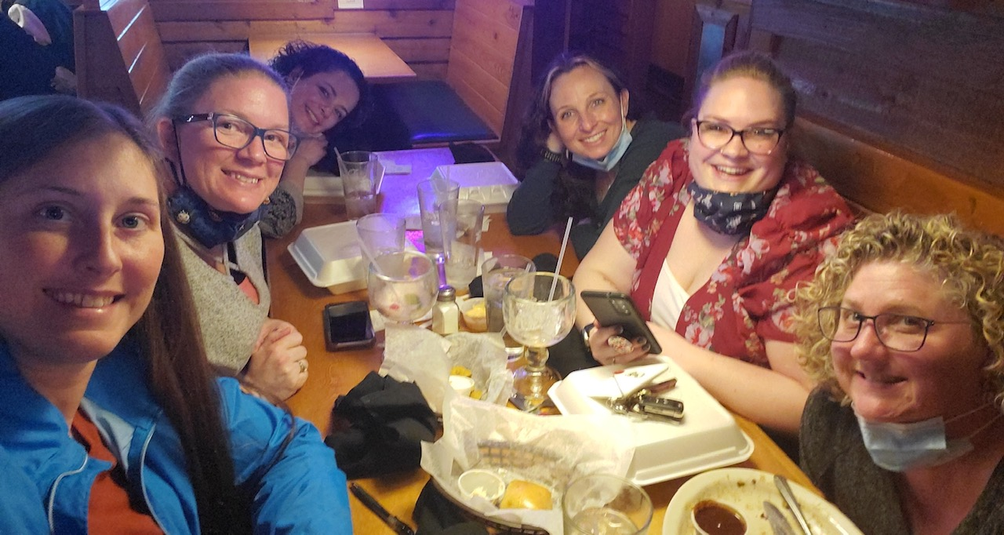
First time eating together in over a year on March 31, 2021 after everyone was vaccinated

Radiology

Cathy Roberts

The Indiana Radiology Program from the ADAA continues to be a very successful program for assistants who need to obtain their Radiology License and are working on the job or moving into the state. The assistant can join the ADAA and take the Indiana Radiology courses at no additional fee. It is a win-win as the ADAA/IDAA has new members and the assistant can take the Radiology courses at the membership fee. This is very cost effective for most dental assistants. Information is on our IDAA website, www.Indaa.org and our ADAA website, www.adaausa.org. If you have any questions on the Indiana Radiology Program, please e-mail me at cjrcda@aol.com or cell 812-320-5437.

The Indiana State Department of Health has a new Radiology Licensing Coordinator, Michele Starkey. She can be reached at mstarkey@isdh.in.gov or (317)233-7565.

Ways and Means

Bring your extra money for Ways & Means. We will be having lots of fun items for sale. If you are interested on anything personalized you must preorder. Visit Pink Mimi’s Creations to check out what you can order. I can make custom tumblers, T-shirts, keychains and more. Let me know if you have any questions.

Wendy Yockey
wendyefda@yahoo.com
317-509-2157

IDAA IT News
TO ALL MEMBERS!
Please keep your email and address information updated in your profile on the ADAA website www.adaausa.org. This is how we have your information. If your personal information is not current, you WILL NOT receive the updates from the ADAA and IDAA.

Also, please use your home or personal email so if you are not in the office or you change employment, we can still reach you.

ADAA website: www.adaausa.org
IDAA website: www.indaa.org

Cathy Roberts
IDAA IT Chair

6th District Trustee

Hello Indiana Dental Assistants,

Just a few quick updates from the ADAA. As I am sure most of you are aware by now, the ADAA has a new management company with some familiar faces. Former Executive Director Dr. John Kasper and his wife have decided to retire and sell Solutions for Associations. His staff is staying on with the new management company, Seven12management, and John has decided to stick around as long as needed to aid in the transition. I am excited to see how the new voices of a larger team will aid the ADAA in growth and a brighter future as they have already been hard at work moving us forward. They are excited to reach out to as many assistants across the nation as possible through modern technology and means.

Indiana has seen growth in membership even during the pandemic, largely from our radiology program. It is important to reach out to new members, but let’s not forget we need to also retain membership. Don’t forget the importance of the people that are already members, and their hard work to make us a better association. Thank you all for our continued support for the IDAA and the ADAA. Our voices and hard work make the profession better for all and our efforts and strength in numbers help to bring out positive changes. We need to continue to our upward growth in membership.

Lastly, my three-year term as your 6th District Trustee will come to an end this year at the ADAA Annual Session on October 23-24, 2021. I am deciding not to run again the coming year as I am getting more and more busy with dental school. I am currently looking for a person to take over my role as the 6th District Trustee. Please look inside your hearts to see if you would like to run for this office and represent an amazing group of people. As your trustee I have learned a lot about our association and met amazing people from Indiana (of course), Michigan, and Illinois. I have made so many great friendships and found even better mentors’ trough my time and travels as a trustee. It has been great to be the voice of the 6th district on the Board of Trustees, and if you have any questions about the position, please reach out to me. I look forward to seeing all of you at the IDAA Annual Session, where we will make memories to last a lifetime while moving our state into a brighter future together.

Sincerely,

Jacob Rexing RDH, EFDA
ADAA 6th District Trustee
IDAA Past-President
EDAS Past President
IUSD Class of 2024

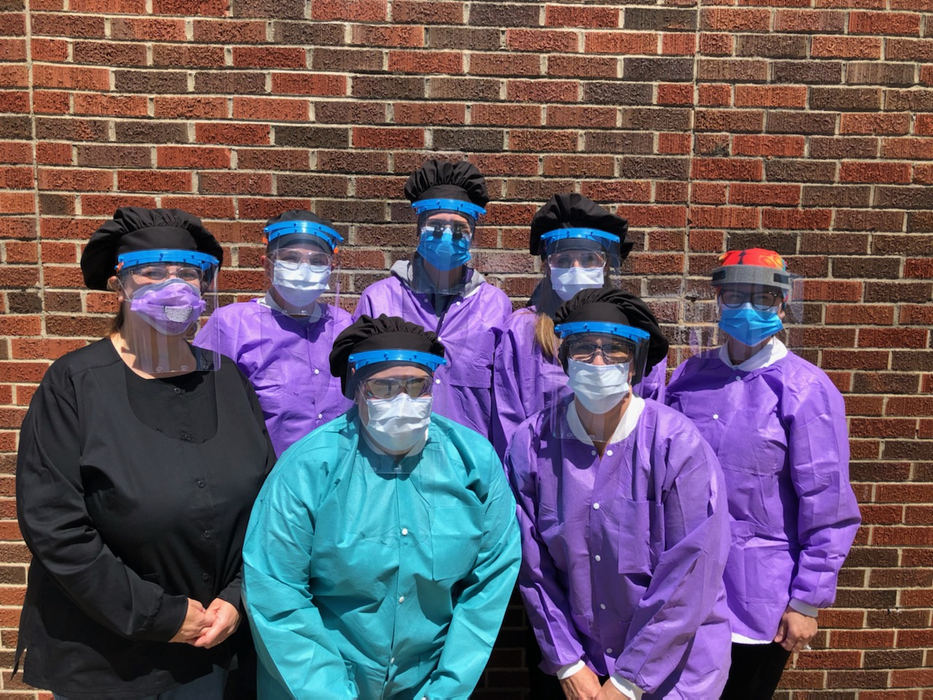
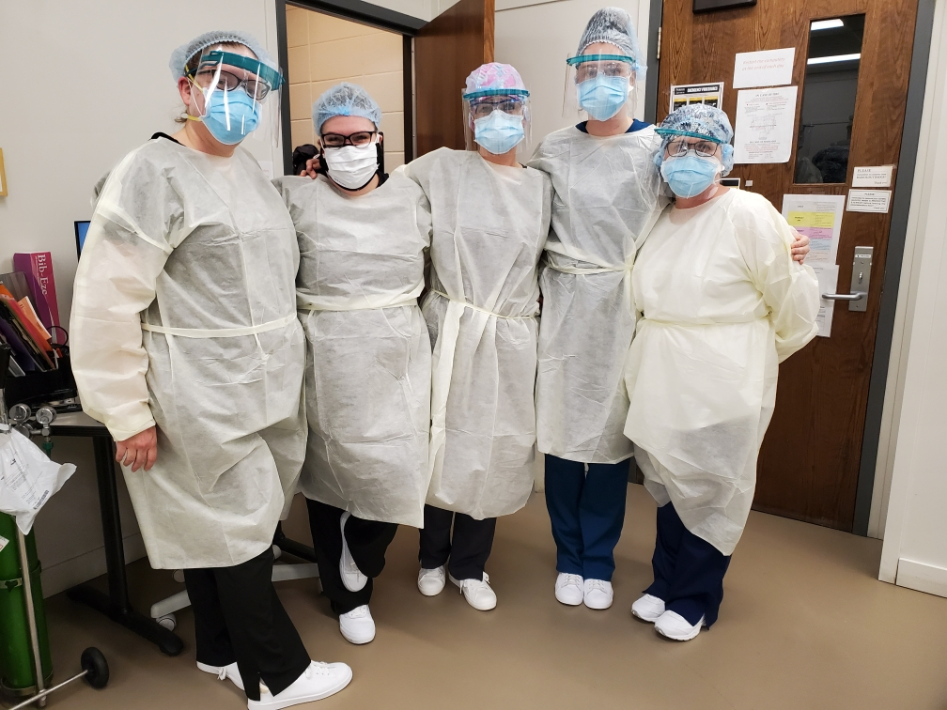
Dr. Sitzman and Wolf in Evansville, Indiana when they first came back from the shutdown.
IUFW CDA Faculty

Vera Hewins Loyalty Award

I am so honored to have received the Vera Hewins Loyalty Award last year and serve as the chair of the award this year. The Vera Hewins Loyalty Award is awarded to a dental assistant that lives their life devoted to dental assistants and the association. Vera Hewins was a devoted member to the ADAA and IDAA and her local component. She worked hard to promote the association. I challenge each and every one of you to be like Vera Hewins in your dedication, loyalty, and passion for dental assisting. I encourage every one of you to step up and be a leader just like Vera did and to overcome the hardships thrown your way.
If you know someone that is deserving of this prestigious award, please nominate them. By receiving this award assistants are able to recognize the impact that they truly have on those around them by just being an example and having pride in what they have accomplished. Only electronic submissions will be accepted unless otherwise discussed.

Nominations can be sent to me at:
Jacob.rexing@gmail.com or you can reach me at
(812) 604-9363
They will be due no later than 30 days prior to our annual session. Voting for the Vera Hewins award will be done virtually during our lunch/break May 14th.

I look Forward to seeing you all soon!
Sincerely,
Jacob Rexing RDH, EFDA
ADAA 6th District Trustee
IDAA Past-President
EDAS Past President
IUSD Class of 2024
NOMINATION FOR VERA HEWINS LOYALTY AWARD
Nomination Form

Name:
Address:
Employer:
Number of years in dentistry:
Currently certified:
Personal Information:

OFFICES AND COMMITTEES

National:
State:
Local:
Number of national meetings attended:
Number of state meetings attended:
List community activities during years in dentistry:

We would also like you to write a short explanation of why you feel this candidate is deserving of this award. (This should be written by an officer of the component sponsoring the candidate and should be typed on an additional sheet of paper and sent with this form electronically) Nominee’s employer may wish to send a letter or recommendation as well.

Submitted by:
Date:

Ramona Gunstra Award

Nominations

In 1987, the IDAA instituted a new award: The Ramona Gunstra Outstanding Service Award. Ramona was our IDAA president in 1971-1972 and she continued to give of her time and talents to the IDAA. To this date, only 21 IDAA members have been chosen to receive this prestigious award.

I am so honored to be one of the chosen to receive this award. Ramona was an inspiration and mentor to all of us. It is important to keep her enthusiasm and tradition of service alive for our newer members. Please consider nominating someone who deserves this award.
Please read the following criteria and nominate a candidate who you believe is worthy of this award.

- Must be a former IDAA President
- Must have a minimum of 15 years of productive membership in the IDAA
- Must be a former recipient of the Vera Hewins Award and have remained active in services to the association since receiving the award.

For a nomination form, please contact me at: jasonkelly101699@yahoo.com.

The deadline for submission is 30 days prior to our annual session.

All former recipients who are attending the IDAA Annual Session will meet briefly during our lunch break/voting break 15 minutes prior to our 2nd HOD to discuss the nominations.

Sincerely,
Sheila Clancy, CDA, MBA
Ramona Gunstra Award Recipient 2020

IDAA Anna Marie Dixon

New Member Involvement Award

The Anna Marie Dixon New Member Involvement Award shall be presented to a member who has shown the most outstanding achievement in promoting the objectives of this association and furthering the profession of dental assisting.

Qualifications:

- Shall be an active or federal services member of the Indiana Dental Assistants Association
- The Nominee must have no more than five (5) consecutive years of membership with the Indiana Dental Assistants Association.
- Shall not have been a previous member.
- Shall have excelled in our motto of ‘Education, Efficiency, loyalty and Service’, during years of active membership.
- Shall have participated on local, state, and/or national offices, Federal Services level and/or IDAA Council or IDAA Special Committee
- Shall have excelled in services above and beyond expected duties.
- Shall not have been a previous recipient of this award.
- Shall not be an employee of ADAA.

Procedure:

- The candidate’s name and qualifications shall be submitted by a member electronically via email using Microsoft word v. 98 or later to the email address of the Vice President Cathy Roberts cjrcda@aol.com no later than 30 days prior to Annual Session. All electronically submitted documentation must be typed.
- It is the responsibility of the individual who is submitting the nomination to confirm the receipt of the nomination if a confirmation email is not received stating the nomination was received.
- The IDAA Vice President will verify date of membership.

Voting:

- Nominees’ application shall be electronically sent to the Vice President. The Vice President shall forward all applications to the members of The Executive Committee for review of each applicant’s application and qualifications.
- Voting shall be by email ballot of the Executive Committee.
- The candidate receiving the majority of vote’s casts shall be the award recipient.
- The name of the recipient shall not be revealed until the time of the presentation of the award.

A certificate and a $75.00 check shall be presented during Annual Session.

