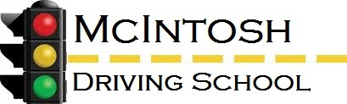

**Schedule of Fees**

|  |  |
| --- | --- |
| Driver Education Class/Behind the Wheel Training  (8 Hours Classroom/6 Hours Behind the Wheel) | **$280.00** |
| 8 Hours Classroom Only | **$100.00** |
| 6 Hours Behind the Wheel Training | **$180.00** |
| Additional Behind the Wheel Training (Minimum 2 Hours) | **$50.00**  **(per Hour)** |
| DMV Road Test | **$50.00** |
| Duplicate Paperwork (Certificate) | **$10.00** |

*\*\*McIntosh Driving School requires 24 hours’ notice of cancellation for behind the wheel training. Failure to notify will result in a $35.00 assessment to the final bill for each occurrence. Please call as soon as possible to reschedule.*

***\*\*\* Payment arrangements are accepted but all payments are due before certificate and PLA will be issued\*\*\****