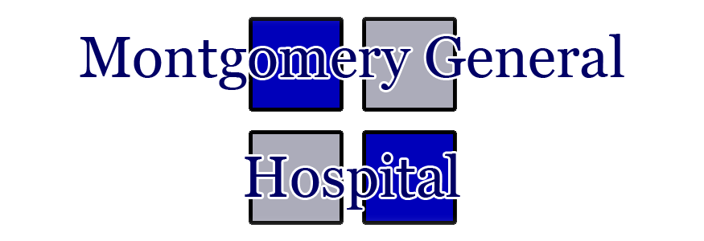2016 Community Health Assessment Implementation Plan

Submitted: May 15, 2017

Background
In late 2016, Montgomery General Hospital (MGH) conducted a Community Health Needs Assessment (CHNA). The data for this assessment was collected from a variety of sources that included a county wide survey, input from community based leadership, and statistics concerning population health for the area. The complete CHNA can be found at www.mghwv.com.

Priorities
The CHNA revealed four priority health issues to be addressed through an implementation plan. These areas are the areas that we will focus on:
- Physical Inactivity and Obesity
- Diabetes Education
- Substance Abuse and Mental Health
- Transportation

Implementation Strategy
MGH recognizes that a community health improvement plan is critical in creating and developing certain policies that address the needs of the community. These policies and directives help define the action that will target and promote healthier living, by pinpointing its strengths and weaknesses, while capitalizing on opportunities.
Collaborative efforts within the organization, in conjunction with the doctors and surrounding community are crucial in the success of the assessment. Montgomery General Hospital will be undertaking many steps in the coming years and will respond to each priority health need listed above. In order to deliver improvements, there is a detailed plan in place that was designed for success that addresses each health issue.

Priority: Physical Inactivity and Obesity
Physical inactivity and obesity are prevalent among residents in the community and surrounding areas. Unhealthy eating habits and lack of physical inactivity can lead to a variety of health issues including type 2 diabetes, high blood pressure, coronary artery disease, and sleep apnea.
MGH currently offers free access to the fitness center on its campus to all community members. The facility provides a variety of equipment including treadmill, elliptical bikes, free weights, and recumbent bikes.
In June 2017, the YMCA will be opening a facility in Montgomery and MGH plans to partner with them to provide services for health living and youth development, in the near future. The YMCA plans to reopen the former college’s indoor pool. This reopening will allow for water sports, swimming lessons, and open swim times to be available to the community. This reopening has allowed for discussions concerning a future swim team at the local high school. In addition, the YMCA will offer a host of sports to children in the community. Soccer, which is not currently available in the community, will be the first sport offered. The YMCA's services will provide resource as well as a convenient venue for an active lifestyle for both adults and children in the community. Having a diverse selection of sports and athletic offerings will be significant in bringing the community out of all ages.

Priority: Diabetes Education
Diabetes is significant in MGH's service area. If left untreated, a person's health and well being can be seriously affected.
MGH employs a Certified Diabetes Educator whom works with both the patients and their primary care physician to educate the patient and assist in diabetes management. The MGH Diabetes Education Center is open three days each week. Alice Lockman is 1 of only ten Certified Dietary Educators in West Virginia and is commonly referred to as the “Sugar Lady” for her knowledge and contributions to her communities, in which she lives and works.
In the future, in collaboration with Alice Lockman – FNP, MGH plans to implement a series of programs intended to educate. Education is key in fighting against diabetes – both in the older and younger generations. The Lunch and Learn is a twice a year event, that is open to the public, free and typically lasts an hour. This event teaches the population proper food menus, what to eat, different activities and how to effectively manage ones diabetes. This is done primarily with Lockman and several other speakers, with extensive knowledge of diabetes.
The Elderly Educational Outreach is a program that is being implemented in elderly community centers such as the High Rise Apartment Complex. These educational sessions focus on low-carb meals, cost efficiency and overall eating habits. MGH and Lockman also intend on partnering with Valley High School and having educational lectures, slide shows and proper nutritional tips that these kids can take and implement as they move on to college and early adulthood.
Montgomery General Hospital recognizes that they must maintain a technological edge and is adapting into its new website, a tab dedicated to diabetes education. This would encompass much information that is free to the public and will also inform on how to make an appointment with Alice Lockman. It will also offer statistical information, thoughts, tips, recipes and event dates, such as the annual Children’s Fair that MGH hosts.
Alice Lockman and MGH are dedicated to educating, preventing and treating diabetes on many levels and will continue to do so in its community.

Priority: Substance Abuse and Mental Health
Abuse of illicit drugs is not only a national crisis but a concern for member of MGH's service area. Individual with addiction disorders are at risk for serious health and mental issues. Addition affects both the addict and their family and friends.
MGH has developed a referral network to address each patient's addiction needs. MGH is partnering with Highland Health to offer psychiatric screenings and consults through telehealth services. Highland Health maintains ten inpatient beds for substance abuse recovery.
In June, the MGH physician clinic will begin annual psycho-diagnostic, alcohol, and depression screenings on all patients. The screenings will be read by an MGH physician and referred to an appropriate physician. Early detection will curtail the possible devastating outcomes. In addition beginning in June, KVC Health System will begin seeing patients on the MGH campus. KVC specializes in in-home family support, foster care, adoption, behavioral healthcare, and youth substance abuse treatment. The MGH campus office will specialize in behavioral health and substance abuse. The presence of KVC will provide both MGH primary care and emergency room physicians a convenient referral contact which may result in immediate intervention.

Priority: Transportation
The community survey results revealed a need for transportation to receive healthcare. Patients may delay or not seek treatment due to transportation issues.
Currently, MGH owns a van which is used to transport nursing home and extended care patients to and from physician appointments. This also allows family member to accompany their loved ones to appointment which on occasion they would not have been able to attend due to lack of transportation.
Over the next two years, MGH plans to explore the possibility offering a community transportation program. This program would offer community members transportation to and from physician appointments, outpatient tests, and therapy services. The program would require purchasing an additional van and adding an additional employee. Another concern MGH will explore is the service schedule to assure that the program benefits as many members as possible each day.

Conclusion
MGH is committed to addressing each of the priority needs over the next two years. This implementation plan will serve as a guide to address the needs the community identified. MGH will continue to monitor these key areas and strive to improve the health and quality of life for the community. In partnering with the community and Healthcare providers there are several variables that will make this a success. A commitment to improving health that reflects a common understanding of the problem and a joint approach to solutions and actions, in which all parties are contributing towards this singular goal, is significant. A true partnership and collaboration amongst all cannot be repeated enough and will result in a healthier community.

"Desire is the key to motivation, but it's the determination and commitment to an unrelenting pursuit of your goal - a commitment to excellence - that will enable you to attain the success you seek."

