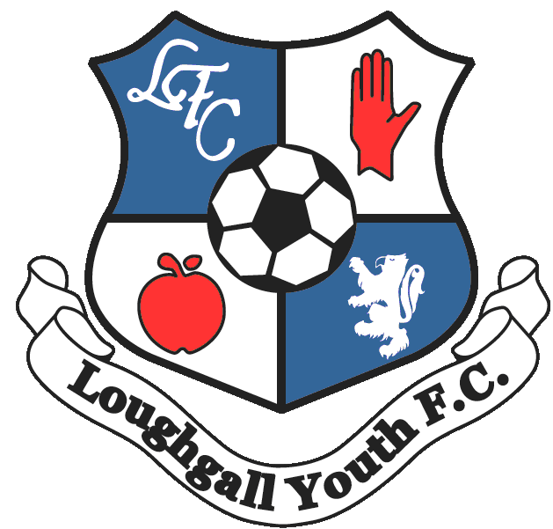

Loughgall Youth Football Club
Code of Conduct for Parents, Guardians and Spectators

As primary carers for their children, parents and guardians assume overall responsibility for the positive development of their child and therefore have a responsibility to conduct themselves in a manner which supports this process.

Loughgall Youth Football Club expects all parents and guardians to promote the positive aspects of football by demonstrating exemplary behaviour at all times – this includes encouraging their child’s participation in the game, demonstrating respect for staff and officials and behaving responsibly on the sidelines.

Persistent breaches of the code may result in the parent or guardian being asked to stay away from club activities and may also result in their child being removed from the club.

As a Parent / Guardian I will:

- encourage my child to play by the rules and teach them that they can only do their best
- show appreciation and respect for coaches, volunteers and other players
- be realistic and never exert undue pressure or expectations on my child
- praise effort and participation rather than focusing on performance and results
- accept decisions made by match officials
- behave responsibly on the sidelines (this includes not screaming or shouting)
- encourage children to show respect to their coach, team mates, opponents and match officials by demonstrating exemplary behaviour myself
- promote my child’s participation in playing football for fun
- encourage their child to play by the rules and teach them that they can only do their best
- refrain from engaging in inappropriate use of social media – this includes posting comments on social media sites that may cause harm to others or bring the club into disrepute
- complete and return the Registration / Consent Form pertaining to my child’s participation
- deliver and collect my child to and from coaching sessions and matches punctually if required – depending on the age of the young person, venue and arrangements with club coaches / volunteers
- ensure my child is properly and adequately attired and equipped – particularly for seasonal weather conditions
- ensure that proper footwear and protective equipment are worn at ALL times
- detail any health concerns relating to my child on the consent form, in particular breathing or chest conditions. I will also inform the coach of any changes to my child’s health.
- inform the coach / co-ordinator if my child has been ill or hurt recently
inform the coach prior to departure from the field of play if my child is to be collected early from a coaching session
ensure my child’s hygiene and nutritional needs are met
never attempt to fulfil my own ambitions and aspirations through my child’s involvement in football

Parents / guardians have the right to:

- know their child is safe
- be informed of problems or concerns relating to their child
- be informed if their child is injured
- speak to staff and voice any concerns about their child

CODE OF CONDUCT FOR SPECTATORS

While spectators are allowed to show support for their team and bring atmosphere to a football match, they sometimes display abusive and intimidating behaviour. This type of behaviour is unacceptable and needs to be eradicated from the game so that football can be an enjoyable experience for everyone involved. Spectators have a role to play in promoting high standards of behaviour in the game so that everyone benefits from the positive aspects of football.

As a spectator at club activities, I will:

- never enter the field of play unless permitted to do so by the referee
- refrain from the use of offensive, insulting or abusive language or behaviour
- not condone violent behaviour from coaches, players, match officials, opponents or spectators
- respect decisions made by match officials
- praise effort and achievements and never criticise mistakes
- let the coaches do the coaching
- encourage young players to respect their opponents and the match officials
- promote the importance of respect and fair play

Print Name __________________________

Signed _____________________________

