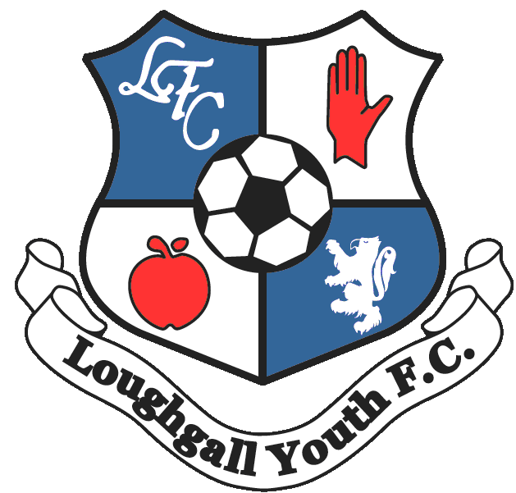

Loughgall Youth Football Club
Code of Conduct for Children and Young People

Loughgall Youth Football Club strive to contribute to the sporting and social development of children and young people by presenting them with an opportunity to engage in football activities. In order for football to be a positive experience for all children and young people, Loughgall Youth expect high standards of behaviour to be demonstrated by all players so that everyone can benefit from the positive aspects of the game.

Players have a responsibility to conduct themselves in a manner which does not bring the club into disrepute. Any behaviour in breach of the club’s Code of Conduct may result in disciplinary action being taken.

As a player participating in club activities, I will:

- behave and listen to all instructions from coaches and volunteers
- take care of and respect equipment owned by the club or a rented facility
- refrain from behaviour that will bring the club into disrepute
- refrain from the use of foul, abusive, racial, discriminatory and sectarian references
- refrain from bullying behaviour or the persistent use of rough and dangerous play
- refrain from engaging in inappropriate use of social media – this includes posting comments or images on social media sites that may cause harm to others or bring the club into disrepute
- report inappropriate behaviour
- never tell lies about other adults, children or young people
- respect my coaches and teammates
- show respect to other players, staff and volunteers
- respect officials and accept their decisions
- respect opponents and not cheat
- play fairly
- be gracious in defeat
- not use violence
- shake hands with the other team and the referee at the end of a match
- keep within the defined boundary of the playing / coaching area unless, instructed otherwise
- ensure I am punctual for training, matches and any other club activity
- advise the team coach of any injury or medical condition sustained before or during club activities
- advise the team coach if I am unavailable to play or participate in club activities
- be collected on time
- be responsible for my own kit
- wear appropriate footwear / shin pads
- bring my own water bottle / fluid

Children and young people participating in Loughgall Youth programmes have the right to:

- feel safe and protected
- be respected and listened to
- contribute by offering constructive comments / feed back
- privacy
- enjoy football in a protective environment
- be referred to professional help if needed
- be protected from inappropriate behaviour / abuse from staff and volunteers
- appropriate levels of confidentiality
- participate on an equal basis, appropriate to their ability
- experience competition and the desire to win
- be believed when they ask for and volunteers

Players name ____________________

