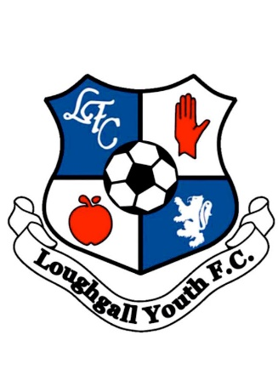

To Parents, guardians and players,

Welcome to Loughgall Youth,

Loughgall youth has been in existence for nearly 20 years now and caters for players from U6-U17. The aim of the club is to develop players to the best of their ability to be able to play at the highest level possible for the benefit of both the player, and Loughgall Football Club.
Loughgall shall promote equality, regarding gender, religion and race, as well as promoting fair play and sportsmanship.

The club has seen a significant increase in players representing the club over the last few years with nearly 250 players now pulling on the Loughgall Youth shirt every weekend. The last 2 years has also seen the introduction of a Girls only section to our academy and the fielding of Our Lakers team in the GDC small sided games.

The club are based at our new Willis CRL Arena 3G facility, and this has allowed us to bring all strands of the Loughgall Football family together onto one site which is the envy of many clubs across the Country.

We know, from talking to parents and the significant increase in numbers pulling on the Loughgall Youth shirt, that you recognise the quality of coaching that players receive at Loughgall Youth. As a parent or guardian you have a role to play in your child’s football development. Help support the coach by ensuring that your child turns up to training and matches on time, prepared and ready to enjoy their football.

Thank you for your continuing support,

Loughgall Youth committee

