Town of Elbridge
Office Location:5 State Route 31, PO Box568, Jordan, NY 13080
CONTACT INFORMATION FOR SITE PLAN REVIEW PROCESS:
TOWN CLERK - DEBRA STAPLETON 315.689.9031x1
PLANNNG BOARD CHAIRMAN MARC MACRO 315.480.1355
PLANNING BOARD SECRETARY CINDY WEIRS 315.209.4370
TOWN ZONING OFFICER HOWARD TANNER 315.730-7439

TOWN OF ELBRIDGE
PLANNING BOARD APPLICATION
□SITE PLAN □ MINOR SUBDIVISION □ MAJOR SUBDIVISION □ LOT LINE ADJUSTMENT

Applicant Name: _____________________________________________________________

Applicant Address: _________________________________________ Phone: ___________

Property Location: ________________________________ Tax Map Number: ___________

Property Owner’ Name (if different than applicant) _________________________________

Attorney: _________________________________________________ Phone: ___________

Architect: ________________________________________________ Phone: ____________

Property Zoning: _______________________________________ Total Area: ___________

Description of project: ________________________________________________________
___________________________________________________________________________
___________________________________________________________________________
___________________________________________________________________________

REQUIREMENT: Six (6) copies of your application including a map or survey of the project must be filed with the Town Clerk.

___________________________________________________________________________

Filing Fee: $
Date Received: __________

Amount Received: __________

By: ______________________

PLEASE RETURN THE FIRST 10 PAGES TO THE TOWN OF ELBRIDGE CODES OFFICE AT THE ABOVE LOCATION
REQUIREMENTS: Check yes/no to indicate information included with application. In general, all information is required.
I. Survey of the property signed by a New York State licensed surveyor including the following:
YES NO
[ ] [ ] a) Direction and distance to nearest intersection

[ ] [ ] b) Property lines, boundaries of property plotted to scale

[ ] [ ] c) Center line and edge of pavement

[ ] [ ] d) Street right of way

[ ] [ ] e) Use and ownership of all adjacent properties

[ ] [ ] f) Dimensions and location of all structures existing on the site

[ ] [ ] g) Location of all existing trees of greater than a 6” caliper

[ ] [ ] h) Dimensions of structure to be added or modified including distance
from front, side and rear property lines

[ ] [ ] i) Proposed and existing topographical information

[ ] [ ] j) Location of State Wetland, Federal Wetlands, Federal floodway or
Floodplain

[ ] [ ] k) All existing easements and utility lines and watercourses
II. Elevations of all sides of the structure to be added or modified including:
[ ] [ ] a) Building material and color

[ ] [ ] b) Maximum height of building

[ ] [ ] c) Location, design and type of construction of all parking and truck
loading area
III. Site plan including the following information:
[ ] [ ] a) Area to be paved and location of all sidewalks

[ ] [ ] b) Parking space stripping plan with dimensions including location of
handicapped spaces
[ ] [ ] c) all landscaping including:
Note on plan that all planting & grass be maintained. Not all trees
Should be deciduous. Deciduous trees shall be minimum 2-1/2”
Caliper. Other trees shall be a minimum of 8’ from the ground to the
top of the tree.

[ ] [ ] d) Drainage concept including inverts and pipe sizes

[ ] [ ] e) All proposed site lighting both on the building and on the site.
Including pole height and lamp type and wattage
[ ] [ ] f) Any outside storage

[ ] [ ] g) Extent and type of curbing

[ ] [ ] h) Location of all underground services of power, telephone and
cable including locations where services are not underground

[ ] [ ] i) Proposed signage including any flagpoles and/or planters. Include
signage both on building and freestanding and illumination of same

[ ] [ ] j) Location of any outside trash receptacles; including recycling
containers

[ ] [ ] k) Location of any outside equipment including generators, HVAC
and the like

[ ] [ ] l) Location and size of water and sewer

[ ] [ ] m) Location of fire hydrants on site, or if none on site, a note
including location of closest fire hydrant

[ ] [ ] n) Location of curb cuts, exits and entrances
IV. STATUTORY REQUIREMENTS: TOWN LAW PROPOSAL
Number of parking spaces ____________ ____________
Lot coverage ____________ ____________
Building & pavement coverage ____________ ____________
Front yard setback ____________ ____________
Rear yard setback ____________ ____________
Maximum height of building ____________ ____________
V. Briefly describe the project. Include existing structures to remain, new structures, and general changes in grade.
VI. Is the subject property within the Onondaga County Agricultural District #3?
Yes [ ] No [ ]

Is the subject property within 500’ of the Onondaga County Agricultural District #3?
Yes [ ] No [ ]

Is the subject property within 500’ of an operating farm?
Yes [ ] No [ ]

Do the subject premises presently contain a farm operation?
Yes [ ] No [ ]
** If the answers to any of the questions in Section VI is “Yes” you must complete and attach to this application the Agricultural Data Statement which may be obtained from the clerk.

TOWN OF ELBRIDGE
PLANNING BOARD ACTION

Developer _____________________ Project Name __________________________

Address _______________________ ______________________________________

______________________________ Attorney ______________________________

______________________________ Address _______________________________

Phone _________________________ Phone _________________________________

******************************************************************************
Application filed:____________ 20 _____

Fee paid $ ____________ ____________ 20 _____

Estimated professional fees: $ ____________

Date paid ____________ 20 _____

SEQRA type: ______________________________________________________

SEQRA Determination: Poss _____ Neg _____ ____________ 20 _____

SOCPA reference: ____________ 20 _____

Recommendation: ___________________________________________________

__________________________________________________________________

Public hearing: ____________ 20 _____

Fee Paid $_____________ ____________ 20 _____

Decision: __________________________________________________________

__________________________________________________________________

Covenants:

Signed by Developer _____________ 20 _____

Approved by Town _____________ 20 _____

Notice of action: _____________________________________________________

Extensions: ______________________________________________________

STATE OF NEW YORK

COUNTY OF ONONDAGA
TOWN OF ELBRIDGE

__________________________________ being duly sworn deposes and says:

I have reviewed §809 of the General Municipal law, a copy of which has been furnished to me by the Elbridge Town Clerk and issued under the provisions of the Ordinances, Local Laws, Rules or Regulations of the Town of Elbridge, do hereby certify that I have read the provisions of Section §809 of the General Municipal Law of the State of New York attached to this certificate.

I do further certify that there is no officer of the State of New York, the County of Onondaga or of the Town of Elbridge or of any other municipality of which the Town of Elbridge is a part who is interested in the favorable exercise of discretion by said Board as to this application, except for those named below:
Name(s) Address(es)

Signature of Applicant(s) Date

Sworn to before me this _____ day of ___________, _____.

Notary Public

AGRICULTURAL DATA STATEMENT

(pursuant to NY Ag & Mkt Law 305-a; N.Y. Town Law & 283-1; N.Y. Village Law § 7-739 and N.Y. Gen. Mun. Law 239-m)

Applicant Owner (if different from applicant)
Name:

Address:
Name:

Address:

- Type of application: Special Use Permit _____; Site Plan Approval _____
Area Variance _____; Use Variance _____; Subdivision Approval _____

- Description of proposed project:

- Location of proposed project:

Address: _________________________
Tax Map No.: _____________________

- List all farm operations which are both: (i) located within 500 feet of the boundary of the property upon which the project is proposed, and (ii) located in an agricultural district:

(1) Tax Map No.

Property Address:

Name:

Owner Address:
(2) Tax Map No.

Property Address:

Name:

Owner Address:

(3) Tax Map No.

Property Address:

Name:

Owner Address:
(4) Tax Map No.

Property Address:

Name:

Owner Address:

(5) Tax Map No.

Property Address:

Name:

Owner Address:
(6) Tax Map No.

Property Address:

Name:
Owner Address:

- Attach a tax map or other map showing the site of the proposed project relative to the location of the farm operation identified above.

____________________________________________________

Town of Elbridge
Office Location:5 State Route 31, PO Box568, Jordan, NY 13080
CONTACT INFORMATION FOR SITE PLAN REVIEW PROCESS:
TOWN CLERK - DEBRA STAPLETON 315.689.9031x1
PLANNNG BOARD CHAIRMAN MARC MACRO 315.480.1355
PLANNING BOARD SECRETARY CINDY WEIRS 315.209.4370
TOWN ZONING OFFICER Howard Tanner 315.730-7439

TOWN OF ELBRIDGE PLANNING BOARD

SITE PLAN REVIEW CONSIDERATIONS –FOR APPLICANT REVIEW

- The proposed use is in compliance with all other applicable regulations of the Town of Elbridge Zoning Ordinances, and all other applicable local, state and federal regulations.

- The proposed use will not have an adverse impact upon the character or integrity of any land use within the immediate neighborhood having any unique cultural, historical, geographical, architectural, or other special characteristic.

- The proposed use is to be developed in such a way as to ensure maximum amenities available to the site based upon a consideration of the site plan and functional requirements of the proposed use.

- The proposed use is physically and visually compatible with and will not impede the development or redevelopment of the general neighborhood or adversely affect existing land use with close proximity to the subject site.

- The proposed use will be provided with adequate supporting services such as adequate fire and police protection, public and private utilities and all other supporting governmental services necessary and appropriate to the proposed use.

- Controls for vehicular and pedestrian movement are designed to provide for the safety of the general public and for the occupant, employees, attendants, and other persons for whose benefit the use is intended.

- Aesthetic characteristics, including design, texture, materials, etc, will be considered in the review process.

- Physical attributes if the site, including size, shape, elevation, topography and natural vegetation, will be considered in the review process.

TOWN OF ELBRIDGE PLANNING BOARD

Illustrative Site Development Plan
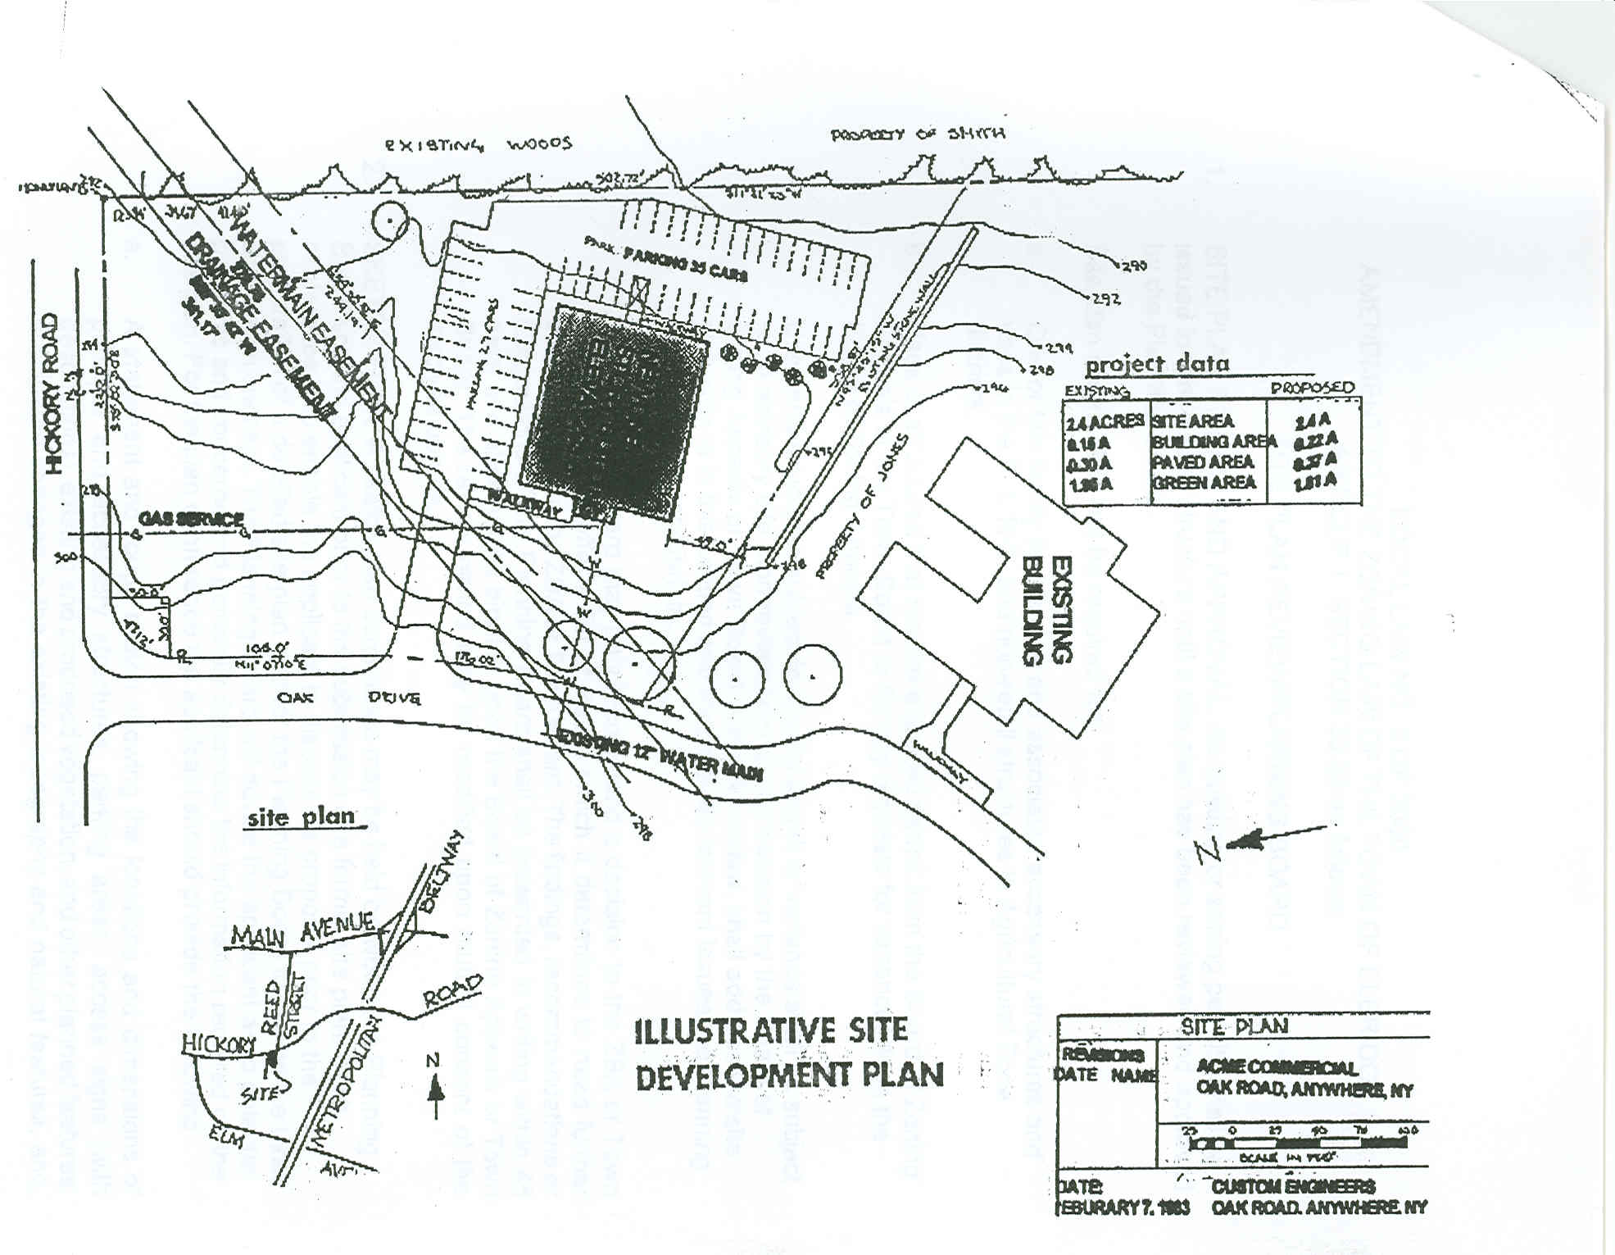

LOCAL LAW NO. 3 OF 2000
AMENDMENT TO THE ZONING LAW OF THE TOWN OF ELBRIDGE
ARTICLE 1, SECTION: 30.22 as follows:

SITE PLAN REVIEW/PLANNING BOARD

- SITE PLAN REVIEW AND APPROVAL. No building or zoning permits shall be issued for any use or structure until a site plan has been reviewed and approved by the Planning Board.
Site plan review shall-not be required for:

a. One or two family residences and associated accessory structures and uses in the R-1, R-2 and non-retail structure in Agricultural Zone districts.

- Uses or structures that require a special permit from the Board of Zoning Appeals
or the Town Board or for any requests for variances from the Board of Zoning Appeals.

Uses and structures subject to special permit or variance shall be subject to an advisory site plan review prior to and decision by the Board of Zoning Appeals or Town Board. Advisory review, shall address the site plan criteria in this section and may include relevant issues the Planning Board deems appropriate.

The Planning Board may only recommend a decision to the ZBA or Town Board or it may offer a list of issues which it determines to need further consideration by the ZBA or Town Board. The findings, recommendations or suggestions of the Planning Board shall be presented in writing within 45 days and shall not be binding upon the Board of Zoning Appeals or Town Board. The review period may be modified upon mutual consent of the involved boards.

- SKETCH PLAN. A sketch plan conference may be held between the Planning Board and the applicant prior to the submission of a formal site plan. Such conference is to enable the applicant to discuss his proposal prior to the preparation of a detailed site plan and for the Planning Board to review the basic site design concept. The Planning Board will advise the applicant as to potential problems and concerns and generally determine the information required on the site plan. For the plan conference the applicant should provide the following:

a. A statement and rough sketch showing the locations and dimensions of principal and accessory structures, parking areas, access signs (with descriptions), existing and proposed vegetation, and other planned features; anticipated changes in the existing topography and natural features, and where applicable, measures and features to comply with flood hazard and flood insurance regulations.

b. A sketch map of the area which clearly shows the location of the site with respect to nearby streets, rights-of-way, properties, easements and other pertinent features; and

- A topographic or contour map.

- APPLICATION FOR SITE PLAN APPROVAL. An application for site plan approval shall be made in writing to the chairman of the Planning board no less than ten (10) working days before any scheduled or special Planning Board meeting. The applicant shall submit a site plan and supporting data which have been Prepared by an architect, landscape architect, engineer or land surveyor and which shall include the following information presented drawn form from this checklist:

a. Title of drawing, including name and address or applicant and person responsible for preparation of such drawing;

- North arrow, scale and date;

- Boundaries of the property plotted to scale;

- Existing watercourses;

- Grading and drainage plan, showing existing and proposed contours;

- Location, design, type of construction proposed use and exterior dimensions of all buildings;

- Location, design and type of construction of all parking and truck loading areas, showing access and egress;

- Provisions for pedestrians

- Location of outdoor storage, if any;

- Location, design and construction materials of all existing or proposed site improvements including drains, culverts, retaining walls and fences;

- Description of the method of sewage disposal and location, design, and construction materials of such facilities:

- Description of the method of securing public water and location, design and construction materials of such facilities;

- Location of fire and other emergency zones, including the location of fire hydrants;

- Location, design and construction materials of all energy distribution facilities, including electrical, gas and solar energy;

- Location, site and design and type of construction of all proposed signs:

- Location and proposed development of all buffer areas, including existing vegetation cover;

- Location and design of outdoor lighting facilities;

- Identification of the location and amount of building area Proposed for retail sales or similar commercial activity;

- General landscaping plan and planting schedule;

- An estimated project construction schedule:

- Record of application for and approval status of all necessary permits from state and county officials;

- Identification of any state or county permits required for the Projects execution;

- Other elements integral to the proposed development as considered necessary by the Planning Board;

- SEQR submission:

- Names of property owners within 500’ of property;

- Current survey.

- REVIEW OF SITE PLAN. The Planning Board’s review of the site plan shall include, as appropriate but is not limited to, the following general considerations:

1. Location, arrangement, size, design and general site compatibility of building, lighting and signs;

2. a. Adequacy and arrangement of vehicular traffic access and circulation, including intersections, road widths, pavement surfaces.

b. Location, arrangement, appearance and sufficiency or off-street parking and loading.

c. Adequacy and arrangement of pedestrian traffic access and circulation, walkway structures, control of intersections with vehicular traffic and overall pedestrian convenience.

d. Adequacy of storm water and drainage facilities.

e. Adequacy of water supply and sewage disposal facilities.

f. Adequacy, type ad arrangement of trees, shrubs and other landscaping, constituting a visual and/or noise buffer between the applicant’s and adjoining lands, including the maximum retention of existing vegetation.

g. Adequacy of fire lanes and other emergency zones and the provision of fire hydrants.
h. Special attention to the adequacy and impact of structures, roadways and landscaping in areas with susceptibility to ponding, flooding and/or erosion.

- PLANNING BOARD ACTION ON SITE PLAN. Within forty-five (45) days of the receipt of an application for site plan approval, the Planning Board shall render a decision, file said decision with the Town Clerk, and mail such decision to the applicant with a copy to the Zoning Enforcement Officer. At the Board’s option, such decision may be reached at a public hearing called for the purpose. The time within which a decision must be rendered may be extended by mutual consent of the applicant and Planning Board.

a. Upon approval of the site plan and payment by the applicant of all fees and reimbursable costs due to the Town, the Planning Board shall endorse its approval on a copy of the final site plan and shall forward a copy to the applicant, Zoning Enforcement Officer, and file same with the Town Clerk. “As Built” plans must be filed with the Planning Board.

b. Upon disapproval of a site plan, the Planning Board shall so inform the Zoning Enforcement Officer and he shall deny a zoning permit to the applicant. The Planning Board shall also notify the applicant in writing of its decision and its reasons for disapproval. Such disapproval shall be filed with the Town Clerk.

- REIMBURSABLE COSTS. All reasonable costs incurred by the Planning Board for consultation fees or other extraordinary expenses in connection with the review of a proposed site plan shall be charged to the applicant.

GENERAL MUNICIPAL LAW

SECTION 809, Disclosure in certain applications.

- Every application, petition or request submitted for a variance, amendment, change of zoning, approval of plat, exemption of plat or official map, license or permit, pursuant to the provisions of any ordinance, local law, rule or regulation constituting the zoning and planning regulations of a municipality or a part, in the person, partnership or association making such application, petition or request (hereinafter called the applicant) to the extent known to such applicant,

- For the purpose of this section an officer or employee shall be deemed to have an interest in the applicant when he, his spouse, or their brothers, sisters, parents, children, grandchildren, or the spouse of any of them

  - is the applicant, or
  - is an officer, director, partner or employee of the applicant, or
  - legally or beneficially owns or controls stock of a corporate applicant or is a member of a partnership or association applicant, or
  - is a party to an agreement with such an applicant, express or implied, whereby he may receive any payment or other benefit, whether or not for service rendered, dependent or contingent upon the favorable approval of such application, petition or request.

- In the County of Nassau the provisions of subdivisions one and two of this section shall also apply to a party officer. “Party officer” shall mean any person holding any position or office, whether by election, appointment or otherwise, in any party as defined by subdivision four of section two of the election law.

- Ownership of less than five per cent of the Stock of a corporation whose stock is listed on the New York American Stock Exchanges shall not constitute an interest for the purposes of this section.

- A person who knowingly and intentionally violates this section shall be guilty of a misdemeanor.

NOTE: See page “5” of Part One

