

GFWC-Pleasant Prairie Woman’s Club

May 2019 Newsletter

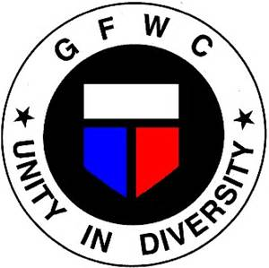



Thank you to our Conservation Committee (Cheri S., Connie C., Sue L., & Mary M.) for putting together a very informative program with our for the Village of Pleasant Prairie Administrator Nathan Thiel to speak about the exciting changes in the Village Green.

Equally exciting is our new partnership with the Pleasant Prairie Historical Society for the 2020 100th Anniversary of Woman’s Right to Vote Event. We will be organizing committees soon to begin the planning process.

The May meeting shall be exciting, not only do we get to honor the recipients of the Pearl Perry Ruffolo Scholarships but we also get to celebrate the charities that will be receiving donations. This is a meeting no one should miss since you get to see where all your hard work raising money is going.

Our spring dinner will be held on Thursday, June 13 at Casa Capri. Cocktails will be at 6:00 PM and dinner will start at 6:30 PM. The cost of the dinner is $20 per person. Michelle Rundle will be collecting payment for the dinner at the May meeting.

**May’s Birthday’s**

2nd - Charlene Nelson



Membership Dues for 2019-2020 in the amount of $25 is due at the May meeting, please submit payment to Michelle.

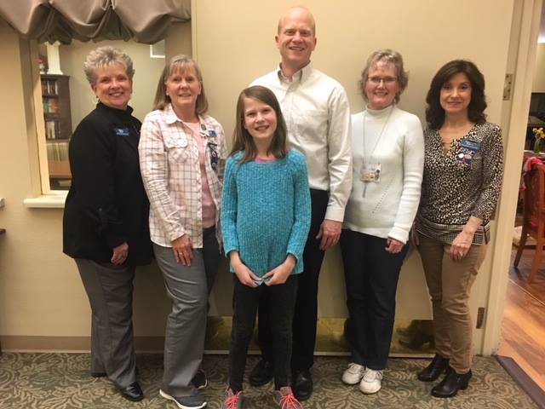

Thank you Highway Cleanup crew! Sue, Vickie, Cheri, Lucille, Michelle & Deb

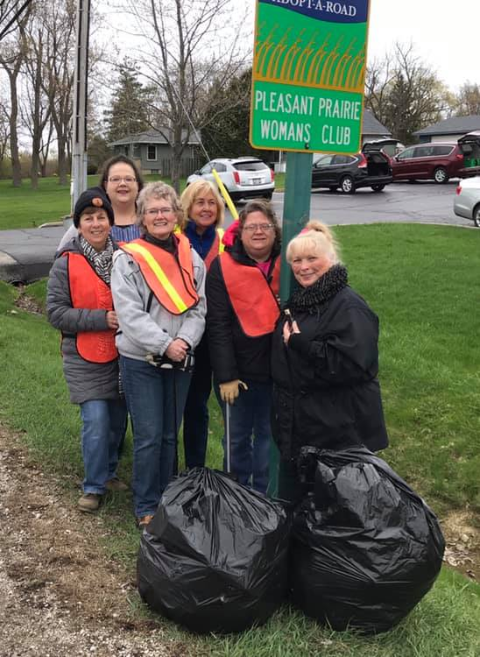



This year we will be participating in the Rolling Meadows Neighborhood Rummage Sale on May 31 & June 1. All members are asked for donations for the rummage sale that are already priced and ready for sale. It was decided that we will not be selling clothes. A sign-up sheet will be passed around at our May meeting to help during set-up, the rummage sale, and if you have a table we can borrow for the weekend.

If we have many items left over by the end of the Rummage sale, Cindy B. has offered the use of her driveway for the Allendale Neighborhood Rummage Sale.

We are looking for 2 – 3 ladies to help Kim Hemphill bring up to date the wall of honor at the Pleasant Prairie Post Office. Date and time will be determined by what works best with the group. Signup sheet will be available at the May Meeting or contact Kim directly.





One of the Charities we are donating to is Selah Freedom. Along with a donation, we are also asking all members to help stock their laundry room in May. They are in need of laundry detergent, fabric softener, laundry baskets, iron, ironing board etc. If you use it in your laundry room, they could use it too. Please bring donations to the May meeting to be presented to Selah Freedom.



As many of you have learned, Brookdale Pleasant Prairie has been sold. Our new contact, when confirming our monthly meetings, will be Ms. Lori Keltner. I was informed that this should not change anything for us but I thought it would be a good time to remind everyone of the guidelines they have requested from us since we began meeting there. Please remember we are guests in the resident’s home and they have use of the dining room until 6:15 PM. It is very important that members do not arrive before that time. Special consideration has been made for the Hostess Committee members to arrive earlier to set up. When calling to confirm meeting dates, please call at least 2 weeks prior to the meeting. If you have any special requests, please do so at that time

We will be having our first Restaurant fundraiser at Baker Street on Saturday May 25th Head out for breakfast, lunch or dinner and tell them you are there supporting Pleasant Prairie Woman’s club and a percentage of your bill will come back to us. Tell your friends and family and don’t forget to mention you are there for Pleasant Prairie Woman’s Club to receive credit.



Don’t forget to sign-up for a committee. The sign-up sheet will go around again in May. If you are unable to attend, please contact Vickie, if you do not sign up in May, a committee will be assigned to you.



**May 2-4 – GFWC-WI Convention @ Double Tree in Pleasant Prairie**

**May 9th – General Meeting**

**May 31 – June 1 – Rolling Hills Neighborhood Rummage Sale**

**June 13th – General Meeting Spring Dinner@ Casa Capri**

**TBD – Tree Planting Ceremony**

**Ongoing Fundraisers**



May 9th

Brookdale

6:15 PM arrival

6:30 PM Meeting

**Our Contact Information**  
GFWC-Pleasant Prairie Woman’s Club  
P.O. Box 580260  
Pleasant Prairie, WI 53158  
262-412-6481  
<https://ppwc64.org/>

<https://www.facebook.com/PPWC64/>

**Our Contact Information**  
GFWC-Pleasant Prairie Woman’s Club  
P.O. Box 580260  
Pleasant Prairie, WI 53158  
262-412-6481  
<https://ppwc64.org/>

<https://www.facebook.com/PPWC64/>