GFWC- Pleasant Prairie Woman’s Club
June, 2022 Newsletter

A big thank you to the Education and Special Philanthropic Committees for hosting the May meeting and doing such an outstanding job deciding who should receive the scholarships and philanthropic awards. Lucille P. was the chairwoman for the Education Committee and Vickie R. was the chairwoman for the Philanthropic Committee. The members of these committees were Michelle R., Nancy D., Mary B., Donna F., Sue S. and Terri H.
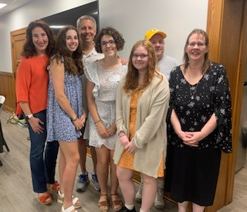
The two $1000 Pearl Ruffolo Memorial Educational Scholarship winners were Taylor W. and Elly H. After discussion, members also voted unanimously to offer a third $1000 scholarship to Cassandra S., whose score put her in third place and a family situation presented a financial need.

The June E. Nelson Philanthropic Awards were presented to a representative from each of the following organizations: Circle of Hope, Garden of Eatin’, Habitat for Humanity of Kenosha, Hospice Alliance, Marleighs Ministry, National Alliance on Mental Illness NAMI, Pleasant Prairie History Museum, Pleasant Prairie Police Department, St. Vincent DePaul, Shalom Center, SWAAC Southern WI All Airborne Chapter and United Methodist Women (UMW)- Period Poverty. Each member representing their organization spoke briefly about what their organization does.
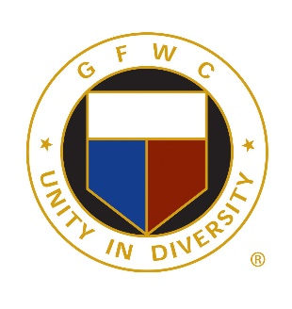
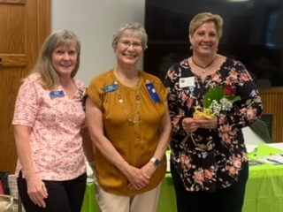
It is my pleasure to extend a warm welcome to our new member, Becky S. installed at our May meeting.

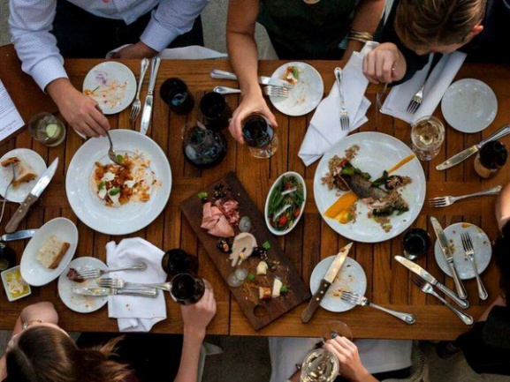
Our spring dinner will be held on Thursday, June 9th at Casa Capri. The cost for this dinner is $25 per person. Cocktails will be at 6:00pm. “Women in Motion” will be performing a dance routine at 6:30pm, dinner will be served at 7:00pm. New executive board members will also be installed at this meeting.

The buffet menu will consist of Sirloin Beef Tips, Chicken Parmigiano, Stuffed Shells with Cheese and Spinach, Mashed Potatoes, Mostaccioli, Mixed Vegetables, 3 Bean Salad, Potato Salad, Cole Slaw, Tossed Salad, Bread / Butter, Cottage Cheese, and Coffee / Iced Tea.
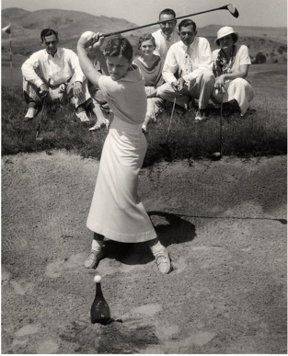
If you are able to help at the Pleasant Prairie Historical Society’s annual fundraiser “Tee Off to Summer” please use this link to sign up: https://www.signupgenius.com/go/10C0F49AFAC2FA0FCC61-historical

If we are still interested in having a rummage sale again this summer we are in need of a location. If you are willing to host this sale in your drive way please contact Fran.
Once we know if we are having this sale, a signup sheet will be emailed for volunteers willing to help setup, work during the sale and take down.
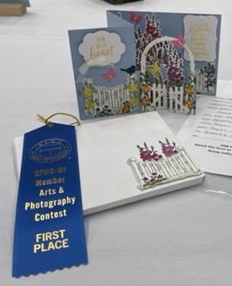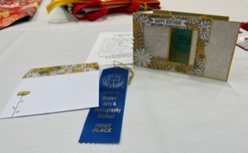
Congratulations to Carol S. for winning 2 blue ribbons at the GFWC Wisconsin Members Arts & Crafts Contest!

Have you signed up for a monthly committee yet? If you haven’t signed up please talk to Sue L. at the June dinner. If you do not sign up for a committee by the June meeting nor contact Sue L., a committee will be assigned to you.

June 25-28 GFWC International Convention in New Orleans
August 11 PPWC Annual Picnic location TBD
Sept. 16-18 GFWC-WI Fall Workshop in Stevens Point
Sept. 29-Oct. 2 Great Lakes Region Convention “Diamonds in Dairyland” in Brookfield, WI at the Brookfield
Conference Center

Contact Information:
GFWC-Pleasant Prairie Woman’s Club
P.O. Box 580260
Pleasant Prairie, WI 53158
Website: www.PPWC64.org
https://ppwc64.org/ https://www.facebook.com/PPWC64/

2022 June E. Nelson Philanthropic Award Recipients

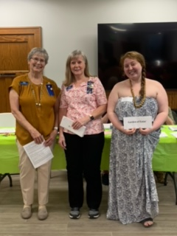
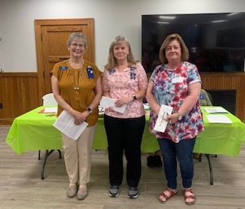
Circle of Hope

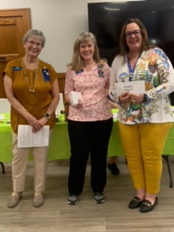
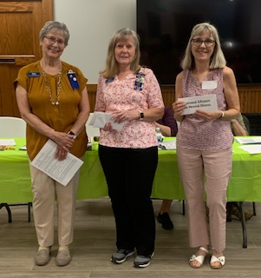
National Alliance on Mental Illness
Hospice Alliance
Garden of Eatin’

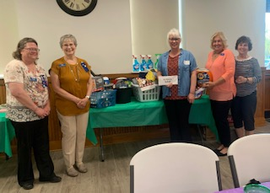
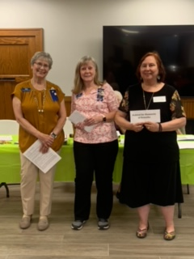
Habitat for Humanity
St. Vincent DePaul

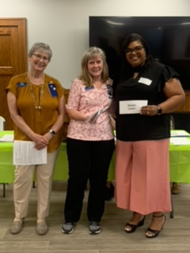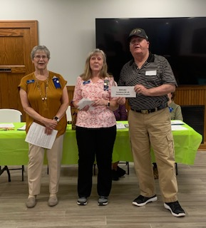
S.W.A.A.C. – Southern Wisconsin All American Airborne Chapter

Shalom Center

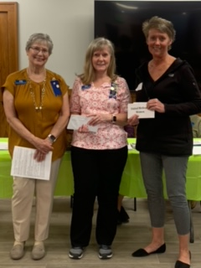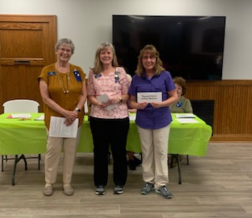
Pleasant Prairie History Museum
First United Methodist Church
Period Poverty/Love in Action

