KCFL 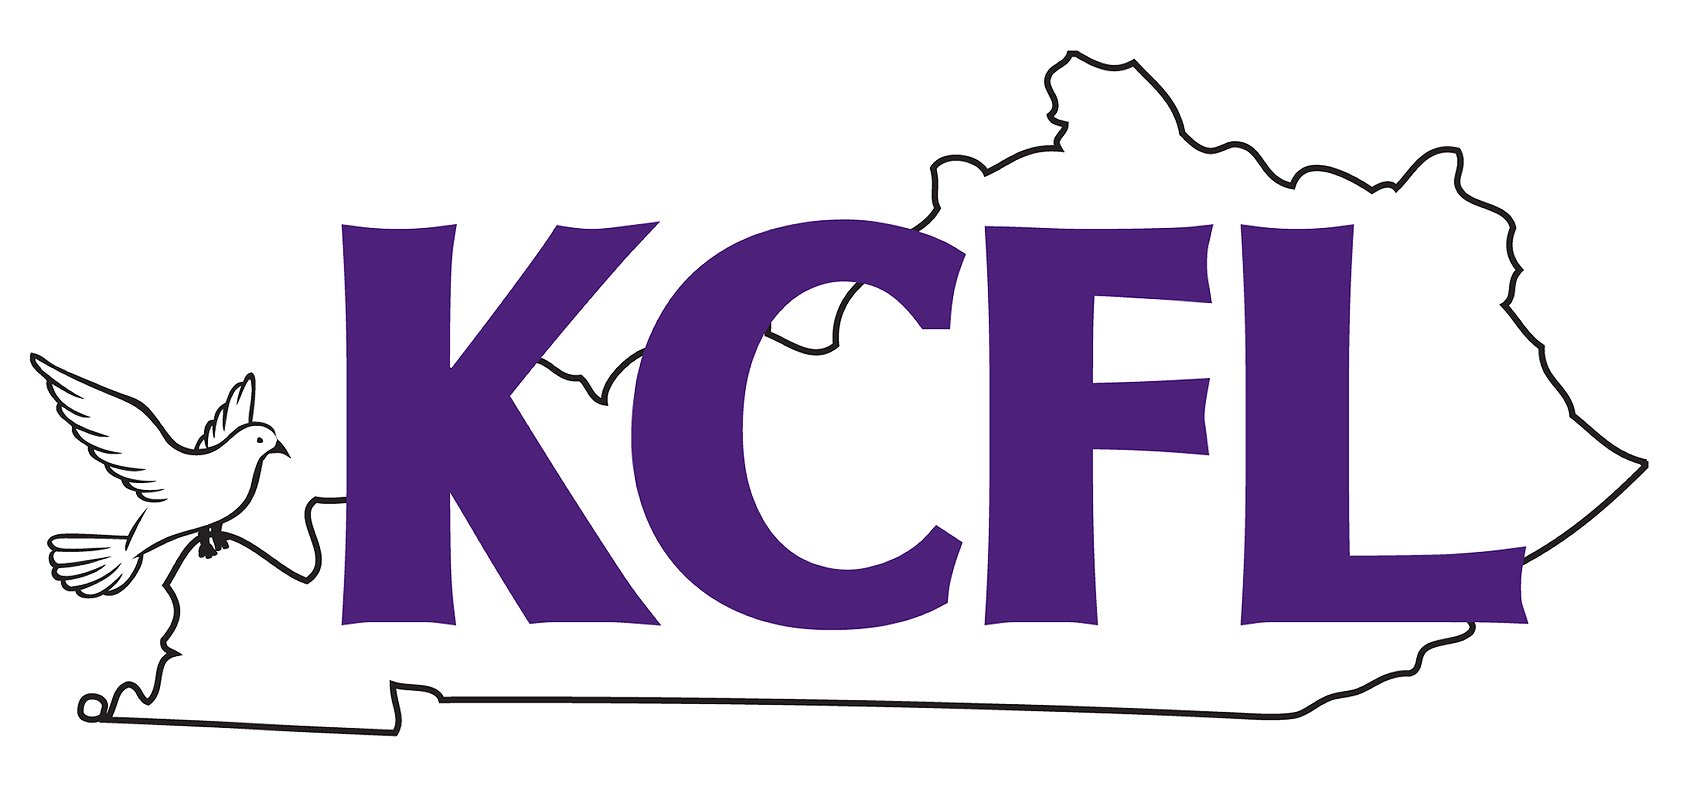
925 S. Lincoln Blvd.
Hodgenville KY 42748

Dear Coaches:

The state qualifying meet for the Grand National CFL Tournament will be held on held on March 3 at LaRue County High School in Hodgenville. This year we will qualify six individuals in each event to send to the Grand National tournament in Chicago, IL over the Memorial Day Weekend, May 23-24, 2020.

For the qualifying tournament, you must provide one (1) judge for every six speech students you enter; for Lincoln/Douglas you must provide one (1) judge for every two debaters you enter; for Public Forum and Policy Debate you must provide one (1) judge for every two teams you enter. Remember that for NCFL Grand Nationals we must supply one (1) judge for every two entries in speech events and one (1) judge for each STUDENT in Lincoln/Douglas, 1.5 judges for each TEAM in Policy Debate, and 1 judge for each Public Forum TEAM. These quotas MUST BE HONORED, so if you can’t provide the judges for nationals, do not bring debaters to the qualifier! You must be prepared to give me your judges’ names on March 3 at the qualifier.

The entry deadline for the KCFL tournament is Tuesday, March 3, 2020. Registration will be done via the web at www.tabroom.com and is currently open. The debate tournament directors will be Eric Cecil of LaRue County and Woody Zorn of Hebron Middle School. If you have any questions about debate, you can contact either of them at big_ump@yahoo.com or woody.zorn@bullitt.kyschools.us. If you have any questions about the speech tournament, please feel free to call me at 270-358-2210 (school), 270-766-7994 (cell), or email me at katy.cecil@larue.kyschools.us.

The entry fee for each student is $20.00. Duo-interpretation, Public Forum Debate, and Policy Debate count as two entries. Doubling is allowed, HOWEVER, a student may not double in two debate events – in other words, a student cannot do congress AND LD, or PFD AND LD. I hope that is clear. Also understand that doubling out of debate rounds tends to make the tournament run longer, but I am willing to make that sacrifice so that students can maximize their chances at earning a spot to nationals

Remember, there is no doubling allowed at the national tournament, so a student can only QUALIFY one event; however, students may enter two events at the state qualifier and take the event he/she prefers to nationals (with the caveat that that preference will be indicated in writing before the tournament begins). You will be permitted to drop students at no charge until 4:00 p.m. on March 5, 2020. I prefer drops to be made via your online entry, but I would also ask that you send me an email to let me know you have made changes to your entry. After March 5, you will have to drop by emailing me, and I will assess a $20.00 drop fee. A judge drop is not acceptable; however, if you drop a judge the morning of the tournament, it will cost you $50.00. This fee WILL be assessed. Please do not drop judges.

Congress: Bills are due no later than March 2, 2020. This is absolutely non-negotiable. I will post all of the bills I have received by the morning of March 3, 2020 on the tabroom.com website. No bills will be accepted once the deadline has passed.

Entries to the Grand National Tournament will be $80.00 per individual student. You may pay me at the conclusion of the tournament, or I can invoice you. Either way is acceptable.

IF a student who qualifies chooses not to attend the national tournament for whatever reason, he/she will not be refunded the entry fee. The final deadline for notifying me that a student will not be attending the NCFL Grand National Tournament is May 10, 2020. There is no excuse for waiting. If you have to drop a student after the final deadline, you will be assessed a $50.00 drop fee in addition to forfeiting the original entry fee. If you drop a judge at the NCFL tournament, and you had better not, there will be a $500.00 drop fee. Students who qualify should go! If students can’t go to NCFL because of graduation or other conflicts, please don’t enter them in the state tournament.

Please visit the NCFL site (www.ncfl.org) as ballots for many of the events have been revised. There are many notable changes, and it is your responsibility to know the rules for your events.

Please remember that you must be ready to provide me with a judge for every two speech students you qualify and one judge for every Lincoln/Douglas debater and/or PFD team, and 1.5 JUDGES for every Policy Debate TEAM you qualify.

I look forward to seeing you in March, and I strongly urge the new coaches in the league to review the bylaws, rules, and ballots for NCFL at the web site – www.ncfl.org. All coaches should make use of the site to get pertinent hotel information.

Sincerely,

Katy Blair Cecil
KCFL Moderator

