Property Condition Report

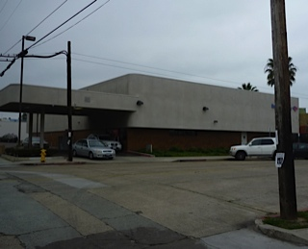

Inspection Address: 900 Opal Ave.
San Diego, CA 92109

Inspection Date: 2/05/2013

Prepared for: Mr. *********

Report Number: C-020512

Prepared by: Corey Folsom & Associates
578 Washington Blvd., #403
Marina del Rey, CA 90292
310.922.5851 or 408.205.5915

Table of Contents

1.0 Introduction……......……………………….………..2

2.0 Executive Summary...…………………….…………4

3.0 Structure / Exterior……….. …………...….………...5

4.0 Electrical…….…………… …………...….…….…..6

5.0 Heating/Ventilation/Air Conditioning (HVAC).…....8

6.0 Plumbing…..…………………………….………….9

7.0 Roofing….…………………………………….…....11

8.0 Interior…...……………………………………...….13

9.0 Grounds…...……………………………………......15

10.0 Primary Recommendations………………………...16

11.0 Closing Comments……...…………………….…....16

APPENDIX A – Statement of Qualifications

APPENDIX B – Photographs
Property Condition Report

900 Opal Ave, San Diego, CA 92109

INTRODUCTION
1.0 General Comments
As per the request of Mr. ******** (property owner) and in accordance with our Proposal dated 1/29/13, Corey Folsom & Associates conducted a site inspection at 900 Opal Ave. San Diego, CA 92109 on 2/05/13. We performed a visual inspection to identify the existing conditions of the following building components:

- Structure
- Electrical system (under 600 volts)
- Plumbing system
- Roof surface (weather and access permitting)
- Interior components (non-cosmetic)
- Exterior wall components including doors and windows
- Grounds including walkways and parking (excluding retaining walls, fences and landscaping)

This assessment meets the ASTM standard E2018-08 for Property Condition Assessments except where noted and is valid for the date of the inspection. This report provides recommendations and priorities for:

- Remedying major deficiencies
- Updating aging major components
- Undertaking further detailed investigations

The PCA scope did not include evaluation of specialty electrical systems (e.g. low-voltage telecommunication and security systems). In addition, no assessment was made of use-specific equipment such as conveyance systems, production equipment or security systems. Use-specific concerns that depend on the number of employees, type or use, or local codes were not included. The recommendations are for remedial actions considered to be beyond the normal maintenance of the building.

This report is intended for the exclusive use of the client. Use of the information contained within the report by any other party is not intended, and, therefore, we accept no responsibility for such use.

This report is considered preliminary in nature. Before any major repairs are undertaken, we recommend that a specialist perform a detailed survey and develop a plan of action and quotation for your approval. We recommend that you obtain three written proposals from appropriately licensed and qualified contractors for specific cost data. When provided, our estimates of life expectancy are based on the assumption that relevant systems are adequately maintained.

We did not perform any computations or engineering analysis as part of this evaluation, nor did we conduct a code compliance review. The examination of fire separation walls with other occupancies is outside the scope of this inspection. No warranty of condition is implied. The photographs are an integral part of this report and must be included in any review or document-sharing.

This report is a general overview of the structural components and major systems. It is not intended to be technically exhaustive in any one field. If further information is desired, specialists in the relevant fields should be retained to perform additional evaluations.

A determination as to the presence of animal pests, rodents, termites, decay, or other wood destroying organisms is beyond the scope of this inspection. A qualified pest control firm should be contacted with any questions concerning the presence or treatment of these organisms. Periodic examinations should be made by a licensed pest control firm as part of routine property maintenance.

We may make recommendations or suggestions in this report that differ from requirements by the local building department. For determinations as to what is permitted in this jurisdiction, the local building department should be consulted.

This report includes only those areas that are visually accessible and not areas that are made inaccessible by walls, concrete, earth, or any other obstacle to physical access or visual inspection, such as furniture or stored items. Defects in mechanical equipment not disclosed by our functional operation or visual inspection are not included. Items or conditions not mentioned in this report are not within the scope of this inspection. An examination of every window, door, light switch, outlet, water valve, etc., was not made. Rather, a statistical sampling was made.
This report does not include information as to the presence, condition, or safety of equipment, systems, or components specifically related to manufacturing or business operations.

Life safety components and fire protection systems or equipment are excluded from this report unless as otherwise noted. We suggest you make certain that fire protection systems are regularly inspected and that periodic inspection records are available. For a complete review of life-safety conditions we recommend a fire marshal be consulted.

For your reference, the following definitions may be helpful:
Excellent: Component or system is in “as new” condition, requiring no rehabilitation and should perform in accordance with expected performance.

Good: Component or system is sound and performing its function, although it may show signs of normal wear and tear. Some minor rehabilitation work may be required.

Fair: Component or system falls into one or more of the following categories; a) Evidence of previous repairs not in compliance with commonly accepted practice, b) Workmanship not in compliance with commonly accepted standards, c) Component or system is obsolete, d) Approaching end of expected service life. Repair to prolong service life or replacement is required.

Poor: Component or system has either failed or cannot be relied upon to continue performing its original function as a result of having exceeded its expected service life, excessive deferred maintenance or state of disrepair. Present condition could contribute to or cause the deterioration of other adjoining elements or systems. Repair or replacement is required.

Adequate or serviceable: Component or system is of a capacity that is defined as enough for what is required, sufficient, suitable, and/or conforms to standard construction practices.

All ratings are determined by comparison to other buildings of similar age and construction type.

All directions (left, right, front, rear, etc.) referred to are from the viewpoint of an observer standing in front of the building (on Opal) and facing the main (now unused) entry.

1.1 Plans
We did not examine structural plans. A detailed examination of building plans or other documents is beyond the scope of this inspection. Often a discussion with a building representative is informative.

1.2 Interview
We were unable to interview the building maintenance representative, John Doe. We do not know which services the company he works for is responsible for.

We did not ascertain if there are any outstanding building code or fire code notices of violation from the city or fire marshal or if there is any pending or ongoing litigation related to the building’s physical condition.

We did not learn of any Barrier Removal Plan for this property.

2.0 EXECUTIVE SUMMARY
This report provides observations and recommendations based on a property condition assessment performed at 900 Opal Ave. San Diego, CA 92109 on 2/5/13. The current primary use of this property is as a bank and associated parking. This property is currently occupied. A determination as to whether this building, or its anticipated use, complies with local occupancy requirements is beyond the scope of this inspection.

Here and at the end of this report (Section 11), we list recommendations we believe to be the most important. These recommendations should not be considered the only significant items. You should establish your own priorities after thoroughly studying this report, reviewing all the recommendations in the report, and consulting experts or specialists as desired. In addition, we ask you to call us if there is anything in the report that you do not understand or need further information on.

- One portion of the exposed slab edge (facing Opal) has horizontal cracking. My recommendation is to have a qualified engineer perform an inspection and then follow their recommended course of action, if any.

- The electrical meter and main shutoff are located at the (locked & un-accessed) electrical room.

- The rooftop HVAC units are in excellent condition.

- The visible supply plumbing system appears to be in good condition. The waste plumbing system appears to be essentially functional, but simply due to the age of the system, a sewer lateral test is suggested. The water heater is in need of seismic strapping. Replacement may be anticipated for the water heater. Only one toilet is a low-flow type.

- The roof covering is in good condition with some maintenance suggested.

- The rear lot asphalt paving is in mostly poor condition. The main lot asphalt paving is in mostly good condition except for poor condition at the drive-through ATM area. (Paving company estimate delivered separately.)

- Ten exterior windows and the front (unused) entry doors are scratched with graffiti and there is possible moisture intrusion along the front wall.

- ADA improvements may be considered – see section 10.

- A Phase I Environmental Site Assessment was not requested as part of our service.

3.0 STRUCTURE/EXTERIOR

3.1 Description

3.1.1 This is a two-story building wood-framed building (approximately 12,900 square feet) with a wood-framed roof diaphragm and textured exterior finish that is occupied by a bank at this time. The foundation is a concrete slab. The slab was covered by finished surfaces. The floor covering presents a limitation to full inspection. No determination was made by us as to the seismic resistance of this building.

    - The building has clad and metal frame windows with fixed glazing. Glazing is critical to the ability to maintain a weather-tight building envelope. Inspection of the window seals should take place annually.

    - There is an entry door at the right side (in use) as well as an unused entry at the front and one metal side entry doors on the left in addition to the electrical room door.

3.2 Observations and Recommendations

    - Horizontal slab cracking was seen in along the east end of the front wall (between the unused lobby door and the right front corner) as seen under the exterior cladding. We cannot adequately judge the relevance of this cracking and suggest a careful examination of the by a qualified engineer in addition to trimming the vegetation away from the exterior walls to check for additional cracking. (We also saw cracking in the cement barge coat along other portions of the front wall, which we are not concerned about.)

    - We saw floor slab cracking in two places in the teller area – see photo. They are both less than 2’ long and both display some displacement. We cannot effectively judge their significance and so would defer to the comments of a qualified engineer.

    - The tile joints are deteriorated on at least three corners (vertical edge) as well as damage seen at the columns supporting the roof over the drive-up ATM. We advise repair.

    - We found the left exterior side door to be in poor condition due to metal corrosion. Replacement will be needed at some point.

    - We noted graffiti scratched into at least ten windows (on the front and right side) as well as the same to the front (unused) lobby doors.

    - We observed some exterior surface stucco cracking. We suggest sealing of stucco cracking as part of normal maintenance.

General Foundation Comments:
The adequacy and condition of area soils, footings, foundations, and structural framing can only be determined after a detailed analysis by a soils, geotechnical, or structural engineer. This type of analysis and these determinations are beyond the scope of this inspection.

4.0 ELECTRICAL

4.1 Description

4.1.1 The electrical service supplied to the building is underground. There is a large electrical transformer at the rear parking lot. The vault interior was not accessed, often the equipment in these vaults are the responsibility of the electric utility provider.

4.1.2 This building is supplied with a 400-ampere, three phase, four-wire service with use currents of 480/208v and 240/120v. The capacity was determined by the rating of the main disconnect and enclosure labeling. The short-circuit rating is labeled as 50,000 amperes. Due to the increased hazard with a three-phase system no electrical panels were opened during this inspection.

4.1.3 The distribution panels employ circuit breakers and are located in a locked electrical room as well as in the records storage area. Wiring examined is copper. Consider having a licensed electrician review the integrity of the wiring and determine your electrical demand needs and potential upgrade costs.

4.1.4 The electrical meter is believed to be in the main electrical utility room. This area was not accessed at the time of the inspection. We advise a careful review once access is obtained.

4.2 Observations and Recommendations

    - While detailed load calculations were not performed, this service is believed to be adequate for current usage. Consider all electrical conditions as life and safety issues and correct all electrical conditions as a priority by utilizing the services of a qualified electrician to fully evaluate / review all electrical components and connections and to determine your electrical needs and any upgrade costs.

    - The utility transformer vault has vehicular barriers installed on three sides only, even though there is vehicle movement on the side without a barrier. We suggest installing an additional vehicular barrier at the utility transformer vault – see photo.

    - Individual circuits are without the benefit of permanent labeling at the panel in the records storage area (panel C). We suggest improvement to circuit labeling for increased safety.

    - Panel B had open knockouts at the deadfront cover. Fill all openings with inserts designed for this purpose.

    - GFCI outlets were not observed in appropriate areas. An open electrical junction box was seen in my viewing of sample areas above the ceiling tiles. We advise a comprehensive review of the ceiling plenum area (above the ceiling tiles) and correction of all electrical deficiencies. We suggest installing / verifying GFCI outlets in all bathroom and “wet” locations.

    - Conduit at the (left) exterior is exposed (due to overwatering?) and we suggest careful backfilling here.

    - Lighting lacks diffusers / covers. Bare bulbs could be contacted and broken by an inattentive person causing serious injury. We advise installing covers at all lighting fixtures.

GFCI Notes:
Ground fault circuit interrupters are breakers or receptacle outlets designed to protect against electrical shocks. In recent years, most jurisdictions have required ground fault protection for outlets at building exteriors and in restrooms, basement, and garages (except those serving a designated appliance). Recent regulations require GFCI protection at all break room, kitchen countertop, and wet bar receptacles. A single GFCI receptacle may protect other outlets downstream on the same circuit. GFCI devices have test buttons that should be operated periodically to ensure the devices are functioning properly.

5.0 HEATING/VENTILATION/AIR CONDITIONING (HVAC)

5.1 Description

    - There are six rooftop package natural gas HVAC units (all manufactured by “Carrier”, 208/230v, 1-phase. SEER-14 is the type of refrigerant class used.
Unit 1 - S/N 3510G40409
Unit 2 - S/N 3610G10014
Unit 3 - S/N 3510G40411
Unit 4 – S/N 3510G40410
Unit 5 – S/N 3510G40412
Unit 6 - S/N 3510G40370
These types of appliances have an expected useful life of 20 years, but actual performance varies greatly.

    - There are four rooftop HVAC condensers (manufactured by “Carrier” – model # and S/N’s not determined). We believe they serve the ATM closets. These type of appliances have an expected service life of 20 years, but actual performance varies greatly.

    - HVAC maintenance records are posted on the wall at the bottom of the rooftop access ladder.

5.2 Observations and Recommendations

    - All rooftop HVAC units appear to be in excellent condition and responded to normal controls.

    - Employees stated that they’re generally pleased with the interior heating and cooling performance, except that the main lobby is hard to get to just the right comfort setting.

    - The ceiling combustion air register is dirty near the water heater. We suggest cleaning of this air screen at least annually.

    - Despite the recent installation of the rooftop HVAC units, visible corrosion is evident at the cabinets and fins. We believe this is due to the coastal air and that closer to 10 years is a more reasonable life expectancy for HVAC appliances in this environment.

General HVAC notes:
The inspection of the HVAC system includes a visual examination of the exposed and accessible equipment, controls, filters and distribution. We examine these items for function, excessive or unusual wear and general state of repair. Heat exchangers are inaccessible by design and require a costly and specialized inspection. Our inspection does not include disassembly of the system/s, nor does it encompass “set-back” or programmable thermostatic features. To obtain maximum efficiency and reliability from your HVAC system, we recommend annual servicing and inspection by a qualified technician.
6.0 PLUMBING

6.1 Description

6.1.1 The visible supply piping consists of copper pipe. The visible waste piping consists of cast iron pipe. The water quality and water pressure was not tested. Only one toilet is low-flow type.

6.1.2 There is a 30-gallon gas-fired water heater (manufactured in 1998) located in the utility room. These units typically last 15 years although early failure is not uncommon.

6.1.3 There are two non-public office restrooms (Men’s and Women’s) on each story.

6.1.4 We located a natural gas meter and main shutoff at the exterior (left).

6.1.5 The main water entrance consists of a 2” diameter copper pipe with valve shutoff located at the rear parking lot next to the electrical transformer. The shutoff valve was not tested. We did not note a backflow preventer. We did not test the main water shutoff due to the risk of creating a leak, but we advise making certain that the water can be easily shutoff in the event of an emergency.

6.2 Observations and Recommendations

    - The waste plumbing system appears to be essentially functional, but simply due to the age of the system, a sewer lateral test is suggested.

    - We believe the copper portions of the plumbing system to be in good condition and functioning as designed. Installation of modern valve stops at the downstairs toilet rooms is a small and prudent investment. Corrosion was seen at the valves in the downstairs toilet rooms.

    - The water piping is leaking at the rear alley – see photo. We recommend correction as needed by a qualified plumber, utilizing all new materials and installed in strict conformance with the latest industry standards.

    - The water heater does not have sufficient seismic strapping. Provide appropriate seismic strapping immediately. This water heater is at/approaching the end of it’s service life and replacement may be anticipated. Consider installing an overflow pan with a drain to the exterior under the water heater to protect finished surfaces and prevent mold and other damage in the event of a leak.

    - The water heater exhaust vent flue is not well secured. (Single-wall metal flue sections should be connected with at least 3 sheet metal screws at each joint.) We recommend prompt repair by a qualified tradesperson for increased safety.

    - The breakroom sink has a (non-approved) ribbed drain. These drains are more subject to clogging. A qualified plumber should make correction as needed using all new materials and standards.

    - The breakroom sink disposal responded to normal controls (although we obviously did not test it by putting food into the drain).

    - The toilets flushed and filled properly although large air bubbles occurred during flushing at several toilets. This often indicates partial clogging of the waste pipe or plumbing vents. We suggest further inquiry by a qualified plumber.

    - The fan in the upstairs women’s toilet room did not respond to the wall switch. The right sink drains slowly here as well.

    - The natural gas meter and adjacent piping has corrosion / rust and we suggest asking the utility provider to examine it.

General Plumbing Comments:
Angle stops are shutoff valves normally found beneath sinks and toilets in modern construction. They provide a convenient disconnect in case of leakage and facilitate repairs. These shutoff valves are rarely used, and may “freeze” in place or leak when operated. Angle stops should be operated periodically to keep the valves functional. We do not normally turn these valves during an inspection as this may cause them to leak. Installation of modern valve stops is a small and prudent investment.

Waste piping should be cleaned out periodically to remove any accumulation of grease, hair, or dirt, and to help prevent future debris blockage and subsequent drainage failure. We do not inspect buried, or otherwise inaccessible, supply or waste piping.

The gas and water piping was not fully accessible and an examination of each connection was not made. The standard test for gas leakage is to have the piping pressure-tested.

We recommend storing a large wrench near the main gas valve to shut the gas off quickly in an emergency. To shut off the gas, turn the valve 90 degrees so the handle is at a right angle to the pipe.

7.0 ROOFING

7.1 Description

    - The building has a built-up roof covering protected with a cap sheet. This type of roof covering system has a life expectancy of 20+ years.

    - The building has an internal rainwater collection system with secondary (overflow) drains. Downspouts discharge into an underground drainage system to minimize water accumulation near the foundation. We did not test these systems. It would be prudent to test the drainage performance prior to the first heavy rain.

    - There is a parapet wall structure to shield the rooftop equipment from view.

    - The roof access is an interior ladder and an openable hatch.

7.2 Observations and Recommendations

    - The main field of the roof covering is in good condition, but there is less than ideal roof slope in a few areas and drains higher than the immediate roof surface that has created water ponding. Since water is heavy, water ponding can lead to settling of the roof surface, which leads to greater water ponding and further settling / leaking. In our opinion, the roof needs improvement to better facilitate water shedding in the low spots / water ponding areas (and any repairs should be of the best quality).

    - The middle parapet wall top edge and the perimeter parapet sides that face south and west are due for re-coating in the next couple years.

    - Debris has built up on the roof. Debris should be periodically removed to ensure proper functioning of the roof. There is scattered material (possibly left over from HVAC installation) that should also be removed.

    - HVAC condenser units (2) are mounted on supports that are not flashed or otherwise attached to the roof. Ideally, all rooftop equipment should be installed on raised, flashed platforms or curbs. We recommend that a qualified roof specialist review the HVAC installation with regard to improving the appliance supports / roof flashings.

    - Flashing detail is in need of improvement to better direct water into the rain gutters.

    - Downspouts should be extended and/or grading improvements made to minimize water accumulation near the foundation. Keep the rain gutters clear of debris on a regular schedule.

General Roofing Comments

Roof surfaces, rain gutters, downspouts, and subsurface drain lines should be checked regularly. Leaves and other debris should be removed as needed. Gutter joints and connections may need periodic caulking or sealing. Screens can be installed at downspout gutter connections to keep debris from blocking the downspouts. We recommend periodic inspections be performed to be sure the roof drainage systems function properly. Observing roof and foundation areas during or shortly after heavy rains is a good way to find deficiencies in the roof and area drainage systems.

This inspection addresses only the apparent visual condition of roofing materials, and does not include invasive testing or guarantee against present or future leakage. All roof systems require periodic maintenance. Failure to perform routine maintenance will usually result in leaks and accelerated deterioration of the roof covering and flashings. Annual examinations should be made by a qualified roofer for periodic maintenance and repair.

8.0 INTERIOR

8.1 Description

8.1.1 The office wall finishes are drywall and wall upholstery. The office floors are carpeting and tile and vinyl/linoleum. The office ceilings are suspended acoustical tile and drywall. The ceiling is insulated with R-19 insulation batting. Interior walls are wood partitions, covered with finished drywall. Wall /ceiling cracks / stains are not uncommon, but I did not determine their exact nature. All cracks / stains should be monitored on any building.

    - There are two stairways that provide access to and from the second story. The cargo lift was not operated and no data plate was seen, so no comments can be offered.

    - Posted emergency evacuation plans were not seen. We advise posting of accurate emergency evacuation plans.

    - We did not note the presence of an automatic fire suppression sprinkler system.

8.2 Observations and Recommendations

    - There is mold of an unidentified type seen (see photo) at the front wall. We believe this is due to a cabinet being too close to the wall to provide adequate air circulation. There is evidence of water intrusion at the windows along this front wall and that may be contributing as well. We always advise professional treatment of mold and we advise destructive testing and/or a thermographic scan to determine if moisture is present behind finished surfaces.

    - The tile portions of the flooring have wear in front of each teller window and a tile is cracked in front of the lobby entrance to the teller area. There is a line of unrepaired small holes in the flooring just in front of where the tellers stand. We suggest simple repair of the holes to protect both the surface and occupants. The flooring in the downstairs men’s toilet room needs seam repair. The vinyl flooring at the entrance of the upstairs storage room is damaged and an approximately 3’ x 3’ section is in need of replacement.

    - Prior to 1980 popcorn-style ceiling finishes and other building materials often contained asbestos. While we sometimes point out possible asbestos-containing material, we do not inspect or test for it. Only laboratory testing can determine its presence. This is a stable and durable material as a ceiling coating and tends to remain intact. It is only hazardous when fibers are released into the air. The main consideration is to keep it sealed with paint. Additional costs are incurred with eventual asbestos disposal.

    - Handrail is loosely mounted at the right stairwell. Also, the handrails are rather low (42” is the standard height). The right stairwell tread covering is deteriorated and tape is being used as temporary repair. We suggest replacement of this stair tread covering for increased safety.

    - Posted emergency evacuation plans were not present. We consider this a life-safety defect and we suggest that you ensure this is accomplished in the near future.

    - We suggest adding green lighted exit signs of the proper height placement at the egress doors open to the public. (Currently, not all signs are lighted and/or green and placement requirements have changed in the past few years.)

    - The downstairs fire extinguisher inspection tags are out of date. We do not determine the correct number or placement of fire extinguishers in a given occupancy or use.

    - The ceiling light fixture at the end of the hall above the left stairwell is inadequately supported and its weight is causing the ceiling tiles to sag. We recommend correction.

    - The breakroom range and oven did not respond to normal controls.

    - The carpet in one of the (left side) offices is very loose and is a tripping hazard. Stored items prevented a full inspection. We advise careful examination by interested parties of all interior areas when the stored items are removed.

    - We observed staining at the ceiling in the walk-up ATM utility room. This may be due to leaking from a previous roof covering as this area of the roof allows water to pool somewhat – refer to roof section for further comments. All ceiling and wall stains should be monitored.

Tenant and Process-related Equipment:
An examination of the process equipment related to business operations is beyond the scope of this inspection. Any comments regarding such are included as a courtesy only and do not represent a definitive inspection of those items. Also, we do not comment on security alarms.

- GROUNDS

9.1 Description

9.1.1 The parking areas are asphalt with concrete curbs. We counted 15 parking spaces (including 2 that are ADA-compliant) at the primary lot adjacent to the building. We counted 55 parking spaces at the rear lot (at the corner of Ferris and Baldwin).

9.1.2 A storm drain was seen at the rear of the building, but we can offer no opinion as to performance of this system. It would be prudent to test and monitor the performance of the drains.

9.1.3 We did not observe or learn of any problems with the underground utilities. The building site is relatively level

9.1.4 A professional paving company assessment is included as a separate addendum.

9.2 Observations and Recommendations

    - The rear lot asphalt paving is in mostly poor condition. The main lot asphalt paving is in mostly good condition except for poor condition at the drive-through ATM area. There is a paving repair estimate delivered as a separate email attachment with specific repair recommendations. The paving company recommendations are conservative and should be considered more or less the minimum work / expense needed to extend the useful life of the paving surfaces.

    - We observed some exterior cracking on the (unused) front lobby entry landing and a divet in the sidewalk in front of this area. The palm trees along the front sidewalk are causing portions of the sidewalk to shift, creating a tripping hazard. We suggest all exterior surface cracks be inspected annually and re-sealed as necessary to prevent water intrusion and tripping hazards. We do not attempt to determine if the sidewalk is the responsibility of the building owner or the city.

    - We are making a note of a small (approx. 2’ x 5’) area of the concrete walkway that has been replaced and the newer section is cracking and sloughing – see photo. Is there an underground issue here? We suggest inquiry with the owner and/or city.

    - We saw evidence of excess landscape irrigation watering (bare soil and water stains on the bottom of the exterior wall cladding). We suspect that you could reduce the water schedule and save water and money. Consider xeriscaping where practical.

10.0 PRIMARY RECOMMENDATIONS
Contractors should be contacted for price quotations and costs can vary substantially according to the contractor selected, the quality of work specified, market forces, the presence of undiscovered conditions, and other factors.

10.1 Opinion Summary of Immediate Repairs
The following table summarizes the report recommendations that should be addressed within the next year.

Recommendations | Reference | Cost
Electrical safety improvements | 4.2 | <$500
Mold remediation / moisture testing | 8.2 | $1,500
water heater strapping | 6.2 | <$200
barrier at utility transformer | 9.2 | <$500
Replace right stair tread covering | 8.2 | $2,000 to $3,000

10.2 Opinion Summary of Short-Term Repairs
The following table summarizes the report recommendations that should be addressed within the next two years. Normal maintenance is not included.

Recommendations | Reference | Cost
Asphalt paving improvements | 9.2 | $12,600
Sewer lateral test & work as needed | 6.2 | $1,000+
Roof improvements | 7.2 | <$3,000

10.3 Opinion Summary of Unpredictable Repairs
The following table summarizes the report recommendations that are unpredictable by nature, but may require attention anytime within the next few years.

Recommendations | Reference | Cost
water heater replacement | 6.2 | $1,000

11.0 CLOSING COMMENTS

Thank you for choosing Corey Folsom & Associates. Should you have any questions or if we can be of further assistance, please contact us.

Please find a statement of qualifications in Appendix A and additional photographs documenting conditions in Appendix B.

Respectfully,
Corey Folsom, Certified Property Inspector
IAEI member
APPENDIX A - Statement of Qualifications

Corey Folsom has performed thousands of inspections for commercial and residential clients as a private building inspector and consultant. These inspections include assessment of condition for acquisition and sale, habitability, cost analysis, problem diagnosis and maintenance scheduling.

Corey Folsom
- Graduated from the College of Eastern Utah, 1999
- Eight years in the construction trades
- Carson, Dunlop & Weldon Commercial Inspection Program, 2005
- Inspection Training Associates Commercial Training, 2003
- Completed the National Home Inspector Exam, 2003
- Member of the International Association of Electrical Inspectors (IAEI) # 7027195
- Member of the American Society of Home Inspectors (ASHI) #243171
- Member of the International Code Council (ICC) #5258977

A partial list of continuing education courses includes:
- International Mechanical Code
- Building Envelope Energy Analysis
- Sub-Area & Crawlspaces
- Concrete Foundations
- Concrete Tile Roofs
- Residential Electrical Systems
- International Residential Code
- Deck Inspections
- Commercial Electrical Systems
- Commercial Flat & Metal Roof Systems
- Ongoing ASHI chapter education seminars

Description of Services
Corey Folsom & Associates provide narrative property condition assessment reports, including inspection and analysis of: roofing, foundations, drainage, electrical, plumbing, mechanical and exterior. We also oversee Environmental Phase I reports. The company retains qualified engineers, technicians and servicepersons who possess all applicable certifications and credentials.

Our Mission Statement

We will exceed client expectations and industry standards

We will represent the high standards of professionalism of those who refer us

We will continually increase the breadth and depth of our knowledge

APPENDIX B – PHOTOGRAPHS

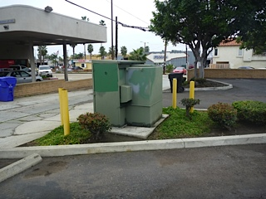
Photo #1: add vehicle barrier here

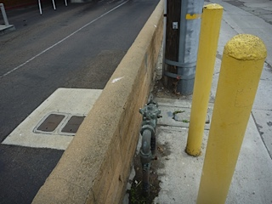
Photo #2: water leak here

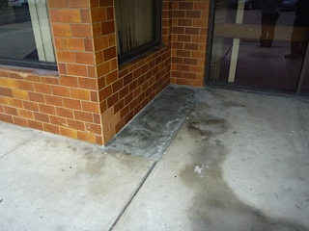
Photo #3: mystery concrete / tile repair
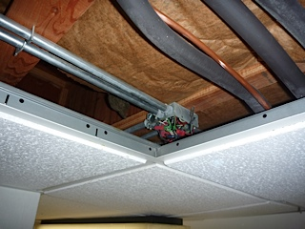
Photo #4: open junction box

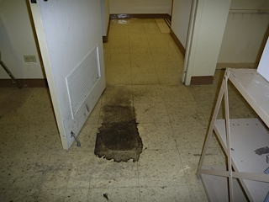
Photo #5: floor damage at file storage rm

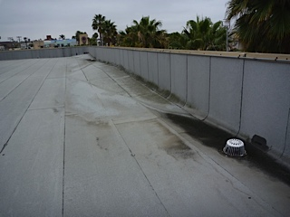
Photo #6: water pools at drains

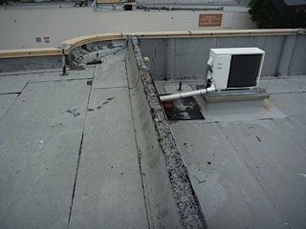
Photo #7: re-seal parapet top and sides

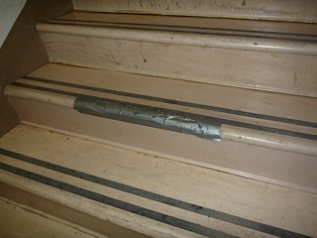
Photo #8: temporary step repair

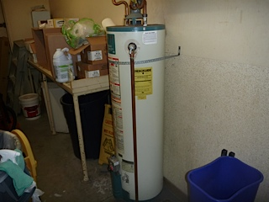
Photo #9: water heater view

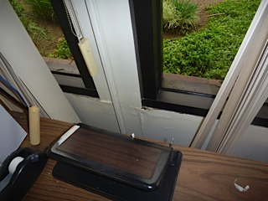
Photo #10: cracking / swelling at window

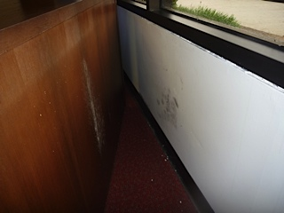
Photo #11: mold at wall and cabinet

