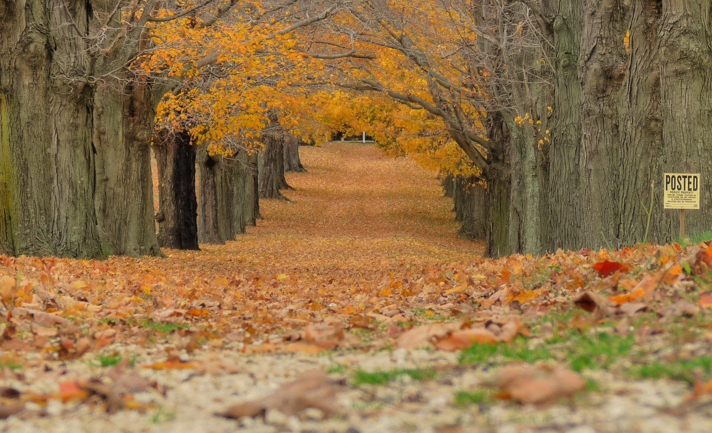


“2026 Fall into Autumn”
at Silver Sands Bridle Club
615 Tomoka Farms Rd. (C.R.415), NSB, FL 32168

2026 SHOW DATES
*dbl pts* April 26th - “Spring Fling” *dbl pts*
Sept. 11th, 12th - “Fall into Autumn” **some divisions dbl pts
*dbl pts* Oct. 9th, 10th - “Hallo-Fest” *dbl pts*

PLEASE NOTE:
April 26th - “Spring Fling” is a shortened schedule and is entirely double pointed
Sept. 11th, 12th - “Fall into Autumn” is only double points for what does not run in April
Oct. 9th, 10th - “Hallo-Fest” is double points for the entire show
*Must participate in all three shows to qualify for Year End Banquet



FRIDAY Sept.11, 2026 - starts at 5:30pm


WU1. Warm Up Red/Blue (open card)

11. Green as Grass Hunter U/S Walk Trot
12. Green as Grass Hunter Crossrails O/F Walk Trot
13. Green as Grass Hunter Crossrails O/F Walk Trot

21. Open Schooling Hunter U/S
22. Open Schooling Hunter O/F 2’
23. Open Schooling Hunter O/F 2’

MC23. Canter Down Farms Medal Challenge 2’3”
$250 JACKPOT (refer to rules)
*second portion Eq on Flat (call back).
Top 3 places pay out.

HH23. Canter Down Farms Handy Hunter Classic 2’3”
$250 JACKPOT (refer to rules)
*second portion U/S (call back). Top 3 places pay out.

31. Training Hunter U/S
32. Training Hunter O/F 2’6”
33. Training Hunter O/F 2’6”

OR9. One Round Pick Your Height 2’9” or Higher

SATURDAY Sept.12, 2026 - starts at 8:30am

41. W/T/C Pleasure U/S
42. W/T/C Pleasure Eq Pattern
43. W/T/C Pleasure Hunter Hack 18” Verticals
$1,600 in PRIZE MONEY

51. Walk Hunter
52. Walk Eq
53. Walk Poles
54. Walk Trot Leadline 1 @ a time

61. Walk Trot All Ages Hunter U/S
62. Walk Trot All Ages Equitation on Flat
63. Walk Trot All Ages Poles
64. Walk Trot Canter 1 @ a time

MHP. Model Horse / Pony

WU2. Warm Up Red/Blue (open card)

71. Beginner Novice Hunter Walk Trot U/S
72. Beginner Novice Hunter Walk Trot Canter U/S
73. Beginner Novice Hunter Walk Trot Crossrails
74. Beginner Novice Hunter Walk Trot Crossrails

MMX. Canter Down Farms Mini Medal Crossrails Walk Trot
$250 JACKPOT (refer to rules)
*second portion Equitation on Flat (call back).
Updated 3/11/26

Top 3 places pay out.

ARENA DRAG
*Gates Open at 6am
*Main Arena Open Schooling 6:30am to 8am

81. Short / Long Stirrup Hunter U/S
82. Short / Long Stirrup Hunter O/F 18”
83. Short / Long Stirrup Hunter O/F 18”

24. Open Schooling Hunter U/S
25. Open Schooling Hunter O/F 2’
26. Open Schooling Hunter O/F 2’

91. Modified Equitation on Flat
92. Modified Equitation O/F 2’3”
93. Modified Equitation O/F 2’3”

EFC. Canter Down Farms Equitation Flat Challenge
$350 JACKPOT Top 3 places pay out.

94. Modified Hunter U/S
95. Modified Hunter O/F 2’3”
96. Modified Hunter O/F 2’3”

34. Training Hunter U/S
35. Training Hunter O/F 2’6”
36. Training Hunter O/F 2’6”

MC26. Canter Down Farms Medal Challenge 2’6”
$250 JACKPOT (refer to rules)
*second portion Equitation on Flat (call back).
Top 3 places pay out.

101. Hopeful Hunter U/S
102. Hopeful Hunter O/F 2’9”
103. Hopeful Hunter O/F 2’9”

HH30. Canter Down Farms Handy Hunter Classic 2’9”
$250 JACKPOT (refer to rules)
*second portion U/S (call back). Top 3 places pay out.

OR3. One Round Pick Your Height 3’ or Higher
$350 CDF Equitation Flat Challenge sponsored by:

Pay Out
1st - $200 / 2nd - $100 / 3rd - $50



