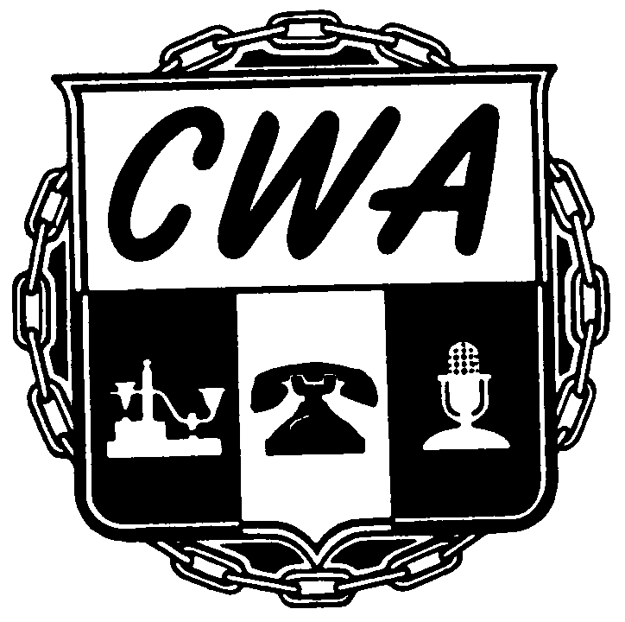
B U L L E T I N
NABET-CWA/ABC-Disney
Washington, D.C.
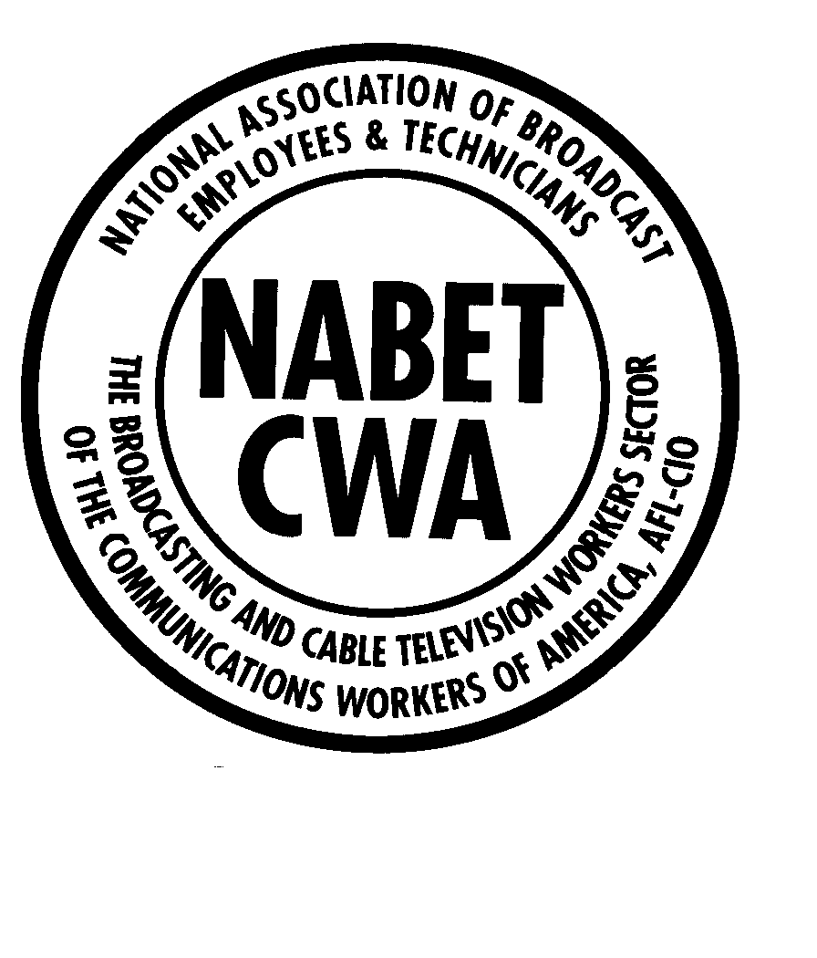

2026 Master Agreement Negotiations - Bulletin #5
June 15, 2026

Electronic voting has concluded for the ABC-Disney ratification balloting concerning the May 1, 2026, Tentative Agreement.

The Network Negotiating Committee is reporting that eligible NABET-CWA members employed by ABC-Disney have ratified the Master Agreement for all Units.

The new ratified Master Agreement covers broadcast technicians, newswriters, producers, and desk assistants at various Company Network and TV station operations in New York, Chicago, Washington, D.C., Los Angeles, and San Francisco.

Most terms and conditions of the new agreement are effective October 1, 2026, unless otherwise stated in any individual proposal contained in the May 1, 2026, contract offer. The transition from bi-weekly to weekly pay will also take place this coming October.

The next annual minimum scale wage increase of 3% will be for the payroll period starting April 3, 2027.
You can review the Summary document prepared by the NNC, as well as the complete Tentative Agreement, by visiting your NABET-CWA Local website or the Sector website (www.nabetcwa.org).
In the coming weeks, the Union and the Company will begin the drafting process for the printed 2026-2031 Master Agreement, and it will be released to the members as soon as it becomes available.

In Solidarity,
Your NABET-CWA-ABC Network Negotiating Committee

Local 16: Jim Joyce, President; William Bores, Former President;

Local 31: Alex Staherski, Vice-President; Bantu Opiotennione, President

Local 41: Stephen Griswold, President; Patrick Keating and Michael Johnson, Executive Board Members

Local 51: Carrie Biggs-Adams, President; Brad Belstock, Vice-President;
Colin Tuttle, Executive Board Member

NABET-CWA Sector: Charlie Braico, NABET-CWA President and Chief Spokesperson;
Judi Chartier, General Counsel;
Steve Rubbinaccio, Sports Agreement Coordinator;
Ron Gabalski, Chief of Staff and Assistant to the President

