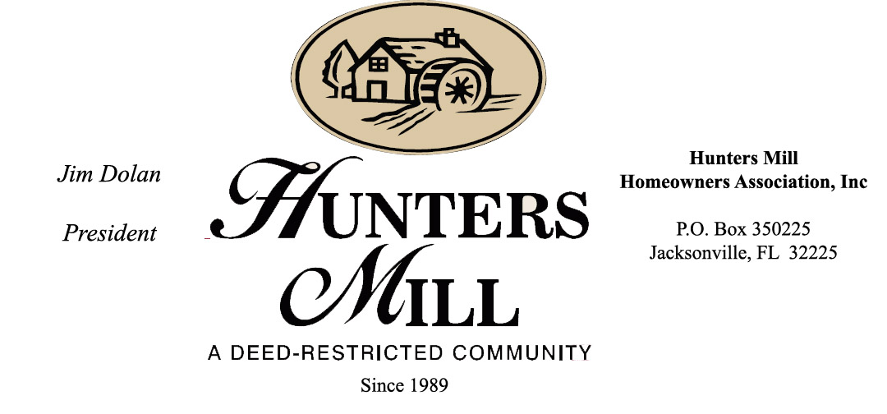

**Hunters Mill Homeowners Association**

**Architectural Control Committee review form**

**Submit via email to :** [**contact@huntersmillofjacksonville.com**](mailto:contact@huntersmillofjacksonville.com)

**Homeowners Name:**

**Address:**

**Email Address:**

**Contact Number**

Please Circle below what describes your project best

Pool Building Add on

Outdoor Kitchen and Dining area Parking/Drive

Shed Roof

Landscaping Fence

Please give a Brief description of the project you are submitting for review:

Please provide a drawing, sketch, photo, or plans that show proposed project.

For Fencing provide a photo of the fence

Does this project require a permit from the city or county? YES NO

Who is performing the work? Licensed Contractor Homeowner

What is the proposed start date?

What is the expected end date?

**Official Use only**

Date received Date Returned Approved/Denied

Notes: