

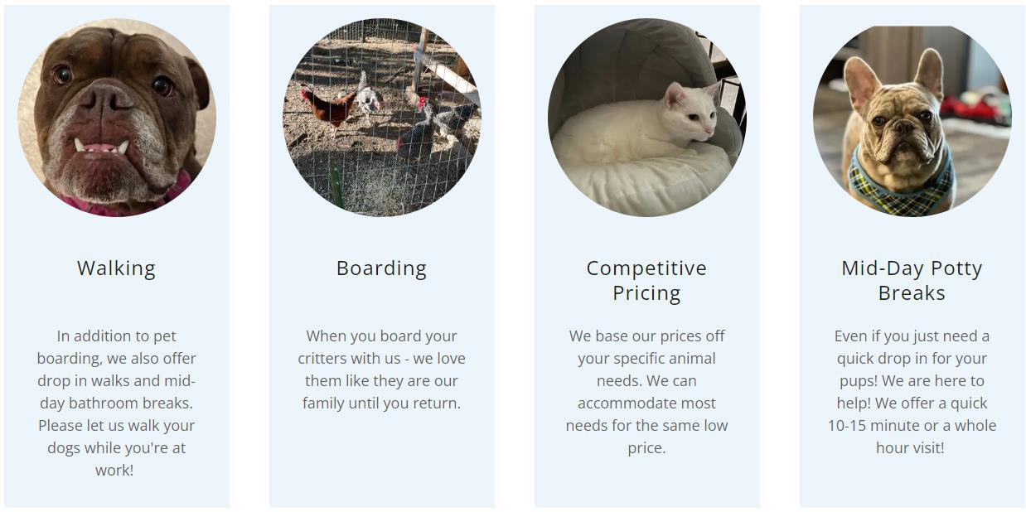

Client Agreement

## South St. Paul, Minnesota, United States

(612) 578 -9070 | [Info@fuzzycrittersitters.com](mailto:Info@fuzzycrittersitters.com)

At Fuzzy Critter Sitters, our mission is to provide dependable and trustworthy care for your beloved pets. Born out of our own challenges in finding reliable pet care, we are dedicated to creating a

service that pet owners can consistently depend on. Our passion for animals drives us to ensure that every pet receives the love, attention, and care they deserve, giving you peace of mind whenever you need it.

We strive to make the booking and payment process as convenient as possible for our customers. We are excited to offer invoicing for our services, which will be sent directly to your email once you

confirm your dates with us. We want to ensure that your experience with us is seamless and stress- free. If you have any questions or need further clarification on the invoicing process, please feel free to let us know. Multiple payment options available: credit cards, Apple Pay, PayPal, Venmo, and direct bank transfers.

At Fuzzy Critter Sitters, we are excited to share that we are now Licensed and Bonded. This accreditation ensures that we meet the necessary standards and requirements to provide

professional and reliable pet care services. Your pets' safety and well-being are our top priorities, and being Licensed and Bonded gives you peace of mind knowing that your fuzzy friends are in good

hands. If you have any questions or would like more information about our licensure and bonding, please feel free to reach out.

# Pet Day Care

We offer daily care for your beloved pets while you're at work or away. Our services are tailored to meet your specific needs and ensure the well-being of your fuzzy friends. Whether you require dog walking, feeding, playtime, or any other pet care services, we are here to help. Please reach out to us to discuss how we can best assist you and your pets. Thank you for considering Fuzzy Critter Sitters for your pet

care needs.

*Drop-in Care (Starting at $65/day)*

We offer multiple daily visits to cater to your pet's needs, ensuring they receive the attention and care they deserve. Our standard visits typically include breakfast, dinner, and bedtime check-ins, which

encompass morning and evening feedings, playtime, and bathroom breaks for your fuzzy companions. In addition to caring for your pets, we are happy to assist with additional tasks such as bringing in your

mail/packages, watering plants, setting out trash bins.

*Drop-in Care Plus (Starting at $85/day)*

At Fuzzy Critter Sitters, we offer multiple daily visits to ensure your pets' needs are well taken care of. Our drop-in visits include breakfast, lunch, dinner, and bedtime check-ins. This comprehensive service covers morning and evening feedings, playtime, bathroom breaks, and any other specific requirements your pets may have. Additionally, we are happy to bring in your mail/packages, set out your trash bins, and water plants during our visits to give your home that extra touch of care.

*Over Night Care (Starting at $125/day)*

Our Overnight package for your four dogs includes all the services offered in our drop-in care plus, with the additional benefit of an overnight stay at your home. The overnight stay lasts until 9:00 AM the following day. This service starts at $125.00 per day for the first dog, with an extra charge for each additional dog. We understand the importance of finding the right care for your fuzzy companions, and we want to ensure that you have all the information you need to make the best decision.

*Boarding in Our Home (Starting at $50/day)*

At Fuzzy Critter Sitters, we offer a personalized boarding experience where we only accommodate one family per day in our home. Our boarding rates start at $50.00 per day for the first dog, and each additional dog is $5.00 per day. This ensures that your dog’s receive individualized attention and care

during their stay with us. If you have any more questions or would like to proceed with booking, feel free to let us know.

# Pet Services

*Dog Walking ($1/min $20 minimum)*

You have the flexibility to choose the duration of the walk that best suits your dogs' needs. Our pricing is structured at $1 per minute with a 15-minute minimum to book a walk. Additionally, if you have more than one dog joining the walk, there is an additional fee of $5 per extra dog. Please note that walks scheduled after 7 PM will incur a late walk fee of $5. If you require a walk on the same day as the request, there is a same-day request fee of $10.

*Bathroom Drop Ins (Starting at $16/drop in)*

We understand that life can get busy, and sometimes you may run late from work. Our 10–15-minute drop-ins are perfect for those last-minute overtime situations or when you have plans after work. During the drop-in, we will let your pups out to stretch their legs and go to the bathroom. We'll engage them in playtime to keep them active and happy before safely returning them inside. We're here to provide convenient and reliable care for your pets at Fuzzy Critter Sitters

*Yard Clean Up (Starting at $70/hour)*

We offer yard clean-up services starting at $70 per hour, with a one-hour minimum required for booking. Our team will bring the necessary tools, including a scooper and bags, to ensure a thorough clean-up of your yard. We understand the importance of maintaining a clean outdoor space for your fuzzy friends.

For yard clean-up services, the rate for additional dogs is a flat fee of $10 per dog.

*Litter box cleaning (Starting at $15/cleaning)*

Every pet owner has unique needs when it comes to caring for their fuzzy friends. If you are planning a vacation and simply need someone to stop by and take care of your cats by scooping the litter box, we offer a convenient service starting at $15.00 per visit. This service is ideal for cat owners who are away for a short period and want to ensure their feline companions are comfortable and well-cared for in their absence.

*Cat or Dog Nail Trims (Starting at $15/trim)*

We offer nail trims starting at $15.00 per session for cats. For dog nail trims we charge $25. For each additional animal we charge an extra $5 per animal.

*Medications*

At Fuzzy Critter Sitters, we understand the importance of ensuring your pets receive the care they need, especially when it comes to administering medications. Rest assured that our experienced team is

trained and capable of administering pet medications while you're away, including insulin if needed. Your pets' health and well-being are our top priorities, and we are committed to providing them with the best possible care during your time apart. If your fuzzy friends require any special medications or treatments, please let us know during the meet and greet so we can discuss the details and ensure we meet their

specific needs.

# Contracted Services

Pet Name Breed Age

Schedule:

Special Instructions or Needs:

Veterinarian Name: Phone Number

Veterinarian Address:

Emergency Contact: Phone Number

## Pet Day Care

 Daily care tailored to meet your specific needs.

 Services include dog walking, feeding, playtime, and more.

## Drop in Care

 Multiple daily visits including breakfast, dinner, and bedtime check-ins.

 Additional tasks: mail/package retrieval, plant watering, trash bin setting.

## Drop-in Care Plus

 Comprehensive care with breakfast, lunch, dinner, and bedtime check-ins.

 Additional tasks: mail/package retrieval, plant watering, trash bin setting.

## Overnight Care in Your Home

 Includes all drop-in care plus services with an overnight stay until 9:00 am the following day.

## Boarding in Our Home

 Personalized boarding experience accommodating one family per day.

## Dog Walking

 Flexible walk durations.

 Additional fees for extra dogs, late walks, and same day requests.

## Bathroom Drop-ins

 10 to15 minute drop-ins for bathroom breaks and playtime.

## Yard Cleanup

 Yard cleanup services.

## Litter Box Cleaning

 Convenient litter box cleaning.

## Cat Nail Trims

 Cat nail trims.

## Medications

 Administration of pet medications, including insulin.

# Holiday Hours

Reservations taking place over holidays will be charged a $15 holiday fee. Observed holidays for Fuzzy Critter Sitters are New Year’s Day, Easter, Memorial Day, Independence Day, Labor Day, Thanksgiving Day, Christmas Eve, and Christmas Day. This fee helps us ensure that our dedicated staff can provide excellent care for your fuzzy companions during busy holiday periods.

# Cancellations

As a responsible practice, Fuzzy Critter Sitters requires a 50% deposit to secure your desired service dates. Please note that this deposit is non-refundable in case of cancellation, and it is not transferable to other dates or services. The deposit is specifically for the dates you have requested, ensuring that we reserve our availability for your fuzzy companions during that period.

Initial and Date A 50% deposit is required to secure your service dates. Initial and Date The deposit is nonrefundable and nontransferable.

Initial and Date Cancellations for packages and scheduled walks are nonrefundable.

Initial and Date This contract is good for one calendar year. Each case has a per need basis.

# Contracted Services and Fees

Client Acknowledgment

By signing below, I acknowledge that I have read and agree to the contracted services and fees listed above and to the terms and services outlined in this agreement. I understand and accept the cancellation policy, and I agree to the prices quoted for the services selected.

Client Name: Business Owner Name:

Client Signature: Business Owner Signature:

Pet Name: Date:

Date:

Thank you for choosing Fuzzy Critter Sitters for your pet care needs.

We look forward to providing exceptional care for your fuzzy companions.