#### Missouri Peace Officer License Application

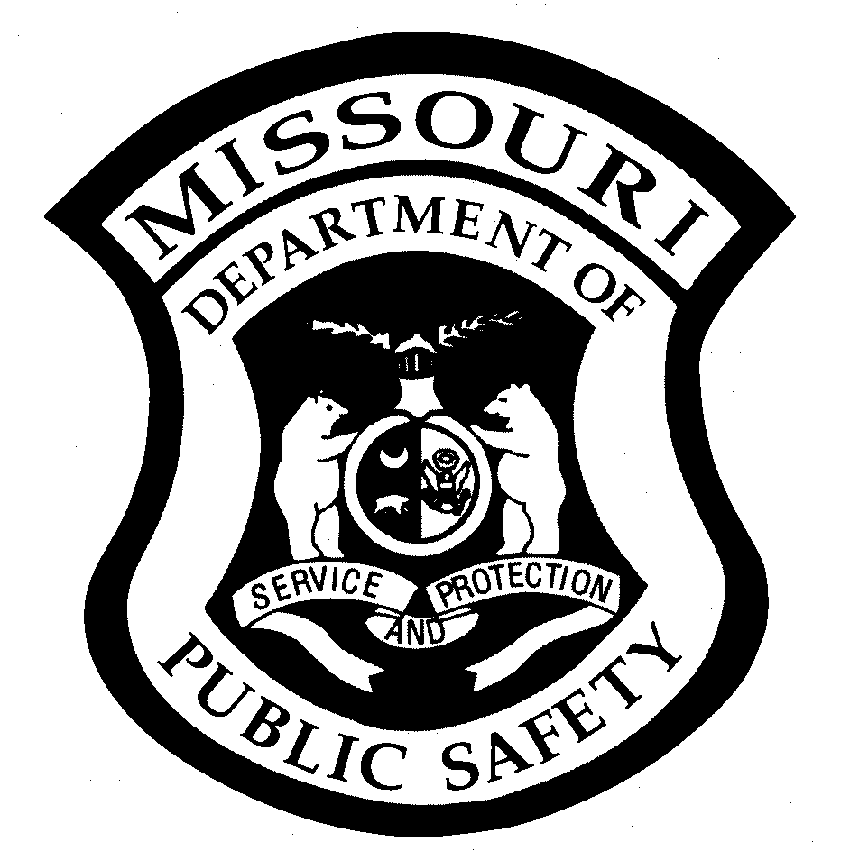



Last Revised 10.21.2022

|  |  |  |  |  |  |  |  |
| --- | --- | --- | --- | --- | --- | --- | --- |
| **LICENSED TRAINING CENTER INFORMATION** | | | | | | | |
| **Training Center Name** | | | | | | | |
|  | | | | | | | |
| **Name (Last, First, Middle)** | | **E-Mail Address** | | | | **Social Security Number** | |
| **Mailing Address** | | | **City** | | **State** | | **Zip Code** |
| **Telephone Number**  **( )** | | | **Date of Birth** | **Age** | **Gender**  **Male**   **Female** | | |
| **ATTESTATION BY APPLICANT** | | | | | | | |
| Have you previously applied for admittance into any other a basic law enforcement academy?  **Yes**   **No**  If yes, please indicate the name of the training center AND the state in which it was located: ___________________________  If you did not attend this training center, or your application to attend was not accepted, please list why:   _____________________________________________________________________________________________________  **I am aware that causing a material fact to be misrepresented for the purpose of obtaining a peace officer license issued pursuant to Chapter 590 RSMo, is a Class B Misdemeanor.**  Signature of Applicant Date | | | | | | | |
| **PLEASE ATTACH ALL DOCUMENTS LISTED BELOW IN THE ORDER THAT THEY ARE REQUESTED.** | | | | | | | |
| 1. Copy of High School Diploma, GED, or Degree from an accredited college or university. 2. Proof of United States Citizenship: Birth Certificate, Passport, or Naturalization Documentation. If name has been changed, include marriage license, divorce decree, or legal name change documentation. 3. Completed Missouri Peace Officer License Legal Questionnaire **and** the Authorization for Release of Information. 4. Photocopy of the applicant’s current state issued driver’s license. | | | | | | | |
| **ADDITIONAL INFORMATION REQUIRED FROM CERTAIN TRAINING CENTERS** | | | | | | | |
| In addition to the three items listed above, the following items are required from the **Missouri State Highway Patrol, the Missouri Department of Conservation, the St. Louis City Police Department, the Kansas City Police Department, and the Springfield Police Department**:  1 Agency ORI: _________________________  2 Date Applicant will be Commissioned by your department, unless individual is an open enrollment applicant:________________ | | | | | | | |
| **SEND THIS FORM AND ATTACHMENTS TO POST** | | | | | | | |
| Missouri Department of Public Safety  Peace Officer Standards & Training  (POST) Program  Attn: Cheryl Parris  P.O. Box 749  Jefferson City, MO 65102  Phone: (573) 526-2764  Fax: (573) 751-5399  Email: cheryl.parris@dps.mo.gov  Website: <https://dps.mo.gov/post> | **FOR POST USE ONLY:**  POST Test Date: ________________ Proof of U.S. Citizenship:_______  Graduation Date: ________________ Diploma/Degree:______________  IADLEST Check: ________________ Legal Questionnaire:___________  Basic Training Hours: _____________ SID# _______________________  Processed by: ___________________ Reviewed by:_____________________  Program Manager Approval: ______________________ Date: _____________ | | | | | | |