Missouri Peace Officer License Application
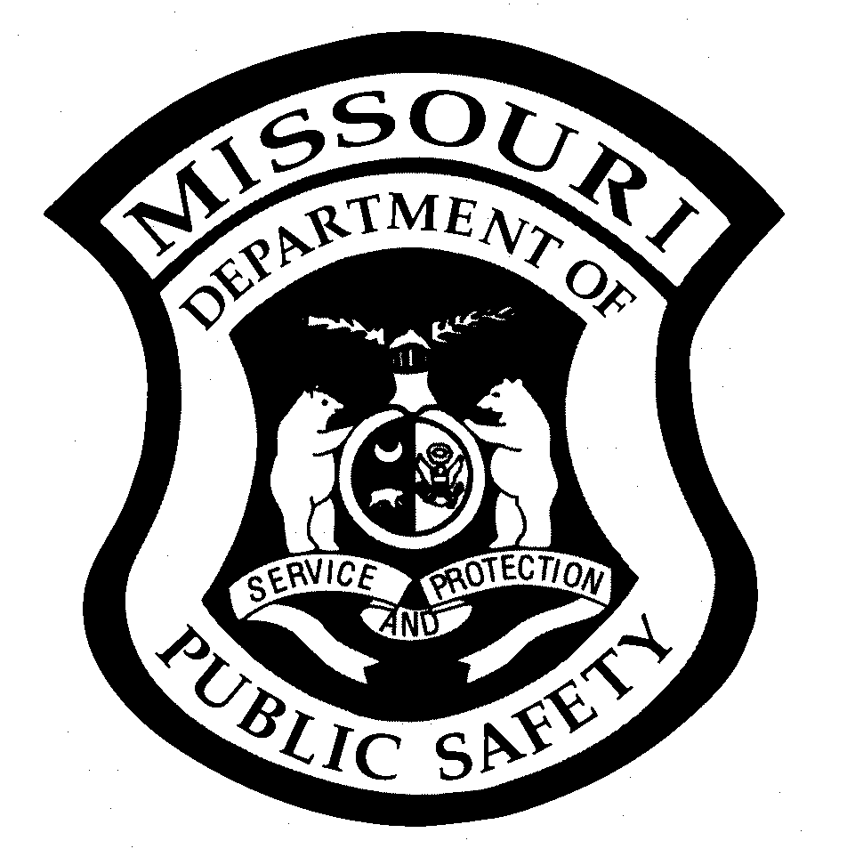
Last Revised 06.08.2020

LICENSED TRAINING CENTER INFORMATION
Training Center Name  CASS COUNTY SHERIFF’SS OFFICE  REGIONAL TRAINING ACADEMY |  |  |  | Contact Name  SGT. J BECKER-SCHUTTE  ACADEMY & TRAINING DIRECTOR
Contact’s E-mail Address  JBS@CASSMOSHERIFF.ORG |  |  | Phone Number  ( 8 1 6 ) 3 8 0 – 8 7 0 8 |  |  |  | Fax Number  ( 8 1 6 ) 3 8 0 – 8 3 3 4
APPLICANT INFORMATION
Name (Last, First, Middle) |  | E-Mail Address |  |  |  |  |  | Social Security Number
Mailing Address |  |  | City |  |  | State |  |  | Zip Code
Telephone Number  ( ) |  |  | Date of Birth |  | Age | Gender  Male Female
ATTESTATION BY APPLICANT
Have you previously applied for admittance into any other a basic law enforcement academy? Yes No If yes, please indicate the name of the training center and the state in which it was located: __________________________

I am aware that causing a material fact to be misrepresented for the purpose of obtaining a peace officer license issued pursuant to Chapter 590 RSMo, is a Class B Misdemeanor.

Signature of Applicant Date
PLEASE ATTACH ALL DOCUMENTS LISTED BELOW IN THE ORDER THAT THEY ARE REQUESTED.
- Copy of High School Diploma, GED, or Degree from an accredited college or university.
- Proof of United States Citizenship: Birth Certificate, Passport, or Naturalization Documentation. If name has been changed, include marriage license, divorce decree, or legal name change documentation.
- Completed Missouri Peace Officer License Legal Questionnaire and the Authorization for Release of Information.
- Photocopy of the applicant’s current state issued driver’s license.

ADDITIONAL INFORMATION REQUIRED FROM CERTAIN TRAINING CENTERS
In addition to the three items listed above, the following items are required from the Missouri State Highway Patrol, the Missouri Department of Conservation, the St. Louis City Police Department, the Kansas City Police Department, and the Springfield Police Department:
1 Agency ORI: _________________________________
2 Date Applicant will be Commissioned by your department, unless individual is an open enrollment applicant:_________________
SEND THIS FORM AND ATTACHMENTS TO POST
Missouri Department of Public Safety  Peace Officer Standards & Training  (POST) Program  Attn: Cheryl Parris  P.O. Box 749  Jefferson City, MO 65102  Phone: (573) 526-2764  Fax: (573) 751-5399  Email: cheryl.parris@dps.mo.gov  Website: https://dps.mo.gov/post | FOR POST USE ONLY:  POST Test Date: ________________ Proof of U.S. Citizenship:_______  Graduation Date: ________________ Diploma/Degree:______________  IADLEST Check: ________________ Legal Questionnaire:___________  Basic Training Hours: _____________ SID# _______________________  Processed by: ___________________ Reviewed by:_____________________  Program Manager Approval: ______________________ Date: _____________  License number: ____________

