Clear Care General Information
Clear Care is our scheduling and clock in system that we will use to make sure we are all arriving at the client’s home on time, and leaving on time. We will be able to see when you are at the home, or if you are even 5 minutes late. Everyone must clock in and clock out when arriving and departing from a client’s home. You still must complete a timesheet each week even though you are clocking in/out because the state still requires a paper record with the client and caregiver signature.
Clock in Instructions:
- Use the client’s home phone and dial 1-844-253-4214 immediately upon arrival at the client’s home.
- Listen to the prompts and press 1 to clock in or to choose your name
- Listen to the care plan for the day if any has been set, and note any activities that need to be completed before you leave
- At the end of your shift, clock out by using the client’s home phone and dial 1-844-253-4214.
- If you see any major conditions in the change of your client press 8 to leave a voicemail for the office about it. ONLY REPORT CLIENT INFORMATION HERE, NOTHING ELSE! BE PROFESSIONAL BECAUSE THE FAMILY CAN ACCESS THESE VOICEMAILS AS WELL.
- If you drove the client in YOUR vehicle, and you need to report mileage, press 7 and report the number of miles. Do not record mileage to and from work.
- Press 9 to clock out, and wait to hear the voice confirmation that you have been clocked out, and hang up.
General Rules:
If you are working a live in client, you do not have to clock in or out every day. Just clock in on the day you arrive, and clock out on the day you leave.
You cannot clock in if you arrive too early. Our system will not allow it. You must clock in at your scheduled time. If you arrive early, you will not be paid for that time, you are on your own time until your shift begins.
You only have a window of about 10 minutes to clock in late. You will receive a notification that you have not clocked in via a text message sent to your cell phone. We will also call you if you have not clocked in to make sure you are at your client’s home. CALL THE OFFICE IMMEDIATLEY IF YOU ARE GOING TO BE LATE, EVEN 5 MINUTES.
If you need to change or swap your schedule, you must call the office so we can change it on the schedule so you can clock in.
You will receive notifications from our scheduling software. DO NOT REPLY to these messages, as we will not receive them. If you need to talk to someone, CALL the office. The text message will come from a 415 or 605 area code. DO NOT UNSUBSCRIBE from notifications! We will be alerted if you do, and we will have no way of sending you messages if needed. Reminder texts for your next day shift is sent at 5pm the day before. Remember, if your client lives in GA, these times are in Central Standard Time, so add an hour to the time you need to arrive. Call our office for any questions.

Accessing your Schedule and Client Assessments
You must go to the www.home-at-heart.com to access the clear care login site. Once you get to our website, click on employment tab on the front page and click on Clear Care Log in.
Once you click on the link to log in, your log in page will look like this:
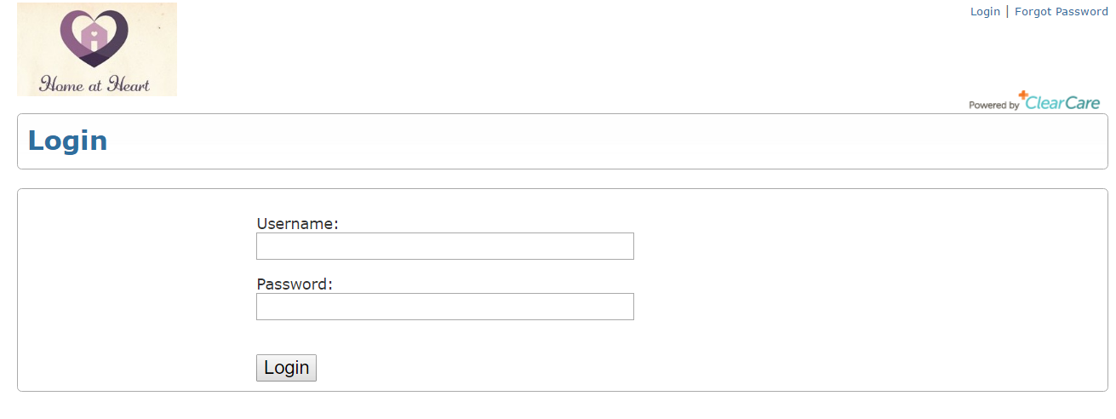

There you will enter your email for your username, and your password (last name and last 4 of social security number all lowercase, no dashes or spaces).
You will be directed to a page like this:
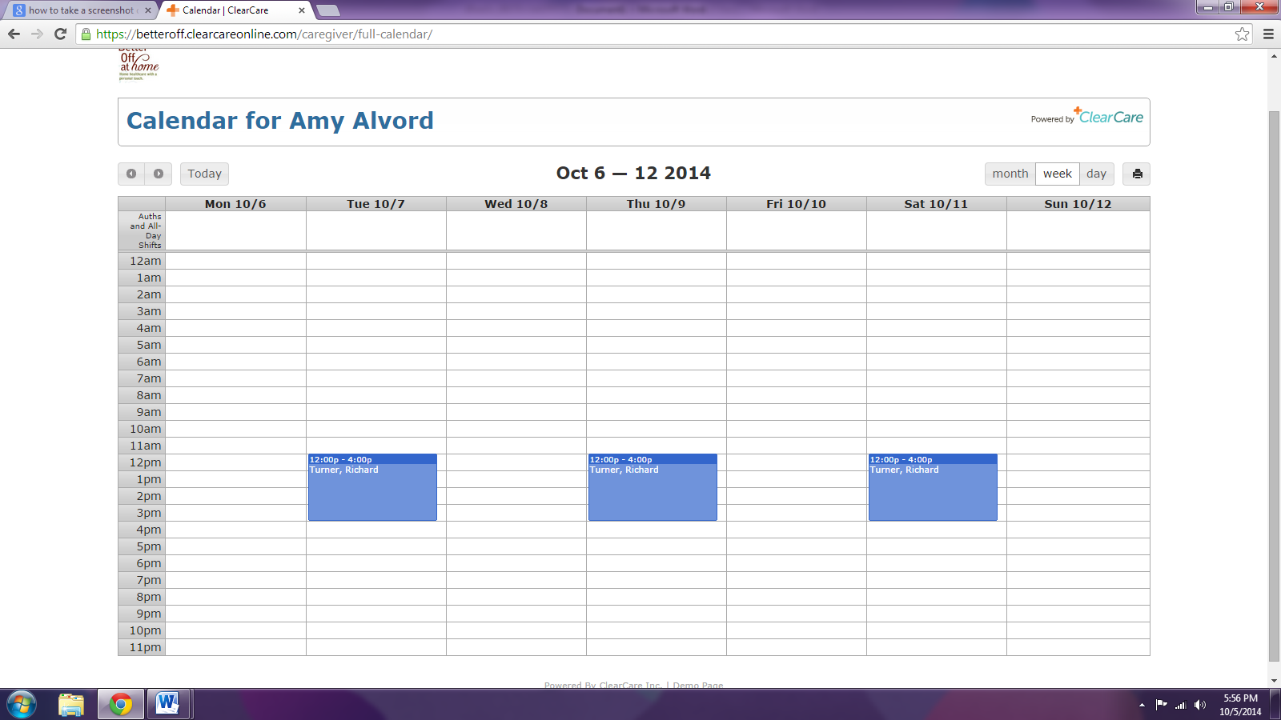
Navigate through the weeks here
Print here
Notice you can view your calendar by month, week or day.

The blue boxes are your actual upcoming schedules. They will have your client’s name in it and the times you visit them.
If you click on the blue schedule, you will find this:
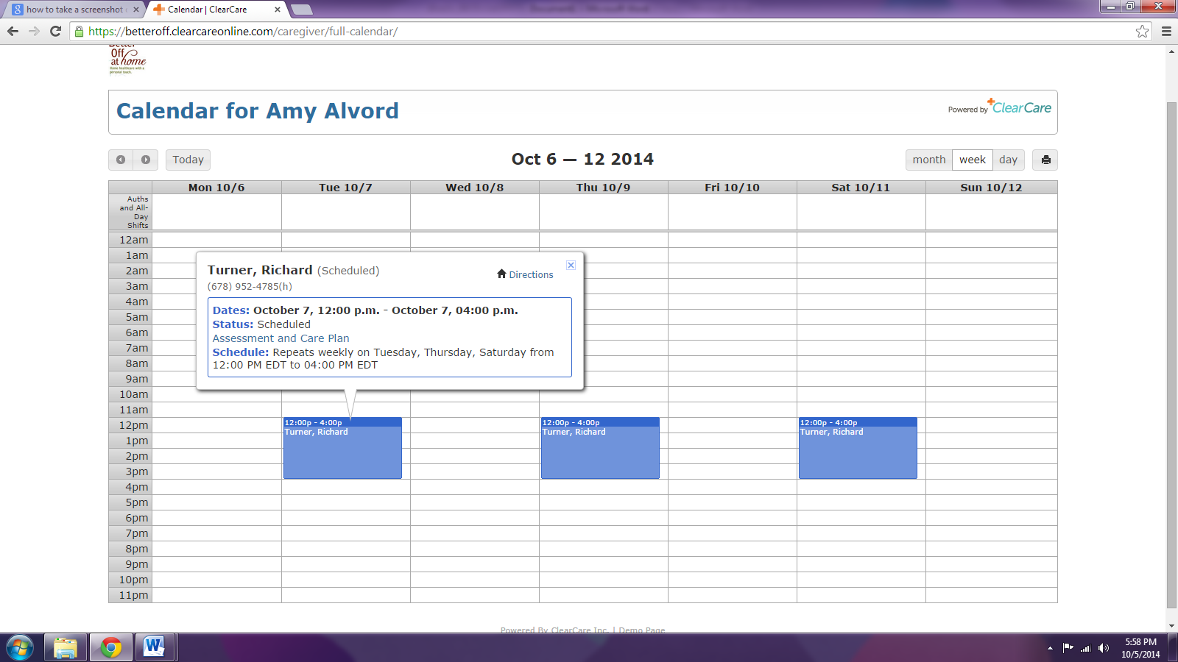
A smaller box appears and in it is a blue link (circled above) that says Assessment and Care Plan. Also notice you will see a directions button Click on it, and you will get directions to the client’s home.
When you click on the blue Assessment and Care Plan link, you will see this:
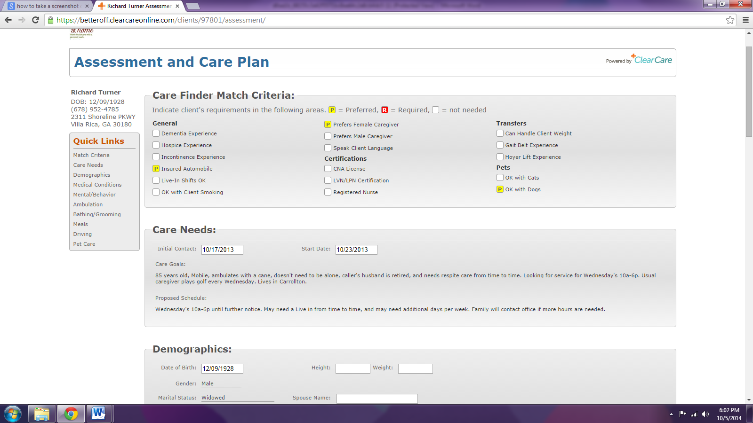
Quick Links
Address
Here, you can read all about your client’s needs. You will find their address in the upper left hand corner. The Quick Links buttons below the address lets you easily navigate through the assessment to find information you need about your client. You may also print the assessment by right-clicking on the page and clicking print.
You may also go to your app store and download our Clearcare GO app. You will log in using the same credentials as you would use online, and you can watch a short tutorial about how to use the app. You can clock in and out via this app and access all of the above with ease. Please call our office if you have any questions or need any help.

