FORUM

Cornell Law School's Alumni Magazine

Battling Antisemitism through a Legal Lens and Historical Study
June 12, 2024
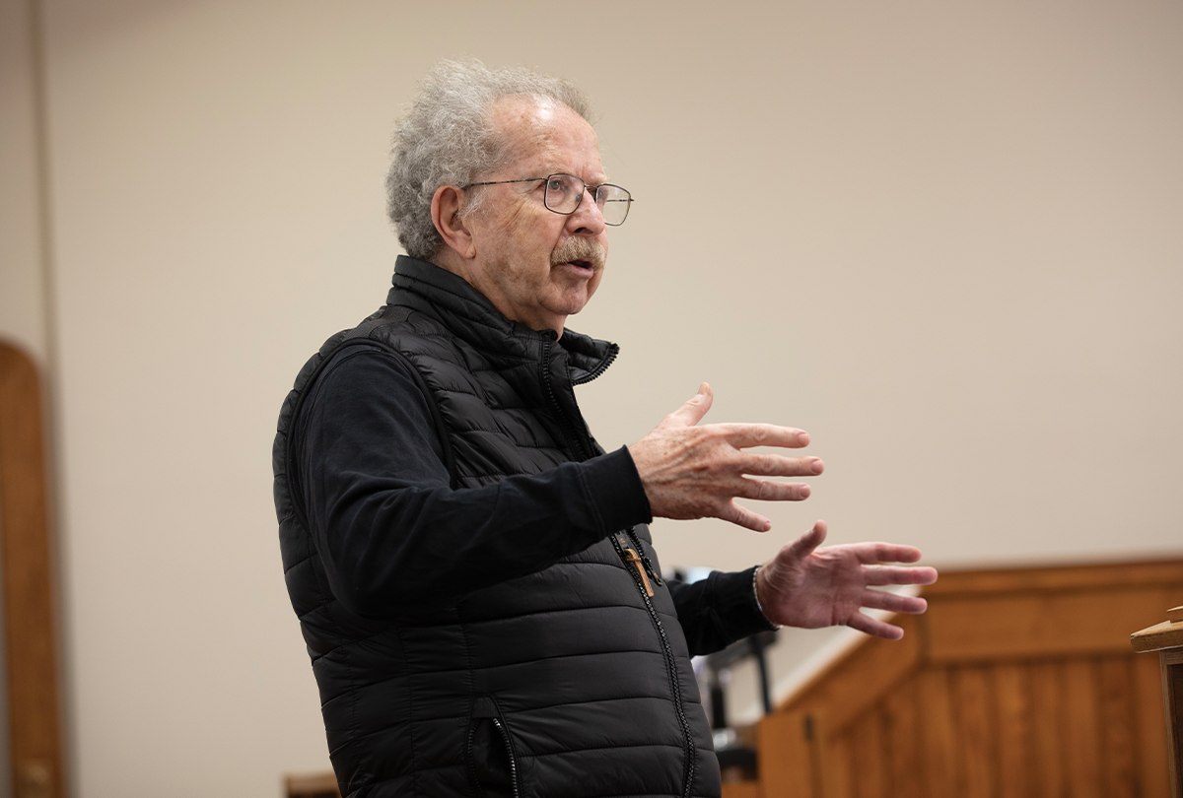
by Eileen Korey
Menachem Rosensaft had been teaching about war crimes, genocide, and the law for more than a decade—at Cornell Law School, Columbia Law School, and Syracuse University College of Law—when he began to envision a different kind of course to be taught. “I needed to step down from my day jobs first,” said Rosensaft, who retired as general counsel and associate executive vice president at the World Jewish Congress at the end of last August. He was planning to “relax and recharge my batteries” and take time to prepare a syllabus for a new course on antisemitism.
“To have a real understanding of genocide, you need to understand antisemitism,” says Rosensaft, adjunct professor of law at Cornell. “Antisemitism was at the core of the perpetration of the Holocaust.” He figured it would take several months to develop a syllabus that would look at antisemitism throughout history and through a legal lens.
Then, October 7 happened.
Within days, Rosensaft gathered with his students in his law of genocide class for open conversation. They expressed emotions and viewpoints, encouraged by their professor who for four decades has been involved in the Israeli-Palestinian peace process. Rosensaft also got a call from Jens David Ohlin, Allan R. Tessler Dean and Professor of Law, who asked if he could accelerate the syllabus and start teaching the new course in January.
“A course like this is rare among law schools,” says Ohlin. “It’s one of many things that makes Cornell distinctive. It demonstrates how our faculty bring their intellectual prowess into the classroom and shape curricula for relevance, always with an eye to the world outside the classroom.” Ohlin, a scholar in international law, war crimes, and genocide, saw the new course as an opportunity to bring legal and moral clarity to emotionally charged issues playing out on college campuses and beyond.
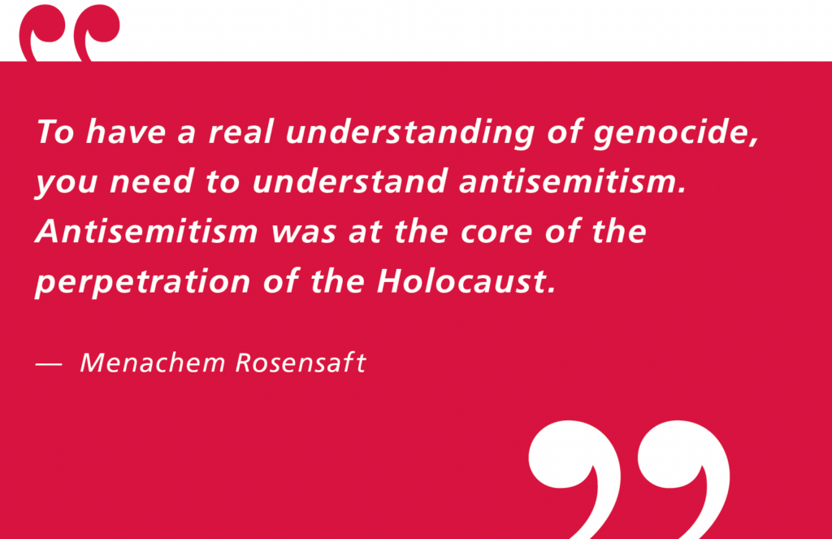
“This is how Cornell responds,” says Ohlin. “We respond with more education, so that our students will understand history, how to get beyond the sound bites and slogans, how to fight antisemitism in the courts, and how the rule of law can battle ignorance and prejudice.”
“Antisemitism in the Courts and in Jurisprudence” spans legal cases from nineteenth- century Europe through Nazi Germany and Stalinist U.S.S.R. to contemporary times. Among the topics covered are ritual murder trials, the Dreyfus affair in France, the Leo Frank trial in Georgia, the defamation case against Henry Ford (publisher of an antisemitic newspaper), the Nazi Nuremberg racial laws, the crimes against humanity charges at the International Military Tribunal at Nuremberg, the prosecution of Jews (“refuseniks”) who wanted to leave the Soviet Union, court proceedings following the Tree of Life Synagogue killings, and recent campus protests.
Rosensaft will present cases where the judicial process was manipulated to frame an innocent individual because of antisemitic attitudes and beliefs. “It’s critical for my students to understand that antisemitism is different from other forms of racism, bigotry, Islamophobia. It’s not that it’s more serious; it’s not. It is, however, different in that every other bigotry is binary, based on race or religion or color or nationality or political orientation or class or gender or sexual orientation. Antisemitism is multi-faceted; it can be more than one of those things combined, and you have to understand which manifestation of antisemitism you’re dealing with in order to counteract it.”
Rosensaft says his goal in the course, offered separately to undergraduates and law students, “is to have my students be able to have nuanced conversations and be comfortable with the uncomfortable. There are gray areas both in history and the law, and they need to be able to navigate them and put them into context. In order to understand the moral imperative of the law, you need to understand the historical and philosophical context. The law can help us take the necessary action against antisemitism.”

