1



**Cambridge IGCSE® Biology (0610) Past paper questions and answers**

**Contents**

Cells and cell processes 2

Cells and cell processes – answers 9

Animal nutrition 12

Animal nutrition – answers 21

Plant nutrition and transport 24

Plant nutrition and transport – answers 35

Respiration and the human transport system 38

Respiration and the human transport system – answers 45

Coordination, response and homeostasis 48

Coordination, response and homeostasis – answers 54

Reproduction in plants 57

Reproduction in plants – answers 62

Human reproduction 65

Human reproduction – answers 72

Inheritance and evolution 75

Inheritance and evolution – answers 84

Organisms and environment 87

Organisms and environment – answers 98

Human influences on the environment 101

Human influences on the environment – answers 110

# Cells and cell processes

## CORE questions

### Core 1

Two characteristics of living organisms are nutrition and respiration.

1. (i) List **three** other characteristics of living organisms.
   1. ..............................................................................................................
   2. ..............................................................................................................
   3. [3]

(ii) Name the process by which green plants produce carbohydrates.

. [1]

[Total: 4]

### Core 2

Table 1 describes some of the characteristics of living organisms. Complete the table by identifying each characteristic described. The first one has been completed as an example.

#### Table 1

|  |  |
| --- | --- |
| Description | Characteristic |
| Responding to stimuli in the environment | Irritability |
| Releasing energy from sugars |  |
| Producing more organisms of the same type |  |
| Getting rid of waste chemicals made in the organism |  |
| Obtaining the materials for growth |  |

[4]

[Total : 4]

### Core 3

Fig. 1 shows a red blood cell and a root hair cell.

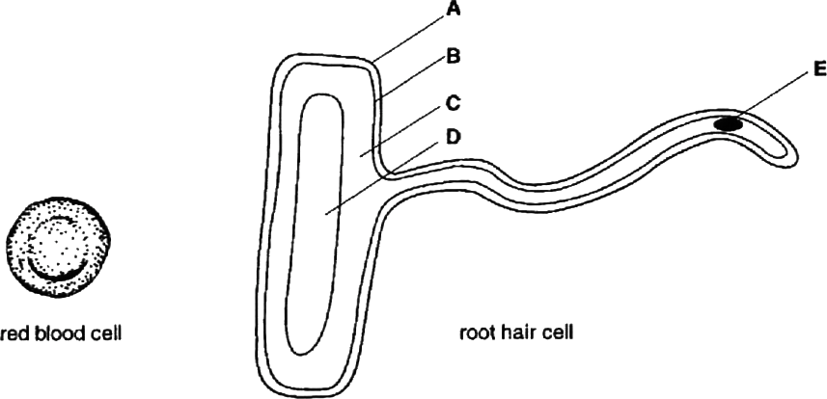

Fig 1

1. (i) Select **two** structures in the root hair cell which are also present in the red blood cell. In each case state the letter, **A** to **E**, and name the structure.
   1. *Letter*.....................................................................................................

*Name of structure ................................................................................*

* 1. *Letter* ....................................................................................................

*Name of structure* [2]

(ii) Name **one** structure which is typical of many plant cells but which is not present in the root hair cell.

. [1]

### Core 3

1. State **one** major function of each cell and describe **one** way in which the cell is adapted to carry out this function.
2. Red blood cell.

*Function* ............................................................................................................

...........................................................................................................................

*Adaptation ........................................................................................................*

. [2]

1. Root hair cell.

*Function* ............................................................................................................

...........................................................................................................................

*Adaptation* ........................................................................................................

. [2]

[Total : 7]

## ALTERNATIVE TO PRACTICAL questions

### Alternative to Practical 1

An experiment was carried out to investigate the effect of different concentrations of sucrose solution on the length of potato strips.

Five test-tubes were set up, each containing a different concentration of sucrose solution. Another tube was set up containing the same volume of distilled water.

A strip of potato tissue was placed in each tube. The strips were of equal size and as shown in Fig. 2

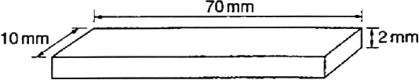

#### Fig. 2

These strips were completely covered by the solutions and were left in the tubes for 30 minutes. The potato strips were removed and measured. The results are shown in Table 2

#### Table 2

|  |  |  |  |
| --- | --- | --- | --- |
| concentration of sucrose solution (mol dm–3) | initial length (mm) | final length (mm) | change in length (mm) |
| 0 | 70 | 73.0 |  |
| 0.2 | 70 | 71.5 |  |
| 0.4 | 70 | 69.0 |  |
| 0.6 | 70 | 67.0 |  |
| 0.8 | 70 | 66.0 |  |
| 1.0 | 70 | 64.5 |  |

### Alternative to Practical 1

1. (i) Complete Table 2 to show the change in length of each strip.
   1. Plot the changes in length against the concentration of sucrose solution on the axes provided. Join the points using ruled lines.

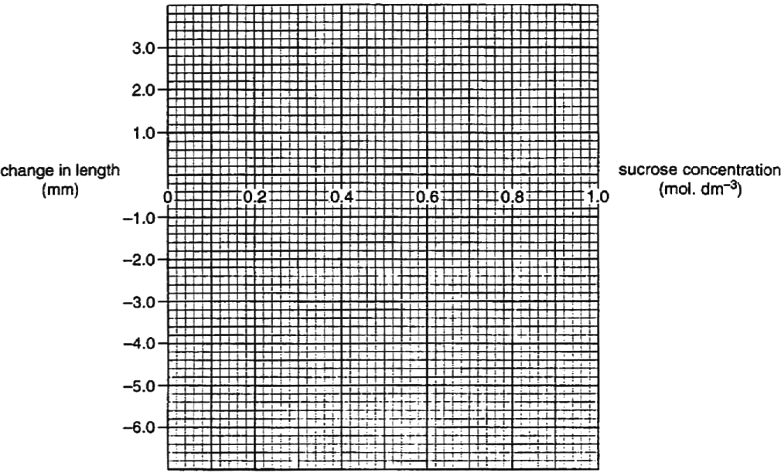

[3]

1. (i) What conclusions can be drawn from these results?

...........................................................................................................................

...........................................................................................................................

...........................................................................................................................

...........................................................................................................................

. [3]

* 1. Name the process that has taken place to bring about these changes in the lengths of the potato strips.

. [1]

## EXTENSION questions

### Extension 1

1. Draw a labelled diagram of a **named** specialised plant cell and describe

its function. [6]

1. Describe the structure and functions of mammalian blood cells. [9] [Total: 15]

### Extension 2

1. What is an *enzyme*? [3]
2. State the conditions in which enzymes work best. [3]
3. Outline the parts played by **named** enzymes in each of the following processes:
   1. germination of seeds;
   2. the use of biological washing powders to remove protein stains;
   3. fat digestion in the alimentary canal.

[9]

[Total: 15]

**Cells and cell processes – answers**

### Core 1

a (i) any three of these

growth (or alternative wording) movement (or alternative wording)

irritability / sensitivity (or alternative wording) excretion (or alternative wording) reproduction (or alternative wording)

(ii) photosynthesis

### Core 2

In order in the table

### Core 3

Respiration Reproduction Excretion Nutrition / feeding

a (i) B – cell membrane

C – cytoplasm

(ii) chloroplasts

b red blood cell

any one of these functions with its relevant adaptation

carries / combines with oxygen haemoglobin present

more space for haemoglobin lack of nucleus

oxygen uptake / release

biconcave shape / increased surface area

root hair cell

uptake of water / minerals

increased surface area / cell extension reject anchorage as a function

### Alternative to Practical 1

a (i) in order in the table

+ 3.0 mm

+ 1.5 mm

- 1.0 mm

- 3.0 mm

- 4.0 mm

- 5.5 mm

(ii) points plotted accurately

neat clear line passing through each point

b (i) potato strips in sucrose solutions lost or decreased in length

potato strips in water or dilute sucrose solutions increased in length point noted of no change in length

(ii) osmosis

### Extension 1

a any six of these points with a maximum of 3 for the diagram (third point) suitable named plant cell

function described

diagram recognisable with main features drawn, at least 3 accurate labels

cell wall

cytoplasm / reference to lack of cytoplasm (sap) vacuole

nucleus

chloroplast (or other named feature appropriate to named cell) b nine points from the following **provided** cell is named

red blood cell or corpuscle / erythrocyte reference to lack of nucleus description of shape

provides large surface area (or alternative wording) reference to presence of haemoglobin

carries / transports oxygen

phagocyte / granulocyte / monocyte / neutrophil has lobed nucleus

can change shape / pass out of capillaries engulfs bacteria (or alternative wording)

digests bacteria / foreign material (or alternative wording)

lymphocyte / B cells / T cells

has large nucleus (or alternative wording) produces antibodies

makes bacteria clump (or alternative wording) / ref. to long term immunity

produces antitoxins

neutralises toxins (or alternative wording)

### Extension 2

1. any three of these

biological / present in living organisms

catalyst / speeds up reaction rate / lowers activation energy reference to protein nature

reference to specificity

1. any three of these

reference to optimum temperature / specified temperature eg 25 – 40°C reference to optimum pH (or specified pH for named enzyme)

only work in liquid medium (or alternative wording)

reference to lack of limiting factors for example concentration of substrate

c (i) any three from

amylase

breaks down to starch

reference to sugar / named sugar **reject** glucose / sucrose use, for example for energy / growth / respiration reference to sugar being soluble for transport

1. any three of these

protease / named protein enzyme, for example pepsin, trypsin breaks down / digests protein

to amino acids / peptides reference to solubility

1. any three of these

lipase

breaks down / digests protein reference to fatty acids and glycerol

reference to molecules small enough to pass through gut wall / into lymph or lacteal

reference to site of action, for example small intestine / duodenum / ileum

# Animal nutrition

## CORE questions

### Core 1

* 1. Much of the food we eat has to be digested.
     1. Explain why food needs to be digested.

[2]

* + 1. Describe the part played by chewing in the process of digestion.

[2]

* 1. (i) Describe how food is moved along the oesophagus by peristalsis.

[3]

(ii) Students sometimes wrongly suggest that food falls down into the stomach under the effect of gravity. Suggest **one** piece of evidence which would oppose this idea.

[1]

### Core 1

* 1. Fig. 1 shows the human digestive system.

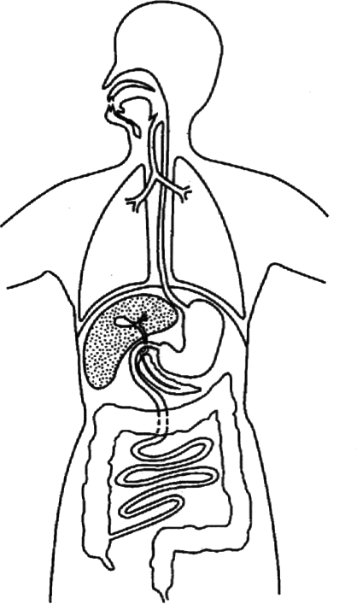

#### Fig. 1

* + 1. Using the appropriate letter, label on Fig 1 where each of the following is produced:

an amylase, (**A**); hydrochloric acid, (**B**); a lipase, (**C**);

a protease, (**D**).

[4]

* + 1. State the nutrient on which protease enzymes act and name the products that are formed.

*Nutrient* .............................................................................................................

*Products* [2]

[Total : 14]

### Core 2

Table 1 shows information about the composition of a fruit.

#### Table 1

|  |  |
| --- | --- |
| nutritional component | amount in 100 g of fruit |
| energy | 162 kJ |
| protein | 0.6 g |
| sugars | 8.7 g |
| fats | trace |
| fibre | 1.6 g |
| minerals | trace |
| vitamins | trace |

1. (i) The average daily amount of protein needed by humans is 66 g.

How many kilograms of this fruit would a person need to eat if this was the only source of protein? Show your working.

*Answer* kg [3]

* 1. List the **four** main chemical elements from which protein is made.

1. [2]
2. (i) Describe how you could safely test this fruit to see if it contains reducing sugars.

[3]

* 1. State what you would observe if a reducing sugar is present. [1]

### Core 2

1. Fruit such as this is an important part of a healthy diet.
2. Suggest **one** reason for eating food rich in fibre.

[1]

1. Name the vitamin which is associated with citrus fruits and green vegetables. State the function of this vitamin in the body.

*Vitamin* ...........................................

*Function* ............................................................................................................ [2]

[Total: 12]

### Core 3

Fig. 2 shows part of the alimentary canal.

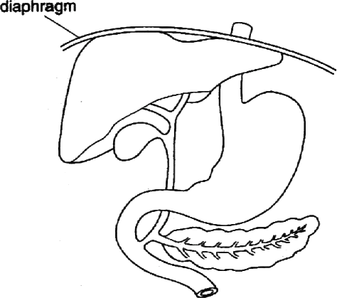

Fig. 2

1. On Fig. 2 label each of the following structures:
   1. stomach;
   2. liver;
   3. pancreas.

[3]

1. Describe the parts played by the liver and the pancreas in the digestion of fats.

*Liver*

*Pancreas* ...........................................................................................................

[4]

[Total:7]

## ALTERNATIVE TO PRACTICAL questions

### Alternative to Practical 1

1. (i) Describe how you would carry out a test to show the presence of fat in a biscuit. What observation would indicate the presence of fat?

*Test*

*Observation ......................................................................................................*

[3]

(ii) Describe how you would use this test to compare the fat content of two different types of biscuit.

. [2]

1. Complete the equation below to summarise the process of fat digestion.

fat + water

................... ..................... + ..................... [3]

[Total: 8]

(enzyme)

## EXTENSION questions

### Extension 1

Health workers in America were concerned about the diets of American people. In response a report was published called `Dietary Goals'.

Fig. 3 compares an average 1977 diet with the report's recommended dietary goals.

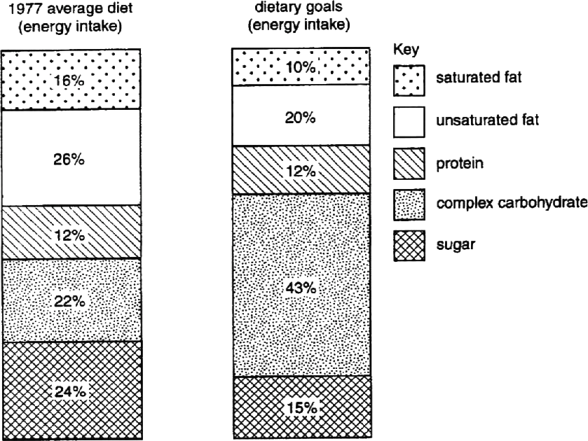

Fig. 3

1. (i) What recommendations were made about changes to the fat content of the diet?

... [2]

(ii) Suggest why these changes were recommended.

[3]

### Extension 1

1. Complex carbohydrates are long chain molecules.

Name a long chain carbohydrate present in

* 1. plant tissue; ................................................
  2. animal tissue. ................................................ [2]

1. Suggest why a reduction in the sugar content of the diet was recommended.

........................................................................................................................................

........................................................................................................................................

. [2]

It was also recommended that people should reduce their salt intake to about 3 g a day.

1. Suggest why a high salt intake can be dangerous to health.

[1]

Babies need a carefully controlled diet to keep them healthy. Mothers are often advised to feed their babies with breast milk rather than with milk derived from cows (formula milk).

1. State **three** advantages of feeding a baby with breast milk compared with formula milk.
2. ...........................................................................................................................
3. ...........................................................................................................................
4. [3]

[Total: 13]

### Extension 2

1. Describe the processes, beginning with nutrition, which result in the formation of proteins in the leaves of a photosynthetic plant. [8]
2. (i) Explain how amino acids in the small intestine of a mammal are assimilated into muscle tissue. [3]

(ii) Outline the role of proteins in animals. [4] [Total: 15]

# Animal nutrition – answers

### Core 1

a(i) to change food into simple / small / soluble form / molecules

for absorption / diffusion(into intestine wall / villi) / carriage in blood

(ii) any two of these

make small enough to swallow increase surface area of particles mix with saliva / enzyme / amylase

b(i) any three of these

contraction of (circular) muscles behind food / bolus relaxation of muscles in front

occurs rhythmically / in waves food forced forward / along tube

(ii) any one of these

can swallow standing on head / hanging upside down can swallow in space with no gravity

some mammals (standing on four legs) have horizontal oesophagus some mammals can regurgitate food against gravity

c(i) A – label to salivary gland / mouth / pancreas

B – label to stomach

C – label to pancreas

D – label to stomach / pancreas / small intestine

(ii) protein / named protein

amino acids / polypeptides / peptides

### Core 2

a(i) 66 / 0.6 = 110

110 x 100 g fruit = 11 (kg)

(ii) carbon, hydrogen, oxygen, nitrogen

b(i) add to Benedict's solution / Fehling's reagent heat

use of water bath / goggles / any other relevant safety practice

(ii) colour change to orange (accept yellow / brick red/ red-brown) c(i) any one of these

aids peristalsis / movement of food along gut(or alternative wording) prevents constipation(or alternative wording)

reduces fat absorption / risk of bowel cancer(or alternative wording)

1. any one of these vitamin C

maintains healthy skin wounds heal more rapidly prevents scurvy

assists uptake of iron

### Core 3

* 1. labels correctly placed
  2. any four of these

liver production of bile / bile salts

emulsifies fats / increases surface area (alternative wording) neutralises stomach acid / raises pH

pancreas

secretes lipase / enzyme digests / breaks down fats to fatty acids and glycerol

### Alternative to Practical 1

a(i) emulsion test – add ethanol / alcohol

pour into water

observation - cloudiness / white / milky / emulsion

(ii) equal quantities of biscuit / same conditions one comparison described e.g. of cloudiness

1. lipase / esterase

fatty acids and glycerol

### Extension 1

a(i) one mark for reduction / one mark for stating figures from reduce fat / saturated fat / unsaturated fat

reduce fat content from 42% to 30% or by a quarter (or alternative wording) reduce saturated fat from 16% to 10 % or by a third or by 6%(or alternative wording)

reduce unsaturated fat from 26% to 20% or by a fifth or by 6%(or alternative wording)

(ii) any one from

reference to problems of obesity (resulting from too much fat in the diet) reference to presence of cholesterol

in (some) saturated fats

can cause atherosclerosis / atheroma / blockage of arteries reference to heart problems(or alternative wording) reference to arthritis problems

b(i) starch / cellulose / hemicellulose / amylose / amylopectin / pectin / callose / insulin Reject glycogen

glycogen / chitin

Reject glucagon

c(i) reference to dental decay(or alternative wording) reference to problems with obesity(or alternative wording) leading to heart disease / diabetes

1. reference to high blood pressure / greater risk of heart attack (or alternative wording)
2. any three of these

breast milk contains antibodies or greater protection from infection

breast milk contains foodstuffs in correct proportions (or alternative wording)

### Extension 2

bottle milk may contain bacteria or cause intestine disease (accept breast milk is sterile)

financial implications of bottle milk some babies are allergic to cow's milk

reference to correct temperature of breast milk

reference to convenience of breast milk or preparation involved with bottle milk

no additives / preservatives in breast milk reference to bonding through breast feeding reference to triggering reduction in size of uterus

a(i) any eight of these

reference to absorption of nitrogen-containing salts by roots ( accept reference to ions)

by diffusion / active transport

reference to nitrogen-fixing bacteria in root nodules nitrogen salts transported in xylem

reference to photosynthesis

carbon dioxide is combined with / reacts with water using energy from (sun)light

reference to chloroplasts / chlorophyll sugars produced

nitrogen is combined with sugars to make amino acids / proteins

b(i) amino acids pass through ileum wall / epithelium or lining or wall of villus absorbed into blood (stream)

transported to muscles in plasma

amino acids synthesized into proteins (or alternative wording)

1. any four of these

reference to growth / repair / formation of new cells reference to hormones

reference to enzymes

constituent of cell membranes(or alternative wording) reference to haemoglobin

reference to collagen reference to keratin reference to antibodies reference to fibrinogen / fibrin

# Plant nutrition and transport

## CORE questions

### Core 1

* 1. The chemical equation for photosynthesis shown below is incomplete.

6H2O  ................................... energy  C6H12O6  ..............................

water

plantpigment

glucose

* + 1. Complete the equation in **either** symbols **or** words. [2]
    2. State the source of energy for this reaction.

[1]

* + 1. Name the plant pigment necessary for this reaction. [1]
    2. Which mineral is needed by a plant to form this pigment? [1]
  1. (i) Name the tissue in which the sugar produced in photosynthesis is carried to other parts of the plant.

[1]

1. In many plants some of the sugar formed in photosynthesis is converted to starch for storage. Explain the advantage of storing starch rather than sugar.

. [2]

1. Name the carbohydrate, formed from sugar produced in photosynthesis, which is used to build cell walls.

[1]

[Total : 9]

### Core 2

Fig. 1 shows changes in the rate of water loss from a plant during part of a day. It also shows changes in the temperature and light intensity over the same period.

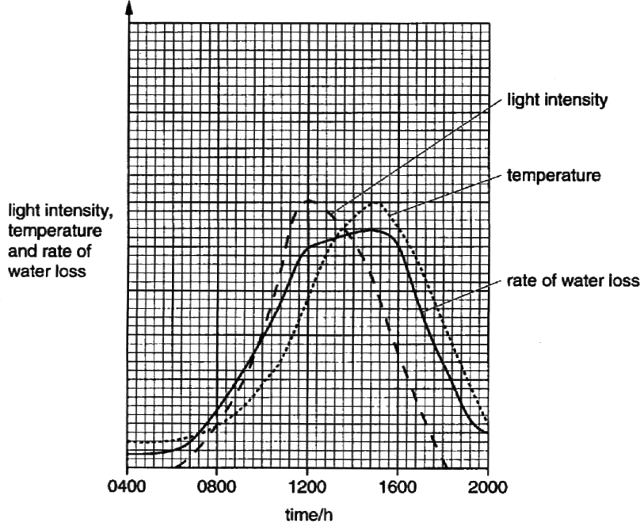

Fig. 1

1. Explain why the rate of water loss rises steeply between 0700 and 1200 hours.

[3]

1. Suggest which factor, light intensity or temperature, has the greater effect on the rate of water loss between 1200 and 1500 hours. Explain your answer.

*Factor* .............................................................................................................................

*Explanation* ....................................................................................................................

. [2]

### Core 2

1. Predict and explain the likely effect on the rate of water loss if there had been heavy rainfall between 1100 and 1200 hours.

*Prediction* .......................................................................................................................

*Explanation* ....................................................................................................................

. [2]

[Total : 7]

## ALTERNATIVE TO PRACTICAL questions

### Alternative to Practical 1

Fig. 2 shows three sets of apparatus, **A, B** and **C**, used to measure different biological processes.

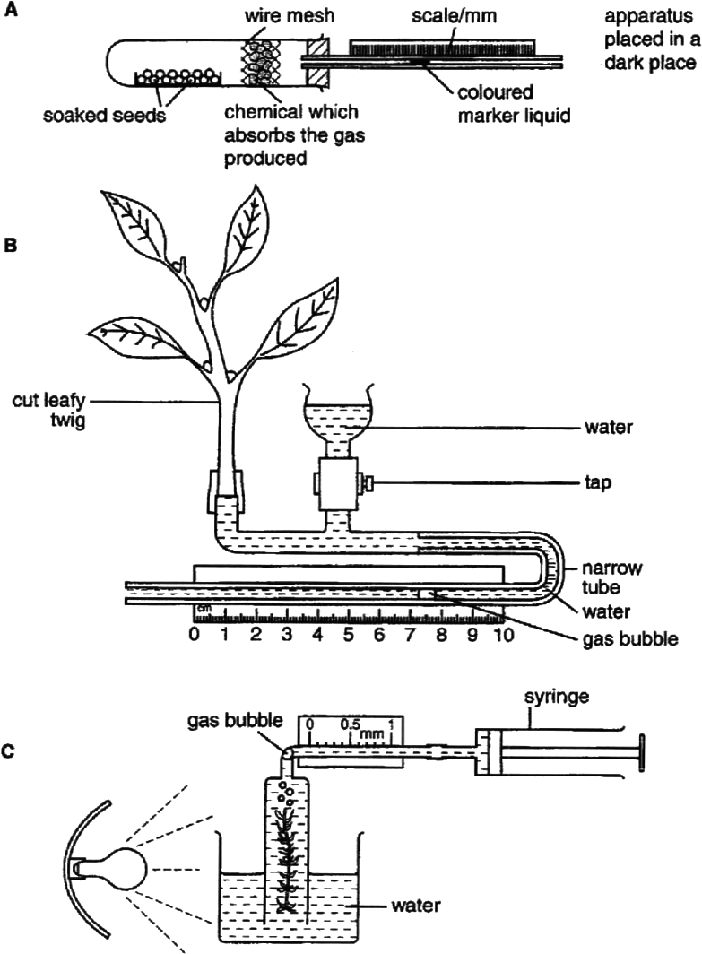

#### Fig. 2

1. Name the process that can be measured by each apparatus.
   1. ...........................................................................................................................
   2. ...........................................................................................................................

**C** [3]

### Alternative to Practical 1

1. (i) Name the gas which is produced by the process measured using apparatus

#### A.

[1]

(ii) Suggest **one** possible control for an experiment using apparatus **A.**

[1]

1. When using apparatus **B**, it is possible to vary the external conditions. Suggest how changing **one named** external condition would affect the biological process measured by apparatus **B.**

[1]

1. (i) Name the gas produced by the process measured using apparatus **C.**

[1]

(ii) How would you keep **one named** external factor constant when using apparatus **C**?

[1]

[Total : 8]

## EXTENSION questions

### Extension 1

Fig. 3 shows part of the lower surface of a typical dicotyledonous leaf.

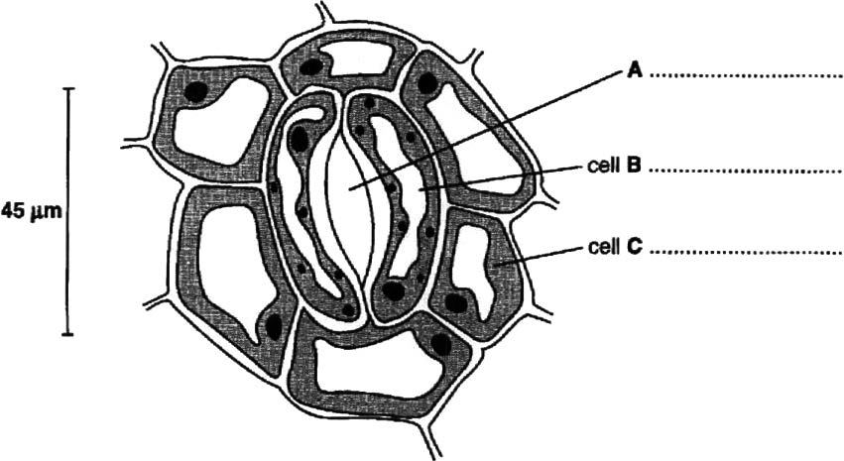

#### Fig. 3

1. On Fig. 3, label part **A** and the cells **B** and **C.** [3]

The surfaces of the leaves of two species of plant were studied and the number of stomata per unit area (stomatal frequency) was recorded.

Cobalt chloride paper changes colour in the presence of water.

Pieces of cobalt chloride paper were attached to the upper and lower surfaces of leaves on both plants. The plants were set up for one hour during the day. Any colour changes were recorded. The experiment was repeated for one hour at night. Table 1 shows the results.

#### Table 1

|  |  |  |  |  |  |  |  |
| --- | --- | --- | --- | --- | --- | --- | --- |
| plant species | stomatal frequency | | colour change to cobalt chloride paper | | | |  |
| lower surface | upper surface | day | | night | | **Key** |
| lower surface | upper surface | lower surface | upper surface | ✔ colour change |
| *Cassia*  *fistula* | 0 | 18 | ✘ | ✔ | ✘ | ✘ | ✘ no colour change |
| *Bauhinia monandra* | 22 | 0 | ✔ | ✘ | ✘ | ✘ |

1. Describe the differences in stomatal distribution between the two species of plant.

. [2]

### Extension 1

1. (i) Explain the colour changes to the cobalt chloride paper during the day.

[3]

(ii) Suggest why there was no colour change for either plant at night.

[1]

1. Outline the mechanism by which water in the roots reaches the leaf.

........................................................................................................................................

........................................................................................................................................

........................................................................................................................................

. [3]

1. State and explain the effect of the following on transpiration rate:
   1. increasing humidity;

. [2]

* 1. increasing temperature.

. [2]

[Total : 16]

### Extension 2

Fig. 4 shows an aphid feeding on a plant stem. Its mouthparts are hollow tubes which are pushed into the stem to remove sugar solution.

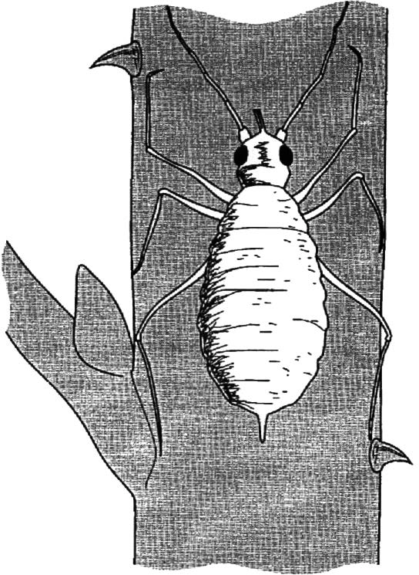

#### Fig. 4

1. Aphids are arthropods. State **two** features, visible in Fig. 4, which are common to all arthropods.
   1. ...........................................................................................................................

2 [2]

1. In which tissue, and by what processes, does the sugar solution move through the plant?

*Tissue* ............................................................................................................................

*Processes* ......................................................................................................................

. [3]

### Extension 2

Some of the sugar solution was collected from the plant stem. Plant cells were placed on a microscope slide and covered with this sugar solution.

1. (i) Describe what changes would occur to each of the cell parts listed below, if the sugar solution was more concentrated than the sap in the cell vacuole.

Sap vacuole

Cytoplasm

Cell wall

[3]

(ii) Explain, in terms of water potential gradient, how these changes occur.

[3]

1. Systemic pesticides can be used to kill pests such as aphids. Describe how the application of these pesticides to leaves kills aphids feeding on the stem.

. [2]

[Total : 13]

### Extension 3

A student carried out an experiment to investigate the growth of floating water plants taken from a pond. Equal masses of the plants were placed into three separate glass containers **A, B** and **C**, similar to the one shown in Fig. 5

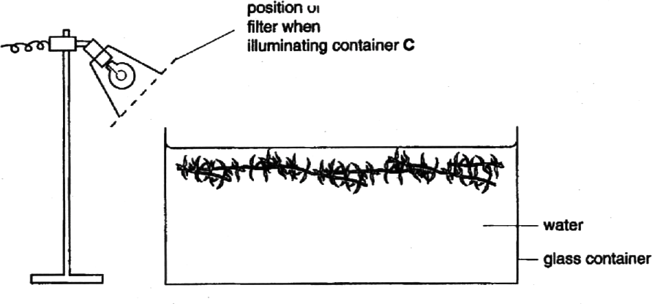

#### Fig. 5

Container **A** was lit by a 250 W bulb, **B** was lit by a 75 W bulb and **C** was lit by a 250 W bulb with a coloured filter in front of the lamp, as shown in Fig. 5

At weekly intervals, the plants were removed from each container in turn, gently dried, weighed and returned to the containers after their mass had been recorded. Fig. 6 shows the results plotted on a graph.

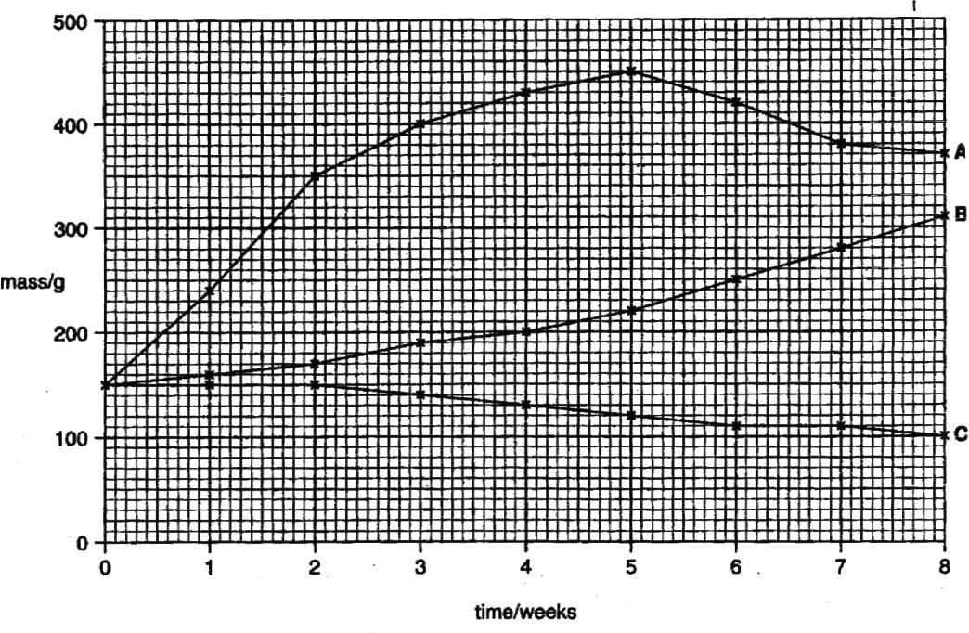

#### Fig. 6

### Extension 3

1. With reference to Fig. 6 calculate the percentage increase in mass of the plants in container **A** during the first five weeks of the experiment. (Show your working.)

% increase [2]

1. Suggest why the mass of plants in container **A** began to decrease after week 5, while the mass of plants in **B** continued to increase.

*Container* **A** ....................................................................................................................

*Container* **B** ....................................................................................................................

. [2]

1. During the eighth week, in which container would there be the least dissolved oxygen? Explain your answer.

*Container* ........................

*Explanation* .................................................................................................................................

. [2]

# Plant nutrition and transport – answers

### Core 1

a any three of these

light intensity increases the stomata open increase in temperature

greater rate of evaporation / transpiration / diffusion

|  |  |  |
| --- | --- | --- |
| b | factor- | temperature |
|  | explanation- | as light decreases the rate of loss continues to rise / temperature and water loss curves peak at the similar time |
| c | prediction- | rate of water loss / transpiration falls / lower |
|  | explanation- | air saturated / humid (thus less evaporation) |

### Core 2

a(i) 6CO2 / carbon dioxide 6O2 / oxygen

1. sun / solar / sunlight
2. chlorophyll
3. magnesium / iron / nitrate / ammonium b(i) phloem
4. starch is insoluble

has no osmotic effect / easier to retain in storage / prevent it being moved

1. cellulose

### Alternative to Practical 1

a A respiration / use of oxygen

* 1. transpiration / uptake of water / water loss
  2. photosynthesis

b(i) carbon dioxide / CO2

(ii) one from

glass beads stones empty tube

boiled, sterile, dry or dead seeds

1. one from

moving air / wind / fan / dry air speed up process enclosed in a bag / increase humidity slow process

cold air slow process

hot air speed up process

in darkness slow process

in light / sunny speed up process d(i) oxygen / O2

1. any one of these

### Extension 1

light-intensity fixed position of bulb / keep light on / same wattage / temperature- heat shield / in water bath / heat filter

carbon dioxide- add hydrogen carbonate to water biotic idea- use same piece of waterweed

* 1. any two from

presence of segmented body or abdomen presence of jointed limbs or appendages presence of head or eyes

presence of exoskeleton

* 1. tissue phloem / sieve tubes processes reference to translocation

reference to active transport or active uptake

c(i) sap vacuole gets smaller / shrinks / loses water / reference to increase in concentration

cytoplasm moves away from (cell) wall

cell wall no longer curves outwards

(ii) any three points

water potential in vacuole / cell is higher than outside

due to lower concentration of sugar molecules / higher concentration if water molecules in vacuole / cell

so water moves out by osmosis through (cell) membrane

d pesticides are absorbed into the leaf / plant / stem aphids feed on / suck / remove poisonous sap

### Extension 2

|  |  |  |
| --- | --- | --- |
| a | A | stoma / stomatal pore |
|  | B | guard cell |
|  | C | epidermal cell / epidermis |

b upper surface

C. Fistula has 18 stomata while B. Monhandra has none lower surface

C. Fistula has no stomata while B. Monhandra has 22

c(i) three of these points

water is only lost if stomata are present stomata open during the day

so water (vapour) is lost reference to transpiration

(ii) stomata are closed at night d any three of these points

reference to xylem

water enters xylem vessel through pots in walls reference to transpiration stream / pull reference to capillary action

reference to root pressure

e(i) rate will decrease

reference to smaller gradient for diffusion

(ii) rate will increase

more energy for evaporation

warm air can hold more water vapour than cold air

### Extension 3

a 300  100

150

 200%

1. container A

depletion of salts / nutrients seeds released

disease

shortage of carbon dioxide reached end of life cycle

container B

photosynthesis growth

nutrients not exhausted food stores

sufficient carbon dioxide

1. container C

least or no photosynthesis occurring respiration exceeds photosynthesis

death of plant so bacteria active, using up oxygen

# Respiration and the human transport system

## CORE questions

### Core 1

Two characteristics of living organisms are nutrition and respiration.

1. (i) List **three** other characteristics of living organisms.
   1. ..............................................................................................................
   2. ..............................................................................................................
   3. [3]

(ii) Name the process by which green plants produce carbohydrates. [1]

1. Living organisms release gases into the atmosphere as a result of their various activities. Complete the table, using a tick (✔) or a cross (✗), to show which gases are released.

|  |  |  |
| --- | --- | --- |
|  | carbon dioxide released into the atmosphere | oxygen released into the atmosphere |
| animals in bright light |  |  |
| green plants in bright light |  |  |
| animals in the dark |  |  |
| green plants in the dark |  |  |

[4]

[Total : 8]

### Core 2

1. Table 1 shows the frequency of human blood groups in a population.

#### Table 1

|  |  |
| --- | --- |
| human blood group | % frequency in the population |
| A | 46 |
| B | 9 |
| AB | 3 |
| O | 42 |

* 1. Plot the data in the table as a bar chart on the grid below.



[3]

* 1. What type of variation is illustrated by these data? State a reason for your answer.

*Type of variation* ...............................................................................................

*Reason* .............................................................................................................

. [2]

### Core 3

Fig. 1 shows a section through the heart.

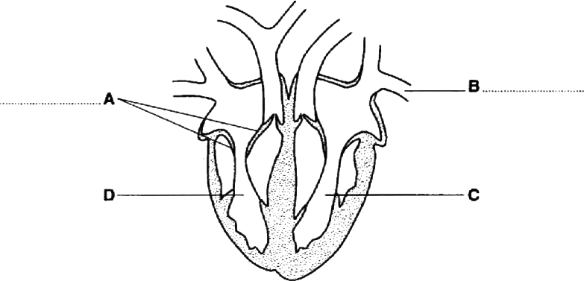

#### Fig. 1

1. On Fig. 1
   1. name the parts labelled **A** and **B**; [2]
   2. shade the cavity of the ventricle which contains oxygenated blood; [1]
   3. suggest why the wall around chamber **C** is much thicker than that around chamber **D.**

. [2]

1. The coronary arteries supply blood to the heart muscle.
   1. Suggest **two** activities of humans which might cause a clot in a coronary artery.
      1. ..............................................................................................................
      2. [2]
   2. Explain what might be the result of such a blockage.

. [2]

### Core 3

1. Fig. 2 shows a plan of the circulatory system.

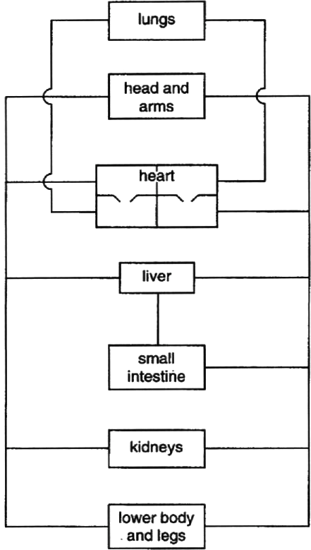

#### Fig. 2

On Fig. 2

* 1. label where urea is formed; [1]
  2. label where urea is excreted; [1]
  3. show, using a series of arrows, the route taken by urea between these two organs. [2]

[Total : 13]

## ALTERNATIVE TO PRACTICAL questions

### Alternative to Practical 1

Fig. 3 shows the apparatus that was used to investigate the activity of yeast in a glucose solution.

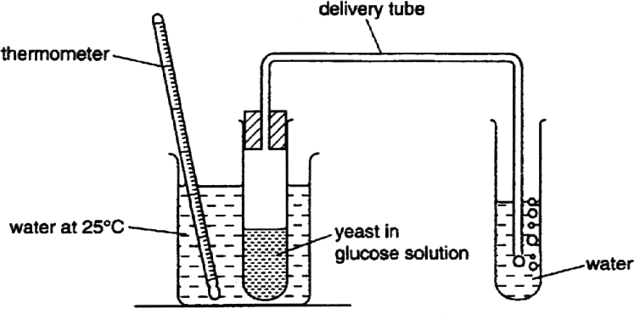

#### Fig. 3

The number of bubbles released in one minute was counted. This was repeated another four times.

The temperature in the water bath was then raised to 35 °C and five more counts were made.

#### Table 2

|  |  |  |
| --- | --- | --- |
|  | number of bubbles released in one minute | |
| 25 °C | 35 °C |
| 1 | 11 | 17 |
| 2 | 12 | 19 |
| 3 | 14 | 20 |
| 4 | 13 | 16 |
| 5 | 10 | 18 |
| total |  |  |
| mean (average) |  |  |

### Alternative to Practical 1

1. (i) Complete Table 3.1 to show the totals and mean numbers of bubbles released at each temperature. [2]
   1. Name the physiological process in yeast which is investigated in this experiment.

[1]

* 1. State the effect of raising the temperature on the activity of yeast.

Explain your answer.

*Effect*

*Explanation* ....................................................................................................... [3]

1. (i) Name the gas present in the bubbles.
   1. Describe a test you could use to identify this gas.

. [2]

1. Explain why it is better to leave the apparatus for a few minutes at each temperature before beginning to count the bubbles.

. [2]

[Total : 10]

## EXTENSION questions

### Extension 1

1. Describe the functions of each of the following parts of the heart:
   1. right atrium;
   2. right ventricle;
   3. tricuspid valve.

[9]

1. Outline the likely causes of a heart attack and suggest what preventive measures can be taken to maintain a healthy heart. [6]

[Total: 15]

### Extension 2

An athlete takes part in a race.

1. Describe and explain what happens to her breathing rate as a result of the race. [5]
2. The level of adrenaline increases at the start of the race. Describe the effect of this increased level of adrenaline in the athlete's body. [4]
3. At the end of the race the athlete's body temperature has increased. Outline the body processes which cause her temperature to return to normal after the race. [6]

[Total: 15]

# Respiration and the human transport system – answers

### Core 1

a(i) any three of these

growth movement

irritability / sensitivity excretion reproduction

1. photosynthesis b

|  |  |  |
| --- | --- | --- |
|  | carbon dioxide released into the atmosphere | oxygen released in to the atmosphere |
| animals in bright light |  | X |
| green plants in bright light | X |  |
| animals in the dark |  | X |
| green plants in the dark |  | X |

### Core 2

* 1. for three marks

axes oriented correctly

both axes labelled and with suitable scale on frequency axis all four columns correctly plotted

* 1. type discontinuous variation

reason there are no intermediate values between the four groups / there are distinctly separate sets of values

### Core 3

a(i) A tricuspid / right atrio-ventricular / right cuspid valve B pulmonary vein

1. all of cavity of left ventricle shaded
2. thicker wall can generate a greater pressurs / more powerful push / pump
3. to pump / push / force blood further / all round the body / not just to the lungs b(i) any two of these

smoking

fat / cholesterol rich diet lack of exercise

stress

1. restrict supply of oxygen / glucose / sugar to heart / ventricle muscle in area dies / heart ttack/ cannot respire

c(i) label to liver

1. label to kidney
2. arrows from liver to heart and heart to kidneys arrows from heart to lungs and back to heart

### Alternative to Practical 1

a(i)

|  |  |  |
| --- | --- | --- |
|  | 25 °C | 35 °C |
| total | 60 | 90 |
| mean (average) | 12 | 18 |

1. respiration / fermentation
2. Effect increase in number of bubbles released per min reference to a numerical increment

Explanation reference to role of enzymes involved / kinetic energy / more molecular collisions of enzyme and substrate

b(i) carbon dioxide

(ii) limewater turns milky white c agitation of tubes

equilibrium / temperature to be reached

### Extension 1

a(i) any three from these

receives blood from vena cava reference to blood being deoxygenated acts as reservoir

reference to thin muscle wall

contracts / reference to atrial systole to move blood to right ventricle

1. any three of these

receives blood from right atrium reference to thick / thicker muscle wall reference to builds up blood pressure

contracts / reference to ventricular systole to move blood to lungs via pulmonary artery

1. any three of these

reference to position

prevents backflow of blood / maintains blood flow in one direction reference to closing a ventricular systole / when pressure starts to build in right ventricle

so blood can only leave via pulmonary artery

b any six of these

reference to high saturated or animal fat diet / reduce saturated or animal fat content of diet

reference to too much cholesterol / reduce cholesterol content of diet fat / cholesterol builds up on coronary artery

atherosclerosis / atheroma

high salt diet / reduce salt content of diet stress / stress management

high blood pressure smoking / stop smoking

lack of exercise / take regular exercise obesity / take control of diet to reduce obesity

### Extension 2

1. any five of these

breathing rate increases

to increase amount of oxygen / to replace used oxygen needed for aerobic respiration

reference to muscles repaying oxygen debt remova of lacic acid

reove / exhale morecarbon dioxide control of breathing rate by brain

1. any four of these

increased heart rate / pulse rate to move blood faster

so more oxygen / glucose goes to muscles non-essential processes slow down increased air flow into lungs / breathing rate so aerobic respiration increases

stimulates conversion of glycogen to glucose increases mental awareness

1. any six of these

increase in sweat production secreted from sweat glands onto skin

sweat evaporated

removing heat from skin surface / reference to cooling effect vasodilation

arterioles

more blood flows near skin blood carries heat

so heat is lost from skin

panting causes heat loss from lungs hairs lowered to allow more heat loss

# Coordination, response and homeostasis

## CORE questions

### Core 1

1. State the term which is used to describe the maintenance of a constant internal environment in the human body.

[1]

1. Describe how each of the following processes helps to maintain the temperature of the body:
   1. sweating;

. [2]

* 1. vasodilation.

[3]

[Total : 6]

### Core 2

Fig. 1 shows the urinary system and its blood supply.

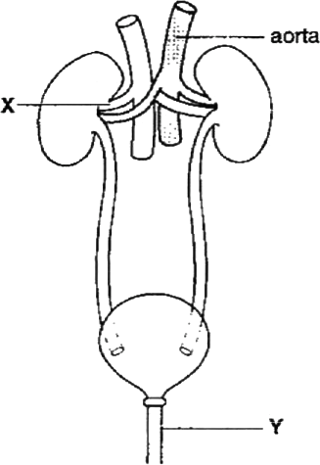

#### Fig. 1

1. (i) Identify the structures labelled **X** and **Y** on Fig. 1.

**X** ..............................................

**Y** .............................................. [2]

(ii) A function of the kidney is to remove urea from the blood. State **one** other function of the kidney.

..... [1]

1. The liver forms urea by breaking down excess amino acids. Name **two** other substances which are broken down by the liver.
   1. ..............................................
   2. .............................................. [2]
2. The liver and kidneys are organs which help to maintain a constant internal environment.

Which term describes this process?

.................................................. [1]

[Total:6]

### Core 3

1. A student reaching for a book on a bookshelf pricks his finger on the sharp point of a nail. He pulls his hand away very quickly.
   1. State the type of response which has occurred. [1]
   2. What is the effector in this response?

[1]

* 1. Name the type of nerve cell which links the central nervous system to the effector.

[1]

1. Fig. 2 shows part of the leg of a crab.

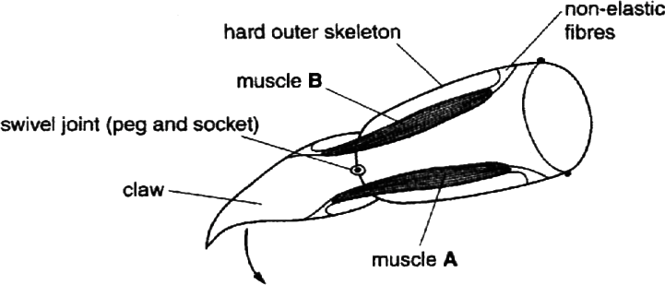

Fig. 2

* 1. State what happens to muscles, **A** and **B**, in order for the claw to move in the direction of the arrow.

*Muscle* **A** ...........................................................................................................

*Muscle* **B** [1]

* 1. Why do muscles in the leg occur in pairs?

[1]

* 1. Suggest why the fibres which join the muscle to the skeleton are non-elastic.

[1]

[Total : 6]]

## ALTERNATIVE TO PRACTICAL questions

### Alternative to practical 1

Fig. 3 shows a rotating clinostat with five seedlings attached.

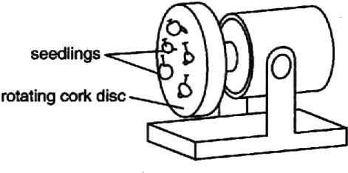

Fig. 3

The cork disc is rotated slowly so that all sides of the seedlings are equally exposed to the stimulus of gravity.

1. (i) On the diagram below, show the appearance of the seedlings after being attached to the rotating clinostat for two days. No labels are required.

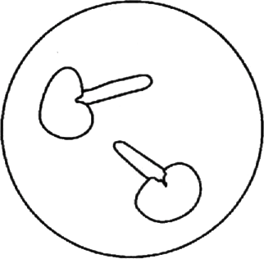

[1]

* 1. On the diagram below, show the appearance of the seedlings after two days if the clinostat had **not** been rotating.

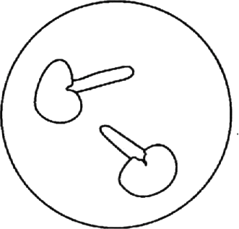

[2]

### Alternative to practical 1

* 1. Explain the new appearance of the seedlings in (a) (ii) after two days.

. [2]

1. (i) What condition must be provided to ensure continued growth of the seedlings over the two day period?

[1]

* 1. How could this be achieved?

[1]

1. Describe how you would ensure that **only** the response to gravity is being investigated.

[1]

[Total : 8]

## EXTENSION questions

### Extension 1

1. (i) Define the term *reflex action*. [3]

(ii) Describe the pupil reflex and explain its advantages. [5]

1. Distinguish between rods and cones in terms of function and distribution. [4]
2. Suggest how damage to **three named** parts of the eye could result in impaired vision or blindness. [3]

### Extension 2

[Total:15]

1. (i) Define the term *reflex action*. [3]

(ii) Describe the pupil reflex and explain its advantages. [5]

1. Distinguish between rods and cones in terms of function and distribution. [4]
2. Suggest how damage to **three named** parts of the eye could result in impaired vision or blindness. [3]

[Total:15]

# Coordination, response and homeostasis – answers

### Core 1

1. homeostasis

b(i) evaporation of sweat / water

removes heat from the body / cools the body / reference to latent heat of vaporisation

(ii) arterioles in skin relax

increased blood flow through surface capillaries more heat loss from body by convection / radiation

### Core 2

a(i) **X** – renal vein

**Y** – urethra

(ii) remove water / salts (from blood) or osmoregulation or

control of water / salt content (of the blood) b any two from these

alcohol

drugs / named drug haemoglobin

hormones / named hormone toxins

c homeostasis

### Core 3

a(i) reflex response / action / involuntary / automatic

1. arm muscles / named arm muscle / muscle (unqualified)
2. motor (neurone)

b(i) **A** – contracts **B** – relaxes **reject** – expands / stretches

1. to pull leg / part of leg in opposite / different directions
2. to pass / transmit all of muscle pull to skeleton / not to lose some pull in stretching the fibres

### Alternative to Practical 1

a(i) diagram shows all seedlings with longer straight roots

1. diagram shows all seedlings with curved roots towards source of gravity correct extended growth region
2. root tip / root / radicle responds towards gravity / grows downwards / shows geotropism

**reject** points downwards / bends (or alternative wording) correct reference to role of auxins

b(i) any one from

water / moisture air / oxygen

correct temperature / heat / warmth

**reject** carbon dioxide, light, minerals

(ii) must link to b(i) water / moisture

protective covering / glass / plastic box / keep seedlings moist / prevent seedlings drying out / adds water daily / supply water / soaked cotton wool

warmth

heat from lamp / in temperature box / facing the sun / out of air conditioned area / warm room

air / oxygen

ventilation / fan / breathing

c keep apparatus in the dark / uniform continuous light / red light / in light from all directions / keep moist to avoid hydrotropism

### Extension 1

a(i) automatic response to a stimulus

and one from

reference to very fast

reference to innate / not learned

(ii) any six points from these

light shines on (or alternative wording) retina electrical impulse generated (or alternative wording) passed to brain via motor neurones

to iris

circular muscles contract **reject** references to ciliary muscles to make pupils smaller

protects rods and cones / retina from damage

reflex is very fast / does not require thought / does not require decision

1. any four from

cones detect colour

reference to three types of cones / detect red, green, blue cones needed for fine detail

rods cannot detect colour / only produce image in black and white rods distributed all over retina

cones concentrated in fovea / yellow spot

cones only stimulated by bright light / rods sensitive to dim light

1. any three from these

rods / cones / retina / damaged by bright light so not receptive lens cloudy or damaged so light cannot pass through

cornea cloudy or damaged so light cannot pass through eyeball deformed / retina detached so cannot focus

optic nerve damaged so no impulses transmitted (or alternative wording)

### Extension 2

1. any four points from these excretion

removal from the body of waste products of metabolism

reference to substances which are poisonous / in excess / surplus to requirements

eqestion

removal of faeces from the body reference to via anus

1. drawing marks

includes aorta, renal artery, kidney, ureter, bladder and urethra drawing clear and parts correctly labelled

explanation

reference to blood from aorta to renal artery blood enters kidney

water filtered out

reference to formation of urine urine passes down ureter reference to storage in bladder

reference to sphincter muscle and role urine passes through urethra

1. any four from

reference to deamination / breakdown of proteins or amino acids reference to formation of urea

reference to breakdown of hormones / named hormones reference to breakdown of alcohol

reference to breakdown of nicotine / other named drugs

# Reproduction in plants

## CORE questions

### Core 1

A plant was allowed to disperse its seeds naturally. The seedlings were examined two weeks after they had started to grow. They were found to be of very different heights.

* 1. Suggest **three** environmental factors which could have affected the height of the seedlings.
     1. ...........................................................................................................................
     2. ...........................................................................................................................
     3. [3]
  2. The seedlings all developed from the seeds of a single plant. The plants which later developed from these seedlings showed a number of inherited differences. Suggest **three** possible reasons for these inherited differences.
     1. ...........................................................................................................................
     2. ...........................................................................................................................
     3. ...........................................................................................................................

[3]

[Total : 11]

### Core 2

Fig 1 shows a section through a bean flower.

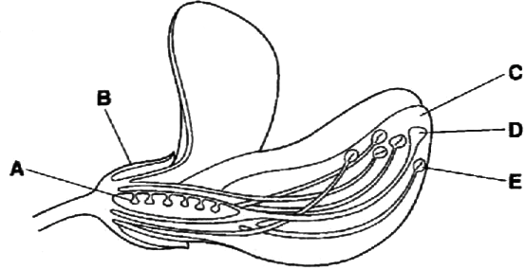

#### Fig.1

1. Name the parts labelled **A** and **B.**
   1. ..................................................
   2. .................................................. [2]
2. This flower is insect pollinated. Suggest how parts **C, D** and **E** help in pollination of this flower.

[3]

1. After pollination the ovules develop into seeds. Describe the events which occur after pollination and which result in the formation of seeds.

[4]

[Total : 9]

## EXTENSION questions

### Extension 1

Fig. 2 is a longitudinal section through a root tip showing the regions of growth and development.

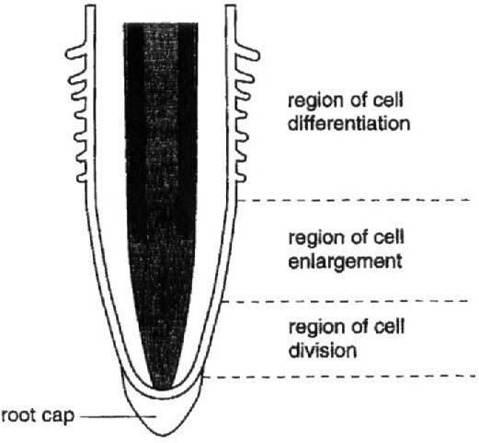

#### Fig. 2

1. Distinguish between the terms *growth* and *development*.

[3]

1. Outline what happens in the region of cell division.

[3]

### Extension 1

The enlarging cells get bigger by absorbing water.

1. (i) Name the process responsible for this absorption of water.

[1]

* 1. What condition must exist in a cell for water absorption to occur?

[1]

* 1. Which cell feature prevents the enlarging cells from bursting? [1]
  2. Suggest how the enlargement of these cells makes the root grow longer.

. [2]

In the region of cell differentiation, a number of different tissues are formed.

1. (i) Define the term *tissue*.

. [2]

* 1. Table 1 contains some information about root tissues and their functions. Complete the table.

#### Table 1

|  |  |
| --- | --- |
| name of tissue | function |
| xylem |  |
|  | transport of sugars |
|  | absorption of water from the soil |

[3]

[Total: 16]

### Extension 2

1. Define the term *pollination*. [2]
2. Describe the structure of a **named** insect-pollinated flower and state the functions of its parts. [10]
3. Describe how cross-pollination leads to variation in a species. [3] [Total:15]

### Extension 3

1. Discuss, giving examples, how the use of modem technology has resulted in increased food production. [9]
2. How is plant growth affected by a deficiency of magnesium ions? [3]
3. How can minerals, trapped in the bodies of dead animals, become available for plant use? [3]

[Total:14]

**Reproduction in plants – answers**

### Core 1

* 1. any three of these

amount / brightness of sunlight / light water availability

mineral supply rooting space

other soil factors e.g. pH

disease infections / damage by herbivores / animals affected by competitor species

* 1. any three of these

meiosis leading to variations in ovules / female gametes / nuclei meiosis leading to variation on pollen grains / male gametes / nuclei second / male parent may be different for different seeds / fertilisation of ovules from different pollen grains

possibility of mutations / specific mutagen action

correct reference to different genotypes of parents / heterozygous state for some genes

### Core 2

* + 1. A ovule / ovary B sepal / calyx
    2. C (petals are) coloured / bright / shaped / produce nectar / have nectar guides to attract insects

D (stigma / style) receives pollen from pollinator / insect

E (anther / stamen) produces pollen / place pollen on insect

* + 1. fusion of gametes / nuclei / fertilisation plus any three of these

pollen tube grows / develops / forms through / down style / to ovary

to micropyle / ovule / embryo sac

male gamete passes through pollen tube / moves to female gamete/nucleus

zygote develops into embryo

reference to female gamete as egg cell, ovum

### Extension 1

1. growth at least one from

increase in size or number of cells or dry mass / getting larger irreversible / permanent

due to cell division

development at least one from increase in complexity

formation of different cells / tissues / organs / additions of new features

1. three references from mitosis chromosomes division of nucleus

formation of new cells / daughter cells

being identical / of same genetic composition c(i) osmosis / diffusion

1. higher concentration of solutes than outside the cell / lower water potential in cell
2. cell wall
3. two points from

cell swells up / becomes turgid / gets longer / elongates press against each other

results in increase in overall length of root / whole root gets longer downward growth as a result of upper part of root being anchored cells elongate vertically

d(i) group of cells of the same type carrying out the same function

1. name of tissue function

(xylem) transport of water or minerals / support phloem / sieve tubes (transport of sugars)

root hair (cells) (absorption of water from soil)

### Extension 2

* 1. transfer of pollen

from anther / stamen to stigma

* 1. ten marks from the following

named insect-pollinated flower

sepals, description of position or shape or appearance reference to protection of flower while in bud

petals, description of position or shape or appearance

attracting insects / acting as landing stage / guides present to direct insects to nectar

stamen = anther + filament

anther, description of position or shape or appearance pollen

filament, description of position or shape or appearance supports anther

carpel = stigma + style + ovary

stigma, description of position or shape or appearance receives pollen

style, description of position or shape or appearance

supports stigma for pollination / acts as a pathway for pollen tube ovary, descriptions of position or shape or appearance

contains ovules / reference to site of fertilisation / becomes the fruit nectary position / reference to scent

produces nectar

flower stem supports flower for greater visibility to insects

receptacle acts as base for other flower parts ovule and position

forms seeds

* 1. reference to mixing of genetic material can result in different genotypes

so phenotypes / offspring appearance can be different

### Extension 3

1. any nine from these

chemical or artificial fertilisers provide more of named mineral or element

results in greater crop yield (linked to above)

pesticides / fungicides reduces crop damage by insects or fungi / farm animal infestation

herbicides reduce competition between crop and weeds for named requirements (e.g. light / minerals / water)

reference to use of machinery

larger areas of land to be cultivated / saves time reference to artificial selection of crop types

results in greater yield / ability to grow crops on harsh climates reference to genetic engineering / cloning

one example of use

reference to use of bacteria to make yoghurt reference to use of yeast in bread-making

reference to use of single cell protein to make meat substitutes reference to controlled conditions in greenhouse

reference to improved weather forecasting and application use of satellites to observe crop disease / need for fertiliser use of computerisation and application

reference to intensive animal farming / fish farming use of animal food concentrates / balanced feeding

use of antibiotics / hormones / other drugs for animal rearing / plant growing or fruit production

reference to biological control of pests

1. any three of these

needed for production of chlorophyll needed to trap sunlight

reference to photosynthesis no sugars produced

so protein synthesis not possible

reference to chlorosis / yellowing of leaves / pale leaves

1. reference to decomposition / rotting

by fungi / bacteria / saprophytes / named decomposers releases minerals into the soil

# Human reproduction

## CORE questions

### Core 1

1. State what is meant by the term *sexual reproduction*.

[3]

1. Fig. 1 shows the mate reproductive system.

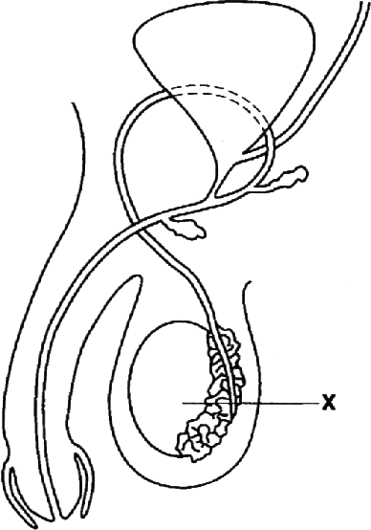

#### Fig. 1

* 1. Name the part labelled **X** and state **two** of its functions.

*Name* .............................................................................................................................

*Function 1 ......................................................................................................................*

*Function 2* ......................................................................................................................

[3]

* 1. Birth control can be brought about by surgery. Mark clearly on Fig. 1 where such an operation would be carried out in a male. [1]

### Core 1

1. The male sex hormone causes a number of changes in the body during puberty. State **two** of these changes other than changes to the reproductive system.
2. ....................................................................................................................................

........................................................................................................................................

1. ....................................................................................................................................

. [2]

[Total : 9]

### Core 2

Table 1 shows the average masses of girls and boys from birth to 20 years of age.

#### Table 1

|  |  |  |  |
| --- | --- | --- | --- |
| girls | | boys | |
| age/years | mass/kg | age/years | mass/kg |
| 0 | 3 | 0 | 4 |
| 1 | 9 | 1 | 10 |
| 4 | 16 | 4 | 16 |
| 8 | 25 | 8 | 28 |
| 12 | 40 | 12 | 38 |
| 16 | 53 | 16 | 59 |
| 20 | 56 | 20 | 65 |

1. (i) Plot both sets of data as separate curves on the grid provided opposite. [5]
   1. Using your graph, state at which ages the average masses of girls and boys are the same.

. [2]

* 1. State **two** factors, apart from its sex, which could affect the mass of a baby at birth.
     1. ..............................................................................................................
     2. [2]

1. (i) What evidence in the graph shows that girls undergo puberty before boys? [1]
   1. Name the hormone responsible for the changes which occur at puberty in females.

[1]

* 1. State **two** changes which occur at puberty in females.
     1. ..............................................................................................................
     2. ..............................................................................................................

[Total: 13]

### Core 2

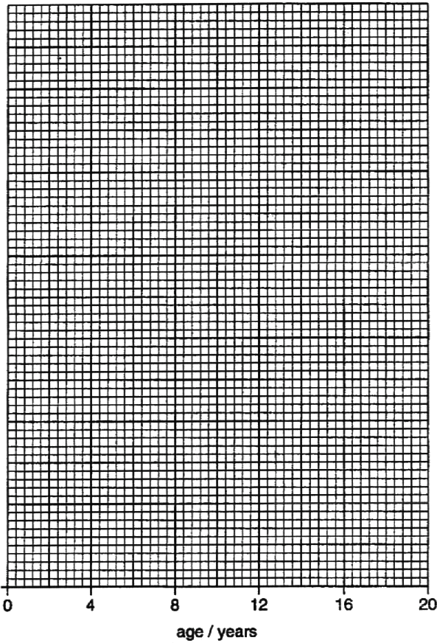

## EXTENSION questions

### Extension 1

Pregnant women at high risk of having a baby with Down’s syndrome are often offered an amniocentesis. This technique is shown in Fig. 2

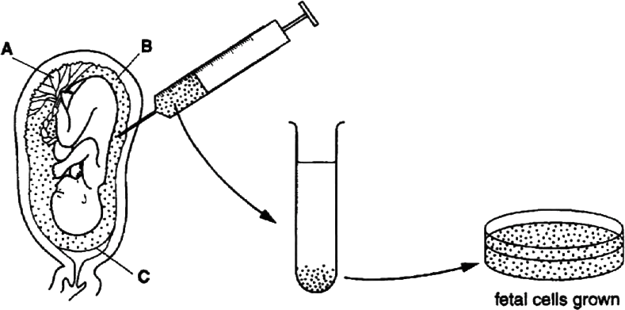

#### Fig. 2

1. Complete the table by identifying the parts labelled **A, B** and **C** and stating a function of each one.

|  |  |  |
| --- | --- | --- |
| part | name | function |
| **A** |  |  |
| **B** |  |  |
| **C** |  |  |

[6]

The technique involves taking a sample of **B** from within the uterus. Fetal cells in the sample are then grown and analysed.

1. (i) Suggest how the cells would be different from normal cells if the fetus has Down’s syndrome.

.... [1]

(ii) What is the cause of this difference?

[1]

### Extension 1

1. Suggest how the sex of the fetus could be identified by observation of fetal cells.

[3]

During pregnancy women may also be monitored in other ways, including urine sampling.

1. Suggest why the urine of pregnant women is analysed.

. [2]

[Total: 13]

### Extension 2

1. Describe the movement of **named** materials from the mother to the fetus. [6]
2. Describe the signs, symptoms and effects of the disease syphilis. [6]
3. Explain
   1. how HIV is transmitted, and
   2. how its spread can be prevented. [7]
4. Explain why the methods for treating syphilis cannot be used for the treatment of AIDS. [2]

# Human reproduction – answers

### Core 1

a increase in numbers / producing new individuals requiring the fusion / joining

of gametes / sperm and ovum / two special cells / genetic material / DNA form two individuals

b(i) X – testis

production of sperm / gametes

production of testosterone / male hormone

(ii) mark / cut shown clearly on sperm duct, not at the junction with the urethra c any two from

deepening of voice / breaking of voice development of facial hair development of pubic / axillary hair widening of shoulder girdle enlargement of limb muscles

### Core 2

a(i) five marks awarded as follows

vertical axis labelled logical scale

points plotted accurately points joined

lines identified

1. 10 / 11 years

14 / 15 years

1. any two from mother’s diet

genetic factors disease

if mother smokes / passive smoking

if it is a single / multiple birth / premature birth

b(i) increase in mass in teenage years begins earlier / girls at 12 are heavier then boys

1. oestrogen
2. any two of these

onset of menstrual cycle / periods start / ovulation starts widening of hips

development of breasts / mammary glands axillary hair / pubic hair

redistribution of fat layer under skin

### Extension 1

a A = placenta reference to transfer / exchange of materials, mother to foetus /

v.v.

B = amniotic fluid cushions foetus from physical damage / absorbs excretory materials from foetus / supports foetus

C = amnion / amniotic sac / amniotic membrane

contains amniotic fluid / secretes amniotic fluid b(i) reference to presence of 47 chromosomes / extra chromosome

(ii) reference to mutation

reference to unequal chromosome division reference to extra number 21 chromosome

1. reference to use of microscope / analyse or observe chromosomes presence of xx chromosomes = girl / female

presence of xy chromosomes = boy / male

1. EITHER

reference to testing for presence of glucose to test for diabetes

OR

reference to testing for protein

reference to possible consequences of protein loss reference to testing for diseases

reference to testing for drugs reference to checking hormone levels

### Extension 2

1. any six of these points reference to placenta

allows maternal blood to come close to that of foetus allows diffusion of materials

reference to foetal capillaries reference to transfer of oxygen

from maternal red blood cells / haemoglobin

reference to transfer of glucose / amino acid / other named nutrient reference to transfer of antibodies

reference to plasma, linked to above

pass from placenta to foetus via umbilical cord / vein

1. any six of the following

chancre / hard lump / painless sore / blister on part of body which contacted partner reference to rash / sore throat

reference to raised temperature reference to headache

reference to ulceration / sores on other parts of body reference to discharge

any tertiary symptom or effect: hair loss / teeth / nose / skeleton / skin / brain / nervous system / liver / blood vessels / paralysis / blindness / infertility / insanity /

aneurism / death / damage to foetus reference to 3 stage disease / stages named

c(i) any four of these

transmitted in named body fluid e.g. blood, semen passed during unprotected sex

reference to use of shared needles / razors / unsterilised needles reference to blood transfusions with unscreened blood / organ transplants reference to transmission from mother to foetus

(ii) any three of these

reference to education about AIDS / HIV

use of condom during sexual intercourse / reference to safe sex use of sterile needles / do not share needles / avoid contact with contaminated

blood

avoid casual sex

d any two from

syphilis is caused by a bacterium HIV is a virus, not AIDS

antibiotics are not effective against viruses

# Inheritance and evolution

## CORE questions

### Core 1

Hair colour in mice is controlled by a gene with two alleles. A homozygous black-haired mouse was bred with a homozygous brown-haired mouse. All the offspring were black-haired.

1. (i) Explain what is meant by the terms *homozygous* and *recessive*.

*Homozygous* .....................................................................................................

*Recessive* .........................................................................................................

. [2]

(ii) Which is the dominant hair colour in mice?

[1]

1. One of the heterozygous black-haired offspring was bred with a homozygous brown- haired mouse.
   1. Using the symbols **B** and **b** to represent the two alleles, draw a genetic diagram to show the outcome of this cross. [4]
   2. State the ratio of the phenotypes of the offspring. [1]

[Total : 8]

### Core 2

Fig. 1 shows, in outline, the stages of the division of a cell.

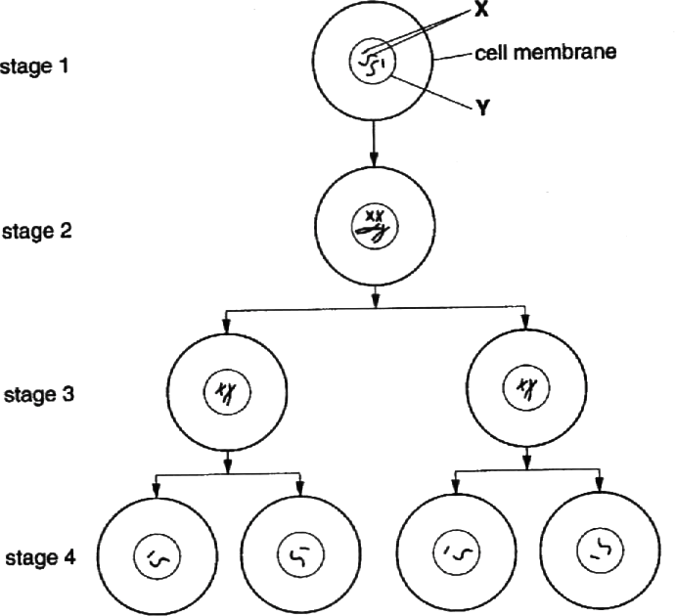

#### Fig. 1

1. (i) Name the structures labelled **X** and **Y.**
   1. ........................................
   2. ..............................

[2]

1. Identify, with a reason, the type of cell division shown in Fig. 1.

*Type of cell division* ..........................................................................................

*Reason* .............................................................................................................

[2]

1. Name an organ in the body where this type of cell division occurs. [1]
2. What process must occur if a cell in stage 4 is to form a cell similar to that shown in stage 1?

[1]

[Total : 6]

### Core 3

Fig. 2 shows the inheritance of a condition in humans known as phenylketonuria (PKU).

This condition affects the liver, causing it to produce toxins which can affect the mental health of the sufferer.

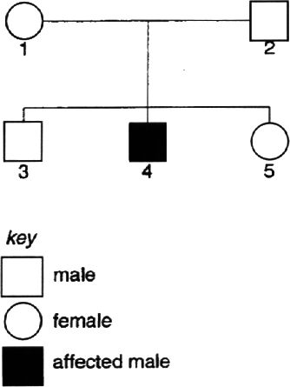

#### Fig. 2

1. State, with an explanation, whether the allele for PKU is dominant or recessive.

[3]

1. (i) Using the symbols **H** for the dominant allele and **h** for the recessive allele, state the genotypes of individuals 1 and 4.

*Individual 1.* ......................................................................................................

*Individual 4.* [2]

(ii) What are the **two** possible genotypes of individual 3? [1]

[Total : 6]

## ALTERNATIVE TO PRACTICAL questions

### Alternative to Practical 1

Fig. 3 is a photograph of a flight feather of a bird.

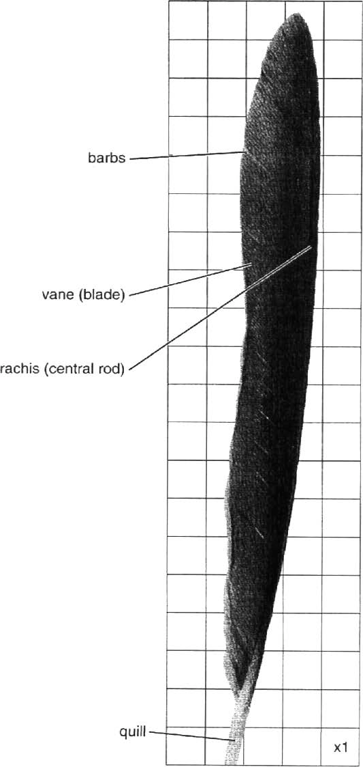

#### Fig. 3

1. Determine the surface area of the feather, excluding the quill.

Show your working.

*Surface area of feather* ........................................cm2 [3]

### Alternative to Practical 1

Fig. 4 is a photograph of a down feather. These feathers form a dense layer close to the skin surface of a bird.

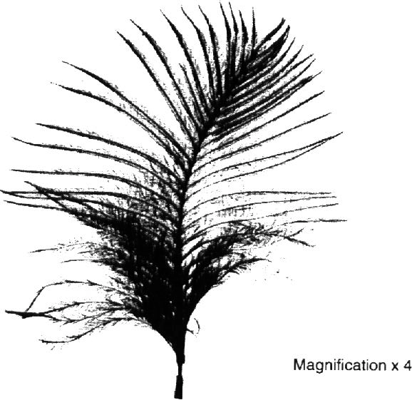

#### Fig. 4

1. Complete Table 1 to show **three visible** differences between the flight feather in Fig. 3 and the down feather in Fig. 4.

#### Table 1

|  |  |  |
| --- | --- | --- |
|  | flight feather | down feather |
| 1 | ....................................... | ....................................... |
| ....................................... | ....................................... |
| 2 | ....................................... | ....................................... |
| ....................................... | ....................................... |
| 3 | ....................................... | ....................................... |
| ....................................... | ....................................... |

[3]

### Alternative to Practical 1

1. (i) Suggest how the down feathers may be important especially to young birds in cold climates.

. [2]

(ii) Using a beaker of hot water to represent a young bird, describe an experiment you could carry out to support your suggestion in (c) (i).

[3]

[Total : 11]

## EXTENSION questions

### Extension 1

Cystic fibrosis is an inherited disorder in humans in which an important protein is not produced. This protein is responsible for preventing the accumulation of thick and sticky mucus in the breathing tubes. The allele which causes cystic fibrosis is recessive to the normal allele (F).

1. State the genotype of
   1. a carrier of cystic fibrosis; [1]
   2. a sufferer of cystic fibrosis [1]
2. Draw a genetic diagram to show if it is possible for a man with a dominant pair of alleles and a woman who is a carrier to produce a baby with cystic fibrosis. Identify the phenotypes of the children.

[4]

1. Suggest how the build up of sticky mucus would affect a sufferer of cystic fibrosis.

. [2]

[Total : 8]

### Extension 2

Some people suffer from sickle cell anaemia. They have abnormal red blood cells.

1. (i) Describe the shape of a **normal** red blood cell.

[1]

* 1. State how the appearance of an abnormal red blood cell from a sufferer of sickle cell anaemia differs from a normal red blood cell.

[1]

* 1. What is the effect of sickle cell haemoglobin on the function of the red blood cell?

[1]

The allele for normal haemoglobin is represented by the symbol HA. The allele for sickle cell haemoglobin is represented by the symbol HS. The alleles are codominant.

1. State the genotypes for
2. a person with normal haemoglobin;

[1]

1. a heterozygous person;

[1]

1. a person with sickle cell anaemia.

[1]

1. Which of the genotypes stated in (b) is likely to result in
2. the greatest protection from malaria?

[1]

1. the greatest risk of an early death in a malaria-free country? [1]

A man with sickle cell anaemia married a woman heterozygous for sickle cell.

1. Using a genetic diagram, predict the possible percentage of their children that would suffer from sickle cell anaemia.

*Percentage* .............................................. [5]

[Total : 13]

### Extension 2

A man with sickle cell anaemia married a woman heterozygous for sickle cell.

(d) Using a genetic diagram, predict the possible percentage of their children that would suffer from sickle cell anaemia.

*Percentage* ................................. [5]

[Total : 13]

# Inheritance and evolution – answers

### Core 1

a(i) homozygous – both alleles present are the same / individual received the same allele from both parents / gametes

recessive – an allele which is only exhibited when present in the homozygous state / when the dominant allele is not present / masked by dominant allele, not gene

(ii) black

b(i) up to 4 points are scored for the following

use of capital B for dominant (black) allele / lower case b for recessive allele correct genotypes for both parents (Bb, bb)

gametes correctly displayed (B, b and b, b or b) correct genotypes of offspring (Bb, bb)

correct phenotypes identified (for all offspring)

(ii) correct ratio predicted (1:1 or 1 in 2 or 50%, 50%)

### Core 2

a(i) X – chromosomes

Y – nucleus / nuclear membrane

1. meiosis – four nuclei are produced / number of chromosomes / genetic material is halved / new nuclei haploid
2. ovary / testis / gonad

b fertilisation / fusion of sperm and ovum / gametes / formation of zygote

### Core 3

1. recessive

4 has inherited PKU from parents (or alternative wording)

as it is not apparent in 1 or 2 / neither parent shows it / if dominant a parent would show it / have PKU

b(i) 1 – Hh 4 – hh

1. HH and Hh

### Alternative to Practical 1

* 1. working includes

squares to be marked on the feather breakdown of rows into sub-totals / tally grids total to be in the range 25 – 30 cm2

* 1. three visible differences to include references to shape, area, appearance of barb or blade, appearance of rachis (central rod), size or shape of quill

c(i) insulation / traps air / keeps it warm / stops heat escaping / traps heat maintains body temperature / homiothermy / warm blooded reference to young birds do not fly or less

active so generate less heat / large surface area to volume ratio / no regulation of body temperature / not able to keep temperature the same

(ii) any three of these within the context of a fair test

uses several feathers or any insulation to wrap around a body / glassware use of thermometer to follow cooling recorded at intervals

comparison of apparatus with and without any covering or with flight feathers

### Extension 1

a(i) Ff

(ii) ff

b

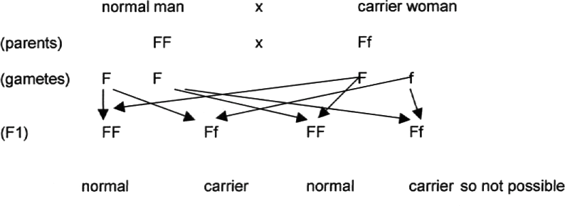

* 1. any two of these

reference to trachea /bronchi / bronchioles / alveoli blocked or congested makes gaseous exchange more difficult

reference to lack of energy / respiration impaired reference to being more susceptible to infections reference to digestion affected

### Extension 2

a(i) biconcave disc

1. reference to sickle / crescent shaped
2. able to carry / absorb less oxygen b(i) HAHA
3. HAHS
4. HSHS

c(i) HSHS

(ii) HSHS

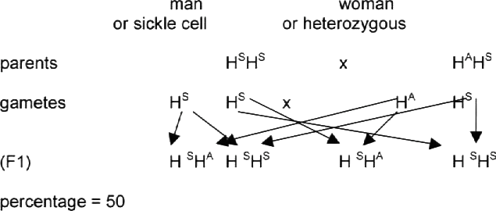d

# Organisms and environment

## CORE questions

### Core 1

Fig. 1 shows five arthropods, each of which could carry disease organisms.

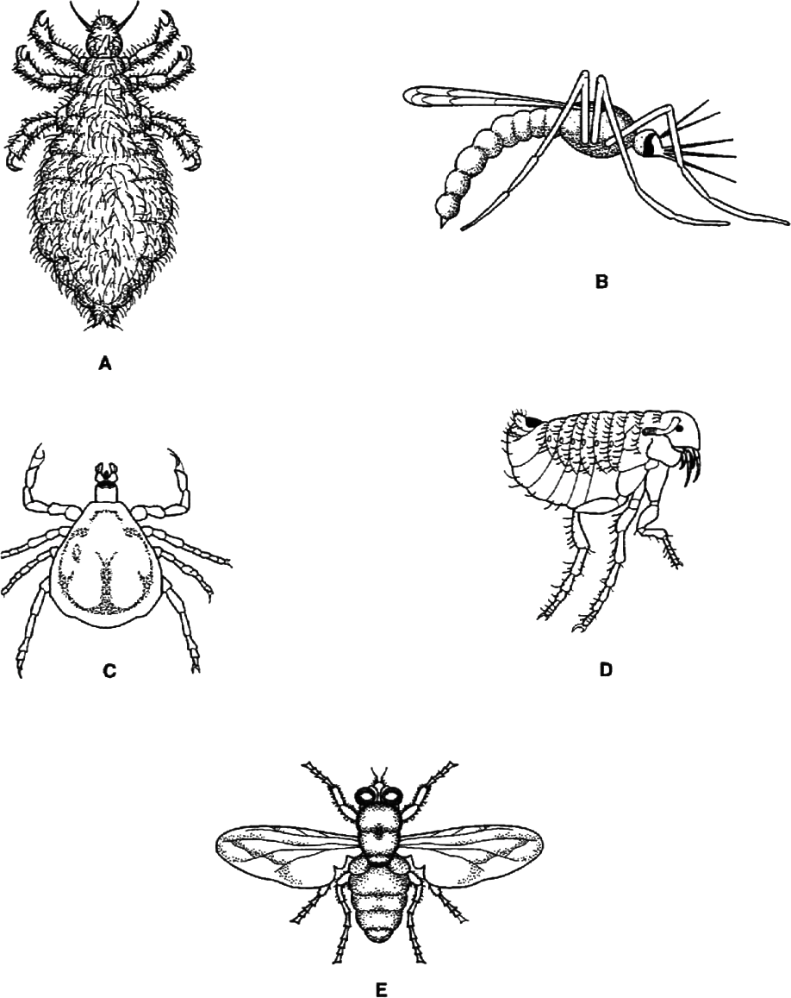

#### Fig. 1

### Core 1

Use the key to identify each of the animals. Complete Table 1 to show your identifications.

KEY

1. Wings present Go to 2

Wings absent Go to 3

1. Wings longer than the abdomen *Musca*

Wings shorter than the abdomen *Anopheles*

1. Has three pairs of legs Go to 4

Has four pairs of legs *Ornithodorus*

1. All pairs of legs of similar length *Pediculus*

One pair of legs shorter than the other two pairs *Pulex*

#### Table 1

|  |  |
| --- | --- |
| Name of arthropod | Letter |
| *Anopheles* |  |
| *Musca* |  |
| *Ornithodorus* |  |
| *Pediculus* |  |
| *Pulex* |  |

[4]

[Total : 4]

### Core 2

Fig. 2 shows single leaves from each of six different trees.

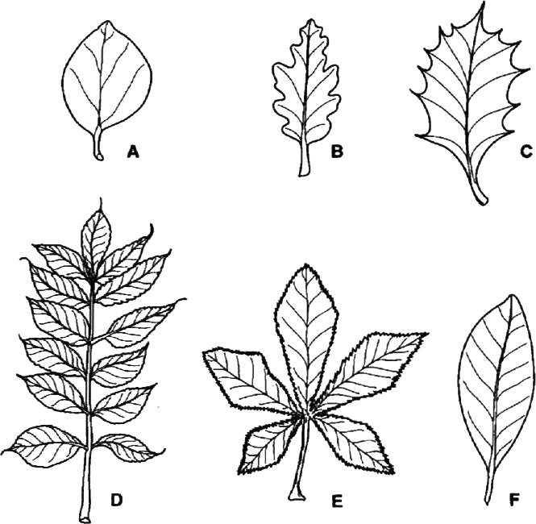

#### Fig. 2

Use the key below to identify from which tree each leaf comes. Write the name of each tree in the correct box of Table **2.** As you work through the key, tick the boxes in Table **2** to show how you identified each leaf. Leaf A has been identified for you as an example.

#### Key

|  |  |  |  |
| --- | --- | --- | --- |
|  | | | Name of tree |
| 1 | (a) | Leaf with a smooth outline | 2 |
|  | (b) | Leaf with a jagged outline | 3 |
| 2 | (a) | Leaf about the same length as width | *Cydonia* |
|  | (b) | Leaf about twice as long as it is wide | *Magnolia* |
| 3 | (a) | Leaf divided into more than two distinct parts | 4 |
|  | (b) | Leaf not divided into more than two distinct parts | 5 |
| 4 | (a) | Leaf divided into five parts | *Aesculus* |
|  | (b) | Leaf divided into ten or more parts | *Fraxinus* |
| 5 | (a) | Leaf with pointed spines along its edge | *Ilex* |
|  | (b) | Leaf with rounded lobes along its edge | *Quercus* |

### Core 2

#### Table 2

|  |  |  |  |  |  |  |  |  |  |  |  |
| --- | --- | --- | --- | --- | --- | --- | --- | --- | --- | --- | --- |
| Leaf | 1a | 1b | 2a | 2b | 3a | 3b | 4a | 4b | 5a | 5b | Name of tree |
| **A** | ✔ |  | ✔ |  |  |  |  |  |  |  | *Cydonia* |
| **B** |  |  |  |  |  |  |  |  |  |  |  |
| **C** |  |  |  |  |  |  |  |  |  |  |  |
| **D** |  |  |  |  |  |  |  |  |  |  |  |
| **E** |  |  |  |  |  |  |  |  |  |  |  |
| **F** |  |  |  |  |  |  |  |  |  |  |  |

[4]

[Total : 4]

### Core 3

Fig. 3 shows a nitrogen cycle for open grassland.

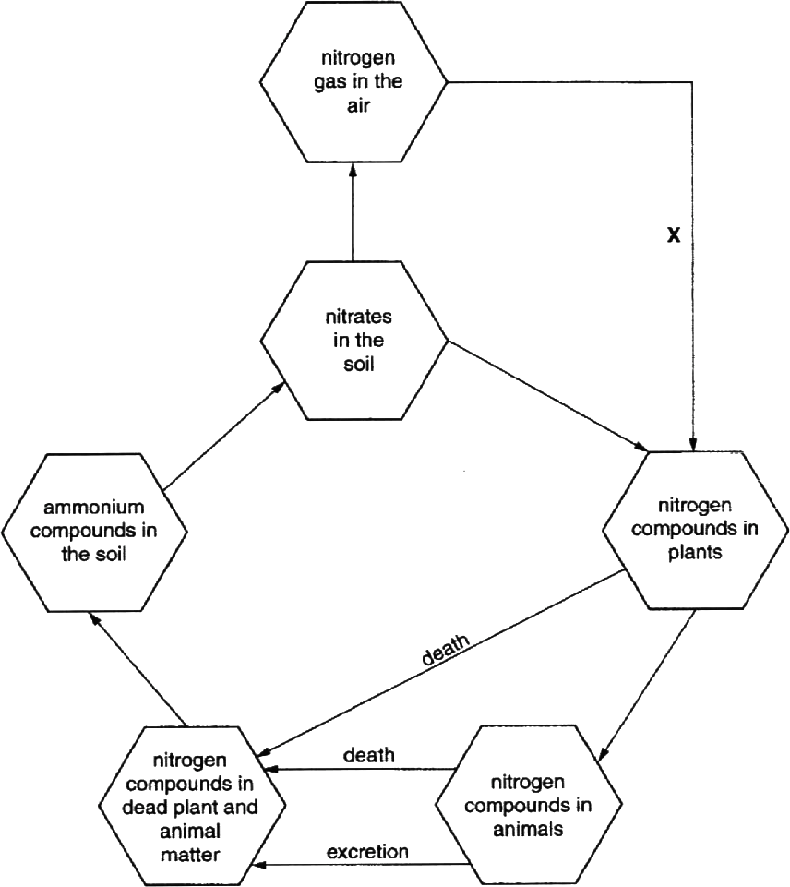

#### Fig. 3

1. (i) Name **one** nitrogen compound found in plants.

. [1]

* 1. Name an example of a nitrogen compound which is excreted by mammals. [1]

### Core 3

* 1. Process **X** can only occur in certain plants. Which group of organisms carry out this process and where in a plant are they found?

*Organism* ..........................................................................................................

Where found [2]

1. The grassland is ploughed up and turned into farmland. Crops of maize are grown on it year after year.
2. Predict and explain the effect of this change on the nitrogen cycle and on the crop yield.

*Effect on the nitrogen cycle* ..............................................................................

*Effect on crop yield* ...........................................................................................

[4]

1. Suggest **one** way in which the farmer could prevent the effect on crop yield.

[1]

[Total : 9]

## ALTERNATIVE TO PRACTICAL questions

### Alternative to Practical 1

Fig. 4 shows a food web for a freshwater pond.

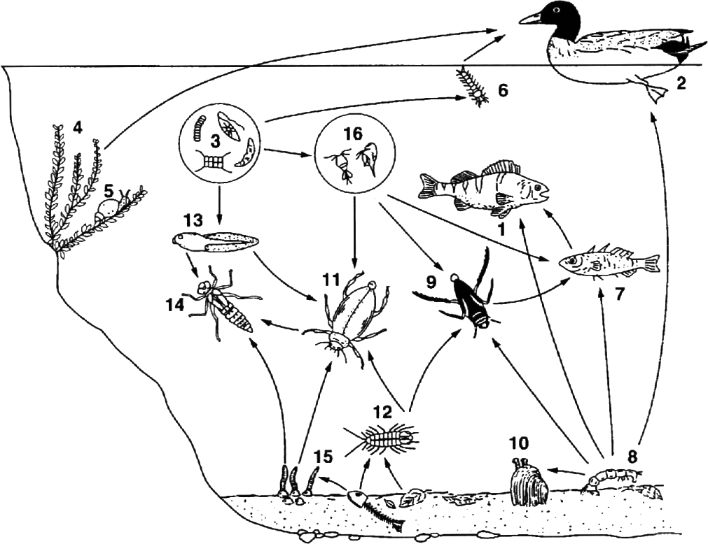

#### Fig. 4

(organisms 3 and 16 are greatly enlarged)

1. Two trophic levels are listed below. For each level, state **two** examples from Fig. **4**

Identify them by their **numbers.**

* 1. *Primary consumers (herbivores)* .................... and .......................
  2. *Secondary consumers (carnivores)* .................... and ....................

[2]

### Alternative to a practical 1

1. Using only the numbers in Fig. 4 construct a simple food chain with **five** stages.

. [2]

1. Suggest how you could collect large numbers of the microscopic organisms numbered **3** in Fig. 4.

. [2]

[Total : 6]

## EXTENSION questions

### Extension 1

1. Distinguish between the following groups of organisms:
   1. viruses and bacteria;
   2. arachnids and crustacea;
   3. monocotyledons and dicotyledons. [12]
2. Using an example, explain the term *binomial system*. [3] [Total : 15]

### Extension 2

Fig. 5 shows the proportion of all known species in each of the main groups of organisms.

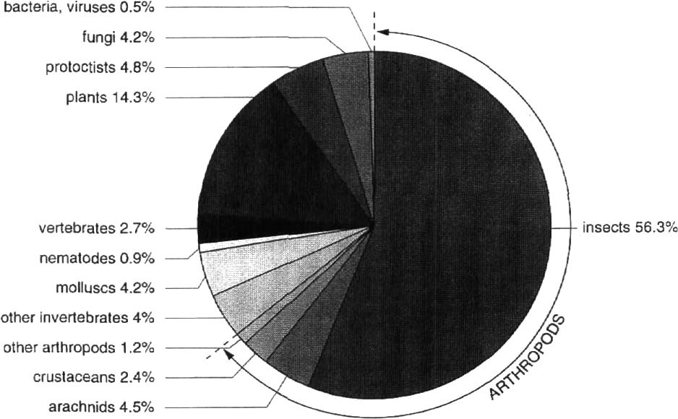

#### Fig. 5

1. (i) Apart from insects, which group of organisms in Fig. 5 has the most known species?

[1]

* 1. Fungi are shown as a separate group of organisms. State **two** reasons why fungi are **not** classified as plants.
     1. ..............................................................................................................
     2. [2]

### Extension 2

1. (i) Use information from the pie chart to calculate what percentage of the arthropods are insects. Show your working.

............................................% [2]

* 1. State **one** feature of insects which contributes to their success and explain how this feature is beneficial to the group.

*Feature* .............................................................................................................

*Explanation* .......................................................................................................

[3]

1. 2.7% of all known species are vertebrates. Birds is one class of vertebrates.
2. State **one** feature which distinguishes this class from ail the other vertebrate classes.

[1]

1. State **one** external feature which birds have in common with fish. [1]
2. It is estimated that 1.7 million species of organisms have been named. Use data from the pie chart to calculate the total number of plant species known. Show your working.

*Total* ............................................ [2]

[Total: 12]

# Organisms and environment – answers

### Core 1

|  |  |
| --- | --- |
| Name of arthropod | Letter |
| Anopheles | B |
| Musca | E |
| Ornithodorus | C |
| Pediculus | A |
| Pulex | D |

### Core 2

The table shows the correct answers, up to four correct gain credit. Check carefully that no extra ticks are added.

|  |  |  |  |  |  |  |  |  |  |  |  |
| --- | --- | --- | --- | --- | --- | --- | --- | --- | --- | --- | --- |
| Leaf | 1a | 1b | 2a | 2b | 3a | 3b | 4a | 4b | 5a | 5b | Name of tree |
| A |  |  |  |  |  |  |  |  |  |  |  |
| B |  | x |  |  |  | x |  |  |  | x | Quercus |
| C |  | x |  |  |  | x |  |  | x |  | Ilex |
| D |  | x |  |  | x |  |  | x |  |  | Fraxinus |
| E |  | x |  |  | x |  | x |  |  |  | Aesculus |
| F | x |  |  | x |  |  |  |  |  |  | Magnolia |

### Core 3

a(i) any one of these

amino acid protein enzyme

named plant protein enzyme

* 1. urea
  2. nitrogen fixing bacteria

in root nodules or roots of leguminous plants or a named example

b(i) nitrogen cycle

plant or crop material removed from field, less material to decay less nitrates released or formed

crop yield

would gradually decrease over a period of years less nitrates to form protein or new cells

(ii) add fertilisers or manure

use of leguminous crops or named example

### Alternative to Practical 1

|  |  |  |
| --- | --- | --- |
| a(i) | two from | 16, 6, 13, 5, 2 |
| (ii) | two from | 14, 11, 10, 9, 7, 1 |

|  |  |  |  |  |  |  |
| --- | --- | --- | --- | --- | --- | --- |
| b | 3 | 16 | 9 | 7 | 1 | Links must carry  arrows. |

c any two from these

using a fine net / centrifuge / filter / sieve detail of how the apparatus is used sample soil from the river bed

details of how this could be sorted shine light

to attract organisms

### Extension 1

|  |  |  |
| --- | --- | --- |
| a(i) | any four from |  |
|  | BACTERIA  have a cell wall have DNA (strand)  Are larger  have a slime capsule have a membrane have cytoplasm  Can reproduce outside cells show all life processes  Can have flagellum | VIRUSES  have a protein coat have RNA or DNA are smaller  have no slime capsule have no membrane have no cytoplasm  can only reproduce inside living cells only show reproduction  no flagellum |
| (ii) | any four from |  |
|  | ARACHNIDS  have 4 pairs of legs / 8 legs have no antennae  have simple eyes  have chelicerae / poison fangs have a cephalothorax  have thin / no carapace breathe with gill / lung books | CRUSTACEA  have 5 pairs of legs / 10 legs or more have antennae / have two pairs  have compound eyes  have no chelicerae / poison fangs poorly defined cephalothorax have thick carapace  have gills |
| (iii) | any four from |  |

|  |  |
| --- | --- |
| MONOCOTS | DICOTS |
| have one cotyledon / food store / seed leaves | have two cotyledons / food stores / seed leaves |
| have strap-shaped leaves flower parts are grouped into threes | have broader leaves  flower parts are grouped in 4’s / 5’s / larger numbers |
| have fibrous roots | have tap roots |
| have stomata evenly distributed on both leaf surfaces | have stomata unevenly distributed on leaf surfaces |
| have vascular bundles scattered | vascular bundles arranged in ring |

1. three of the following points

named example using genus and species reference to two names for the organism reference to genus and species reference to use in classification

### Extension 2

a(i) plants

(ii) any two from

reference to method of nutrition or no chlorophyll no cellulose cell walls or reference to chitin present hyphae present or reference to mycelium

b(i) 56.3 × 100

64.4

= 87.4%

(ii) Possible features

wings / impermeable cuticle or exoskeleton / antennae / 3 pairs of legs / compound eyes / small size / large numbers formed through reproduction

Possible explanations linked to named features

Wings: reference to flying, to find food, to escape from predators, to find a mate

Cuticle: to reduce water loss, to survive in hot or dry places, muscle attachment, protection from predators, protection of internal organs

Antennae: to sense food, early warning of predators, to sense a mate

Small size: easy to hide from predators, only small amounts of food or water needed to survive

Large numbers: some will survive to breed, reference to variation Spiracles: for ventilation, control of ventilation

Reproduce in large numbers: so some will survive, increases chances of variation to cope with environmental change

c(i) Presence of feathers/beak

1. refernce to scales/eyes/tail/mouth/anus

d(I) 1700000 14.3

100

 243100

# Human influences on the environment

## CORE questions

### Core 1

In the summer of 1998 about 2000 mink were released from captivity into one area of forest in southern Britain. Mink are aggressive carnivorous mammals.

The graph shows how the population of mink might change over a few years if there were no human interference.

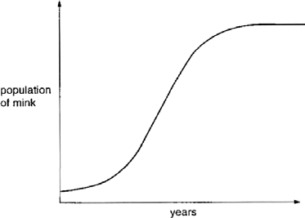

* 1. State **three** factors which would cause the mink population to become constant.
     1. ....................................................................................................................................

........................................................................................................................................

* + 1. .....................................................................................................................................

........................................................................................................................................

* + 1. .....................................................................................................................................

. [3]

* 1. It might be expected that a graph for human world population would show a similar pattern. However, it is now thought that the human population will continue to grow steadily. Suggest **three** reasons why this might happen.
     1. .....................................................................................................................................

........................................................................................................................................

* + 1. ....................................................................................................................................

........................................................................................................................................

* + 1. ....................................................................................................................................

. [3]

[Total : 6]

### Core 2

Fig. 1 shows a food web which includes some organisms in the African grasslands.

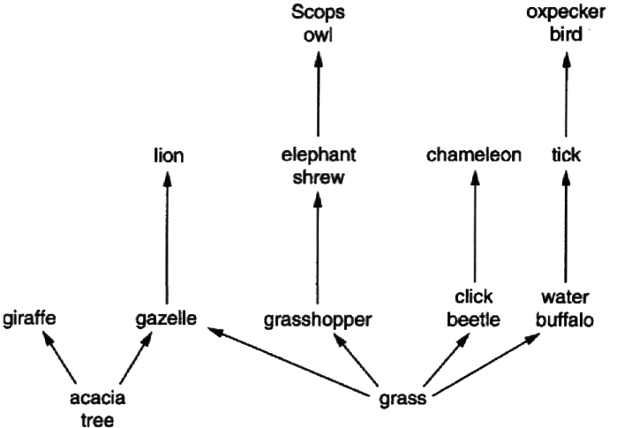

#### Fig. 1

1. (i) In the space below draw a food chain consisting of **four** organisms. The organisms must be part of the food web.

[2]

(ii) Using examples from the food web, explain the difference between producers and consumers.

[4]

### Core 2

1. When weather conditions are favourable the grasshopper population can suddenly increase enormously.

Predict and explain the effect this might have on the

* 1. Scops owl population;

. [2]

* 1. water buffalo population;

. [2]

* 1. giraffe population.

[3]

[Total : 13]

### Core 3

Sheep were first taken to the island of Tasmania in 1814. Fig. **2** shows changes in the size of the sheep population in Tasmania between 1818 and 1930.

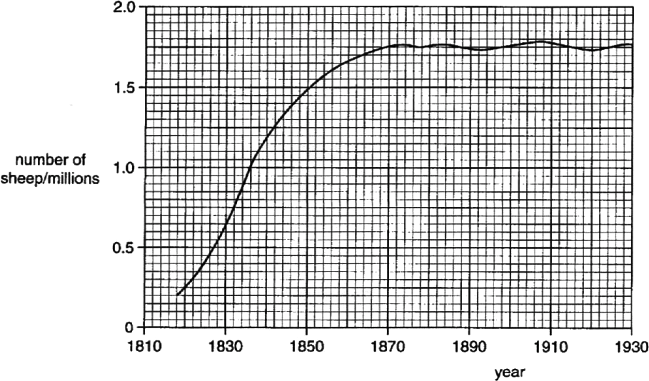

#### Fig. 2

1. State the size of the sheep population in 1842.

[1]

1. (i) Suggest biological reasons for the steep rise in the number of sheep between 1830 and 1840.

. [2]

(ii) Suggest biological reasons for the shape of the curve between 1870 and 1890.

. [2]

[Total : 5]

## ALTERNATIVE TO PRACTICAL questions

### Alternative to Practical 1

Samples of animals living on the surface of logs in a woodland were collected. The animals found on the top and sides were brushed carefully into a tray.

The animals found on the underside of the logs were brushed carefully into a second tray.

The animals were identified, sorted into groups and counted. This information was recorded in Table 2 1

#### Table 1

|  |  |  |  |
| --- | --- | --- | --- |
| animal group | feeding category | number of animals | |
| top and sides of log | underside of log |
| snails | herbivores | 4 | 3 |
| mites | herbivores | 12 | 9 |
| larvae of flies | herbivores | 1 | 8 |
| centipedes | carnivores | 0 | 5 |
| spiders | carnivores | 2 | 7 |
| beetles | carnivores | 2 | 4 |
| woodlice | detritivores* | 2 | 10 |
| millipedes | detritivores* | 1 | 4 |

* Detritivores are animals that eat dead matter such as fallen leaves.

1. (i) Complete Table 2 to show the numbers of animals in each feeding category expressed as a percentage of the total number of animals found on the underside of the logs.

#### Table 2

|  |  |  |
| --- | --- | --- |
| feeding category | number of animals found on the underside of the logs | percentage % |
| Herbivores | 20 |  |
| Carnivores | 16 |  |
| Detritivores | 14 |  |
| Total | 50 | 100 |

[2]

### Alternative to Practical 1

(ii) Using Fig. **3**, construct a pie chart to show the proportion of herbivores, carnivores and detritivores collected from the underside of the logs.

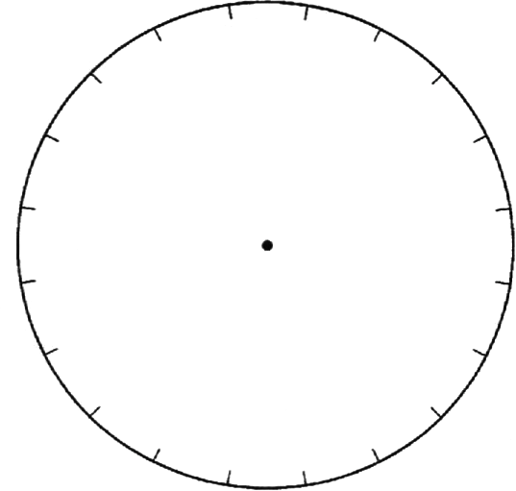

#### Fig. 3

[2]

1. Suggest **two** reasons why most animals were found on the underside of the logs.
   1. ....................................................................................................................................

........................................................................................................................................

* 1. ....................................................................................................................................

. [2]

1. Describe an investigation you could carry out to compare the number of animals living amongst fallen leaves in two different woodland habitats.

[4]

[Total : 10]

## EXTENSION questions

### Extension 1

South Uist is a small island which provides one of the few remaining summer habitats for a bird called the Corncrake (*Crex crex*). It lives in hay fields where it feeds on insects, worms and seeds. South Uist provides a good habitat because there are plenty of hay fields where the Corncrake can nest and there are few predators.

However, a small mammal called the Hedgehog (*Erinaceus europaeus*) was released onto the island. The Hedgehog also has few natural predators and will feed on the eggs of Corncrakes, as well as on insects and worms. The number of Hedgehogs on South Uist has risen rapidly to 10 000 while Corncrakes are becoming endangered as their numbers worldwide are falling.

1. (i) State **two** features which birds and mammals have in common.
   1. .......................................................................................................................
   2. .......................................................................................................................
2. State **two** features which distinguish birds from mammals.
   1. .......................................................................................................................
   2. .......................................................................................................................

[4]

1. Suggest why isolated islands such as South Uist are more easily colonised by birds than mammals.

[1]

1. State **three** reasons why South Uist provides a good habitat for Corncrakes.
   1. ....................................................................................................................................
   2. ....................................................................................................................................

3 [3]

1. Explain why Corncrakes are becoming endangered by Hedgehogs.

........................................................................................................................................

........................................................................................................................................

. [2]

### Extension 1

1. Draw a food web to show the feeding relationships described in the passage. Assume that insects and worms feed on leaves.

[4]

1. Suggest two ways by which the extinction of the Corncrake may be prevented.
   1. ....................................................................................................................................

........................................................................................................................................

* 1. ....................................................................................................................................

. [2]

[Total : 16]

### Extension 2

1. Describe and explain the possible effects of allowing untreated sewage to enter a small lake. [5]
2. Outline a treatment of sewage which would produce re-usable water. [6]
3. Describe how a plant living in a dry habitat is adapted to conserve water. [4]

# Human influences on the environment – answers

### Core 1

1. any three of these

predators of the mink

competition with other predators for the same food prey limited by availability of prey’s food

disease / parasites

1. any three of these

humans have no natural predators

food supplies may be moved from areas of excess to areas of shortage medical advances in disease prevention

medical advances in curing / treating patients humans modify habitats for themselves limited use of family planning programmes

### Core 2

|  |  |  |  |  |
| --- | --- | --- | --- | --- |
| a(i) | grass or plant  grass or plant bird | grasshopper water  buffalo | elephant shrew tick | Scops owl /  oxpecker |

linked by arrows pointing towards the consumers

(ii) named producer example

makes its own food / glucose / gains energy by photosynthesis named consumer example

gains energy / takes in / eats ready-made food / other organisms

b(i) Scops owl population would rise – plague of grasshoppers would increase elephant shrew population / food if Scops owl will increase

water buffalo population would fall – more grass eaten by grasshoppers / less food available for water buffalo

1. grasshoppers eat more grass so less food for gazelles

**either** gazelles eat more acacia so less food for giraffes and population falls

**or** gazelle population falls and eats less acacia so more food for giraffes so population rises

### Core 3

* 1. 1.25 million

b(i) any two from these

most of offspring surviving

little / no competition for / plenty of food / space few / no natural parasites / predators / diseases no limiting factors

(ii) any two of these

births equal deaths

some factor / food supply limiting / competition for food / space / because of overcrowding

introduction of / increase in parasites / disease / predators / competitor species / deliberate husbandry

### Alternative to Practical 1

a(i) in order in the table

40

32

28

(ii) the pie chart should show

correct proportions for the segments

correct order of segments (largest starting at 12 position and going clockwise in decreasing size)

* 1. wet / damp

darkness (or alternative wording)

* 1. to include four of these points

hand search and / or Tullgren funnel sample standard area

same time of year

identify animals and trophic levels repetition of samples

### Extension 1

a(i) any two from

four limbs

body covering (or alternative wording) backbone

warm blooded lungs

(ii) any two from, provided feature linked to correct group birds have feathers / animals have fur

birds lay eggs / mammals produce live young mammals suckle young

birds have a beak

birds have scales on legs

1. birds can fly over water or it is difficult for mammals to swim long distances
2. few predators present

hay fields present for nesting

hay fields provide a food source (or alternative wording)

1. any two of these

hedgehogs eat corncrake eggs

hedgehogs eat the same food / reference to insects or worms corncrakes nest on the ground

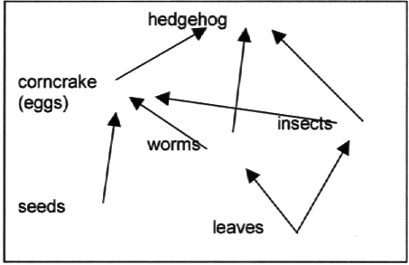e

f any two of these

remove / exterminate hedgehogs from the island create corncrake sanctuaries (which are hedgehog-fre) introduce corncrakes to other islands

reference to captive breeding programme

### Extension 2

1. any five of the following points

reference to the presence of nitrates / phosphates effect of above i.e. plants grow faster

reference to light blocked out for deeper plants plants die (linked of the above points)

dead plants provide food for bacteria numbers of bacteria increase

animals in water die due to lack of oxygen bacteria respire (aerobically), using up oxygen reference to eutrophication

reference to possible presence of disease- causing organisms

1. any six of the following points

sewage screened (or alternative wording) to remove large objects settling tanks allow grit to settle out

sludge allowed to settle out

reference to anaerobic conditions killing aerobic pathogens, linked to above remaining liquid sprayed onto stones or clinker

reference to presence of protoctists / bacteria microorganisms feed on sewage

harmful substances removed, linked to above

reference to aerobic stage killing many anaerobic bacteria reference to clear water effluent produced (or alternative wording) reference to chlorination

1. any four of these thick cuticle

reduced number of stomata stomata only open at night rolled leaves

hairs on leaves

leaves reduced to spines deep or long roots

fleshy stem

® IGCSE is the registered trademark of Cambridge International Examinations.

© Cambridge International Examinations 2014