THE TRAVAILS OF BUSINESS TRAVEL – EARLY 20th CENTURY STYLE

Ian Burdon

William McLellan was Charles Merz’ Partner for more than 30 years. He was the visionary behind the Galloway Hydro Scheme which is still generating some 85 years after first commissioning. In the Memorandum (below) to staff in the Newcastle Office of M&M, he recounts his eventful journey from Buenos Aires to Southampton in the Summer of 1914. He had been visiting The Argentine in connection with his Firm’s involvement in the electrification of the Central Argentine & Buenos Aires Western Railway. The advent of intercontinental air travel must have made an enormous difference to the conduct of international business in later years!

-----------------------------------------------------------------------------------------------------------------------------------

TO: The Staff MERZ AND MCLELLAN
OFFICE CORRESPONDENCE
FROM: Mr McLellan - Newcastle

27th August 1914

As it may possibly interest the staff and as shewing the effect which our Navy has had on German commerce, I give below a short description of my voyage from Buenos Aires to Southampton:
In order to spend as much time with Mr. Lydall as possible and yet to be able to see Mr. Jones, who was due to leave England on his way to Australia about 14th August, I took a passage from Buenos Aires by the Hamburg-Amerika liner BLUCHER, sailing on 23rd July and due in Southampton on 11th August. The BLUCHER was originally a North Atlantic boat and has a tonnage of about 12,000, with a speed of some 15/16 knots. She had on board one thousand third class passengers, about 250 second class passengers, and about 80 first class passengers. The first mentioned were largely Portuguese and Spanish emigrants returning home; the first- and second-class passengers were of all kinds of nationalities.
At Rio de Janiero were first heard of the trouble between Austria and Serbia, but no one attached very much importance to it as it seemed to us an ordinary Balkan row.
The programme of the BLUCHER involved sailing from Rio to Lisbon without a stop. In leaving Rio we saw lying at anchor two big Brazilian dreadnoughts, and a small British cruiser, the GLASGOW, this being, I understand, the only British war vessel in South American waters.
In addition to the passengers referred to above, the BLUCHER had on board £800,000 in gold, which was said to be for the London branch of the Dresdner Bank.
On July 31^{st,} a notice was posted that on the following morning we would pass St. Paul’s Rocks, which are partially submerged islands just north of the equator. On Saturday morning, August 1st, we crossed the equator, but before reaching the Rocks, the BLUCHER slowed down to half speed on the receipt of wireless news that the European situation was very grave. In the afternoon the ship turned back, proceeding at half speed to the nearest point on the South American coast - Pernambuco - and at 6.a.m. on Sunday morning, the 2nd August, we were going full speed towards this port, the captain stating that he was returning to Pernambuco for orders and that if England kept out of the war he would proceed on his journey as they were not afraid of anything that France could do in the naval way. We arrived at Pernambuco on Monday and found there five other German boats which had also turned back. These were: SANTOS, SIERRA NEVADA, SAN NICOLAS, EISENACH, and RAMESIS.
On August 4th I went ashore at Pernambuco and cabled to London using the telegraphic address ‘Amberkraft’. This telegram, although accepted, was never delivered, and I learned afterwards that no telegram using a code address had a chance of getting through as the Censor promptly suppressed it.
At Pernambuco we found all the banks closed until August 17th, the exchange business in chaos, the only currency accepted being gold.
On returning on board the BLUCHER (which was then anchored in Pernambuco Bay), the captain announced his intention of going into the harbour, as the Bay, being dangerous, he had to keep steam up the whole time and was therefore consuming unnecessary coal. We accordingly weighed anchor, apparently with the object of steaming into harbour, but at 7 o’clock all lights were turned out and the ship steamed at full speed towards Bahia, a port about a day’s sail to the south of Pernambuco. At midnight the ship was still going strongly to the south, but on turning out next morning found that the BLUCHER way back at Pernambuco and learned that at one o’clock in the morning they had received a wireless message from the German Consul that war with England had been declared and that the GLASGOW had left Rio de Janiero to capture the BLUCHER on account of the gold which she had on board. I believe this latter statement to be incorrect because we received later news that the GLASGOW had stopped a British collier and taken the coal with which she was loaded (and which belonged to the Brazilian Government) promising to pay for it at the rate of £2 per ton.
The BLUCHER lay anchored in Pernambuco Bay the whole of the 5th, and a notice was posted that London was being bombarded by Zeppelins and that a battle was raging in the North Sea. The notice terminated with the news (which proved to be the only true statement) that at this point the German cable had been cut. The passengers and crew of the BLUCHER were put on a limited food allowance, with the result that the third-class passengers promptly mutinied. This was readily quelled.
A notice was posted that the passengers must find their way to their destination as best they could. The Brazilian authorities were not making matters any too easy for the Germans, and the passengers on going ashore found that all the fares to England were doubled, all the banks closed, and no cheques were accepted. They therefore besieged the various national consuls. The only boats sailing to Europe were the Dutch boats and the English Royal Mail. The latter only booked Britishers to Southampton and neutrals as far as Lisbon, the former booked neutrals only. (It appeared incidentally that a boat of this line, the FRIESIA, had been loaded with German reservists returning home from Buenos Aires and Santos, the whole of whom had to turn out at Rio de Janiero and compelled to find their way back to their starting point as best they could.
While lying at Pernambuco the number of German boats seeking shelter gradually increased, until by Sunday the 9th August, there were in harbour 10 German boats, including a German West African boat loaded with soldiers, which had started out from Africa for Hamburg but which was forced to cross the Atlantic in order to get into a safe neutral port.
After about the 6th (i.e., two days after the declaration of war by England) the British merchant boats carried on their voyages without interruption, and on the 11th the Royal Mail boat the ARLANZA, bound for Europe, anchored at Pernambuco. I took a passage on board after some considerable difficulty in the matter of money.
Nothing of any note happened until Friday, the 14th August, when we reached a point about 1,600 miles away from Lisbon. There we got into touch with a British cruiser by wireless telegraphy. This cruiser, however, refused either to let us tell her our position or to disclose her own. Evidently this had been carefully thought out to avoid having messages tapped.
On Sunday August 16th, about half past twelve in the afternoon we saw a boat away on the horizon steaming quickly south-east. When someway behind us she suddenly turned and came for us at full speed, going three knots to our two. Getting within hail, she signalled to the ARLANZA to heave to or she would be sunk, and turned out to be the KAISER WILHELM DE GROSSE, a North German Lloyd Atlantic liner, capable of steaming 22½ knots - the ARLANZA only steamed 16 knots. Stripped for fighting and equipped with six guns, the KAISER WILHELM did not amount to anything against a war vessel, but any ordinary liner was helpless against her. When therefore she signalled for us to stop, we promptly obeyed and she came close alongside, next signalling that we should heave the wireless aerials overboard. This was duly one. She asked whether we had women and children on board; we replied that we had, having done which she steamed slowly round our bow and down the other side taking a position close under the stern with her guns bearing on the ship.
An English naval captain on board the ARLANZA gave it as his opinion that her correct procedure was to turn all the passengers and crew into boats and then to sink the ship. (Incidentally, the ARLANZA had £200,000 of gold on board and 18,000 quarters of beef). This appeared also to me to be the correct procedure, because it is not possible to take prizes into neutral ports and there was no open German port available for her to take us to, there being probably British cruisers off the two German colonies in West Africa as was evidenced by the fact that the German West African boat previously referred to had to steam to Pernambuco for shelter. The KAISER WILHELM could not take the whole of our passengers on board because there were too many; she could not send a prize crew on board and make us follow, both on account of the number required to make up a prize crew and also on account of the fact that we only steamed 16 knots and her progress would be hampered. Everybody therefore was getting ready to spend an uncomfortable time in the boats. The KAISER WILHELM swung a boat out in the davits loaded with men, to despatch to the ARLANZA, and we assumed that she would take the gold and turn the passengers into the boats, when, to our great surprise, without another word, the KAISER WILHEM suddenly steamed off in a south-easterly direction, i.e., along her original course. We can only conclude that she must have tapped the message of a British cruiser and had not the time required (some 6 or 8 hours) to load the passengers and crew into boats. She was quickly out of sight on the horizon, but since then she has sunk an English cargo boat, the HYADES, which has incidentally carried a good deal of material for the Argentine Railways for us, but which at the time of sinking was loaded with maize for Hamburg.
The latest news (August 27th) is that the KAISER WILHELM DE GROSSE has been sunk off the west coast of African by H.M.S. HIGHFLYER.
Lying at Las Palmas were 12 German vessels and two Austrian merchant ships.
Lying at Lisbon - our next port of call - were between 35 and 45 German merchant ships. Many of them were without money and short of food. They had been ordered by the Portuguese Government to anchor up the river, so as to leave the main portion of Lisbon harbour free for the passage of English boats.
Between Lisbon and Vigo we passed a converted P&O cruiser flying the British war flag - the white ensign, and at Vigo found six German boats including one cable ship and a passenger boat, the GOEBEN - the same name as the big cruiser which has been sold to the Turks.
In the Bay of Biscay, we sighted two big French cruisers, then a fast French Transatlantic boat converted into a cruiser, accompanied by a French scout.
Forty miles from the Cornish coat we were stopped at night by a French boat, which signalled to us to stop, held us under the searchlight for half an hour, then sent a boat’s crew on board with instructions that we were to proceed to Southampton.
We arrived off the Isle of Wight on Saturday morning, the 22nd August, at 7 o’clock and were stopped by a small British torpedo boat and told to anchor for instructions. This we did and found lying in the bay six transport ships, equipped for carrying soldiers but all empty. Between 8 and 9 o’clock, all these transports weighed anchor, steamed some little way out to sea (evidently to avoid a mine field) then turning sharply, steamed up the Solent.
Then one by one eleven transports loaded with soldiers came steaming past us, went some little way out to sea, doubled back on their tracks, signalled, and then steamed off towards France, about half in one direction and half in another, evidently going to two different ports.

My thanks to Sue Bleazard for transcribing the original flimsy carbon copy of this correspondence which was discovered in some personal papers of the late Dr Richard Hore of Merz and McLellan.

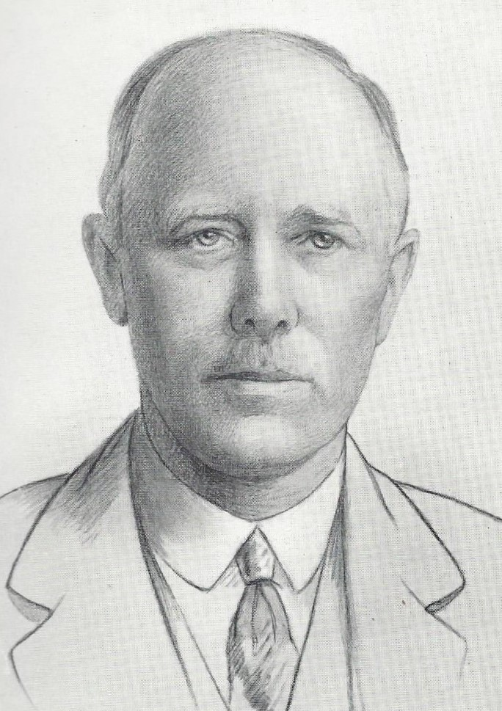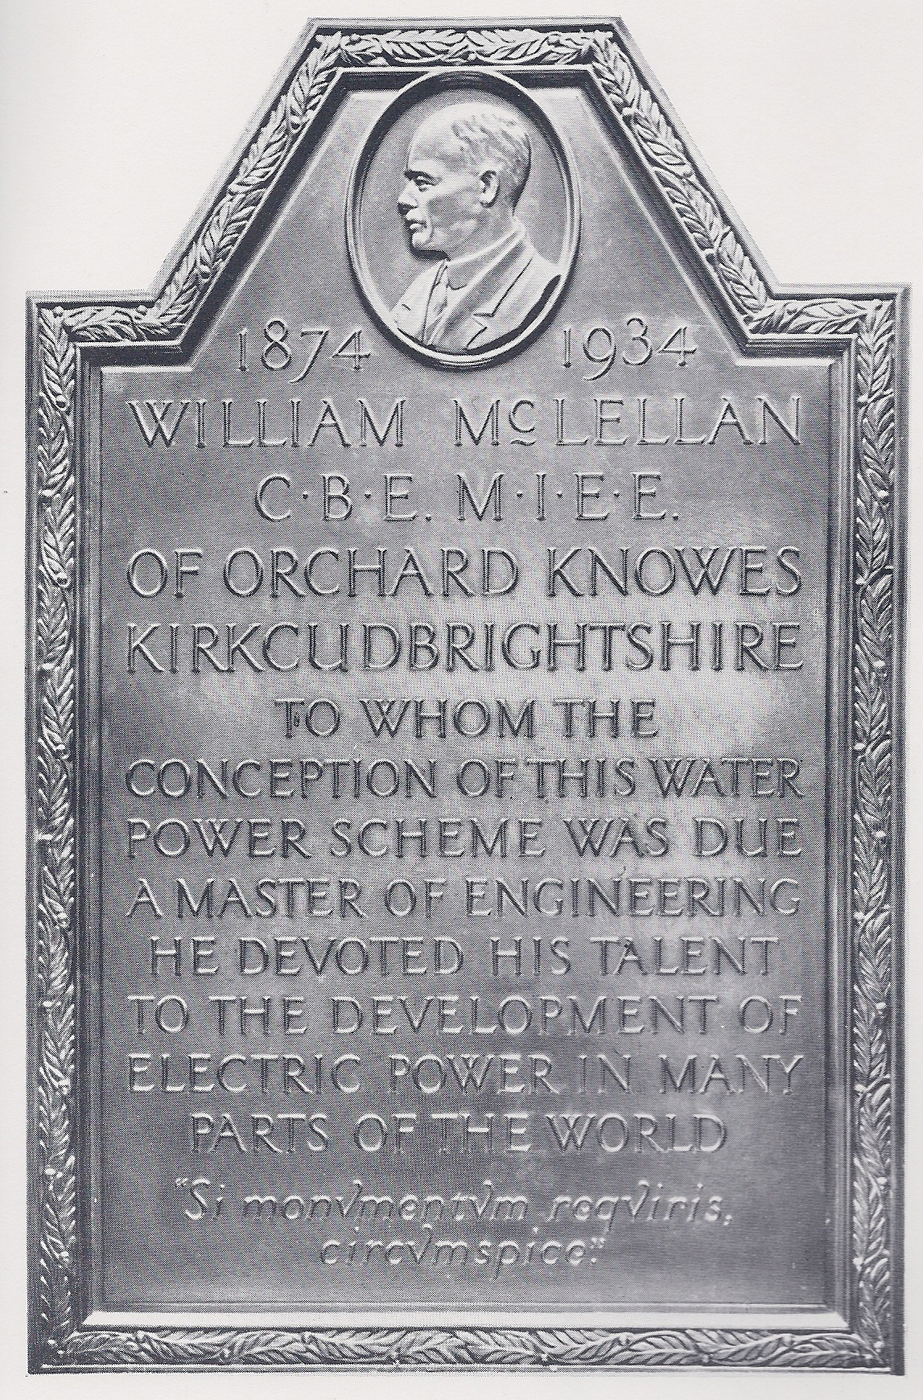

William McLellan (1874 –1934) and his Memorial Plaque in Tongland Power Station, Kirkcudbright.

https://www.gracesguide.co.uk/William_McLellan
Francis Lydall was Chief Assistant in the Traction Department of Siemens at Stafford at the time but later joined M&M and became a Partner in 1927.
The Greek word for electricity – amber- featured in the M&M telegraphic address for many years and was incorporated in the name of the new Office at Killingworth – Amberley - in 1968 and later still as the name of the Firm’s new Office in Newcastle Business Park – Amber Court - in 1990.

