Kathmandu Temple Tours 03 Nights 04 Days

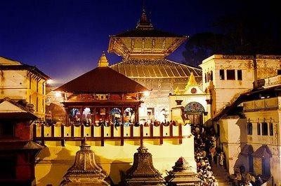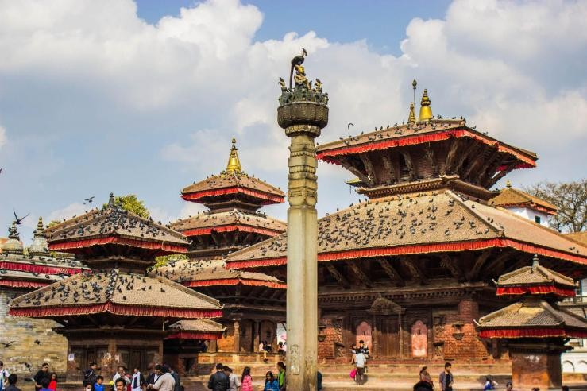

# Day 01: Arrive in Kathmandu

Upon arrival in Kathmandu Airport, you will be greeted and assistance by our Representative. After completing your custom formalities, transfer to Hotel for check-in. **Late afternoon, visit Boudhanath Stupa, Evening, attend Aarati at Pashupatinath Temple.** Drive back to Hotel. Overnight in Kathmandu Hotel.

# Day 02: Kathmandu

After breakfast, visit **Jalanarayan Temple (Sleeping Vishnu in the water).** Later, you will be visiting **Swoyambhunath Stupa (Monkey Temple) and Patan Durbar Square and Krishna Temple.** Drive back to Hotel. Overnight in Kathmandu Hotel.

# Day 03: Kathmandu

Breakfast is at Hotel. Proceed to visit **Kailashnath Mahadev Temple (World’s Tallest Shiva Statue) in Saga. Next, you will be visiting Doleshwor Mahadev Temple (Head of Kedarnath) and later, visit Bhaktapur Durbar Square (shooting spot). Rest of the day is free.** Overnight in Kathmandu Hotel**.**

# Day 04: Kathmandu - Departure

After breakfast, free till departure. Later, on time transfer to International Airport for onward destination.

# ******End of Services******