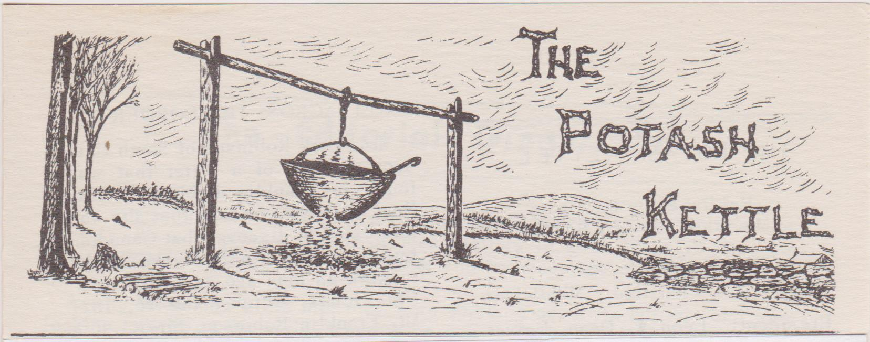
Volume 74
Spring 2022
Number 1

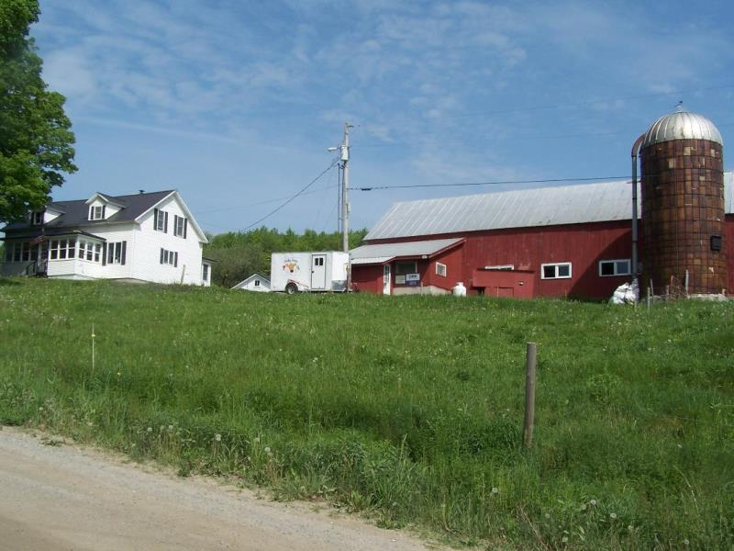 2 2022 Spring Meeting The BAKERSFIELD HISTORICAL SOCIETY May 14, 2022 9-10 a.m. Social Hour with coffee/tea and muffins 10-11 a.m. Business Meeting 11-Noon Gab Fest It may include some Farming and Academy accounts. Noon-1 p.m. Lunch (Prepared by Bakersfield Historical Society) Reserve it with Laurie. 1 p.m. Program Historical Society Video and Talk about Local Barns and farms h (We request that people be fully vaccinated and bring a mask in case regulations change.)
EDITION TITLE: Please note that I will now print “Spring” instead of “Winter”. DIRECTIONS: To 80 East Bakersfield Road in Bakersfield,VT. From the south, head north on Interstate 89 beyond Burlington to I 89 Exit 19 toward St. Albans/US 7/VT 36/VT 104. Go .5 miles and continue straight onto St. Albans State Hwy for 292 feet. Turn right onto VT 104 N. Just .6 miles later, turn right onto VT 36. After 14.6 miles, continue straight onto E. Bakersfield Road. Destination will be 387 more feet on your right. From the north, head south to this I 89 Exit 19 and continue as above. From the east, I would suggest taking VT 15 W and turning onto VT 108 N in Jeffersonville towards Bakersfield and turn right onto East Bakersfield Road towards the town’s center.
President’s Message
I am pleased to be able to meet on May 14th at the Bakersfield Historical Society. After lunch, the Society will present a video and talk about local barns as well as open their museum in the same building. Before lunch, share your folklore, photos, poems, artifacts, etc. at our Gab Fest. Paul and Linda Stanley’s farm is on the cover. Since Franklin County is filled with most of our Vermont farms, that will be our theme this spring, and we welcome your own accounts at the Gab Fest.
Our lunch will reflect the desire for safety precautions and the Historical Society will prepare our lunch. Please let Laurie know if you plan to attend so that she can give them the meals estimate. Call her at 802-879-6467, or email/snail mail her (address on p.7) by May 7th. You can offer $7.00 at the meeting to pay for lunch, or you are welcome to bring your own lunch if you want.
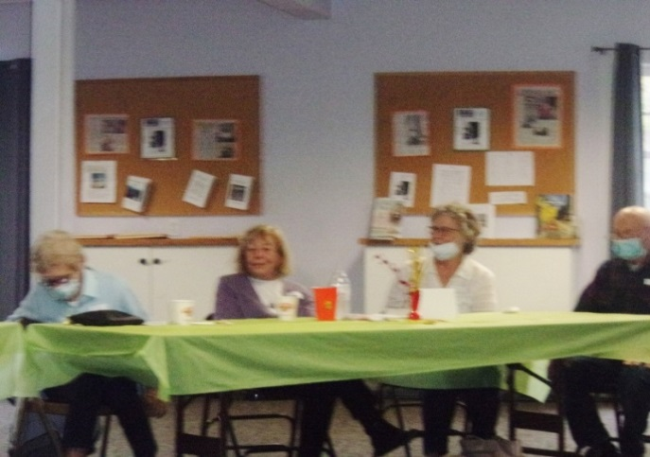
At our fall meeting at the Williston Federated Church, GMFS members voted to approve our Constitutional Amendments and By-Laws and added the Officers’ Duties. I thank Dianne Leary for accepting the board’s request to be our new Vice President, and hopefully someone can offer to still become our treasurer.
Thank-you to Ginger and David Isham who gave a great presentation and helped to set up and reserve the hall. Thanks to Don and Karen Lefebvre who continued to handle our social hour treats. I was happy that John Joachim could help collect the money. Thank-you to all of you who could attend and share with us.
A related Gab Fest article and an emailed church news piece was attached to my February meeting reminder email letter for you to enjoy from the meeting. We are still in need of someone to transcribe our Gab Fests. Meanwhile, I welcome any other printed folklore and Gab Fest articles that I might forward to members via email and save for a future Whittlin’s. So bring your folklore along with you to our Spring Meeting. We will have door prizes and the meeting and lunch will be in the Bakersfield Historical Society hall. Attendants should be fully vaccinated and follow current CDC guidelines about masks and social distancing.
I am looking forward to our May 14th meeting when we can share Vermont farm stories and history. I counted cows when I worked for Resource Economics at UVM around 1970. I tallied all of the Vermont town listers’ numbers of farm animals. I had to punch the number of cows for each farm on their computer card to be entered into the system for Dr. Tromblay to analyze and report on for the state. Franklin County had the most and Addison County came in second. Although I grew up on the main road in Essex Center, my interest grew when interviewing two Essex farm neighbors on Chapin Road.
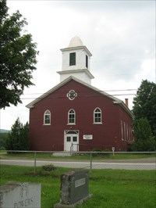
Earle Matthews and Barbara Chapin Egan compared notes. They split the days to bring milk cans in the truck into Essex Junction at the Milton Co-Op each week. When it was apple picking season, Matthews did more. Some farms on Chapin road shared horses to collect sap during sugaring time. The two differed about who made the best syrup. I am pleased to have a maple sugar orchard on that same rocky ridge closer to the center of Essex. We collect sugaring antiques and it would be great to hear more from our GMFS members about their farming experiences. Bring along some photos or antiques to share.
This Historical Society museum in the center of town is in the old “South Academy” and later was St. George’s Catholic Church until the society purchased it in 1998. Bakersfield Historical Society is pleased to host our spring meeting. I thank them for this GMFS opportunity and especially Paul and Linda Stanley who helped to plan the event. I hope many of you can come.
Fondly,

Laurie Jordan, president
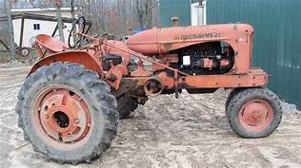
FARMING FOLKLORE IDEAS
A G O A T C H E E S E S H E A
D E V P O H E R N T G H O G S
A W H A Y L O F T O G A L C H
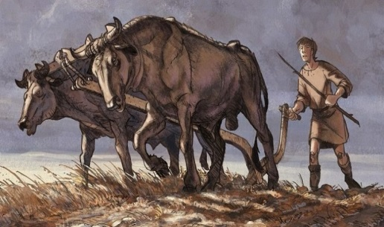
S U G A R D E V I L C R S I E
C M O N I T O R B A R N T L E
O P R E S S I D E R A K E E P
X O C P O T A S H U T O I S R
E Y H T C O M B I N E R N T U
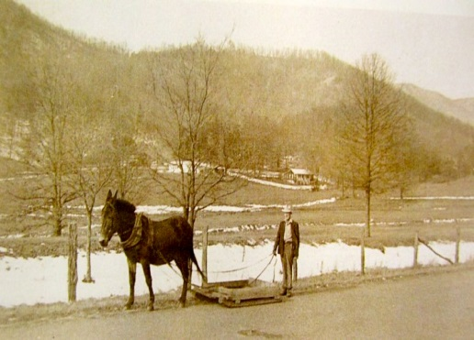
N M A S S E Y F E R G U S O N
Y S R E P I T C H F O R K N E
O I D T U R K E Y D R I V E R
K C A S W O O D L O T N E B O
E K R E T T Y C O R N C R O P
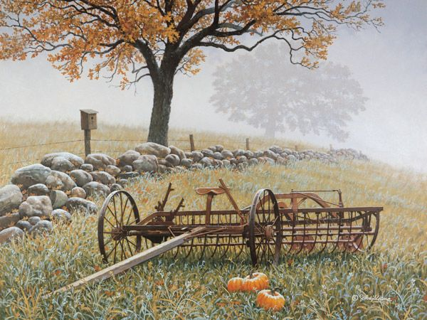
S L O S O U L E S P O U T A R
R E D T R E E M A P L T Y T O
We invite you to share at our spring meeting your
GAB FEST/FARMS FOLKLORE
HAYLOFT PITCH FORK
MONITOR BARN SIDE RAKE
ORCHARD STONE BOAT GOAT CHEESE
WOOD LOT MASSEY FERGUSON HOLSTEIN
SHEEP RUN COMBINE SUGAR DEVIL
TURKEY DRIVE SOULE SPOUT CORN CROP
OXEN YOKE SICKLE POTASH
HOGS EGG CRATE
GREEN MOUNTAIN FOLKLORE SOCIETY
AUTUMN 2021 MEETING, WILLISTON, VT
Saturday, October 16, 2021
The meeting was called to order at 10:10 a.m.
President Laurie Jordan thanked Ginger Isham for helping arrange the meeting and afternoon program. Laurie also noted her husband grew up two doors down from the Church hosting this meeting. Thanks also to Don and Karen Lefebvre for the coffee table and to John Joachim for running the registration table.
Former president Dianne Leary was welcomed back. We are so happy to have her back as Vice President.
Secretary’s Report
A MOTION TO ACCEPT THE SECRETARY’S REPORT FROM THE AUGUST 2021 EXECUTIVE BOARD MEETING was offered by John Joachim, seconded by Don Lefebvre and approved unanimously.
Treasurer’s Report
John Joachim has resigned from the Treasurer’s position, so a new treasurer is needed.
All funds have been transferred to a new checking account in December 2019.
Printing costs increased; printing color photos in our two publications (Whittlins and the Potash Kettle) is expensive so they will need to be added with discretion.
Our membership form now offers separate lines for dues and donations so we can track the breakdown better.
The GMFS received our $5,500 endowment back from the Vermont Historical Society. Per the directive of the founder, Leon Dean, the Society is precluded from spending the principle, just any earned interest. However, the fund is approximately $150 short, so the principle needs to be replenished as soon as possible. The funds should be replaced after the donations and annual dues collected at this meeting are tallied. But the Society needs to consider ways to increase income so the endowment is never in danger of being spent again.
A MOTION TO ACCEPT THREE YEARS (2019, 2020, AND 2021) OF TREASURER’S REPORTS was offered by Fern Sparks, seconded by Karen, and approved unanimously.
Bylaws and Constitution
Amendments to both documents have been discussed and proposed at previous meetings. Laurie outlined the major changes:
- County directors deleted
- UVM’s Wilbur Collection will be the recipient of funds and materials if and when the GMFS is dissolved. Dissolution requirements updated
- Membership terms regarding dues clarified
- Editorial board reduced from three to two members

A MOTION TO ACCEPT ALL CHANGES TO THE BYLAWS AND CONSTITUTION was offered and approved unanimously. Thanks to Laurie for all her hard work on this necessary project.
Board Nominations and Other Positions
Laurie has been organizing the finances, following up on John’s good work. John agreed to remain a signatory on GMFS bank accounts, along with Laurie.
We need a new editor for the Whittlins. We need someone to collect and prepare stories for printing. The stories shared at Gabfest can be archived on portable media like discs or flashdrives, while the speaker should write their stories and send to an editor for compilation and printing in either publication. Paul Stanley noted that documentation of oral history is absolutely vital. UVM can take our materials in almost any format and archive them for future generations. Paul volunteered to oversee managing the collection of oral and written Gab Fest stories in the future for UVM.
No Whittlins will be published for 2021.
Membership Meeting Planning
The Spring 2022 meeting is tentatively proposed for May 14, 2022 and the suggested Gabfest theme is farming. Location is yet to be determined, somewhere in Franklin County like Fairfield or Fairfax might be good. Paul volunteered to coordinate the arrangements.
Publicizing our autumn meeting event in the Vermont Historical Society newsletter has led to interest in our group.
Old Business
The GMFS website needs to be updated and the existing link needs to be deleted because it indicates we are no longer in existence. We could create a Facebook address, but that needs constant updating.
New Business
Because of increased printing and mailing costs, we need to increase membership dues. Ways to reduce costs would be to encourage the electronic dissemination of our publications; the membership form could ask if the member wanted our publications mailed or emailed.
A MOTION TO INCREASE AN ANNUAL INDIVIDUAL MEMBERSHIP FEES FROM $10 TO $15, BEGINNING IN 2023 was offered by John, seconded by Ginger, and approved unanimously.
There being no further business, the meeting was adjourned at 11:35.
Respectfully submitted,
BRIDGET O’DONNELL Board Secretary
OFFICERS
President Vice President Laurie Jordan (879-6467) Dianne Leary 259 River Road 4670 Greenbush Road Essex Jct., VT 05452 Charlotte, VT 05445 greenmountainfolkloresociety3lj@aol.com dleary123@yahoo.com Secretary Treasurer Bridget O’Donnell Laurie Jordan 83 N Champlain St Apt H Please email or mail a lunch reservation Burlington, VT 05401 request to our treasurer, Laurie Jordan. bridgetodonnell2002@yahoo.com Make the checks out to GMFS.
Other Executive Board Members Don Lefebvre Swanton Paul Stanley East Fairfield Fern Sparks Burlington
A Farm Song from Ginger Isham:
Written in March 2018 - a winter of ice, snow and sleet. After George & Sylvia
passed away in 1986/87 their children and families had a potluck once a month taking turns at each others homes. I got the idea to write this song from The
Green Mountaineer winter 1987/88 article called Game Song about school
children at Shaftsbury School.
Chorus
What'll we do in Williston, Williston, Williston
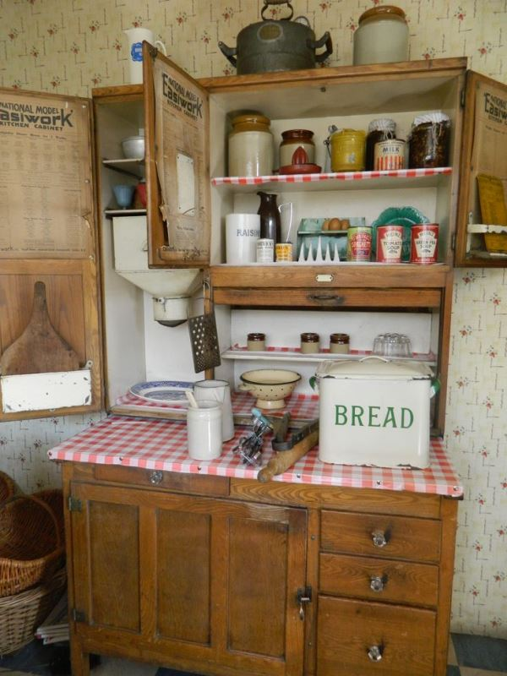
What'll we do in Williston on a Sunday afternoon
Verse 1 ( as adults)
We'll bake some beans and make some bread
Talk about what lies ahead
Reminisce about yesterday
As farmers we cut and baled some hay
Planted carrots, potatoes and beans
Boiled jams, jellies and maple cream
Gathered some eggs and canned some beef
Bedtime came - what a relief
Verse 2 ( as children)
In winter we climbed the hill to slide
Sometimes crashed side by side
Until frost took over our finger tips
Reddened our nose and chapped our lips
Soon we raced for the house and heat
Then off to bed for a good-nights sleep
Tomorrow will bring snow and sleet
Chorus

WHITTLIN’S:
The editor of the Whittlin's, Don Lefebvre, decided to resign and as of this date, we are still in need of a volunteer(s) to be our Whittlin's Editor(s). I am sure that Don can help anyone who would like to volunteer as a new editor. Let the president know if you can continue this publication. Regretfully, GMFS cannot send its members a Whittlin's at this time, but save your articles for future Whittlin’s! Or you can send them to the president to attach in an email during the year. You will then receive some folklore along with the regular VHS newsletter.
GMFS enters its events in the Vermont Historical Society newsletter. As a member of VHS, GMFS members have access to the emailed newsletters when Laurie forwards them to members. You can then know what events are at historical societies and towns and download some of the programs.
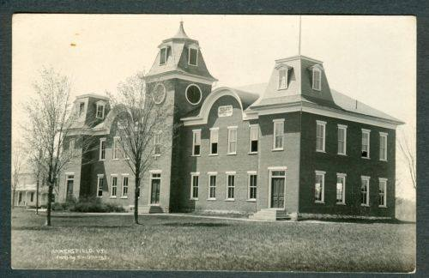
The Bakersfield Academy: Our meeting is within walking distance to the historic marker which reads, “Opened in August, 1879, Brigham Academy was heralded as the beginning of the educational millennium in Vermont.” It became the local public high school in 1966 and later the middle school until 1986. Born in Bakersfield in 1807, Peter Bent Brigham became a successful Boston business man and endowed $40,000 to be used for the town’s local education. Although the windows are boarded up, the Academy holds much local folklore from when it filled the gap between elementary school and college with courses such as classical languages, art, music, and science. Many other Vermont towns eventually had such an Academy of higher learning.
DUES: The board mailed an Invitation to Donate letter and dues reminder to our GMFS members after our October meeting to try to raise GMFS funds. Thank-you to the members who updated their dues and/or sent GMFS a donation to help us continue. The Treasurer has updated our paid membership list. Our Constitution states, “annual dues are payable in January of each year” and “a new membership received during the last four months of any calendar year shall be considered paid for the following year.” GMFS currently has 50 members, and please check your address labels for the year when you last paid dues for. _ _ _ _ _ _ _ _ _ _ _ _ _ _ _ _ _ _ _ _ _ _ _ _ _ _ _ _ _ _ _ _ _ _ _ _ _ _ _ _ _ _ _ _ _ _ _ _ _ _ _ _ _ _ _ _ _ _ _ _ _ _ _ _ _ _ _ _ _ _ _ _ _ _ _ _ _ _ Y Yes, I want to become a member of the Green Mountain Folklore Society CC Sign me up for a one year membership. I will (hopefully) receive a Whittlin’s publication (or some attached email articles during the year). I will get a semi-annual newsletter, The Potash Kettle, that includes information about the GMFS spring and fall meetings and the VHS email newsletters.
NAME: ________________________________ TELEPHONE: _____________
ADDRESS: _______________________________________________________
CITY: _____________________________ STATE: _______ ZIP: __________
EMAIL ADDRESS: _________________________________________________
DATE: _________ AMOUNT: Dues: ______ Donation? ______ Other? ______
Annual (2023) dues will be $15.00. Please make a check out to GMFS and mail to: L Laurie Jordan GMFS 259 River Rd. Essex Jct., VT 05452

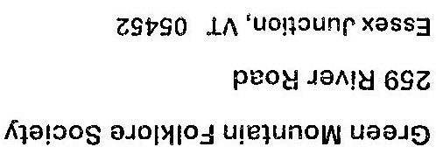

The Green Mountain Folklore Society
GMFS was founded in 1948 by UVM Professor Leon W. Dean. The purpose of the Society is to collect, preserve and make available the folklore of the State of Vermont. Meetings are held twice yearly in the spring and fall. Annual dues are $15.00 and include a VHS membership, 2 issues of the GMFS Potash Kettle Newsletter, and (we hope in the next year) one issue of The Whittlin’s publication.

