Case Shiller RMarkdown
Ira Sharenow
2023-04-21

Introduction
I have been working cooperatively with a Madison Wisconsin area housing expert. Previously, I looked at single family housing sales in the Madison area but did not distinguish between repeat sales and sales of new property. This analysis focuses exclusively on repeat sales and was inspired by the work done by Case-Shiller. However, I am not in any way associated with the Case-Shiller organization. This work is not the same as the Case-Shiller Index.
https://www.spglobal.com/spdji/en/indices/indicators/sp-corelogic-case-shiller-20-city-composite-home-price-nsa-index/#overview
https://wolfstreet.com/2023/02/28/the-most-splendid-housing-bubbles-in-america-february-update-biggest-price-drops-now-in-phoenix-portland-las-vegas-san-francisco-seattle-denver-san-diego/

Technical and R Statisitcal Programming Note
The document is mostly R ggplot2 graphs followed by R flextables. In the flextables, if the annualized appreciation was less than 1% it appears in bold red. If instead it was more than 7%, it appears in bold green.
The data manipulation was done with the R tidyverse, mostly dplyr. Moving averages used the slider package.
https://irasharenow.com/
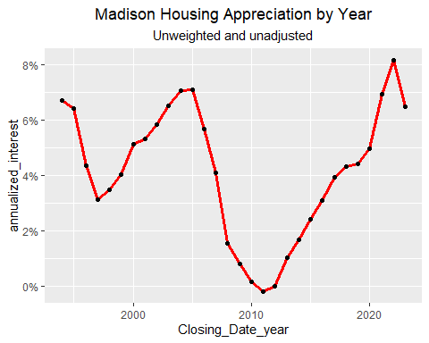
Table 1: Appreciation by Year
Madison Housing Appreciation by Year
Unweighted and unadjusted
year | appreciation | counts
1994 | 6.70% | 1
1995 | 6.40% | 65
1996 | 4.30% | 176
1997 | 3.10% | 289
1998 | 3.50% | 490
1999 | 4.00% | 614
2000 | 5.10% | 682
2001 | 5.30% | 822
2002 | 5.90% | 1022
2003 | 6.50% | 1199
2004 | 7.10% | 555
2005 | 7.10% | 533
2006 | 5.70% | 504
2007 | 4.10% | 551
2008 | 1.60% | 562
2009 | 0.80% | 705
2010 | 0.20% | 694
2011 | -0.20% | 721
2012 | 0.00% | 964
2013 | 1.00% | 1389
2014 | 1.70% | 1315
2015 | 2.40% | 1600
2016 | 3.10% | 1734
2017 | 4.00% | 1767
2018 | 4.30% | 1842
2019 | 4.40% | 1741
2020 | 5.00% | 1944
2021 | 6.90% | 2047
2022 | 8.20% | 1661
2023 | 6.50% | 60
Annualized Interest rate by closing date year
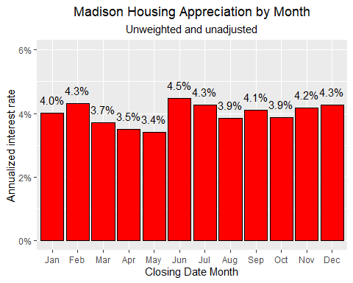
Table 2: Appreciation by Month
Madison Housing Appreciation by Month
Unweighted and unadjusted
month | appreciation | counts
May | 3.40% | 1184
Apr | 3.50% | 1291
Aug | 3.90% | 1958
Jan | 4.00% | 2414
Sep | 4.10% | 3169
Jul | 4.30% | 4088
Jun | 4.50% | 3444
Feb | 4.30% | 3087
Dec | 4.30% | 2183
Nov | 4.20% | 1906
Oct | 3.90% | 1833
Mar | 3.70% | 1692
Annualized Interest rate by closing date month
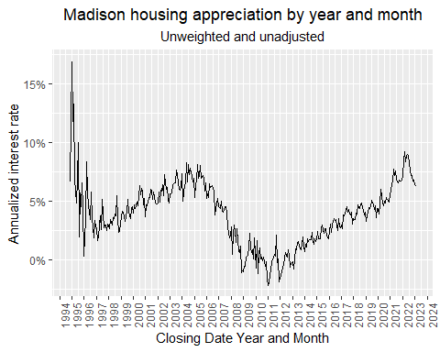
Table 3: Appreciation by Year and Month
Madison Housing Appreciation by Year and Month
Unweighted and unadjusted
year_month | appreciation | counts
2018 Jan | 3.60% | 84
2018 Feb | 3.50% | 84
2018 Mar | 4.00% | 120
2018 Apr | 3.90% | 163
2018 May | 4.70% | 190
2018 Jun | 4.50% | 267
2018 Jul | 4.40% | 230
2018 Aug | 4.80% | 211
2018 Sep | 4.90% | 117
2018 Oct | 4.60% | 138
2018 Nov | 3.90% | 133
2018 Dec | 4.10% | 105
2019 Jan | 3.30% | 74
2019 Feb | 3.80% | 75
2019 Mar | 4.10% | 120
2019 Apr | 4.50% | 121
2019 May | 4.40% | 206
2019 Jun | 4.60% | 232
2019 Jul | 5.10% | 225
2019 Aug | 4.70% | 190
2019 Sep | 4.40% | 140
2019 Oct | 4.60% | 121
2019 Nov | 3.60% | 121
2019 Dec | 4.40% | 116
2020 Jan | 4.40% | 63
2020 Feb | 3.90% | 72
2020 Mar | 4.80% | 124
2020 Apr | 6.00% | 145
2020 May | 4.90% | 163
2020 Jun | 4.70% | 227
2020 Jul | 5.00% | 212
2020 Aug | 4.80% | 199
2020 Sep | 5.30% | 219
2020 Oct | 5.20% | 183
2020 Nov | 5.10% | 175
2020 Dec | 4.90% | 162
2021 Jan | 5.60% | 91
2021 Feb | 6.50% | 69
2021 Mar | 6.70% | 127
2021 Apr | 7.70% | 165
2021 May | 7.20% | 194
2021 Jun | 7.60% | 266
2021 Jul | 6.90% | 242
2021 Aug | 6.80% | 222
2021 Sep | 6.60% | 192
2021 Oct | 6.80% | 175
2021 Nov | 6.80% | 161
2021 Dec | 6.90% | 143
2022 Jan | 7.10% | 68
2022 Feb | 8.50% | 67
2022 Mar | 9.20% | 144
2022 Apr | 8.40% | 116
2022 May | 8.80% | 182
2022 Jun | 9.00% | 235
2022 Jul | 8.90% | 200
2022 Aug | 7.70% | 192
2022 Sep | 7.20% | 147
2022 Oct | 7.20% | 114
2022 Nov | 6.80% | 113
2022 Dec | 6.80% | 83
2023 Jan | 6.50% | 48
2023 Feb | 6.30% | 12
Annualized Interest rate by closing date year and month, 2018-2023
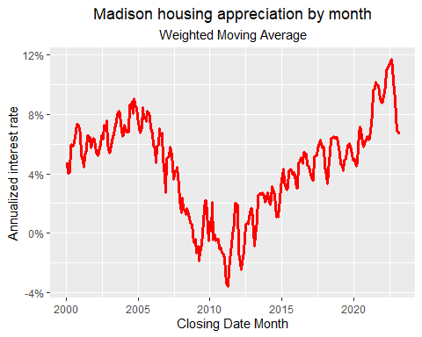
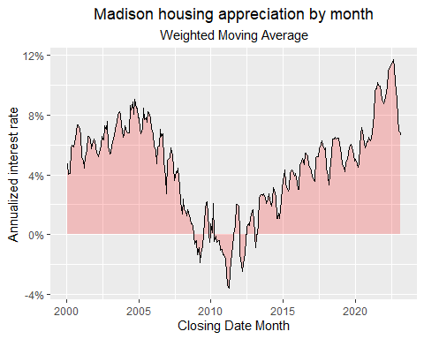
Madison Housing Appreciation by Month
3 Month Moving Average
months | appreciation | counts
2010-01-29 | 0.20% | 120
2010-02-26 | 2.10% | 97
2010-03-31 | -0.40% | 121
2010-04-30 | -0.10% | 176
2010-05-28 | -0.50% | 242
2010-06-30 | -0.40% | 318
2010-07-30 | -0.40% | 284
2010-08-31 | -1.00% | 246
2010-09-30 | -1.00% | 154
2010-10-29 | -1.30% | 136
2010-11-30 | -1.30% | 102
2010-12-30 | -1.60% | 101
2011-01-31 | -2.60% | 104
2011-02-28 | -3.30% | 105
2011-03-31 | -3.60% | 110
2011-04-29 | -2.40% | 146
2011-05-31 | -1.20% | 200
2011-06-30 | -0.80% | 264
2011-07-29 | -0.10% | 280
2011-08-31 | 0.60% | 283
2011-09-30 | 2.00% | 236
2011-10-31 | 2.00% | 189
2011-11-30 | 1.90% | 132
2011-12-30 | -1.30% | 111
2012-01-31 | -2.00% | 108
2012-02-29 | -2.50% | 118
2012-03-30 | -1.90% | 159
2012-04-30 | -1.20% | 202
2012-05-31 | -0.30% | 264
2012-06-29 | 0.60% | 337
2012-07-31 | 0.70% | 382
2012-08-31 | 0.60% | 376
2012-09-28 | 1.10% | 300
2012-10-31 | 1.60% | 231
2012-11-30 | 1.70% | 196
2012-12-31 | 0.10% | 168
2013-01-31 | -0.90% | 163
2013-02-28 | -0.20% | 167
2013-03-30 | 0.80% | 203
2013-04-30 | 2.40% | 276
2013-05-31 | 2.60% | 380
2013-06-28 | 2.70% | 491
2013-07-31 | 2.60% | 555
2013-08-30 | 2.80% | 553
2013-09-30 | 2.50% | 469
2013-10-31 | 2.10% | 360
2013-11-29 | 2.40% | 255
2013-12-31 | 2.70% | 226
2014-01-31 | 2.40% | 190
2014-02-28 | 1.90% | 176
2014-03-31 | 2.30% | 183
2014-04-30 | 3.20% | 252
2014-05-31 | 2.80% | 353
2014-06-30 | 2.60% | 465
2014-07-31 | 1.10% | 522
2014-08-29 | 1.40% | 527
2014-09-30 | 1.10% | 430
2014-10-31 | 2.30% | 336
2014-11-26 | 3.10% | 257
2014-12-31 | 3.60% | 237
2015-01-30 | 4.30% | 212
2015-02-28 | 3.40% | 209
2015-03-31 | 3.20% | 245
2015-04-30 | 2.90% | 333
2015-05-29 | 3.10% | 449
2015-06-30 | 4.20% | 581
2015-07-31 | 4.30% | 670
2015-08-31 | 4.30% | 640
2015-09-30 | 3.90% | 487
2015-10-30 | 4.10% | 365
2015-11-30 | 3.80% | 293
2015-12-31 | 3.00% | 287
2016-01-29 | 3.10% | 260
2016-02-29 | 4.70% | 248
2016-03-31 | 4.90% | 280
2016-04-29 | 5.10% | 372
2016-05-31 | 4.70% | 481
2016-06-30 | 5.40% | 612
2016-07-29 | 5.40% | 633
2016-08-31 | 5.20% | 643
2016-09-30 | 4.60% | 528
2016-10-31 | 4.60% | 430
2016-11-30 | 4.30% | 341
2016-12-30 | 3.90% | 314
2017-01-31 | 3.60% | 281
2017-02-28 | 3.50% | 256
2017-03-31 | 5.10% | 266
2017-04-28 | 5.20% | 348
2017-05-31 | 5.20% | 468
2017-06-30 | 5.80% | 645
2017-07-31 | 6.00% | 689
2017-08-31 | 6.30% | 682
2017-09-29 | 6.00% | 521
2017-10-31 | 5.70% | 467
2017-11-30 | 5.80% | 375
2017-12-29 | 4.50% | 335
2018-01-31 | 3.90% | 284
2018-02-28 | 3.30% | 266
2018-03-30 | 4.90% | 288
2018-04-30 | 5.40% | 367
2018-05-31 | 6.40% | 473
2018-06-29 | 6.40% | 620
2018-07-31 | 6.50% | 687
2018-08-31 | 6.40% | 708
2018-09-28 | 6.50% | 558
2018-10-31 | 6.50% | 466
2018-11-30 | 5.70% | 388
2018-12-31 | 5.40% | 376
2019-01-31 | 4.70% | 312
2019-02-28 | 4.50% | 254
2019-03-29 | 4.20% | 269
2019-04-30 | 4.80% | 316
2019-05-31 | 5.00% | 447
2019-06-28 | 5.50% | 559
2019-07-31 | 5.90% | 663
2019-08-30 | 6.10% | 647
2019-09-30 | 5.90% | 555
2019-10-31 | 5.40% | 451
2019-11-29 | 4.90% | 382
2019-12-31 | 5.00% | 358
2020-01-31 | 4.70% | 300
2020-02-28 | 4.50% | 251
2020-03-31 | 4.80% | 259
2020-04-30 | 6.70% | 341
2020-05-29 | 7.20% | 432
2020-06-30 | 6.90% | 535
2020-07-31 | 6.10% | 602
2020-08-31 | 5.80% | 638
2020-09-30 | 6.20% | 630
2020-10-30 | 6.20% | 601
2020-11-30 | 6.50% | 577
2020-12-31 | 6.30% | 520
2021-01-29 | 6.40% | 428
2021-02-26 | 6.90% | 322
2021-03-31 | 8.00% | 287
2021-04-30 | 9.60% | 361
2021-05-31 | 9.80% | 486
2021-06-30 | 10.20% | 625
2021-07-30 | 10.00% | 702
2021-08-31 | 9.90% | 730
2021-09-30 | 9.50% | 656
2021-10-29 | 9.10% | 589
2021-11-30 | 8.80% | 528
2021-12-31 | 8.80% | 479
2022-01-31 | 9.20% | 372
2022-02-28 | 9.80% | 278
2022-03-31 | 10.90% | 279
2022-04-29 | 11.10% | 327
2022-05-31 | 11.30% | 442
2022-06-30 | 11.40% | 533
2022-07-31 | 11.70% | 617
2022-08-31 | 11.10% | 627
2022-09-30 | 10.20% | 539
2022-10-31 | 9.00% | 453
2022-11-30 | 7.90% | 374
2022-12-30 | 6.90% | 310
2023-01-31 | 6.80% | 244
2023-02-10 | 6.60% | 143
Annualized Interest rate by closing date month

