El Cerrito Data in Pictures

Ira Sharenow

7/28/2021

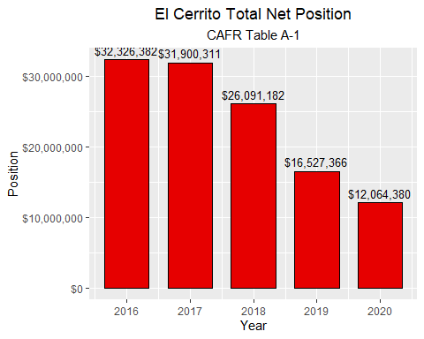

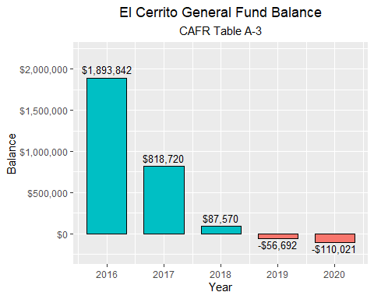

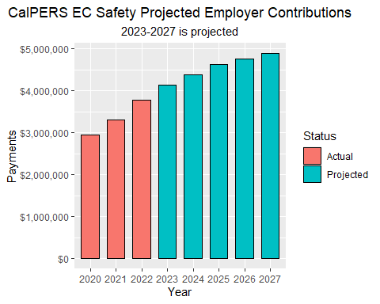

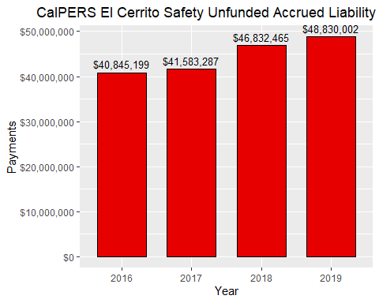

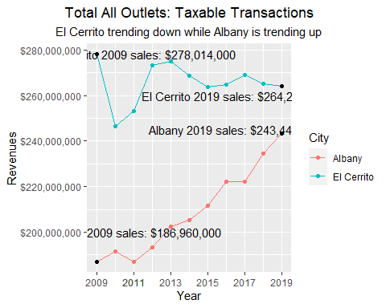

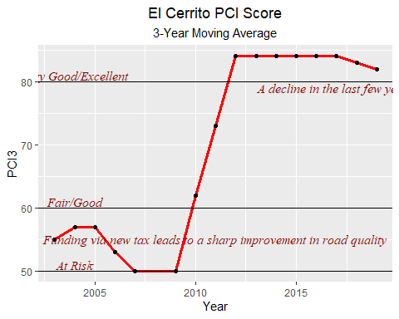

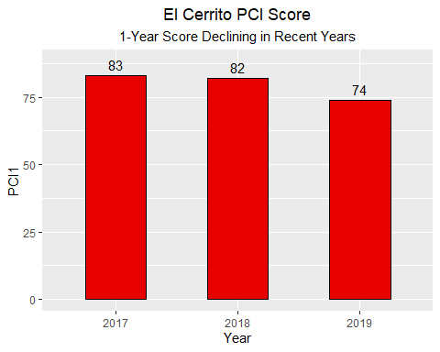

**References**

<https://www.el-cerrito.org/232/Budget-Financial-Information>

<https://www.calpers.ca.gov/page/employers/actuarial-resources/public-agency-actuarial-valuation-reports>  
<https://www.el-cerrito.org/DocumentCenter/View/15599/322021-City-of-El-Cerrito-CalPERS-Retirement-Plan-Presentation>

<https://www.cdtfa.ca.gov/dataportal/dataset.htm?url=TaxSalesCRCityCounty>

<https://www.vitalsigns.mtc.ca.gov/street-pavement-condition>