BIG HARBOR

by
Jerry Guarino
and
Daniel Reed

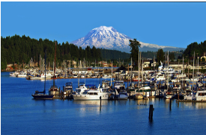

Series Proposal

Overview

BIG HARBOR is a family-style ensemble comedy of chaotic relationships amongst recognizable characters striving for love, in a place much like Gig Harbor (on Washington State's Puget Sound, near Seattle), although smaller and more archetypically idyllic. In Big Harbor, as it is everywhere, love and fulfillment are hard to find. The episodes focus on the misadventures of the Wilson family, the idiosyncratic guests who come to stay at their home, "the finest Bed-and-Breakfast in all the Pacific Northwest," and the hyperbolically bizarre harbor residents. The elder Wilsons, Bob and Nancy (a semi-retired couple) are the Harbor's hub of wisdom and wholesome benevolence. Their adult children, Doug and Linda, run the town's water taxi service. Nancy's older brother, Uncle Jake (who did a little too much LSD in his youth), runs a charter fishing/tour business that features a fully modernized but visually authentic pirate's Brigantine. It's the return of the Wilson's youngest daughter, Debbi, the smartest and most observant character, who has unexpectedly dropped out of college, that triggers the events that become the series.

NUTSHELL
It's How I Met Your Mother meets Newhart.

SERIES Logline
In a picturesque Pacific Northwest harbor town, Debbi, a directionless young lady returns to her family's home, "the finest Bed-and-Breakfast in all the Pacific Northwest," run by her parents, a semi-retired couple venerated by the community. Debbi, along with her older brother and sister (and everybody else), search for love and fulfillment in a place that just might be more than it seems.

PILOT Logline
The day of the Wilson Family's Bed-and-Breakfast's 10-year anniversary, owners' Bob and Nancy's youngest daughter, Debbi, unexpectedly returns from college. That evening, while Bob and Nancy go out for a celebratory dinner, the B&B's website is inundated with lurid postings from a wild, full-house party. Everyone pulls together to salvage the situation before their parents return to a ruined business.

The Characters

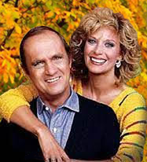
BOB and NANCY WILSON (60's, married, like Bob Newhart and Mary Frann) own and manage "the finest Bed-and-Breakfast in all the Pacific Northwest." Bob is a mature, dedicated husband, overweight, with a dry sense of humor. He studied philosophy in college, which has matured into a firm belief in a benevolent universe.
Nancy is Bob's practical, affectionate college sweetheart who has a flair for decorating and hospitality. She played soccer in college and dual-majored in fine arts and business. They have three adult children (Doug, Linda, and Debbi), still "living at home."
Their goals are to provide safety and security for their kids while modelling a Good Life. Principled and pragmatic, but lacking ambition, finances are a continuing challenge.
Wardrobe: Bob wears casual dress pants, oxford shirts, and cardigan sweaters. Nancy wears casual country dresses, slacks, women’s Keds sneakers, and classy jewelry.

DOUG WILSON (26, like a young Chris Pratt) is the adventurous son, with a B.A. in International Studies from the University of Washington. He spent two years in the peace corps and now runs the harbor's water taxi service with his younger sister, Linda.
Doug's goal is to find a woman with his Mom’s values, but who (a) will do anything for him, (b) surprises him delightfully, and (c) makes him laugh.
A sensitive but stereotypical 30-year-old man, Doug is ever on the lookout for one-night stands but only seems to attract mentally-imbalanced women or those who want to settle down.
Wardrobe: Quite fit, Doug's attire is athletics/sports-themed.

LINDA WILSON (24, hot but insecure, like Jennifer Aniston putting on a brave face) wants a man like Dear Ol' Dad, but only seems to meet guys interested in short-term one-night stands. She studied engineering in college while following her mother's lead and starred on her school's soccer team. Along with Doug, she runs the harbor's water taxi service. With a feel for business, the Mayor will ask her to liaison with developers interested in upgrading and expanding the harbor.
Wardrobe: Non-pretentious, Linda wears preppy blouses and fair isle sweaters (think L.L. Bean).

DEBBI WILSON (20, like a quirky Emma Stone with a "Star-Lord's Mom" vibe) is the family's "wild child," who returns unexpectedly after dropping out of college. Her older self (a matured "future-Debbi") is the show's narrator.
Pretty, flighty, and "alternative," active on social media and backs social/protest causes, she settles back into her former role as the B&B's all-round gopher, but she's also the storyland’s Catalyst archetype. Her return triggers an ongoing series of changes that occur over the course of the show’s many seasons.
Wardrobe: Washed out jeans, graphic t-shirts, hoodies, and combat boots, never jewelry.

All three Wilson children live in the Inn's 3-bedroom guest cottage.

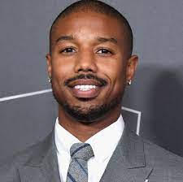
BILL JONES (30s, like Michael B. Jordan) is handsome, smart, mature, and personable. Armed with a good pedigree, a mechanical engineering degree from MIT, and a resume that includes time with the Army Corps of Engineers, he is the LAST "jones" -- all his relatives are dead. To mourn alone, he came to Big Harbor because, when he was a kid, his family once vacationed here. Eventually, he decided to be useful and took the job of maintaining the taxis for the start-up water taxi service run by a local brother and sister. He now also services Jake's pirate fishing boat and Sally's seaplane while sitting on a secret: he owns a patent on a device every internet service provider needs to connect with end-users, resulting in a nest-egg of millions. His goal is to be a valued member of a family again.
Wardrobe: Preppy clothing and cotton sweaters, true to his time in Andover and Cambridge.

UNCLE JAKE (60's, like an always spaced-out Christopher Lloyd) is a former French Foreign Legion hippy, who went through a period of experimenting with "too much LSD." Forever fascinated by pirates, he landed in Hawaii where the idea of captaining a pirate fishing boat for tourists first blossomed. He now channels movie pirates' lines and demeanor, from Long John Silver to Captain Blood to Jack Sparrow. Life, as Jake experiences it, is a Don Quixote-like adventure, so music accompanies him wherever he goes, either late '60's love songs or Dimitri Tiomkin-esque movie scores. Whenever Jake's around, we're in the thick of a swashbuckling adventure, where life is glorious and grand, both melodramatic and supra-real, every moment decisive! This storyland's Fool, Jake focuses on his charters, his sister’s family, and his wenches.
Wardrobe: When not wearing his black-and-white "Jake's Pirate Fishing – ARRGH!" T-shirt (with the Jolly Roger on the back), he wears a pseudo-pirate's outfit of puffy shirt, vest, boots, and hat (sans sword, parrot, and eye-patch).
LAURA LEE (30's, Asian, like Grace Park) is the storyland’s monk archetype, who nevertheless still longs for companionship. She Studied cooking in Japan and now owns and manages a Japanese Steak House in town. Friendly but serious, single and looking, she and the B&B refers customers to one another. When not dealing with Steak House details, she practices Goat Yoga on the beach and prowls international dating sites for her perfect match. Her goal is to build the restaurant into a branded business (including online recipes "Ala Andre”), then sell it to Gordon Ramsey. On the proceeds, she plans to move to a Caribbean island and there raise her child (whether adopted or natural).
Wardrobe: A glamorous clothes horse, she's always a knockout.

MARIA GARCIA (20's, Latina, like Bryana Salaz) is the storyland's Innocent archetype. A recent immigrant from Mexico who works at the B&B, she wants what no one in her family has EVER had: an education and an established career, then a family. Still learning English, she takes classes at the local city college. Easily confused, she is nevertheless well-intentioned, hardworking, and very pretty.
Wardrobe: A typical Latina, Maria wears colorful outfits, classy makeup, and small earrings.

SALLY KOWALSKI (50's, like a hyperactive, fun-loving older Rebel Wilson) lives for intense experiences as the quintessential Cougar. A Calamity Jane-like Australian seaplane pilot, she transports visitors to and from Canada while partying like a 20-year-old.
Wardrobe: Usually in her WWI pilot's long-coat, although her J. Crew blouses and pastel slacks are not cheap. Her hair and makeup are merely an afterthought, so she gives the impression that she just rushed in after shagging all night long.

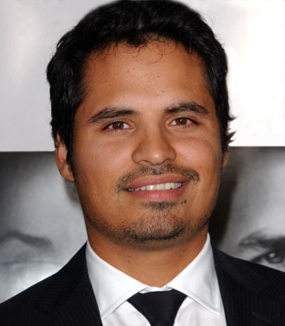
DON DIEGO DeLa VEGA (30's, an always scheming Michael Pena-like con-man) is from South-Central Los Angeles who yearns for money and respect. Sent by his LA Gangland boss father to “make it” in Big Harbor, he’s Season One’s deep Antagonist (akin to Holmes' Moriarty). Everything about him is fake (even his name).
Behind most all the troubles that become something of a plague for the harbor community, he lands upon the idea of updating and transforming it into a thriving Land of Opportunity. A key to the plan is to get rid of the Inn and change Big Harbor's image from “wholesome” to “progressive.”
Eventually, he produces a document (from a forgotten old trunk of family heirlooms) that proves a relative of one of his henchmen (Meemo) is the descendent of a Native American who was given several hundred acres that includes the land upon which the Inn sits. Armed with this assurance, Don Diego makes plans to move the Wilsons out, bulldoze, construct a casino, build new roads, re-zone and update the entire harbor, which successfully lures investors -- until the fraud is revealed.
Wardrobe: Ultra-stylized natty. Everything is tailored.

MEEMO (early 20's, fidgety and unpredictable) is Don Diego's dangerous henchman. Surviving, scrambling his way up, he's still living and conning in South Central LA, but drops-in occasionally.
Wardrobe: Varies from tank-tops and jeans to pimp-like glamor.

ANDRE (40's, supremely insecure) studied at Le Cordon Bleu Madrid, Escuela Universitaria de Hosteleria y Turismo de Sant Pol in Barcelona, and Stephanie Prather's Sabor Vegan Culinary Academy on the island of Mallorca. Flamboyant and dead-on, he’s been bumped from six restaurants on the west coast because he’s a "recovering" near-insufferable prima dona. Came to BG to live with his mother. Cooking at the Inn and Laura’s Steak House are his way back to functionality. As he struggles with his inner demons, praise is his life's blood.

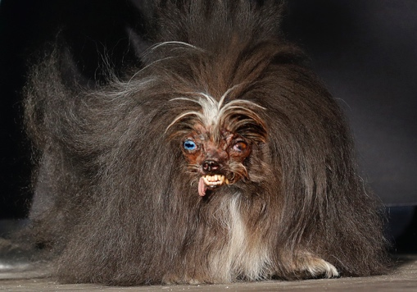
MR. PICKLES (age unknown, the ugliest dog on four legs). An unfortunate fight with a pack of chihuahuas in Mexico made him hideous; even his smile is disturbing. After his owner, Mrs. O’Toole, lands in the hospital, he is adopted by Uncle Jake and eventually becomes a harbor figurehead.
Wardrobe: If anything, it's pirate garb, including a three-corner hat and an eye patch. Like Pig-Pen, he's always dirty and bedraggled.

THE HARBOR RESIDENTS AND VISITORS start out as Plot Devices, although they round-out over time (and each can be the focus of a given episode). These whacky characters add spice, depth, and humor by way of their supremely exaggerated stereotypical characteristics and goals.

The Settings

The harbor, water taxi, and Uncle Jake's tour boat

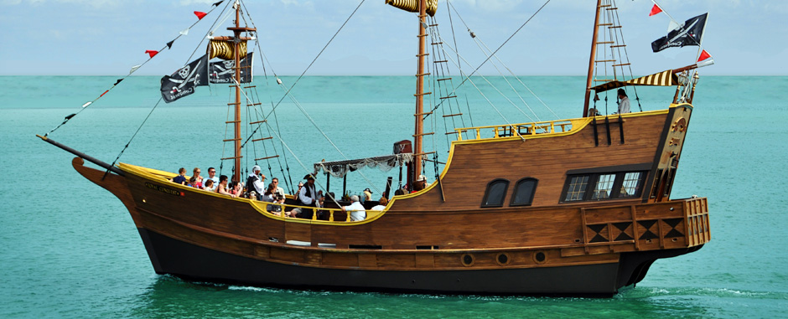

The Wilson Family's B&B
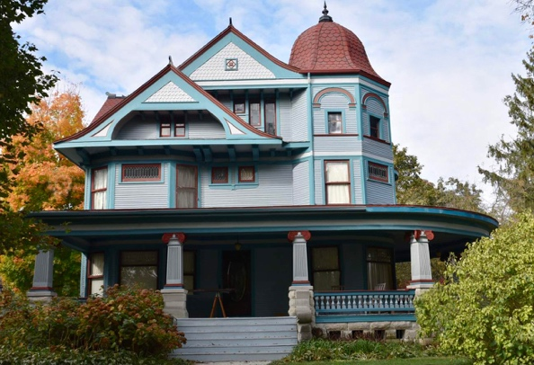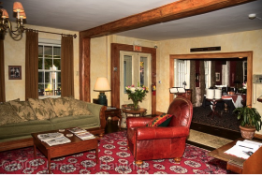

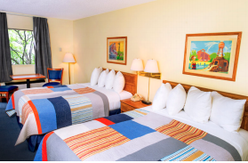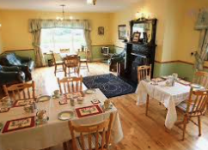

Laura Lee’s Japanese Restaurant The Big Harbor Pub
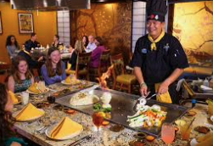
(on the harbor, above the docks)
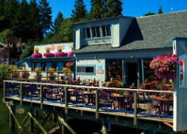

Big Harbor is a sound-stage based multiple-camera show. Beyond the main sets -- the B&B's entry/parlor and guest rooms, the "Counters" (Water Taxi, Jake’s Tours, and Sally's Seaplanes), the docks, and the deck of Jake's pirate ship -- inserts establish the harbor community, its odd residents, the season, and the time of day, while swing sets and green-screen create the different locales. Filming scenes on location is discouraged (if not verboten).

The First Season

Pilot – Family Fun Day
18 sexy tech executives book the Wilson's B&B. Uncle Jake hosts Japanese tourists on his pirate boat. Debbi returns unexpectedly from college. All hell breaks loose when pics of the tech execs' wild party get posted on the Wilson Family's website, threatening not only Bob and Nancy’s romantic anniversary, but the family's livelihood.

Episode 2 – You’re Gonna Need a Bigger Boat
Richard Dreyfus charters Uncle Jake's pirate ship, looking for salmon. DeLa Vega formulates a scheme. Linda and Doug bet again, Bill joins in. Bob starts looking into DeLa Vega. Sally seduces Dreyfus and Jake finds a wench to help him crew.

Episode 3 – Nobody Wants a Millennial Pizza
Visitors from Southern California are overheard complaining about the Mexican food in Big Harbor. Maria enters the Harbor's Burrito Festival contest, rigged by DeLa Vega, who brings in ringers from Los Angeles. Debbi travels to San Francisco. Linda and Doug give-up for awhile.

Episode 4 – Valentine’s Day Massacre
Debbi returns from SF, and she, Doug, and Linda seriously search for true love during a week of dating mishaps. Even Maria is caught up in the romance as a married local councilman propositions her. Bob and Nancy face-down DeLa Vega.

Episode 5 – “ARGH, To the Fish”
The Japanese tourists return for more adventures in Big Harbor, with their wives. Jake suggests a fishing contest, but DeLa Vega interferes. Debbi laments her luck. Laura flirts with one of the Japanese men, but his wife catches them.

Episode 6 – A Three Hour Tour
An homage to Gilligan’s Island with Uncle Jake as the skipper. While Debbi struggles with her long-distance relationship, a major storm beaches the ship overnight on a remote island (which they think is Vashon Island). No cell service or WIFI, and no supplies!

Episode 7 – The Patriot Invasion
While Debbi returns to SF, football fans from Boston take over the B&B during a weekend clash with the Seattle Seahawks. Off the field, it's the super-intense Bostonians vs the laid-back Seattlites. The contrasts become a contest which shows up in different clothing, foods, and local slang (“say your “R”s), prompting DeLa Vega to set-up a gambling den.

Episode 8 – Theft, She Wrote
While Debbi meets someone on the plane home, a mysterious theft at the B&B has everyone looking for the culprit. Angela Lansbury guest stars, and identifies the thief: Don Diego DeLa Vega. Meemo threatens the local judge, "Case dismissed." The chief of police vows to put DeLa Vega away.

Episode 9 – Canada is Only a Short Drive Away
Political humor about American citizens moving to Canada, while wacky Sally brings some Canadians to Big Harbor. Linda and Debbi double-date with men from Vancouver; one successful, the other, not so much. Debbi reveals she's pregnant.

