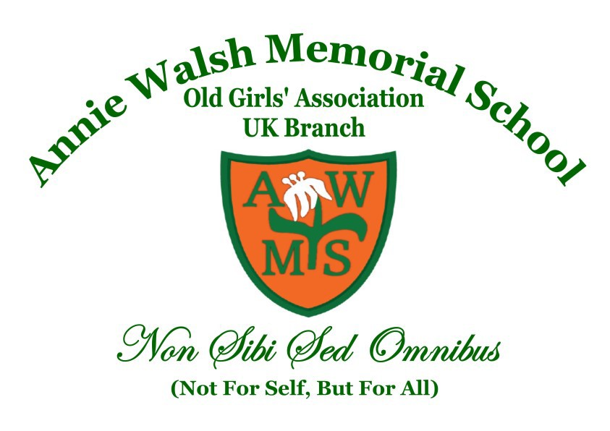
ANNIE WALSH MEMORIAL SCHOOL
Founded 1849

OLD GIRLS' ASSOCIATION [UK BRANCH - 1984]
Registered Charity in the UK: No.1165222
Please retain this part of the form
You may be applying for new or renewed membership. It entitles you to receive Minutes of all meetings, information from the school and functions of the Association/Charity. Meetings are open to all AWOGA Members and are held on every third Saturday of the month.

We normally meet virtually via the zoom platform. You will find the Zoom link for each meeting on the agenda sent out in advance by the Secretary prior to each month’s meeting. Meetings start at 4.00pm prompt and conclude by 6.30pm.

Please note there are no meetings in June when the Luncheon Sale is held and also in August due to the summer break.

KEY NOTES:

Subscription
£30.00 per annum from 1st March 2025. New members pay initial £60 and £30 per annum for subsequent years
Payment made to: Bank: NatWest :Account No.: 17422213 :
Sort Code: 60-03-36
Account Name: AWMS Old Girls Association (UK Branch)
Please do NOT send cash in the post. Payments made by bank transfer should include Ref “Your Name + Subs” and kindly notify the Assistant Treasurer via treasurer@awoga.org.uk when the payment has been made.
A copy of the Constitution, Rules and Bye Laws will be sent to you, on receipt of your Subscription and application Form.
DOB is optional but if provided you will receive a Birthday Card annually. Please let the Pastoral Officer know when you have a special birthday.
For general enquires regarding subscription and payment: treasurer@awoga.org.uk
For general enquiries regarding minutes and monthly meetings: secretary@awoga.org.uk
…..…………………………………………………………………………………………………………...
PLEASE EMAIL THIS FORM TO THE ASSISTANT TREASURER

I would like to subscribe to the membership of the AWOGA UK / Registered Charity UK No.: 1165222

Full Name: ………………………………………………………………………………………………………...

Address: …………………………………………………………………………………………………………...

……………………………………………………………………………………... Postcode …….……………..

Tel: ……………………… Mob: ………………………… Email: ................................…………………..……

Date of Birth: Day ………..……………………… Month………………………………………………..……

I am paying subscription for___________ [year(s)]

I would like to be part of AWOGAUK Whatsapp group…………………(Y/N)
I would like to be part of the PAT(Pastoral are team)………………………..(Y/N)

I am a UK taxpayer and would like AWOGA UK to regard my subscription/s as a Gift Aid donation. I confirm that I have paid an amount of UK income or capital gains tax equal to any tax reclaimed.

Name: …………………………………..………………………………………………………………………….

Signed: ……………………………..……….…… Date: …………..…………………………………………….

By completing this form.

This form can also be completed via AWOGA UK website

Membership | AWOGA UK

