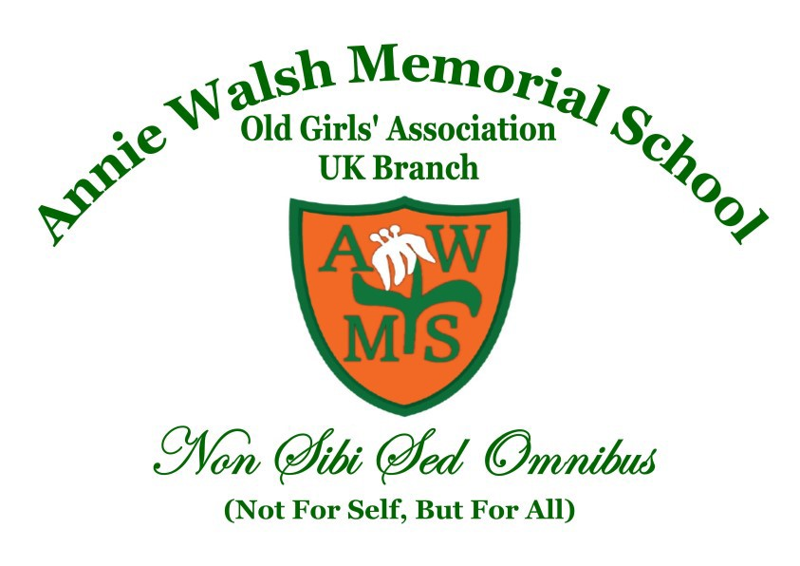
ANNIE WALSH MEMORIAL SCHOOL
Founded 1849

OLD GIRLS' ASSOCIATION [UK BRANCH - 1984]
Registered Charity in the UK: No.1165222
Please keep this part of the form

You may be applying for new or renewed membership. It entitles you to receive Minutes of all meetings, information from the school and functions of the Association/Charity. Meetings are open to all AWOGA Members and are held every third Saturday of the month.

We normally meet physically at the Walworth Methodist Church, 54 Camberwell Road, Camberwell London, SE5 0EW. But due to the pandemic we have been meeting virtually on the Zoom platform. You will find the zoom link for each meeting on the agenda that is sent out by the General Secretary on a monthly basis. Meetings start at 4.00pm prompt and conclude 6.30pm.

Please note there are no Meetings in June when the Luncheon Sale is held and also in August due to the summer holidays.

KEY NOTES:

Subscription fee: £25.00 per annum. New members initial £50 and £25 per annum for subsequent years
Payment to be made to: Bank – NatWest, Account – 17422213, Sort Code - 60-03-36
AWMS Old Girls’ Association (UK Branch)
Cheques to be sent to: Mrs Lorraine Davies, 151 Woolwich Road, Abbey Wood, London, SE2 OPX
Please do not send cash in the post. Payments made by bank transfer should include your Name and “Sub” as the reference and kindly let the Assistant Treasurer know when you have made the payment.
A Membership Card, Rules and Bye Laws will be sent to you, on receipt of your Subscription and Application Form.
DOB is optional but if given you will receive a Birthday Card annually. Please let the Pastoral Officer know when you have a special birthday.
For general enquires regarding subscription and payment: treasurer@awoga.org.uk
For general enquiries regarding minutes and monthly meetings: secretary@awoga.org.uk
…..…………………………………………………………………………………………………………...
PLEASE POST/EMAIL THIS PART OF THE FORM TO THE ASSISTANT TREASURER

I would like to subscribe to the membership of the AWMS Old Girls’ Association [UK Branch] Registered Charity in the UK: No. 1165222

Full Name: ………………………………………………………………………………………………………...

Address: …………………………………………………………………………………………………………...

……………………………………………………………………………………... Postcode …….……………..

Tel: ……………………… Mob: ………………………… Email: ................................…………………..……

Date of Birth: Day ………..……………………… Month………………………………………………..……

I am paying subscription for___________ [year(s)]

I am a UK taxpayer and would like AWOGA UK to regard my subscription/s as a Gift Aid donation. I confirm that I have paid an amount of UK income or capital gains tax equal to any tax reclaimed.

Name: …………………………………..………………………………………………………………………….

Signed: ……………………………..……….…… Date: …………..…………………………………………….

