**Invictus WEST SHORE Application Form**

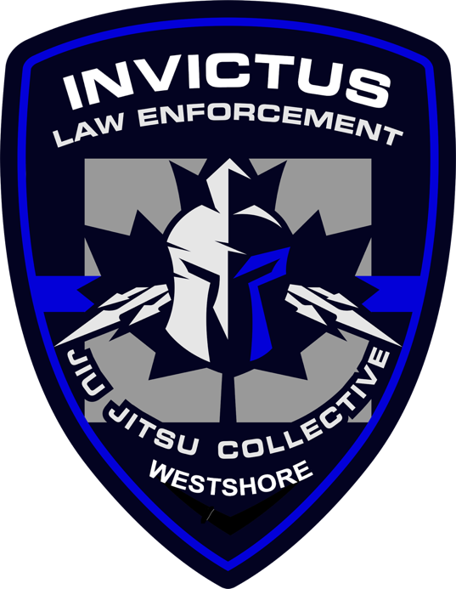

Thank you for your interest in training at the Invictus Westshore location.

Our West Shore academy is located at 4342 West Shore Pkwy #114 Langford BC.

The West Shore location is affiliated with the Invictus Northern Headquarters of the Invictus Law Enforcement Jiu Jitsu Collective, a world-wide movement designed to get police training in proper use of force. As such, there are a few things that are different than a “standard gym” that you may be accustomed to.

**Who We Teach:** At Invictus Westshore we accept applications from the public for our Brazilian Jiu Jitsu Program. Applicants must be 19 years of age or older.

Currently the Police Jiu Jitsu Program is restricted to law enforcement professionals. These include police, corrections, sheriffs, and other similar individuals.

**What We Teach:** We teach two styles of Jiu Jitsu: Brazilian Jiu Jitsu (Helio Gracie Lineage) and POLICE Jiu Jitsu (modern combatives). The focus of the dojo will be on real world application of Jiu Jitsu techniques. Our focus is self defense, real fighting scenarios, arrest, weapon retention, grappling and belt ranking in both PJJ and BJJ.

**All members are vetted through the application process.**

**Who We Are:** Invictus Westshore Owner and Head Instructor Alexander Erwin is a brown belt in Brazilian Jiu Jitsu a 2nd degree black belt in Japanese Jiu Jitsu which he earned under Ari Knazan.

Invictus HQ Head Instructor Ari Knazan is a Level 5 C4C-PJJ Instructor. He is certified by Chad Lyman from Las Vegas. C4C is the gold standard when it comes to police use of force and defensive tactics training. Ari also holds a 2nd degree black belt in BJJ under Keith Owen/Pedro Sauer and a 5th degree black belt in Japanese Jiu Jitsu under Steve Hiscoe.

**Views on Police:** Invictus is unapologetically LEO/Police supportive. We are not a “most cops are good” facility, we are a “the overwhelming number of cops are good” company. If that bothers you in the slightest Invictus Westshore is not for you. Our view is that the overwhelming number of people are good as well.

We are not here to ‘police the police.” There are plenty of people who jump on that train. We are here to serve the police, train them, and better prepare them to execute their mission as true professionals. To that end C4C PJJ/ Invictus will focus on what we can do to make them better. By improving officers and making them more competent, more confident, more in control, and more compassionate C4C PJJ/Invictus will make them safer. If the officer is safer, the community they serve will be safer as well. Everyone benefits from a calm, well trained, in control Police Officer. Regular training within our curriculum will help create that kind of individual.

C4C PJJ/Invictus thoroughly rejects the thought that cops are routinely using excessive or unnecessary force in encounters with the community. We train officers not because of excessive force, but rather because officers often use force in an ineffective manner. *Ineffective force can appear to be excessive force.* Effective force at lower levels can be a way to de-escalate a situation. C4C PJJ / Invictus trained officers are better prepared to dominate positionally those who resist allowing them to control the suspect and use reasonable force options.

We are also unapologetic advocates that officers should train consistently over time. If you have chosen this line of work you have to train. Police Officers should train regularly, and Police Departments should develop training staffs that provide effective training on a consistent basis. We believe we are training, not trained.

**Our Expectations:** Please note that we require students to meet the following in order to maintain membership.

1. Cost for training is **$120/month and paid in full by the first of each month**(E-transfer to invictuswestshore@gmail.com).
2. Private Lessons are available at $100/hr. These may be share by up to 2 students.
3. **YOU MUST FILL OUT AN APPLICATION PRIOR TO ATTENDING A CLASS. This must be approved by Alex Erwin before you attend. Without an application and waiver no one will be allowed to train.** You can direct people to our website: www.invictushq.ca for information.
4. We absolutely encourage you to tell friends and colleagues about your training experience. Please let them know about our website should they want to inquire.

**What Happens Next:** Once you have completed this form, email it back to [invictuswestshore@gmail.com](mailto:invictuswestshore@gmail.com) You will be contacted by Alex who will inform you if you have been accepted to the training cycle. Please review the training schedule on the website.

If accepted to the Dojo, you will be asked to join our Signal Chat group. This group is exclusively for training members only and news and relevant information will be shared on that platform. Please download the Signal App if you don’t have it.

I also encourage you to check out the main [www.invictusleo.com](http://www.invictusleo.com) site as well as our podcast, [www.nozoolions.com](http://www.nozoolions.com)

Regards,

Alexander Erwin

Head Instructor and Owner

[www.invictushq.ca](http://www.invictushq.ca)

[*invictuswestshore@gmail.com*](mailto:invictuswestshore@gmail.com)

*\*This application form is designed to find out more about your goals and what you want out of training. This form is private and will not be shared with anyone else. Please email the completed form back to* [*invictuswestshore@gmail.com*](mailto:invictuswestshore@gmail.com) *when you are done.*

**INVICTUS APPLICATION FORM**

Name:

Date of Birth:

Address:

Email:

Phone Number (for private Signal Chat Group):

How did you hear about us:

Occupation:

If LEO, What department, how long, and current position:

What are your work hours:

Emergency Contact name and number:

Injuries or medical conditions. Please list:

Do you have previous martial arts experience?

If yes, what style(s), how long and what rank?

Where did you previously train and what was the school/instructor’s name?

What style of Jiu Jitsu do you wish to train at Invictus? PJJ/BJJ/Both

What are your goals for training (be specific on what you want out of your training)?

Other Information you think we should know?

Please email this back to [invictuswestshore@gmail.com](mailto:invictuswestshore@gmail.com)