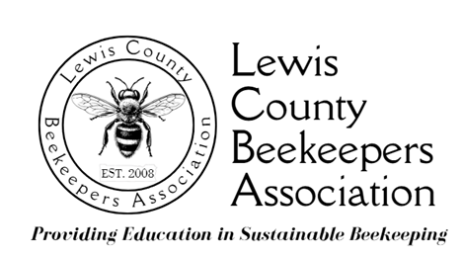

Photo, Audio, and Video Promotion Release Form

The Lewis County Beekeepers’ Association (hereafter, LCBA) may take and use photographs or videos of me and/or my child or materials or excerpts of statements I provided to be used for public information purposes, such as LCBA publications, website, displays, news releases, podcasts, blogs, video presentations, and advertisements with the understanding that my image will be used to promote the educational and outreach programs of LCBA. I do this willingly, expecting no compensation or gratuity of any kind from LCBA.

Please complete and sign:

Parent/Guardian’s Name: __________________________________________________________
Minor’s Name: __________________________________________________________
Address: __________________________________________________________
Telephone: __________________________________________________________
Email: __________________________________________________________
Signature:__________________________________________________________
Date: ______________

