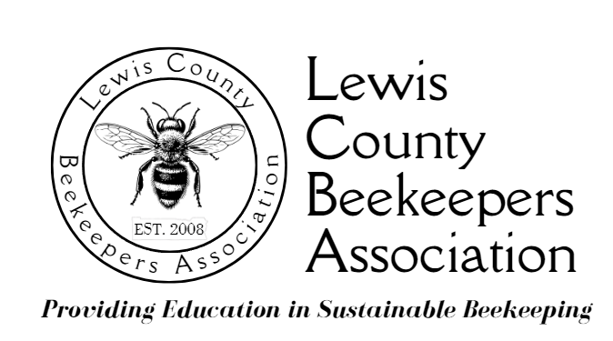

2026 Youth in Beekeeping Scholarship

Application Form

Due Dec. 19, 2025; Email to Noel Sharp, Education Coordinator (nsharp928@gmail.com)
APPLICANT INFORMATION:

Last Name: _______________________________ First Name: _____________________________________________

Date of Birth: ______________________________ Personal Email Address: ___________________________________

Name of Middle or High School (if home schooled, please note): ____________________________________________

School Grade Level: ________________________ Current GPA: _________________________________

Mailing Address:
Street: _____________________________________________________________________________

City: ___________________________________ State: ___ ZIP: ___________________________________

School Phone: ___________________________ School Email:_______________________________________

Name of Principal / Advisor and Position: ________________________________________________________

Name of Parent(s) or Guardian(s): _____________________________________________________________________

Mailing Address: Street: ____________________________________________________________________________

City: ___________________________________ State: ___ ZIP: ____________________________________

Telephones: Home #: _________________________________ Work Phone: ____________________________

Cellphone #: _____________________________

Email Address: ______________________________________________________________________________

(over)

Please list any extra-curricular and/or community activities in which you participate, when they happen, and your role in these activities (you may add a sheet of paper if needed):

Type of Activity: When/Where It Happens: Applicant’s Role in Activity:

__________________________________________________________________________________________________

__________________________________________________________________________________________________

__________________________________________________________________________________________________

Do you have a place to keep a hive of bees? ____Yes ____No

Location:

Personal statement, about 200 words
This is not a formal essay: please just explain in your own words why you would like to try beekeeping. Please include a separate sheet with your statement, which may be typed or neatly hand-printed.

Letters of Recommendation

- Provide two letters of recommendation from references not related to the applicant, one of which will be from a science or agriculture teacher (home-schooled students may provide letters from community members). The reference letter may be sent by U.S. Mail or email to the Youth in Beekeeping Scholarship contact person.

Commitments Youth Scholarship Applicants Must Agree to Make

- I will commit to taking LCBA’s Beginning Beekeeping Course, which will run for 6 Saturday mornings beginning in January 2026 (dates/times TBD) at Centralia College. I understand that I must pass the class to be eligible for bees and equipment.

- I will commit to serving as a volunteer at LCBA’s exhibits at the Spring Youth Fair and on Children’s Day at the Southwest Washington Fair.

- I will commit to speaking briefly to the LCBA membership about what I have learned about beekeeping at the LCBA’s Summer Potluck and Holiday Potluck. (Dates/Times TBD)

- I will commit to attending LCBA workshops and the educational portion of monthly meetings during the year (the Board understands that a few may have to be missed because of conflicts).

- I will commit to keeping a journal of my beekeeping activities and will submit this with the attached Activity Checklist to the LCBA Board for review.

- I understand that the bees & equipment are a loan; if I meet all scholarship commitments & pass the final LCBA inspection of my apiary in the fall, I can keep the bees & equipment.

SIGNATURE OF APPLICANT: ________________________________________________________________

SIGNATURE OF PARENT OR GUARDIAN: ______________________________________________________

