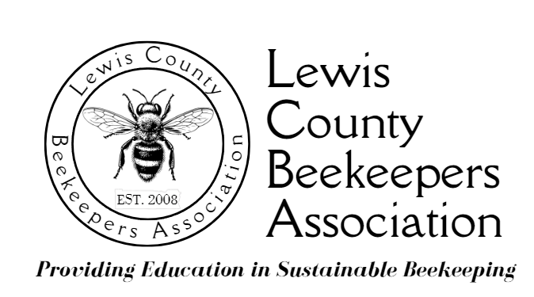

2026 LCBA

YOUTH SCHOLARSHIP EQUIPMENT KIT
(Mentors may make changes to this list after consulting the LCBA Board)

- 2 Langstroth 10 Frame Medium Boxes – Commercial Grade, Unassembled*
- 2 Langstroth 10 Frame Deep Box – Commercial Grade, Unassembled*
- 20 Medium Frames/Wax Foundation – Unassembled*
- 20 Deep Frames/Wax Foundation – Unassembled*
- 1 Bottom Board (screened or solid to be discussed with mentor)
- 1 Entrance Reducer
- 1 10 Frame Inner Cover, unassembled
- 1 10 Frame Telescoping Cover/Sheet Metal covered, unassembled
- 1 Boardman Feeder
- 1 Hive Tool
- 1 Hive Rack
- 1 Smoker
- 1 Bee Brush
- 1 Bee Suit
- 1 Pair Gloves
- Bees (1, 4-pound package of Bees or Nuc)
- Beginning Beekeeping Course at Centralia College
  - 1 Beginning Beekeeping Book

*There will be an opportunity for a hive-building workshop after the LCBA 2026 Beginning Beekeeping Course. Mentors will aid scholarship students in assembling hive boxes

