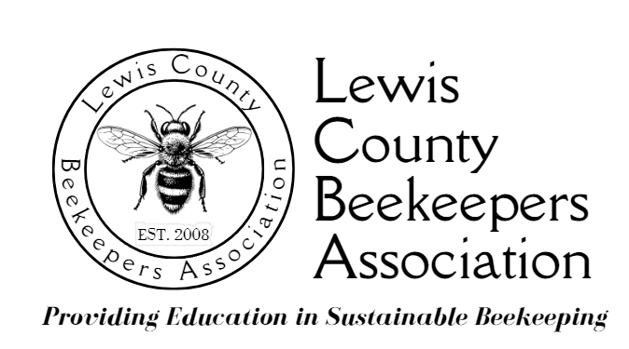

**LCBA Youth in Beekeeping Scholarship Program Description**

To foster a lifelong love of beekeeping and to train the next generation of Lewis County beekeepers, the Lewis County Beekeepers’ Association (LCBA) will grant bees, equipment, and educational opportunities up to the value of $600 each to two to three Lewis County (or south Thurston/North Cowlitz County) applicants who meet the criteria of age, interest, and ability to participate in an 18-month LCBA educational and mentorship program in beekeeping.

Students who will be in 6th to 11th grades in 2025 are eligible (home-schooled students are included). (Availability of mentors is taken into consideration when evaluating applications.)The grant of bees and equipment is a loan to cover the first season of beekeeping; students who meet scholarship requirements will be given bees and equipment to keep.

**Scholarship recipients will be required to:**

* Work under the direction and guidance of an LCBA mentor, to be designated by the Board of Directors, for the duration of the 18-month educational and mentorship program;
* Complete LCBA’s Beginning Beekeeping course;
* Attend at least 10 educational events in any combination of educational presentations at the LCBA monthly meetings and LCBA workshops during the 18-month educational and mentorship program, to be chosen by the recipient in consultation with the beekeeping mentor. New beekeepers must be exposed to a wide range of beekeeping philosophies and practices. Please note that regular inspecting of one’s own bees and mentor visits to the apiary is considered routine bee management and do not count toward the minimum 10 educational events.
* Establish and maintain one bee colony in a Langstroth hive;
* Provide peer mentorship to the next year’s scholarship recipients;
* Be a bee/beekeeping advocate for their community & a positive role model for other youth interested in beekeeping by participating in outreach activities. Youth Scholars are required to help staff LCBA’s exhibits at the Spring Youth Fair and Southwest Washington Fair, & may be asked to participate in bee education programs for school and community groups;
* Keep a journal & present their beekeeping experience in a culminating project to LCBA’s Board of Directors.

**Criteria for Selection:** The applicant must:

* Be a middle school or high school student (6th – 11th grades) residing in and attending school or being home-schooled in Lewis County, north Cowlitz, or south Thurston Counties, in 2025;
* Be from a family new to beekeeping;
* Submit a complete scholarship application, hold-harmless agreement, & photo release form, printed or word-processed;
* Submit a 200-word letter in the applicant’s own words telling why he/she wants to participate in the LCBA Youth in Beekeeping Scholarship Program;
* Provide two letters of recommendation from references not related to the applicant, one of which will be from a science or agriculture teacher (home-schooled students may obtain references from community members); and
* If requested by LCBA’s Board of Directors, complete an interview with the LCBA Scholarship Committee.

**The final selection of scholarship recipients is at the sole discretion of the LCBA Board of Directors and is in part dependent on mentor availability.**