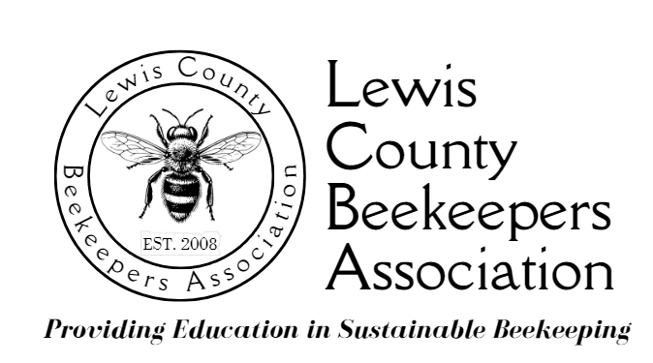

**2025 Youth in Beekeeping Scholarship Application Form**

**Due December 15, 2024; Email to Noel Sharp (**[**nsharp928@gmail.com**](mailto:nsharp928@gmail.com)**), Education Coordinator**

**APPLICANT INFORMATION:**

**Last Name: _______________________________ First Name: _____________________________________________**

**Date of Birth: ______________________________ Personal Email Address: ___________________________________**

**Name of Middle or High School (if home schooled, please note): ____________________________________________**

**School Grade Level: please fill in: ________________________ Current GPA: _________________________________**

**Mailing Address: Street: _____________________________________________________________________________**

**City: ___________________________________ State: ___ ZIP: ____________________________________**

**School Phone: ___________________________ School FAX: ________________________________________**

**Name of Principal / Advisor and Position: ________________________________________________________**

**Name of Parent(s) or Guardian(s): _____________________________________________________________________**

**Mailing Address: Street: ____________________________________________________________________________**

**City: ___________________________________ State: ___ ZIP: ____________________________________**

**Telephones: Home #: _________________________________ Work Phone: ____________________________**

**Cellphone #: _____________________________**

**Email Address: ______________________________________________________________________________**

**Please list any extra-curricular and/or community activities in which you participate, when they happen, and your role in these activities (you may add a sheet of paper if needed):**

**Type of Activity: When/Where It Happens: Applicant’s Role in Activity:**

**__________________________________________________________________________________________________**

**__________________________________________________________________________________________________**

**__________________________________________________________________________________________________**

**(over)**

**Do you have a place to keep a hive of bees? Yes No**

**Location:**

**Personal statement, about 200 words:**

***This is not a formal essay: please just explain in your own words why you would like to try beekeeping. Please append a separate sheet with your statement, which may be typed or neatly hand printed.***

**Also required to complete application:**

**• Provide two letters of recommendation from references not related to the applicant, one of which will be from a science or agriculture teacher (home schooled students may provide letters from community members). The reference letter may be sent by U.S. Mail or email to the Youth in Beekeeping Scholarship contact person.**

* **Commitments Youth Scholarship Applicants Must Agree to Make**
  + **I will commit to take LCBA’s Apprentice Beekeeping Course, which will run for 7 Saturday mornings**

**beginning in January, 2025 (dates/times TBA) at Centralia College. I understand that I must pass the**

**class to be eligible for bees and equipment.**

* **I will commit to serve as a volunteer at LCBA’s exhibits at the Spring Youth Fair and on Children’s Day at the Southwest Washington Fair.**
* **I will commit to speak briefly to the LCBA membership about what I have learned about beekeeping at LCBA’s Summer Potluck (July 2025) and Holiday Potluck (December 2025).**
* **I will commit to attend LCBA workshops and the educational portion of monthly meetings during the year (the board understands that a few may have to be missed because of conflicts).**
* **I understand that the bees & equipment are a loan; if I meet all scholarship commitments & pass the final LCBA inspection of my apiary in the fall, I can keep the bees & equipment.**

**SIGNATURE OF APPLICANT: ________________________________________________________________**

**SIGNATURE OF PARENT OR GUARDIAN: ______________________________________________________**