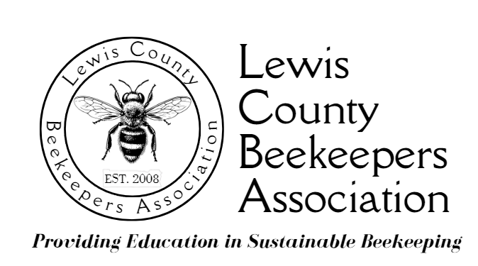

LCBA Youth in Beekeeping Scholarship
Activity Checklist

Scholarship recipients must complete at least 10 activities to qualify to keep their beekeeping equipment and bees. Two activities must include volunteering with the Spring and Southwest Washington Fair. The rest may include attending workshops, monthly LCBA meetings, or other volunteer activities.

1.) Spring Youth Fair Volunteer
Date:____________Hours:__________
2.) Southwest Washington Fair Volunteer
Date:____________Hours:__________
3.) Activity: __________________________________________________
Date:____________Hours:__________
4.) Activity: __________________________________________________
Date:____________Hours:__________

5.) Activity: __________________________________________________
Date:____________Hours:__________
6.) Activity: __________________________________________________
Date:____________Hours:__________
7.) Activity: __________________________________________________
Date:____________Hours:__________
8.) Activity: __________________________________________________
Date:____________Hours:__________
9.) Activity: __________________________________________________
Date:____________Hours:__________
10.) Activity: __________________________________________________
Date:____________Hours:__________

I have completed the ten activities listed above.

Signature of Youth Scholar: _________________________________________

Signature of Parent/Guardian_______________________________________

FOR LCBA to Complete:

Reviewed by Mentor: _______________________________________

Reviewed by Education Coordinator: _________________________________

